[Name of the Writer]
[Name of Instructor]
[Subject]
[Date]

Post: 15 Five Global Product Communication Strategies
Marketing concept Introduction:
Product Communication Strategy is an essential part for the progress of the marketing plan. A product is advertised in the foreign countries with the help of the different communication strategies which conveys publicity theme to customers that allows them to make opinion about different products. Effective product communication strategies prove to be a competitive advantage for the organizations. (Davis and Paul James p.276)
There are basically three global product communication strategies extension, adaptation and invention which are further enhanced into five strategies. (chand, Smriti, 2013.)
Straight Extension:
This strategy includes standardized product with constant communication strategy. Organizations use this strategy so that they can get opportunities in markets of other countries. It is easiest & less expensive and usually this approach is adopted by the small level companies because they don’t have to change their products as well as communication strategy which reduces their cost.
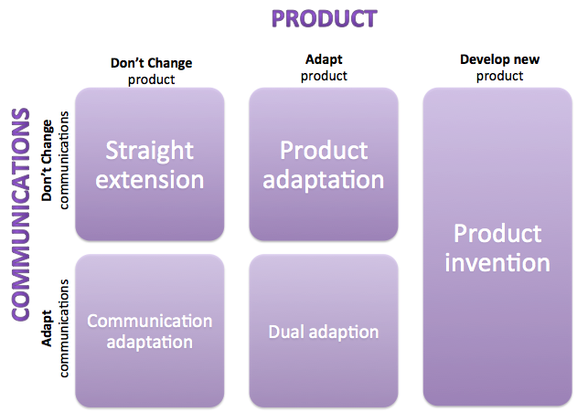
Product Extension and Communication Adaptation:
In this strategy, same products are sold due to the cultural or economic differences. It includes changes in some aspects of the promotion of the product according to the requirements. Implementation cost is low which proves to be a biggest advantage.
Communication Extension and Product Adaptation:
Firms adopt different products because of the changes in the cultural economical social & political environment but their advertisement strategy remains the same and gives the same message. Local markets usually prefer this strategy. This can lead to same core values among the consumers with consistent communication strategy.

Dual Adaptation:
When there are changes in legal and cultural environment in different markets of the countries, dual adaptation is implemented. It involves the adaptation of both the product and the communication strategy.
Product Invention:
This involves the creation of the new product which fits in the market. Global mindset is needed to discover the new product which can work in the whole world market with a greater scope. The costs may be high but it has various advantages.
Marketing concept Application:
My product is the dove soap. I think the strategy used for its campaign is straight extension as the product and communication method remains same. The product is promoted through the advertisements with a little modification. Dove has further extensions but the main product is the same. It gives the fine and smooth look of the skin and the cost for it is also low as they don’t have to change their product and the communication strategies for it.

References
Davis, Paul James. "Effective communication strategies in a franchise organization." Corporate Communications: An International Journal 9.4 (2004): 276-282.
chand, Smriti. “5 Major Product Communication Strategies Used In International Marketing.” Your Article Library, 11 Dec. 2013

