Name of Student
Name of Professor
Name of Class
Day Month Year
SIN TAX: AN ANALYSIS
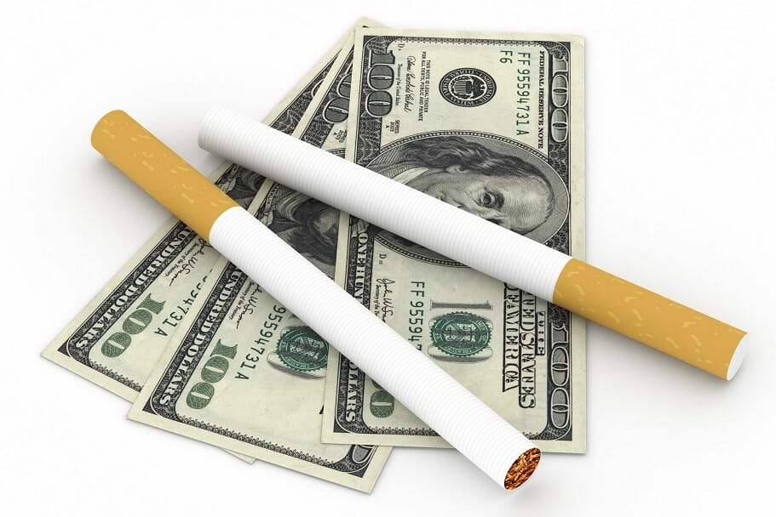
Sin tax, as it is evident from its title, can be defined as a sort of fine or excise tax imposed by governmental authorities on the products where social harm is involved. Such an excise tax is subject to be implemented on all the items which are sold. For instance, the most common products that harm the society are alcohol, betting, sexually exploited material, and cigarettes, and in this regard excise tax imposed on all mentioned items. The overall modus operandi of the sin tax implies that charges are collected either from wholesaler or manufacture. The practice, in turn, affects the price structure of goods and consequently, retail prices increased for consumers (Amadeo, 2019). When it comes to sin tax or excise tax, there are two factions of people. The first faction favors the implications and other terms and conditions of the tax and happily agreed to pay the extra price. On the contrary, the second category denies the efficacy of the process and considers the implementation as “nanny state.” However, it is believed that it has more pros than cons. In the following, a brief comparison of both standpoints is elaborated, and it is proposed that sin tax is an effective stratagem of the government to take charge of harmful societal practices.
A considerable number of people believe that the sin tax is a sort of governmental intrusion in the freedom of citizens. In this regard, it is also argued that if governmental incursion in such personal indulgence matters of citizen persists, the states will become “nanny states.” The libertarians quote two phrases in this regard that say, “do not tell me I cannot do what I want” and do not make me want what I do not want.” The faction of antagonists also explicates its fears that through such advancement and notion of the behavior-based economy, the government will start to treat the citizens as a child. Through sin tax, government is invisibly controlling every luxurious trading activity of citizens that is almost equal to controlling the desires of someone. Sin tax has enough potency to make the adult citizens a dependent child, who cannot do anything entertaining on his own. For this reason, six taxes are nothing but a psychological trauma that is infused into the legislative framework to control the mind of people. (Mattix, 2014) On the other hand, the anti-sin tax people assert that the amount that is charged as a sin tax is not competent enough to work. And therefore, if the government wants to prevent socially harmful methods, it should boost the tax amount so that consumers at least may feel discouraged. Furthermore, the oppositions question the efficacy of the devised sin tax framework that includes cigarettes and alcohol but declares the opium and marijuana illegal. And the government has not applied a sin tax on sugar or sugar-based products, though sugar is also harmful and can cause severe diseases in people.
Regardless of the overall validity of opposing points; it is more feasible to consider the favorable perspective of sin tax. According to general perception, sin tax involves more benefits than adversaries, and therefore such legalizations are in favor of overall societal prosperity. First of all, sin tax is the most effective device to discourage people from practicing health hazarding behaviors. Take the instance of a governmental policy that declared a 0.62 dollars tax on a pack of cigarette that in turn mitigated the overall sales of cigarettes by good 10% in 2009. On the other hand, the sin taxes are not making the state a nanny state as the generated revenues from taxes are utilized smartly in the development of the country. Moreover, the taxes government collects in the name of sin tax aid in providing healthcare treatment to the victims of alcohol and smoking. Similarly, impositions of sin taxes are efficient not only on the individual and economic level but it also affects political stability as well. People used to adopt the practices which are beneficial for them, and therefore it is observed that people support the idea of the sin tax to a vast extent (Griffiths, 2015). According to the general public, sin tax is better than income taxes because through the sin tax government collects money to spend it on the well being of citizens, and it is a distinguishing attribute of excise tax. Take the instance of statistics of 2017, when more than fifty-seven percent American showed their support towards sin tax because the sin tax collected on soda was supposed to utilize on children healthcare facilities (Amadeo, 2019). All such factors make sin tax a superior opt among other fees.
By analyzing the provided comparison between the pros and cons of sin tax and its subject implications, it becomes evident that sin tax is an advantageous legal step. Sin tax provides parameters to control socially harmful behaviors and also support the government to provide necessary health-based services to the citizens. Further, it is observed that such legislative frameworks and indispensable to create equilibrium in society. Without such eradicative measures, society can never ward off negative and perilous behaviors. The bright side of the picture does not sufficiently acquaint people who consider sin tax as nanny state tax, and for this purpose, awareness programs are imperative. Through sin tax a state does not become a nanny state; instead, it becomes prosper and healthy state.

Work Cited
Amadeo, Kimberly. “If Wine Is Taxed, Why Isn't Soda?” The Balance, 2019, www.thebalance.com/sin-tax-definition-examples-4157476.
Griffiths, Paul. “‘Nanny State’ – Is Public Health at Odds with Freedom?” Elsevier Connect, 2015, www.elsevier.com/connect/nanny-state-is-public-health-at-odds-with-freedom.
Mattix, Micah. “Freedom and the Nanny State.” The American Conservative, 2014, www.theamericanconservative.com/prufrock/freedom-and-the-nanny-state/.

