ECONOMIC ANALYSIS OF AMAZON
Name of Student
Name of Institution

Abstract
This analysis tries to capture the various aspects of the market in which Amazon is participating. The company is dominating the market with huge market share and even increasing revenues. The company has no threat from competition as it follows an aggressive approach of acquiring the other companies in the foreign markets. The Company has an inelastic demand for the products which ensures that the revenue increase with an increase in prices. This will also make sure that the customers will have lesser substitutes against the company.

Amazon Analysis
The company was formed in 1993 by Jeff Benzos as online bookstore. The company did not turn up to profits for the first 7 years of operations. The company applied the merger and acquisition strategy as its corporate strategy and did it with great success. The company today shows itself as the online seller that can provide each and everything required by the customers. The company has been converted to a huge retail machine from a garage-based book shop. The company has improved the various processes over time and so has the process of the customer need satisfaction. Today the company has been playing multiple roles from an online bookstore to the grocery store that can sell electronics as well. Now a days the company competes in all kinds of online sales.
Demand and Supply Analysis
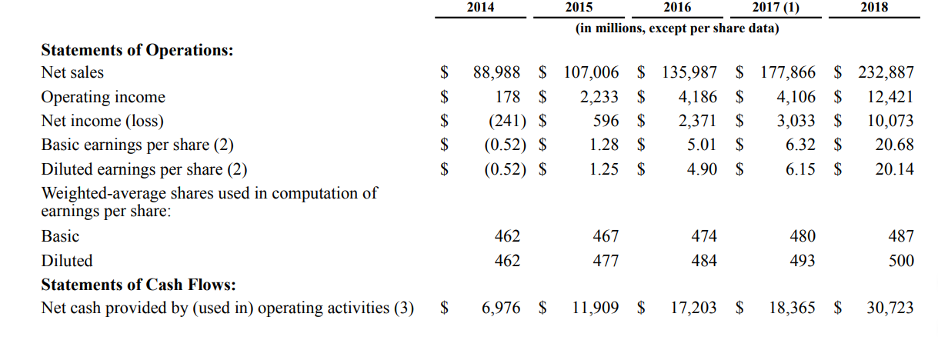
The above picture shows that there is a constant increase in the revenues of the company. This revenue is a function of the prices of the products and their quantities demanded and supplied. Thus, the increase in revenue has shown that the quantities demanded and supplied have increased over time. The demand is the amount of goods that people are willing and able to buy at a given price. This depends mainly on the price. The changes in the price affect the demand but on the same demand curve. The extension in demand occurs as a result of the decrease in prices and a contraction in demand occurs as a result of increase in price. Other factors like the income of the consumers affect the demand in a way that the demand curve shifts to the right or left. The rightward movement is called the rise in demand and the leftward movement is called the fall in demand. Other than these factors, there are certain risks associated with the company that will define the demand and supply aspects for the company. One of the risks that the company is prone to is the risk of non-payment by some of the customers. The company receives the payments in a large variety of ways. Different forms of receipts have different charges or fees associated to them (Amazon, 2018). These costs may increase over a period of time and will result in the increased expenses for the company. There are certain programs that require us to collaborate with other companies for the credit card payments, if these are abolished, our operations will be affected badly. The changes in the procurement rules and regulations set by the governments will also affect the ability of the company to earn more revenues.
Price and Price Elasticity of Demand
Elasticity of demand refers to the responsiveness of the change in demand to a change in price. In order to assess the price elasticity of demand, we will again refer to the revenues section of the above table.
The inelastic demand is when the increase in quantity demanded is less than the increase in price. The demand for the products of the company is inelastic (Senthilnathan, 2016) (Recode, 2019). The major indication for this conclusion is the increase in the revenue and the fact that the cost of production has also increased over time. The characteristic of inelastic demand is that the total revenue in case of inelastic demand will increase in the increase in price.

Analysis of Costs
The online sales model of the company has very little fixed costs which means that the company has to increase the sales by a reasonable amount and the fixed costs for the company will be covered. These fixed costs may be considered as the fees and other expenses that are to be made after a period of time irrespective of the fact that sales happen or not. Similarly, the company increases the revenues to such an extent that these revenues exceed the variable costs as well. The variable costs are kept lower by customizing the huge number of goods for a large number of customers. The company has higher fixed costs as compared to the variable costs that are minimal as compared to the fixed costs. The operational levels of the company are so high that the company is able to lower the per unit fixed costs associated with the production.
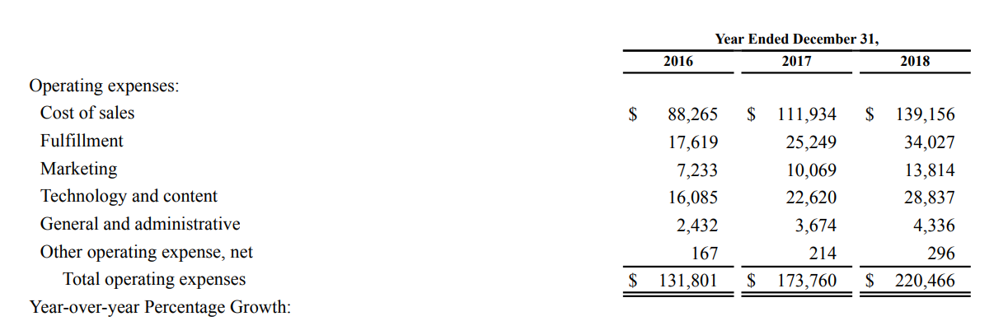
In the above picture, we can see that the overall cost of sales has increased over time. We further analyze that the costs titled fulfilment has increased the most rapidly. From the years 2016 to 2017, we can see that the general and administrative expenses have increased by the highest percentage. The fulfillment costs also shown an increase that is high in percentage. The total operating costs have increased over the period of three years.

The competitive advantage of the company
The competitive advantage of the company is the successful expansion strategy that is accompanied by the takeovers and mergers of certain companies. The company has successfully competed with the giants like Wal-Mart and other grocery stores. The other competitive advantage is the amount of sales that is generated by the company.
Porter’s 5 forces model
This model analyzes the various aspects that can affect an organization in different ways. The model identifies the aspects of the market that measure the power of various players in the markets to affect the company. The power of customers, suppliers bargaining powers are assessed. The competitive rivalry among the competitors is measured. Another aspect is the barrier to entry and exit in the market (Greenspan, 2019).
If we see the market in which the company is working, there are almost no barriers on the entry and exit from the market. Any company can start this business with the help of the online system. The most important aspect that is related to the company under consideration is the competitive rivalry that is very strong. This affects the company as the available opportunities are taken up very quickly by the companies. The Amazon Company has developed a competitive advantage with the help of the huge level of operations attained. This huge competitive advantage also helps the company to successfully implement expansion strategies in the foreign markets through mergers and acquisitions.

Market Share of the company
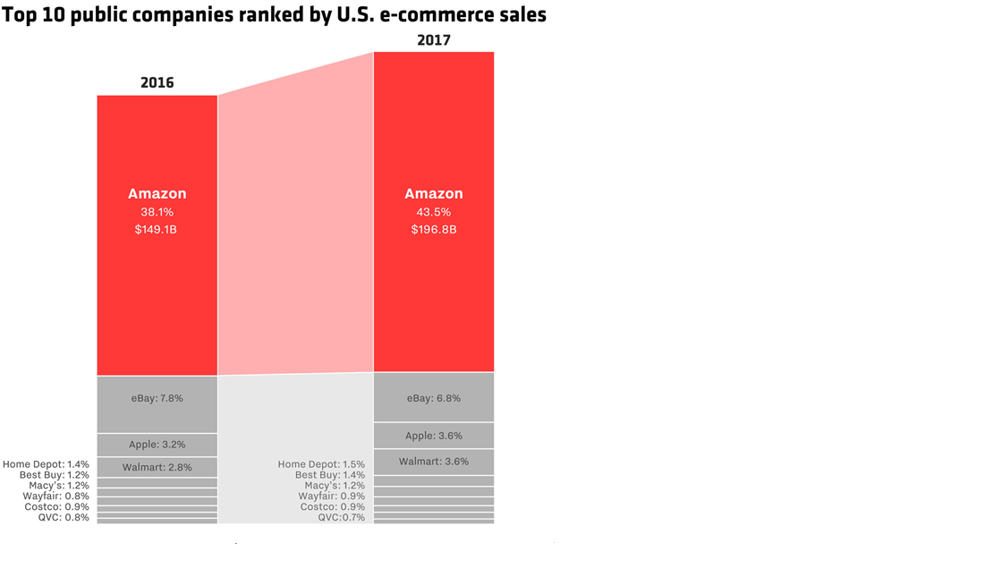
The following picture depicts the market share of all the players in the market.
The above picture shows that Amazon had the largest market share in 2016 and 2017 (Recode, 2019).
The market Structure
The current market structure is monopoly that is created by Amazon. This is characterized by one firm dominating the whole market through its decisions. This impacts the decision making in a way that the company becomes more independent in making the decisions and the other firms have to follow the footsteps of the company (Varian, 1999).
Suggestions
The company should come up with some substantial set up to cover the risks associated with the payments. This will further improve the financial aspects of the company.
The monopoly will be affected very much by the steps taken by the government to regularize it. These steps can be hazardous to the company. Thus, it is recommended that the company voluntarily helps to improve the competition aspects of the market.
The company should come out of the number game and think about any external costs associated with the business activities undertaken by the company.

References
Amazon. (2018, December). https://ir.aboutamazon.com/static-files/0f9e36b1-7e1e-4b52-be17-145dc9d8b5ec. Retrieved from https://ir.aboutamazon.com/static-files/0f9e36b1-7e1e-4b52-be17-145dc9d8b5ec: https://ir.aboutamazon.com/static-files/0f9e36b1-7e1e-4b52-be17-145dc9d8b5ec
Budzinski, O. (2015). Is Amazon the next Google. DE GRUYTER.
Greenspan, R. (2019, February 24). http://panmore.com/amazon-com-inc-five-forces-analysis-recommendations-porters-model. Retrieved from http://panmore.com: http://panmore.com/amazon-com-inc-five-forces-analysis-recommendations-porters-model
Heimeshoff, J. H. (2014). Google, Facebook, Amazon, eBay: Is the internet driving competitionor market monopolization. International economics and economic policy, 49-61.
Recode. (2019). https://www.google.com/search?q=market+share+for+amazon&tbm=isch&source=iu&ictx=1&fir=P5WJ6CfvhJEUAM%253A%252CyHcSWrmntJfWHM%252C_&vet=1&usg=AI4_-kQrhdLxftldsP3tdZVnAohEdRsyRA&sa=X&ved=2ahUKEwjEjv2y9fbhAhWFyYUKHRirDMsQ9QEwAHoECAwQBg#imgrc=P5WJ6CfvhJEUAM:. Retrieved from https://www.google.com: https://www.google.com/search?q=market+share+for+amazon&tbm=isch&source=iu&ictx=1&fir=P5WJ6CfvhJEUAM%253A%252CyHcSWrmntJfWHM%252C_&vet=1&usg=AI4_-kQrhdLxftldsP3tdZVnAohEdRsyRA&sa=X&ved=2ahUKEwjEjv2y9fbhAhWFyYUKHRirDMsQ9QEwAHoECAwQBg#imgrc=P5WJ6CfvhJEUAM:
Senthilnathan, S. (2016). The imopact of elasticity on firm's revenue. international journal of science and research, 1728-1731.
Varian, H. R. (1999, August 30). http://citeseerx.ist.psu.edu/viewdoc/download?doi=10.1.1.68.1683&rep=rep1&type=pdf. Retrieved from http://citeseerx.ist.psu.edu: http://citeseerx.ist.psu.edu/viewdoc/download?doi=10.1.1.68.1683&rep=rep1&type=pdf

