[Writer’s Name]
[Instructor’s Name]
ENG 101 0W1
September 16, 2019
Wireless Network Security
The prevention of unauthorized access or potential damage to a computer by utilizing wireless networks is known as wireless security. Due to the increasing use of technology, hackers are becoming more and more advanced that can lead them to easily exploit the system’s vulnerability. Thus using wireless security is becoming more important these days. Generally, endpoint security is the one that is exploited by the hackers. So to make endpoints computer secure there is a tool known as a wireless protector. This tool automatically disables both endpoints and wireless devices when Ethernet is detected on computers and re-enable the devices when an Ethernet connection is disconnected. This software facilitates in providing a secure IT environment from untrusted devices. It can be deployed using a software management console or by a third party deployment system. By just installing remote service the software can secure multiple computers while also provide several other features such as auto-scanning, auto-discovery and easy to use administration interface. It can secure several endpoint services such as Bluetooth, wireless 802.11, wireless phones, modems and broadband (3G or 4G/WiMAX). It can also help in securing windows 10, 8, 7 and Vista. ("Auto Disable Wireless When Connected To LAN - Windows Mac").
Key features
- It disables wireless when docked.
- It disables devices when LAN is connected
- Disable wireless on Mac-OS X
- Disable wireless devices when Ethernet is detected.
- Wireless computers discovery and scanning
- It collects activity logging as well although that is optional depending upon the user.
System requirements
- To install a product 800MHz processor is required.
- Microsoft Windows XP, Windows 7
- 10 MB Hard disk free space must be available to install a product.

The software is not free although it is not costly as well. It has the option of the free trial but the above-mentioned requirements are needed to be fulfilled. So to install it on the computer was not possible for me due to a lack of processor speed. So, after an extensive search, I came across a tutorial that helps in explaining the downloading steps. Some screenshots are attached below:

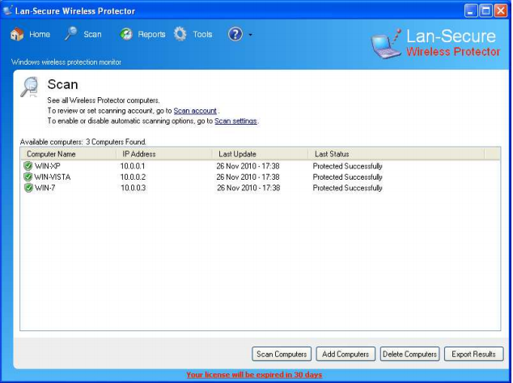
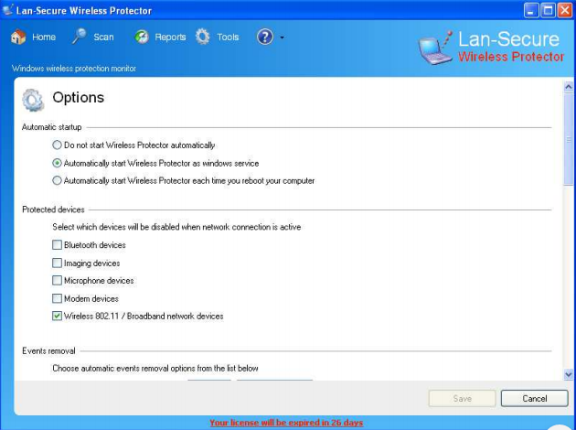

Works Cited
"Auto Disable Wireless When Connected To LAN - Windows Mac". Lan-Secure.Com, 2019, http://www.lan-secure.com/WirelessAutoDisable.htm.

