System: Online shopping website
Use Case Number: | 1
Use Case Name: | Customer Add a product
Description: | Customer select a product and add a product in a cart.
Extended Use case | Order Cancelled
Description: | Customer can cancel order within the time limit.

Use case Name | Order Cancellation
Use case ID | UCA001
Primary Actor | Customer
Secondary Actor | Administrator and shop representatives
Trigger | User tries to buy a product
Brief Description | Customer selects the order and add it to the cart. After some time he cancels the order.
Flow of tasks | User goes to his cart.  Click on the product.  Click on cancel button.  System verifies that the order cancellation service is availed according to the timing policy.  If yes, then order cancelled and user can place another order.
Precondition | The user must have logged in into the system
Post-condition | The user will be able to access and avail the services

Activity Diagram
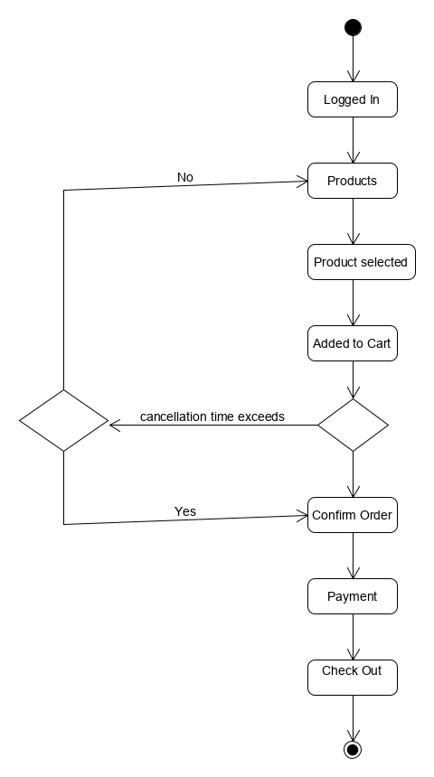

Sequence Diagram:
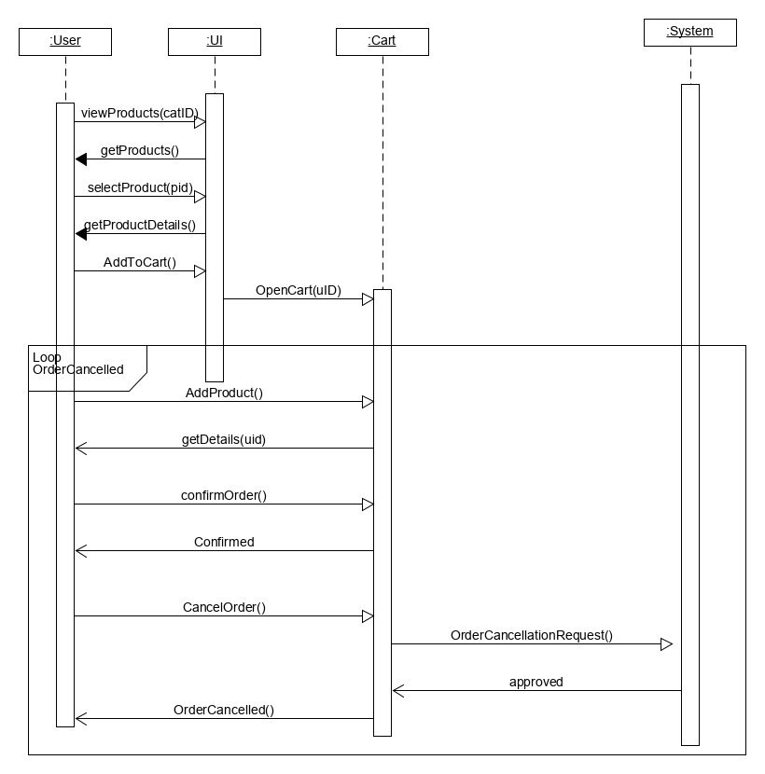

Test Plan:
Test Case ID | Test Case | Procedure | Input | Expected Result | Actual Result
1 | After order confirmation, cancelled button appeared | Logged in system, Add products in cart and confirm order. Cancellation button appeared. | Add Product | Cancellation button in front of each product in a cart | As expected,
2 | Cancelled button working properly | Logged in system, Add products in cart and confirm order. Cancellation button appeared. Click on the button and it shows status. | Add Product  Confirm order  Click on cancellation button | Cancellation request processed | As expected,
3 | System checks the time constraint. | Logged in system, Add products in cart and confirm order. Cancellation button appeared. Click on the button | Add Product  Confirm order  Click on cancellation button | Cancellation request processed | As expected,
4 | Cancellation Request Approved | Logged in system, Add products in cart and confirm order. Cancellation button appeared. Click on the button | Add Product  Confirm order  Click on cancellation button  Cancellation request is done within the time constraint. | Order cancelled | As expected,
5 | Cancellation Request not Approved | Logged in system, Add products in cart and confirm order. Cancellation button appeared. Click on the button | Add Product  Confirm order  Click on cancellation button  Cancellation request is done after the time constraint. | Order Confirmed, Cancellation request not approved | As expected,

Screen Prototype:
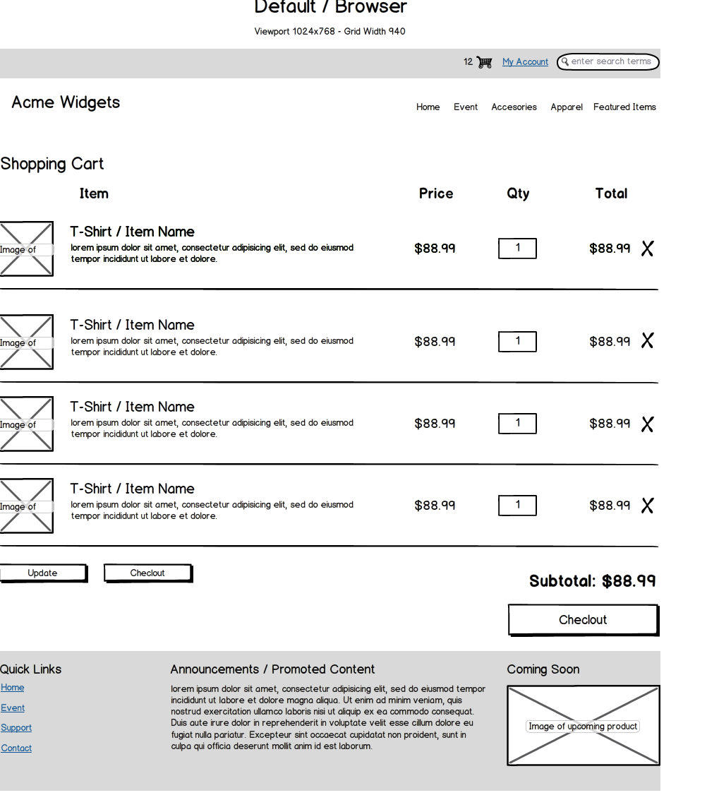

In vision Screen:

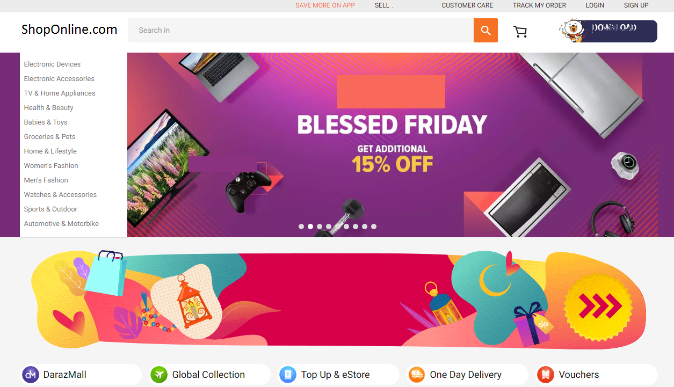

References:
Bastos, R. M., & Ruiz, D. D. A. (2002, January). Extending UML activity diagram for workflow modeling in production systems. In Proceedings of the 35th Annual Hawaii International Conference on System Sciences (pp. 3786-3795). IEEE.
Rodríguez, A., Fernández-Medina, E., Trujillo, J., & Piattini, M. (2011). Secure business process model specification through a UML 2.0 activity diagram profile. Decision Support Systems, 51(3), 446-465.

