**LBL- Cell Cycle & Cell Division**

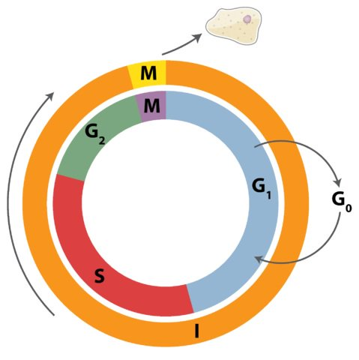

1. Use the circle above and your textbook to diagram the cell cycle.
2. List the main activities of G1, S phase, and G2 of interphase in the circle above.
   1. G1: Cells shows growth and normal function. The cell grows to its size doubled than the previous size and high amount of protein synthesis occurs
   2. S: Chromosome number is doubled and the cell synthesizes its DNA
   3. G2 phase: Cell resumes itself for division by continuing its growth until mitosis starts.
3. Briefly define the following terms:
   1. chromatin- It is the mass of genetic material composed of two things, DNA and proteins which are condensed during eukaryotic cell division to form chromosomes. It is located in the nucleus of our cells.
   2. chromosome- It is a thread like structure which is present in the nucleus of the most living cells, composed of nucleic acids and proteins and has the ability to carry the genetic information in the present genes in between them.
   3. chromatid-When a chromosome is replicated from one copy into two copies from the parental chromosomes to daughter chromosomes, one-half of two identical strands of the two newly formed chromosomes is a chromatid, which is joined together through a centromere.
   4. centromere- A centromere is a specialized sequence of DNA which links a sister chromatid pair.
   5. kinetochore-It is a highly complex protein structure of a disc shape. It is associated in the duplicated chromatids of the eukaryotic cells, at the position where the spindle fibers are attached to pull apart the sister chromatids.
4. Draw a cell going through mitosis. List the main events of each phase.

|  |  |  |  |
| --- | --- | --- | --- |
| Prophase | Metaphase | Anaphase | Telophase |
| C:\Users\Night\Pictures\P.png | C:\Users\Night\Pictures\m.png | C:\Users\Night\Pictures\a.png | C:\Users\Night\Pictures\t.png |
| Main events:  Chromosomes start condensation  Mitotic spindle begins to form which functions in the organization of the chromosome and during mitosis, keeps moving them around.  Nucleus will be ready to break down by the nucleolus disappearing. | Main events:  Chromosomes will align at the metaphase plate  Kinetochores of each chromosome attach to microtubules of opposite spindle poles | Main events:  Sister chromatids will start separation because the glue that holds them together will be broken down,  Each pair of chromosome will move apart, poles separation occurs. | Main events:  Mitotic spindle breaks down to its building blocks  Set of chromosomes is formed with two nuclei, one for each set.  Chromosome start to de condense and will reach their previous stage. |