Name of Student
Name of Professor
Name of Class
Day Month Year
Science Experiment
Abstract
The solar system has a total of eight planets that revolve around the Sun in a much-programmed way. All the eight planets have different features and different atmosphere, but Saturn is quite interesting among them all. There were different hypotheses about the rings and their structures in the older times, but with the advancements, in technologies, all these hypotheses were proved wrong by the scientists and NASA, and now it is confirmed that Saturn's rings are made up of ice and dust particles. In this experiment as well a model of Saturn is made up to clear the concepts of the students about the planet and its rings. At the end of this experiment, the students will be able to visualize the planet and also the rings around it.
Introduction
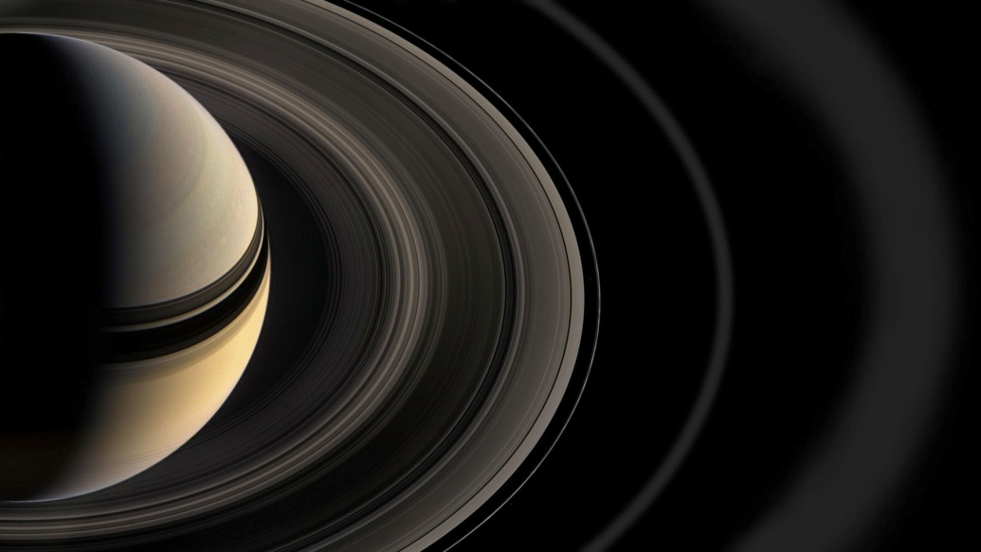
Saturn is the second largest planet of our solar system and the 6th planet from the sun. Because of its exceptional appearance, it is considered as a jewel of our solar system. It has caught the attention of scientists for centuries. It has a magnetizing and attractive appearance because of the reflection of different colors from different angles. The reason behind its bright, vibrant and different colors' reflection in the presence of various elements inside the rings of the planet and in the planet body itself. Just like Uranus and Jupiter, this planet has rings too, but the size of these rings makes Saturn a unique exception. It has 62 moons, and it is the fifth brightest planet in the solar system. This particular planet is the second largest planet in our solar system. This particular planet has many rings that revolve around it in a never-ending loop, having said that this planet is so light that it can easily float in the water. The rings of Saturn are composed of ice. Among these rings, three are quite visible using a telescope from the Earth. These rings house numerous particles that range from the size of little grain to huge mountains. These particles of different sizes are composed of dust, ice, and rocks that are collected from the passing comets(Hamilton). These rings are spread to almost 482,000 km distance from the center of the planet and have almost one-kilometer thickness. These rings show different colors from different angles because of the presence of different elements and compounds. Galileo was the first one to observe the rings of this planet and to propose theories about it.
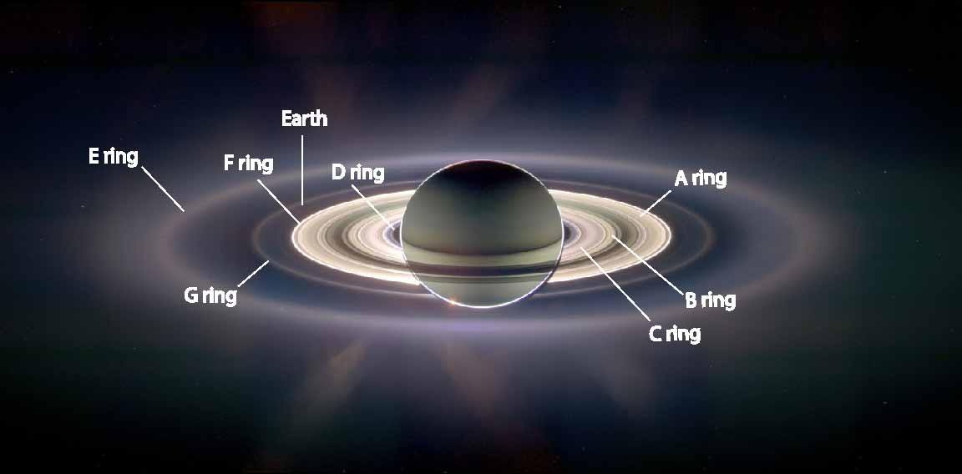
Depending upon the span from the center of Saturn, its rings are categorized alphabetically. The ring that is closest to the planet is referred to as D, and A is the farthest ring from Saturn. There is a gap which separates A and B rings of Saturn which is called Cassini division("Cassini's Month-By-Month Gallery of Saturn's Ring System"). These rings have many structures, particles, and gaps. Moreover, the presence of soft rings has also been revealed by the research, and they are categorized as F and E rings. There are many gaps present between the particles of the rings. Some are created by the satellites of the planet, and some are still the piece of a puzzle for the astronomers.
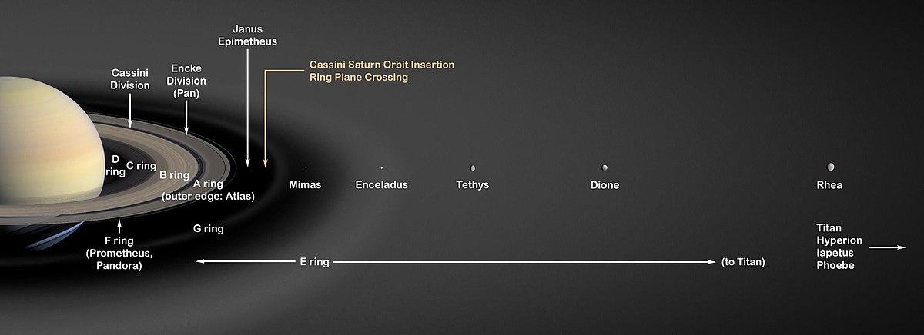
There are various hypotheses that explain how these rings have been formed in Saturn. The most debatable one is that the rings of the planet were massive moons before. They kept revolving around the planet until they crashed with each other and collided.
For years, it was thought by many astronomers in the past that these captivating rings are the solid structures around the planet. Until now it has been researched that these are not solid structures, but these rings are formed when particles of different densities and sizes in different gaps and structure spin around the planet because of the gravitational pull of the planet.
In the year of 1655 Christian Huygens proposed that these unique looking rings are solid bodies. Also in the year 1660 one more astronomer proposed that these rings are actually created by small satellites, his proposal wasn't confirmed for almost 200 years.
After that in advanced times, Pioneer 11 was passed through the ring plane of Saturn in the year of 1979. Moreover, in the years of 1980s Saturn’s ring systems were captured by Voyager 1 and Voyager 2. It was then declined with research that the presence of particles of different densities and sizes in different gaps and structure that are in spinning motion because of the gravitational pull of the planet is forming the unique rings around the planet.
The experiment that I choose for assignment is to describe that rings are composed of the particles of different sizes, structures, and densities. The procedure that I will use, it will illuminate that rings are not around mass around the planet. But they contain different particles that appear as a ring when they are in a spinning motion because of the gravitational pull of the planet.
Materials
I will choose a simple method for my experiment with readily available materials. It can be performed at home too as it accessible materials. My experiment will require:
- Spin Machine
- Glue
- White paper
- Colored Chart
- Scissor
- Pencil
- Sand
- Sugar
- Table Salt
- Crushed Nuts
Method
Cut a circle of a colored chart with scissors. Then paste that circle in the middle of white paper with glue. This colored circle will represent Saturn. Draw four rings around the circle of a colored chart. After that spread glue on the circles that are drawn by pencil. On the other hand, take sugar, table salt, sand, and crushed nuts and mix them up. Next step will be to sprinkle the mixture on the gluey circles. It will be clearly observed that particles of different densities and sizes are scattered in the circles around the colored chart. Now, set the whole apparatus on the spinning machine and observe. 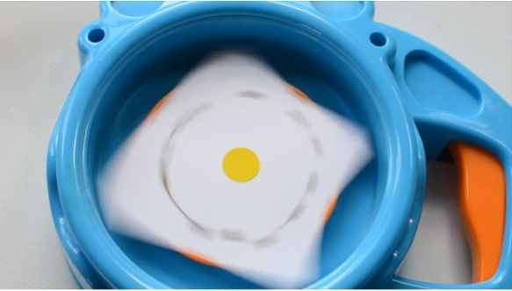
When the whole apparatus will be spinning, it will be observed that the scattered materials of different densities and sizes appear as fine round rings around the circle.
Results
This experiment proves that rings around the planet are not a round mass, but they appear to be that way because of the presence of different particles that are in different gaps, sizes, densities, and structures in a continuous spinning motion because of the gravitational pull of the planet. At the end of this experiment clear and visible rings can be seen around Saturn which will helps the students to understand the concept that the rings present around this planet are solid made up of ice and it can be seen clearly in this experiment. It is a general perception among students that these rings which revolve around the planet Saturn are steel and they are very solid, but with this experiment it will be clear to them that these rings are indeed present around the planet, but they are not solid; they are made up of ice and other dust particles in the space. When astronomers look at the planet from Earth then only it seems that some solid rings are present around. So the results in this experiment show the appearance of rings around the planet which will help them to clear their concept about this planet and the rings around it.
Discussion
For so many years it was believed that these rings around Saturn are Solid, and due to these early perceptions it is still believed among the students of high school level and some college level students as well that may be the rings are solids, so it is very important to conduct experiments in the laboratory along with demonstration so that the students clear their concepts about the structure and composition of these rings. However, the particles in those rings are expected to be water, ice, ice-bergs scattered pieces of comets or may be scattered pieces of colliding moons, etc. in different ratios, structure, and sizes, etc.(Astronomy). Also, many of these particles face gravitational pull of different satellites that revolve around this planet, mainly its 62 moons.
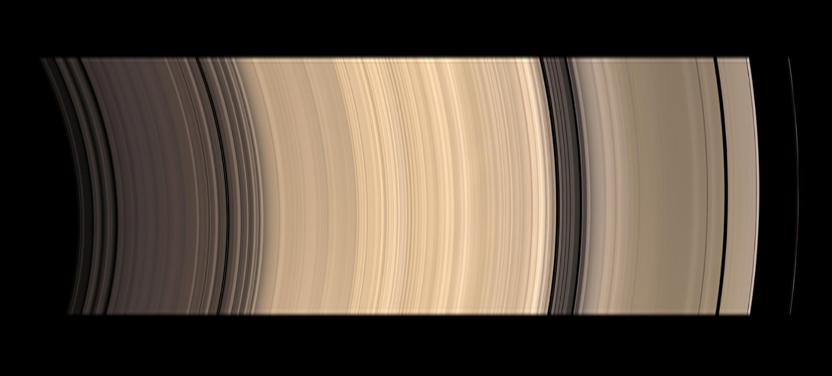
The above picture is captured by NASA which shows the presence of icy objects. Moreover, it can be proved by easy and different other methods too that rings are composed of the particles of different sizes, structures, and densities. They are not around mass around the planet, and they contain different particles that appear as a ring when they are in a spinning motion because of the gravitational pull of the planet.
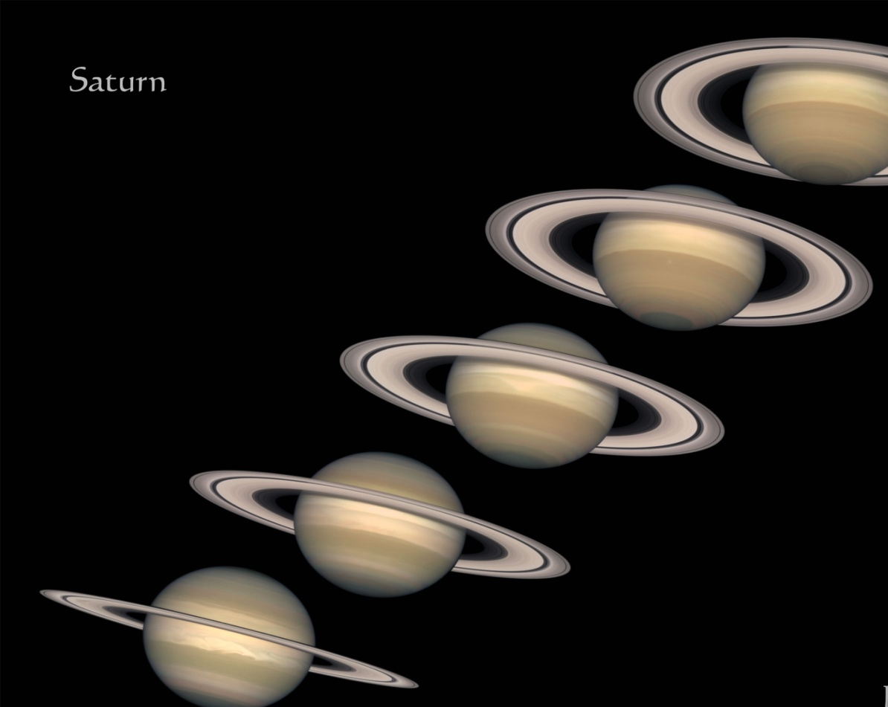
In the above picture which is again issued by NASA, and this picture is taken from the surface of Earth. In this picture the rings of Saturn can be seen quite clearly, also it is clear from this picture that these ring so in so fast around the planet that it is almost impossible to figure out that what is the exact composition of these rings, therefore in the older days many astronomers and people come up with various hypothesis about the rings composition and their spinning around the planet. Until recently with the advancements in technology and with the development of telescopes scientists and able to take a clear insight into the structure of these rings and the prior hypothesis were nullified with the passage of time. So such experiments must be conducted in the laboratories as well to clear the concepts of the students regarding solar system and the planets.

Works Cited
Space.com. N.p., 2019. Web. 5 Jan. 2019.ton, Calvin. "Saturn." Solarviews.com. N.p., 2019. Web. 5 Jan. 2019.
"Cassini's Month-By-Month Gallery of Saturn's Ring System." Pds-rings.seti.org. N.p., 2019. Web. 5 Jan. 2019.
HamilAstronomy, Science. "Saturn's Rings: Composition, Characteristics & Creation."

