[Your Name]
[Instructor Name]
[Course Number]
[Date]
Political Science: California’s Most Powerful Government Branch
Among California’s three Branches of Government, Which Do You Believe Is The Most Powerful, Compared to the Powers of the Other Branches?
Like other states, California’s government also put every possible effort to ensure that there are fully fine and fair practices of the government of the state. The Constitution of the state’s government has also been written which works as a set of principles that state how the people of the states should and would be governed.
The people and leaders of California wanted to have a strong and fully fair government in the state. They also have a concern, which is to protect the people or individuals of the state and prevent the government of the state (California) from abusing its authority and power over the citizens and region. For the purpose, it was and still clear to everybody that such fair and fine government can be brought into presence and action by having three different branches of the state’s government (Carrillo, and Danny, P.P. 655). Hence the three main branches have been developed or the three branches in which California’s government has been organized are; 1) Executive, 2) Legislative, and 3) Judicial branch. These branches have been designed for the purpose to save the government of the state from any corruption or unfair practices.
All of these branches (Executive, Legislative, and Judicial) have been given the power and authority that they can use and apply as per the policies and laws. Further, each of these branches has different types and levels of powers and authorities and each of these powers and authorities is given to the branches as per the requirements and their regulations.
In short, there is always a difference when it comes to having more things to analyze. Similarly, there is a difference in the powers of the three branches of California’s government. While based on these difference (difference in power each branch have), these branches can be more and less powerful than one another. Hence, it can be stated that there are many crucial and important reasons because of which one branch is found the most powerful when compare to the power of others. So there are reasons and facts that clarify that the Executive Branch of California’s government is the most powerful than the rest (Carrillo, and Danny, P.P. 655).
Executive Branch of California’s Government
The executive branch is the branch that is mainly run by the governor of the state. The governor is elected by the people of California for four years each time. The individuals that are aged for more than 18 years and are the residents of California can be elected as the Governor of the state. The governor of California is the only and sole source of communication between the state and the federal government of the United States and the other 49 states of the country.
In terms of responsibility, the executive branch of California’s government is responsible for administering and enforcing the laws of the state of California. While in the practices, the executive branch of California’s government much closely with the legislative branch of California’s government for the purpose to shape the proposed legislation (Carrillo, and Danny, P.P. 655).
A number of state departments are also included in the executive branch of the government of the state. The officials that have been elected publically, appointed by the state's governor, hired into the civil service system if the state, run and direct these departments included in the executive branch of the government.
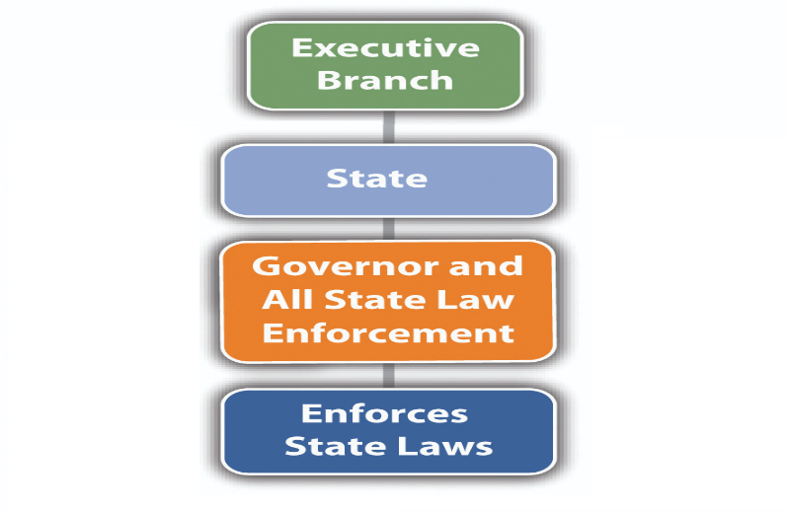
Why the Executive Branch of California's Government is the Most Powerful
More than a single or few reasons and facts are there make the Executive Branch of California’s Government is the Powerful than the other branches. In other words, many reasons and facts (in shape of power) stand out the Executive Branch of California’s government than others. The branch can be seen more powerful when one finds, analyze and compares the powers and authorities each branch of the government exercises.
There are many debates concerning the powerfulness of branches of government of California’s government. I myself was thinking that the executive branch of California’s government has not much power as others while thinking that it has the least power. But (Vogel, P.P. 149-152) finds and lists several reasons that switch one’s thinking. The main argument that the Executive and President branch is the most powerful is still up in the air, but the strong reasons are always there that why the branches are the most powerful especially at the current moment.
The very first and initial reason because of that the executive branch of California’s government is considered as the most powerful is the leader of this branch (Governor) of this branch is elected by the whole population of the states while the Governor works as the Chief Executive and Head of the State of California. It means that the Governor who is the actual head of the state’s government has the hugest amount of power. While he/she is highly connected or associated with this branch while having an association with every branch of the government. Beyond this, another crucial reason that the Executive branch of California’s government is most powerful is its power of persuasion (Carrillo, and Danny, P.P. 655). It is also important to note that it is even more powerful and important that who you are persuading.
In California’s government, the executive branch and Governor try to persuade other concerned and associated parties. Persuasion is one of the hugest deals because it gets individuals and groups on your side, obviously. Hence, this branch (executive) of the government becomes powerful because it gets the right people to go with the ideas and policies. For instance, in the film titled “Lincoln”, Abraham Lincoln tries to inspire and persuade individuals in the office not preferably decided about what they (people) feel regarding slavery. While similar things have seen going in the current time (Vogel, P.P. 149-152).
Other aspects of the government are also there in which the Executive Branch is found the most powerful than the other branches of the state’s government. For example, the executive branch has the authority to exercise practices over the other two branches of the government. The executive branch can be found having the power and authority to appoint judges as well as nominate heads of other agencies of California (California State Capitol Museum, N.P). This power makes the branch most power and differentiated from others because appointing judges and heads of other agencies is the act of appointing heads or leaders and decision-makers for Judicial and Legislative branches.
In addition to this, it has also been written in the Constitution that there is a proper check and balance of every branch of the state's government. Hence it can also be said that every branch of the government is powerful in the same way as others, as well as no branch, is stronger than the other two.
But! It has also been listed clearly that the executive branch has the authority to keep a proper check and balance of Judicial and Legislative branches. Hence this can be reflected as the superior power of the Executive branch over the others. It means that the Executive branch of California’s government is powerful than others. Additionally, it should also be noted and considered that the Executive branch can exercise this power and authority when the budgets and permission for the check and balance are approved by the federal government (California State Capitol Museum, N.P).
The Executive branch of California’s government can do check and balance of both of the branches (Judicial and Legislative branch). The branch can develop and implement policies and strategies as well. Briefly, the Executive branch can be found more powerful than others because it has the authority to nominate justices that serve for life thereafter (Vogel, P.P. 149-152). In this, the governor of the state can veto statutes proposed by the legislature of the states and could appoint or assign some entities (such as justices and judges mentioned above).
As indicated in the Constitution of the United State that the Executive Branch of the federal government tends to be the most powerful mostly, same situation or case can be found on the state level in the government of California (California State Capitol Museum, N.P). The Executive branch of the state’s government tends to be the most powerful mostly.
In short, the specific powers that each branch of California’s government has are as follows.
- Powers of Executives Branch
Including all the above powers, generally, this branch of California’s government enforces the state's laws and policies.
- Powers of Legislative Branch
Among all other powers, the legislative branch has the power to make state’s laws, declare legal decisions regarding California State, regulate intrastate activities, trade, and commerce with other states, and manage state policies (Vogel, P.P. 149-152).
- Powers of Judicial Branch
The main power of the Judicial branch of California’s government is to interpret and limit other branches of the state's government. It includes deciding which law and policy are allowable and which is not.

Work Cited
California State Capitol Museum. "Branches of Government - California State Capitol Museum in Sacramento, California". Guide, Citizens', and Branches Government. Capitolmuseum.Ca.Gov, 2019, http://capitolmuseum.ca.gov/legislation/branches-of-government. Accessed 23 Nov 2019.
Carrillo, David A., and Danny Y. Chou. "California Constitutional Law: Separation of Powers." USFL Rev. 45 (2010): 655.
Vogel, David. "Promoting Sustainable Government Regulation: What We Can Learn From California." Organization & Environment 32.2 (2019): 145-158.

