Paper writing
[Name of the Writer]
[Name of the Institution]

Painting.1
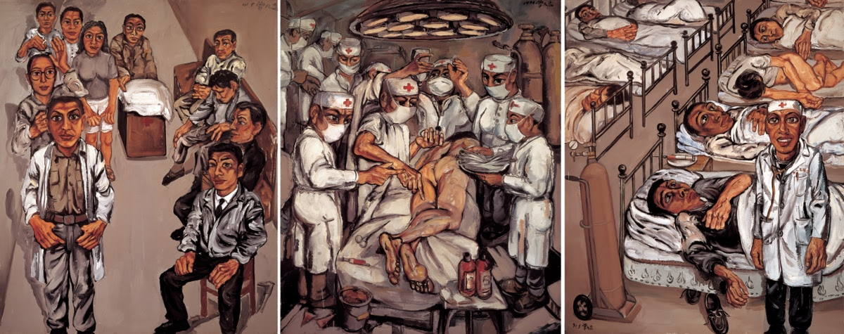
This painting has been made by one of the most influential contemporary painter Zeng Fanzhi, who was born in Wuhan, Hubei in 1964. He was born at the time of the Cultural Revolution in China. One of his biggest inspirations other than traditional work, for becoming a painter, was the painting house where his parents used to work. He is being credited for changing the ways of contemporary painting in China. The picture that has been taken for making a comparison of Chinese contemporary with traditional work is known as Hospital Triptych No.1 and it is the graduation piece of Zeng. This painting has become a reason for great shift in contemporary painting styling.
In this picture, Zeng is more concerned with realism and suppresses idealism by taking a look at the nightmarish version of life realities. In this painting, he has depicted the miseries of world as sick people are there in the hospitals in large number. The brown and grayish tones of this painting are presenting the sad reality of people who used to visit hospitals. People used to wait eagerly for the doctors so that their pain could be lessened. Surgeons are surrounding the naked man who is lying on the operating table. In this painting, Zeng is depicting harsh and complex human experience as he has lived near a hospital for a long time, this gave him the inspiration to portray experience of people who rush to the hospitals for getting rid of their pains.
Painting.2
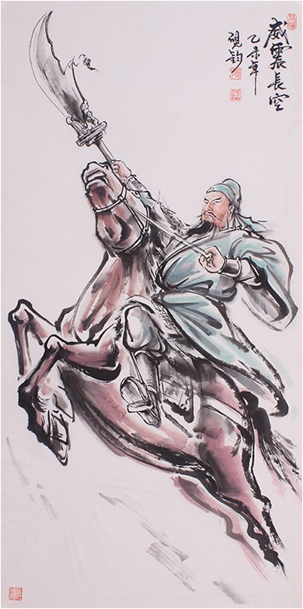

Second painting that has been selected for this comparison is Guan Yu riding horse; Guan is the Chinese god, who is famous for war and wealth. Above given painting is depicting towards the themes of bravery, warfare, courage, and dignity of Yu. From this painting, it could be witnessed that the time period in which Yu was ruling the world was a period of warswhere the bravery and expertises of people used to the tested by their skills that they used to show in wars. This could be one of the paintings that may have inspired Zeng Fanzhi. One thing in this picture that must have inspired Zeng would be realism, as it could be seen that realism is the common theme that has been depicted in both these paintings. Realism could be witnessed in most of the artistic works of Zeng and this fact cannot be denied that in the traditional Chinese artistic work, painters were more concerned with the natural things and were more close to reality and nature. By spinning the wheel of history, it could be seen that in the traditional paintings mostly animals, birds, and flowers were painted as they were present in the surrounding and were also showing the reality of that time as people used to be surrounded with these things (animals, flowers, and birds).
Comparison:
Things that could be looked upon as a contrast between both these paintings are many in numbers and one of the most important differences is the time that has been portrayed in these paintings. For example, in first painting, it could be seen that Zeng has represented sad reality of the present age but on the other hand, in the second picture riding on the horse is pointing towards the time that in old ages people and gods used to fight with other each for getting and retraining power. Second difference that could be seen in both these painting is that in the first painting miseries of people could be seen who are helplessness before various diseases and are relying on doctors for treatment, but by taking a look at the second painting, it could be seen that it was a time when there were no diseases or miseries.
Another major comparison that could be seen in both these paintings is that in the first painting, world has been shown as a place where people are having many difficulties and hardships, but the scenario is totally changed in other painting. In the second painting, there has been portrayed Chinese god who is free from the worldly attack of diseases and miseries. There could be witnessed a difference of attitude as well as Yu is being depicted, one who is having a winning attitude towards all the challenges, but in the second painting, patients are being depicted as ones who are looking towards doctors who could save them. Type of war is also different in both these paintings, as in first painting war is with diseases and health issues but in the second painting, war is with other supernatural and worldly things for proving dominance and achieving wealth.
Next comes the most prominent difference that could be observed in both the works is that, in first painting, doctors are being depicted as ones who are in authority but at the same time they are troubling their patients by showing their dominance over the patients. In second painting it could be seen that Yu has been presented as one who is superior to others but he is there for protecting his people, not for harming them who rely on him and believes in him. Another interesting comparison that should be observed is that in first painting doctors are performing their duties for their own benefits and this spots a light on the selfish and self-centered nature of human, but in the second painting, it could be seen that the Chinese god Guan Yu, is being portrayed as a selfless and brave god who without any greed is having a war for protecting his people.
The link between contemporary and traditional painting:
There is a close link between traditional and contemporary art and it could be seen that the contemporary work has maintained a tie with traditional work by taking a look at the fact that present moments as well as issues were the center of attention. Traditional art was more linked to the realism and ideation was not much appreciated, the same thing could be seen in contemporary art easily. Contemporary art could be viewed as enrooted in traditional art as contemporary takes into consideration moral and social responsibility that is a part of traditional work. This tie could be viewed by taking a look at the centralization of human and nature in both contemporary and traditional works, contemporary art points the social challenges that humanity faces.
Contemporary work maintains it’s tie with traditional work by depicting the essence of the message that could be looked upon as the most common thing in both types of work since ages. Contemporary work by retaining and prioritizing inner essence does not pay much attention to the outer appearance. It could be witnessed that contemporary work strengths it’s tie with traditional work by following its footstep as it could be seen that it mainly repeats those things that were depicted in traditional works such as symbolism. Symbolism is used in the contemporary work for conveying the message to the masses in underlined or hidden words. Conveying message in hidden words has always been considered as the main feature of traditional work. Characteristics of casting impact of thoughts by the artist has also been used in contemporary painting that is one of the most prominent features of traditional work and by abiding by the traditional rules and regulations; contemporary art is maintaining a tie with traditional Chinese work. So as a whole, it could be said that Zeng is among most prominent contemporary Chinese artists who is retaining a tie with traditional work simply by taking into consideration most of the things of traditional art.

End Notes:
- Wang, Eugene Yuejin. Shaping the Lotus Sutra: Buddhist visual culture in medieval China. University of Washington Press, 2005.

Wang, Eugene Yuejin. Shaping the Lotus Sutra: Buddhist visual culture in medieval China. University of Washington Press, 2005.

