Policy Brief
[Name]
[Institution]

Policy Brief
Public wellbeing has consistently been impacted by variations in the climate. Variations in the climate affect the environment that offers us shelter, clean air, food, water, and security. Climatic variations coupled with other stress factors undermine human wellbeing and prosperity in a number of ways. A portion of these impacts have also been witnessed in the United States. People more often than not confuse climate with weather, but both the concepts are poles apart. Weather actually represents an environmental state at any given place and time. On the contrary climate represents such weather conditions which last for multiple decades or longer. There is no doubt that the earth’s temperature has risen over the past decades and is still rising at a steady pace.

Effects of Climate Change
Climatic variations normally affect certain people or groups of people. The variation in climatic effects depends mainly upon the geographic location and the ability of people to cope with calamities owing to climate change. It has been experienced that more often than not climatic variations deteriorate the prevailing vulnerabilities. Geographic location is considered the main factor to influence the vulnerability to climatic variations. In case of US population has been increased in the Southern and Western regions and these areas are most vulnerable to coastal storms (Melillo, 2014). Moreover, people living in the Mountain West are most likely to experience water shortages. Coastal regions of the US coupled with its western regions are most likely to face water, transportation and energy related problems owing climatic variations and population growth (Melillo, 2014).
The ability to cope with climatic variations does not remain constant rather it depends upon the people. There is a large share of older people living in the warmer areas of the US. Such regions will probably witness extremely hot temperatures, famine, and storms in the years to come (Melillo, 2014)
In addition, people living in rural areas depend upon the environment and environmental resources for their survival are most vulnerable to climatic variations. People living in isolated communities will also be the victims of such climatic variations. People living in urban areas are also not safe from the climatic variations, albeit, their vulnerabilities are different from those living in rural areas. Cities are most likely to witness heat waves owing to their dense population (Frumkin, 2016). So, precisely speaking, the issue of climatic variations is neither local or a state issue, but a national issue. A thought provoking and effective policy must be introduced to cope with climatic catastrophes.

Problem Statement
The impacts of climate change are likely to get dreadful in the years to come. This essay will provide a policy brief to cope with varying climate conditions and its deteriorating impacts on human health. The aim of this essay is to provide an insight to the mitigation plan, suggest priorities to deal with future climate change and its deteriorating impacts on human health.

Suggestions for Policy
The impacts of climatic variations on public health are great in number. It is inevitable to recognize such effects prior to suggest policy measures in order to make the health policy more effective. Designing policy sans recognizing the climate change impacts on public health issues would amount to jumping in the sea with blindfolds. Climate change can impact the public health in following ways.
- Heat Waves
- Air Quality
- Water Quality
- Vector-Borne Diseases
Increasing in the temperature is considered as the most abrupt and obvious impact of climate change on public health. Heat waves actually owe the rise in temperature generally in summer months depending upon the geographical location coupled with high level of humidity in the air. Elderly population and young children will most likely to get effected from the heat waves along with urban populace at large. USCDCP (United States Centers for Disease Control and Prevention) demonstrated with the help of graphical representation that which group is most vulnerable to heat waves(Kent, McClure, Zaitchik, Smith, & Gohlke, 2013). The graphical representation given by USCDCP is given below
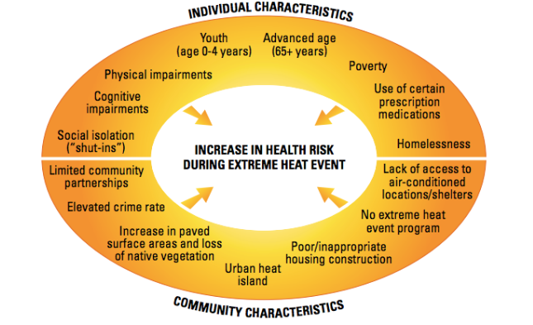

Suggestions
- Data on environmental conditions must be tracked.
- Climate related modeling and forecasting of health issues must be expanded.
- Those people who are at greater risk or most vulnerable to the heatwave must be identified on priority basis.
- All the stakeholders must devise a policy with consensus and the stakeholders are as follows:
- State government
- Local government
- NGOs
- Healthcare professionals
- Community leaders
- Faith-based communities
- All the aspects of climate change concerning heat wave must be communicated to the public, decision makers, and healthcare professionals. These aspects must incorporate risk of the heat wave and mitigation plan for such risks.
- All the stakeholders must be prepared and response plan concerning the health issues of heat wave must be developed.
- Technical advice must be available to all the stake holders especially local and state healthcare institutions in order to implement national readiness measures related to the heatwave effects of climatic variations.
- Budgeting must be proper and local governments must be given due share to deal with climatic catastrophes.
- Carbon emission must be reduced in the urban areas use of materials responsible for ozone depletion must be prohibited at all levels i.e. local, state and national.

Impacts on Healthcare Delivery System
The impact of adopting aforementioned measure for policy making will affect the healthcare delivery system profoundly. It will make the healthcare delivery system more resilient to the climatic change. Suitable funding to healthcare institutions will definitely reduce the burden on contemporary budget of such institutions. This will allow healthcare institutions to dedicate department only for patients who will be affected by the heatwave owing to climate change (Haines, Kovats, Campbell-Lendrum, & Corvalán, 2006). Budget allocation will also help the poor people who cannot afford to bear the healthcare cost. It will also encourage the development of workforce by ensuring the training of competent healthcare professionals.
Climate change is a global change and almost every region and country in the world is being affected by the climate change. Albeit, it is difficult to cope with abrupt climate changes but adopting efficient policy and can actually help us to deal with the monster of climate change (Haines et al., 2006).

References
Frumkin, H. (2016). Urban sprawl and public health. Public Health Reports.
Haines, A., Kovats, R. S., Campbell-Lendrum, D., & Corvalán, C. (2006). Climate change and human health: Impacts, vulnerability and public health. Public Health, 120(7), 585–596.
Kent, S. T., McClure, L. A., Zaitchik, B. F., Smith, T. T., & Gohlke, J. M. (2013). Heat waves and health outcomes in Alabama (USA): The importance of heat wave definition. Environmental Health Perspectives, 122(2), 151–158.
Melillo, J. M. (2014). Climate change impacts in the United States: The third national climate assessment. Government Printing Office.
Vincent, G. K., & Velkoff, V. A. (2010). The next four decades: The older population in the United States: 2010 to 2050. US Department of Commerce, Economics and Statistics Administration, US ….

