Information visualization
The firestorms in California are common that is linked to the issue of global warming. The warm climate is changing the temperature and precipitation levels of the soil that increase the risks of firestorms. The implications depict that the dry areas are becoming drier. Due to an increase in global warming the incidents of wildfires have also increased in California. This also reflects increased risks of droughts with more intense burning. Wildfires have negative consequences including deteriorated human health, environmental degradation and property damage. The risks of wildfires are high for future generations. Firestorms are consistently rising in California since the 1980s. the environmentalists claim that the climate of California is transforming and the soil is getting drier. The moisture that the city gets is only during the winter season.
During summer the risks of firestorms are significantly high due to the temperature rise and dry conditions of the soil. Global warming is the primary cause of climate change because it has resulted in temperature rise that also causes lack of rainfalls. The vegetation is slowly drying out in summers that serve as kindling for fires. The drying vegetation increases the risks of firestorms. Several firestorm incidents occurred in California including July-August series of wildfire. The common events of firestorm include the Carr Fire that occurred in 2018. Mendocino Complex Fire also occurred last year. the Woolsey fire also approached in the same year.
The Landsat Satellite captured the Camp Fire on November 8, 2018, at the town of Paradise, California. The entire area was engulfed in fire because the fire erupted across 90 miles of Sacramento. The facts depict that the fire was spread across 20,000 acres. The Camp Fire caused deaths of 86 people and injuries to many. It caused a massive level of buildings destruction including the deployment of 18,000 structures. The constructions and infrastructures also face the adverse implications of firestorms. Because the environmental conditions have reached the alarming situation the risks of wildfires have also increased. The number of dead trees resorted in 2018 were 129 million. The facts indicate that the Carr fire is the sixth largest wildfire in the history of California.
The increased dependence of society on fossil fuels has caused increased global warming. This has transformed the atmospheric conditions and altered environmental stability. These factors have continually challenged the concepts of environmental sustainability. Other factors include the movement of the people near the forest areas. This also increases the risks of their encounter with the wildfire. “in a lot of California now when fires start, those fires are burning through places that have a lot more plants to burn than they would have if we had been allowing fires to burn for the last hundred years”. The burning is cached by the plants and trees that results in wildfire across a larger area.

Homes damaged by firestorms
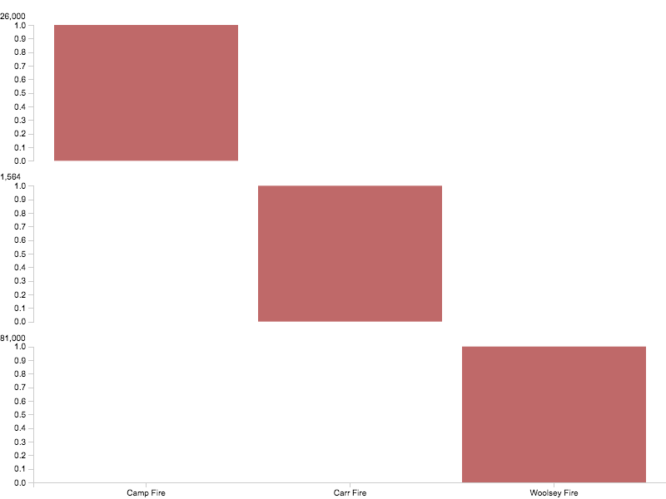
The incident of Camp Fire reflects the extreme threats of wildfire faced by California. The central causes include heat, wind and drought. The fire is one of the deadliest in the history of California that that resulted in 63 deaths and deployment of 12,000 structures. Around 26,000 homes were burned in the firestorm. Hundreds of buildings and infrastructures were also damaged. The flames topped at 70 mph and the fire was scattered to all nearby areas. Human activity is reported as the dominant cause of Camp Fire that involves increased use of fossil fuels, increased consumption of water and exploitation of land resources. The high carbon footprint is linked to the environmental problem of global warming. The fourteen days of triple-digit temperature experienced by California is another prominent cause of the wildfire.
Damages to the buildings
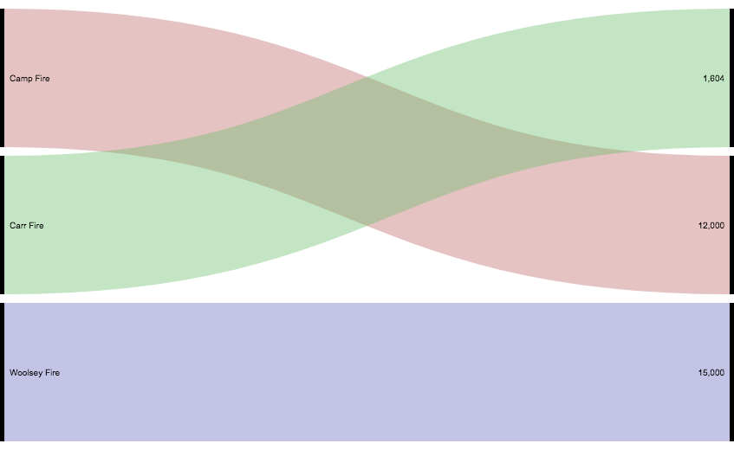
The fire leads to negative implications such as property damage, disease outbreaks, insect infestations and deaths of millions of trees. Firestorms damage the grasslands and affect the ecosystems adversely. The sparking of the power lines is identified as the root cause of Camp Fire. The fire sprawled out to the expensive cities and caused severe burns to the grasslands and forests. The facts about the camp fire indicated that the fire burned 153,336 acres that caused estimated damage of $16.5 billion. The facts associated with the other firestorms of recent years depicts that 96,946 acres of land were burned in the Woolsey fire. It caused the destruction of 1500 buildings and the displacement of 81,000 people. These people had to leave their homes. By August 2018 110 wildfires had caused significant damages to the area of 2 million acres of land. The findings also reflect that the Mendocino fire burned the total area of 459,123 acres of land. there were insurance claims of $845 million in 2018.
The economic impact is also adverse because firestorms cause a massive level of destructions. California reports suffering the damage of $400 billion in 2018. The costs faced by the fire department of California was $1 billion. The statistics also depicts that the forest service spent $2.9 billion in 2017 for preventing wildfires. Due to increased firestorms, the fire department consumes 52 per cent of the state's budget. This also requires investments in the fire engines and hiring of staff.
Deaths in firestorm events
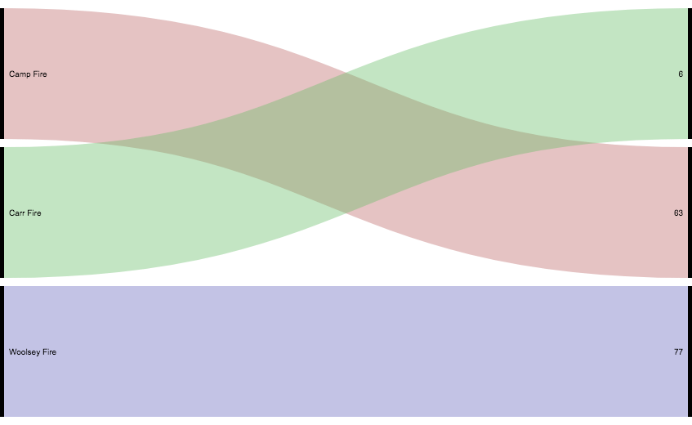

Costs of firestorms
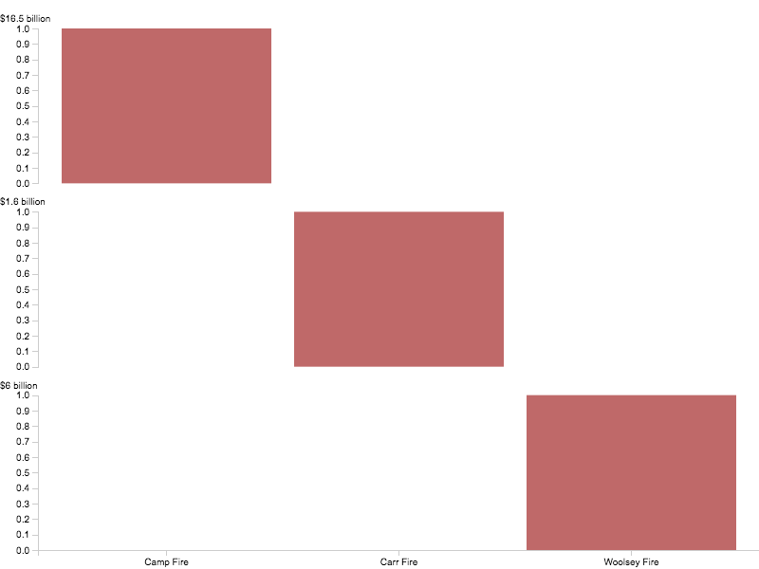

References
AMADEO, KIMBERLY. Wildfire Facts, Their Damage, and Effect on the Economy. 2019. https://www.thebalance.com/wildfires-economic-impact-4160764 (accessed 04 30, 2019).
Pierre-Louis, Kendra. Why Does California Have So Many Wildfires? 2018. https://www.nytimes.com/2018/11/09/climate/why-california-fires.html (accessed 04 30, 2019).
Watts, Anthony. Nov 8th, 2018 #CampFire – captured by LANDSAT satellite at peak rage. 2018. https://wattsupwiththat.com/2018/11/09/nov-8th-2018-campfire-captured-by-landsat-satellite-at-peak-rage/ (accessed 04 30, 2019).

Watts, Anthony. Nov 8th, 2018 #CampFire – captured by LANDSAT satellite at peak rage. 2018. https://wattsupwiththat.com/2018/11/09/nov-8th-2018-campfire-captured-by-landsat-satellite-at-peak-rage/ (accessed 04 30, 2019).
Pierre-Louis, Kendra. Why Does California Have So Many Wildfires? 2018. https://www.nytimes.com/2018/11/09/climate/why-california-fires.html (accessed 04 30, 2019).
AMADEO, KIMBERLY. Wildfire Facts, Their Damage, and Effect on the Economy. 2019. https://www.thebalance.com/wildfires-economic-impact-4160764 (accessed 04 30, 2019).

