Title page
HSA119

Part 1
12.1 Patient day care sheet
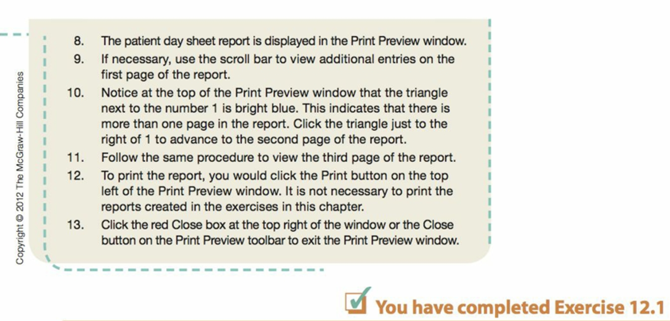
12.2 Practice analysis report
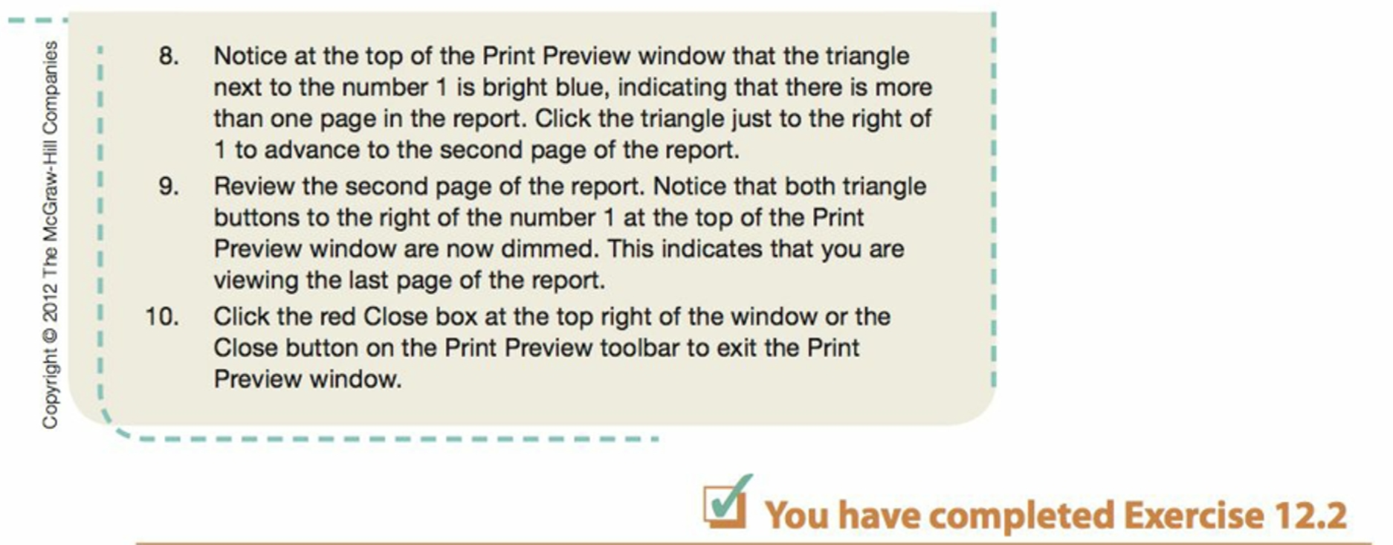
12.3 Provider report
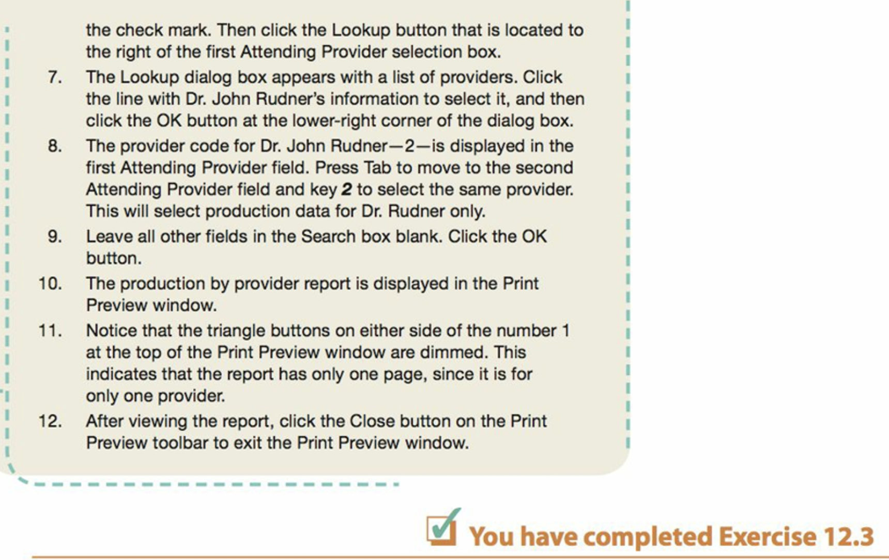
12.4 Patient account ledger
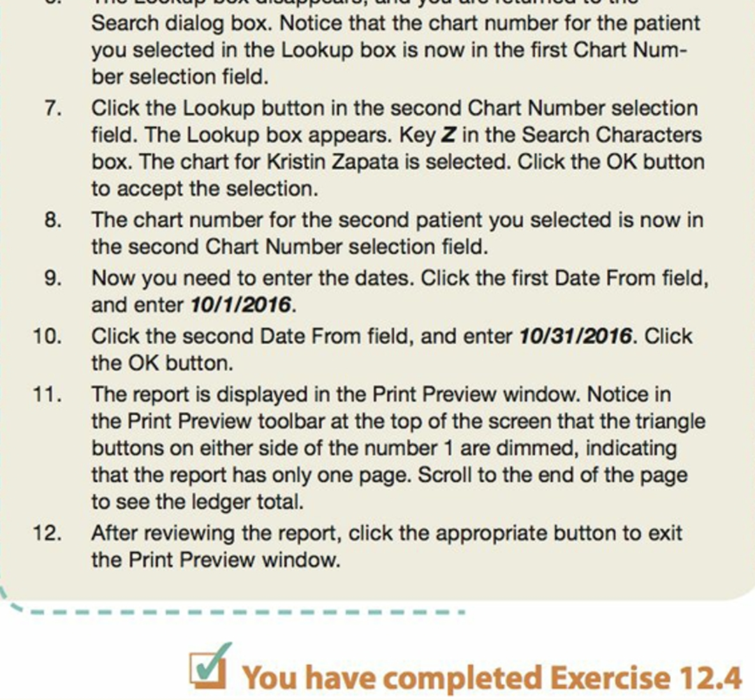
12.5 Patient list
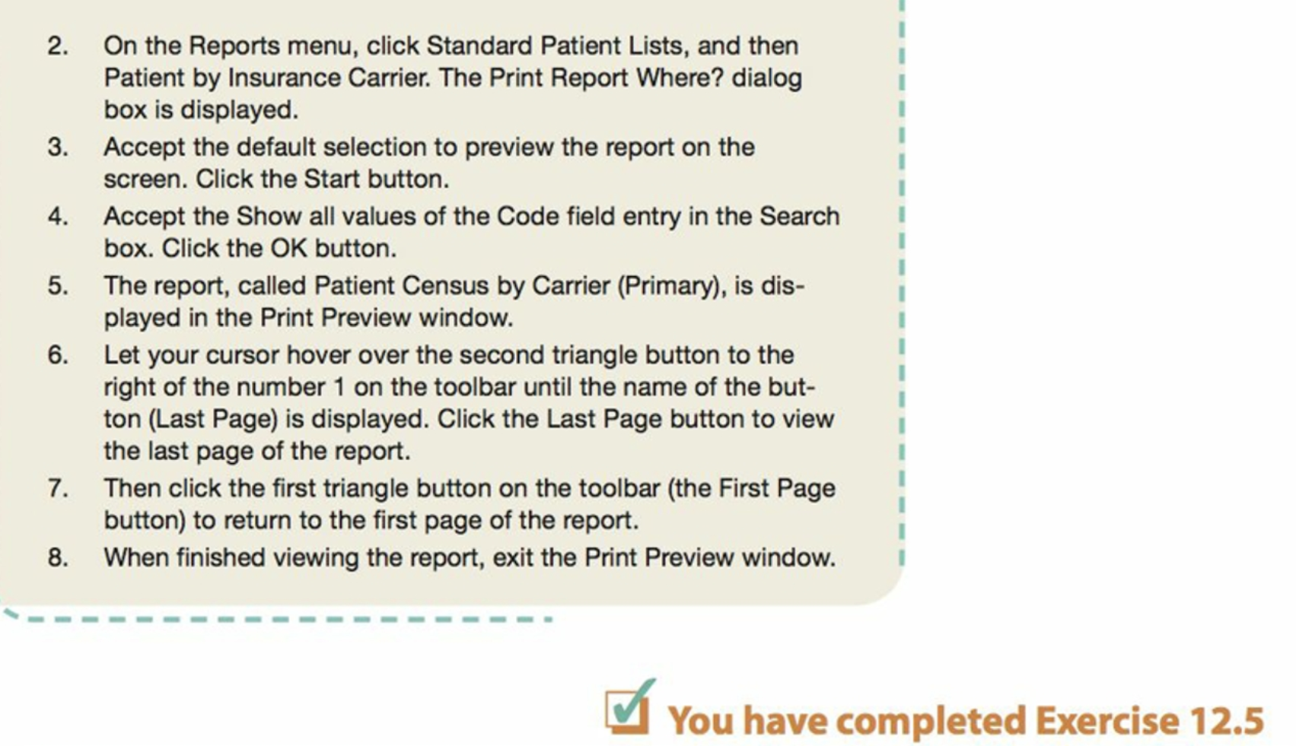

12.6 Aging report
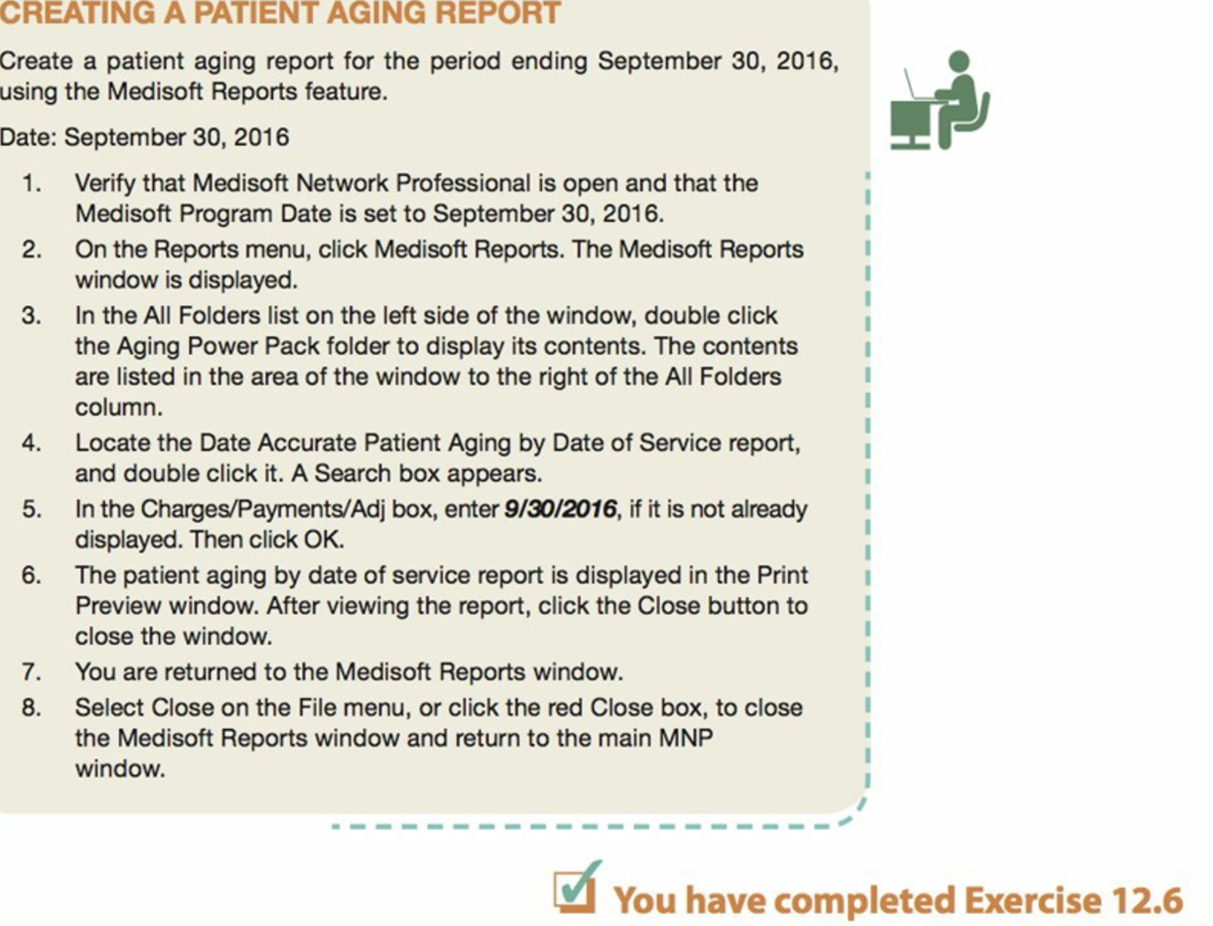
Part 2
- Competencies
The competencies required for entry level employment in healthcare/ HIS include direct encounter with the patients, ability of setting initial setup, managing daily activities and focusing on healthcare. The professionals at entry level must be capable of administrating procedures, communications, laws and ethics.
- Roles
The professionals involved in the healthcare settings include physicians, clinicians and primary care providers. The medical officer needs to perform various roles include overlooking provision of care and supervise the functions performed by the staff. They are also responsible for assessing and diagnosing the needs of the patients. The medical officer ensures the proper standards of care are adopted that leads to high-quality care. They take the role of administrators and keeps check on the activities. They are responsible for handling diverse range of activities.
- SOAP format
SOAP is a common method of documentation adopted in the healthcare settings. Subject: includes history of the patient and medical records such as disease that he suffered in the past. Objective: include clinical examination, results of radiology and extraoral conditions such as swelling or redness. Assessment: include information such as if the patient is asthmatic or not, his smoking history and medications. Plan: it includes steps taken for treating the patients such as use of medications and doses.

- Medical coding
Medical coding is used for documenting the details of the patient such as patient’s diagnosis and medical history. Different code sets used are CPT for Current procedural terminology, HCPCS for Healthcare common procedure coding system, ICD-9 CM for International classification of disease Ninth revision, clinical modification.
- Exercise
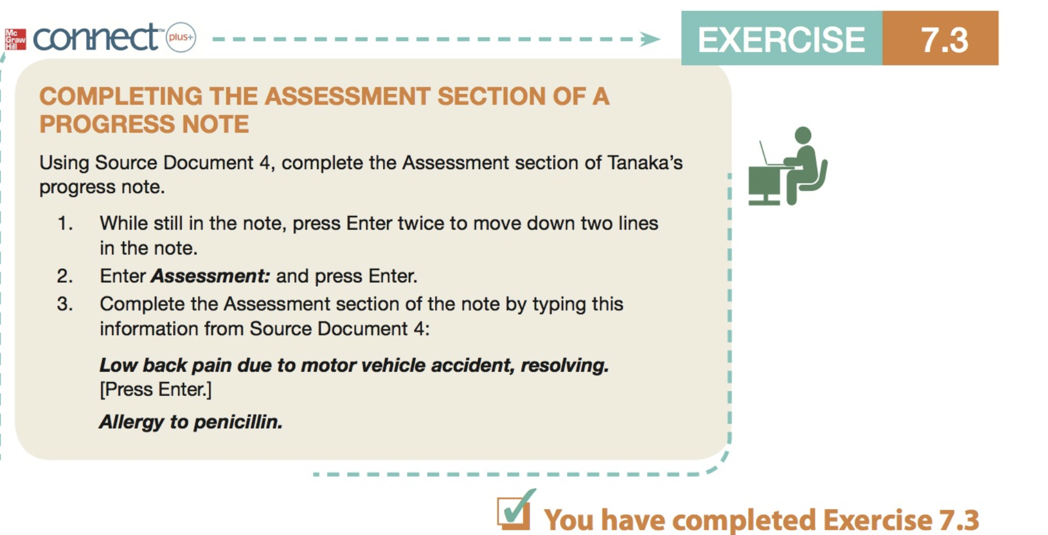
- Health plan
Different health plans include third party payers, preferred provider organizations, Health maintenance organizations, point of service plans, indemnity plans.
- Insurance program
The four major government sponsored insurance plans include Medicare, Medicaid, TRICARE and CHAMPVA. Medicare is an insurance program that was developed according to the Social Security Act. Individual care is offered to the citizens who have ages of 65 years or older. These people must have paid FICA taxes if they want to avail the plan. The plan also provides free medical service to the disabled who are below 18 years. Medicaid is a hospital insurance in which state pays for the hospital expenses, medication etc. The plan works for the citizens who are having ages of 65 years or more. However they must pay premiums for the coverage. TRICARE is another plan offered by the state that offer free service to the citizens who are enrolled for it. This is an extra and alternative care plan for the civilians. It is more expensive and provides enhanced care. CHAMPVA is a health insurance for the veterans. It offers healthcare facilities to the veterans who are disabled or dependent on others. The lifetime health coverage is offered to the veterans according to this plan.

Reference
Sanderson, S. M. (2012). Practice management and EHR: A total patient encounter for Medisoft. McGraw Hill.

