[Name of the Writer]
[Name of Instructor]
Dental
[Date]
Diagnosis
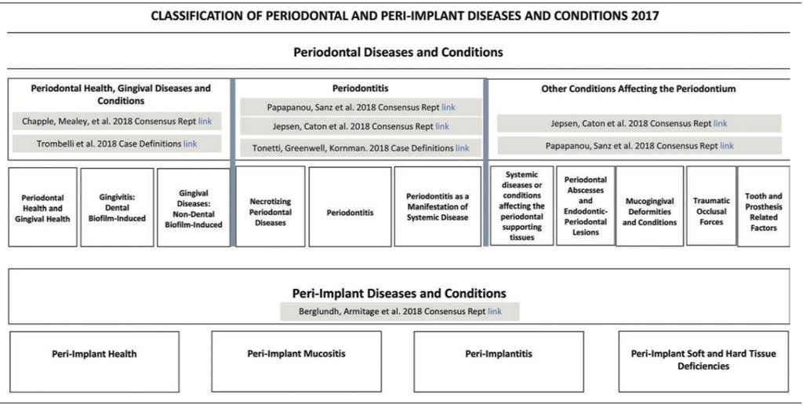
1- In the medical terms, the infections around the structure of the teeth are known as periodontal diseases. These structures include the area of gums, periodontal ligament and the alveolar bone, which is mostly infected. The term Gingivitis is used to mention the early stages of periodontology disease in which it infects the gums at first, then it infects all the tissues around the teeth. However, classifications have been made on the periodontal diseases throughout the history. Whenever Periodontitis is reclassified, some major changes are added. In the same way, the new classification system (2018) is different from the Periodontal Classification of 1999 (Caton et al., p. 53).

Source: Journal of Periodontology
One of the significant change in classification of 1999 is that currently there are three forms of periodontitis, i.e. chronic, aggressive, necrotizing and as a manifestation. On the other hand, the previous classifications were chronic and aggressive categories of periodontitis (Wiebe and Putnins, pp. 594-599). Moreover, in the new classification, the issues regarding the difference between existences of gingival inflammation at one place or more are resolved. It also explains the gingivitis more precisely. In the new classification few terms are replaced by new terms such as excessive occlusal force is replaced by traumatic occlusal force. In addition, features related to prosthesis and tooth are extended in the new classification.
2- Localized and Generalized
Localized Aggressive Periodontitis and Generalized Aggressive Periodontitis are types of Aggressive Periodontitis. Localized aggressive periodontitis refers to the attachment loss of incisor interproximal. On the other side, Generalized is the interproximal attachment loss of minimum three teeth excluding the first molar tooth and incisors. The distinction between localized and generalized types are mostly on the basis of etiology and pathogenesis. Localized aggressive periodontitis happens at the age of adolescence whereas generalized aggressive periodontitis takes place under thirty. Actinobacillus actinomycetemcomitans and other bacteroids cause LAP. On the other hand, GAP is caused by Porphyromonas gingivalis and Gram-negative rods (Modeer and Wondimu, pp. 633-658).
3- Acute versus Chronic disease
Acute disease comes sharply, and it is caused by specific things such as an injury or infection. Moreover, it does not stay more than six months. However, chronic diseases are ongoing diseases and remain more than six months. In addition, it has physical effects on the body. The emotional effects of chronic conditions are like pain, rage, worry and sometimes depression. However, dental diseases are also divided into acute and chronic diseases on the basis of same reasons. For instance, acute gingivitis is referred to the specific infections caused by micro-organism or trauma. On the other hand, Chronic Gingivitis refers to the bacterial plaque of gum tissues around the teeth. The chronic disease further affects the bone tissue along with the gum tissue. The significance of recognizing acute versus chronic diseases is that it will help to choose the treatment of the illness.
4- Gingivitis versus Periodontitis
Gingivitis is the swelling or tenderness of the gums whereas the periodontitis refers to the infection in the gums. Gingivitis is initiated by the bacteria which causes plaque of the gums. On the contrary, in Periodontitis gum is pulled away exposing teeth to harmful microbes. It destroys both gum and bone tissues due to which teeth become moveable. Periodontitis causes tooth loss in grown-ups.
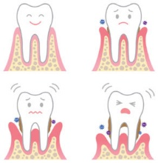

Source: “Tooth Wisdom”
5- A Pseudo Pocket and a Real Pocket
Pseudo pockets are also known as D4346 Scaling whereas real pockets are known as D4341 scaling. Pseudopocket grows due to gingival expansion whereas real pocket is caused when the connective tissue attachment moves away. In addition, supporting periodontal tissues are not effected in case of Pseudopocket while there is a loss of supporting tissues in the real pocket. Thirdly, there is an apical movement of connected epithelium in the real pocket, but there is no loss of epithelium connection in Pseudopocket. Moreover, the base of Pseudopocket should be coronal to suprabony whereas the real pocket base is coronal to horizontal bone loss.
6- The 15 Steps (As Outlined by the AAP) of Periodontal Examination
These are the steps developed by the American Academy of Periodontology for examination of periodontal diseases.
- A medical history will be checked to evaluate if there are influencing conditions that may cause or disease or dental disturbance.
- The reason for the visit should be evaluated along with the dental history. Dental history guides to design a proper treatment.
- Then, extraoral structures should be properly observed and appraised by using different apparatuses.
- In the fourth step, the oral tissues and different structures like lips, the floor of mouth, tongue are checked and evaluated.
- The teeth or its replacements are examined. It is the examination of missing teeth, tooth loose, teeth position, and signs of harmful habits.
- Radiographs are used to diagnose the treatment for the patient. Radiographs are assessed and interpreted.
- Look for any signs of plaque.
- Check the periodontal tissues along with peri-implant tissues and also identify their types.
- Measure the location of the gingival margin. Examining depths and evaluate whether it bleeds on probing or not.
- Identify any tissue abnormalities such as keratinized tissue absences, etc.
- Determine the existence, position, and level of furcation attacks.
- After all of the initial steps, it will be identified that is there any need for additional diagnostic reliefs or medical tests.
- All the information will be saved in the patient’s record file.
- Referral to another physician and recorded.
- On the basis of all the results after the thorough check-up, a proper treatment plan will be prepared for the patient.
7- Differences between Loss of attachment, Attachment Apparatus, and Attached Gingiva
The loss of attachment is the moving of collagen fibers from the cementum. The part of soft tissue attached to teeth also moves towards the top of the roots in loss of attachment. On the other side, attachment apparatus denotes the tissues which connect the teeth to the alveolar bone and periodontal ligament. However, Attached Gingiva refers to the gum tissues which are attached alveolar process and the tooth.

Works Cited
"Gingivitis vs. Periodontitis: What’s The Difference?” Tooth Wisdom, 2019, https://www.toothwisdom.org/a-z/article/gingivitis-vs-periodontitis-whats-the-difference/.
G. Caton, Jack, et al. "A new classification scheme for periodontal and peri‐implant diseases and conditions–Introduction and key changes from the 1999 classification." Journal of Periodontology 89 (2018): S1-S8.
Modeer, Thomas, and Biniyam Wondimu. "Periodontal diseases in children and adolescents." Dental Clinics of North America 44.3 (2000): 633-658.
Wiebe, Colin B., and Edward E. Putnins. "The periodontal disease classification system of the American Academy of Periodontology-an update." Journal-Canadian Dental Association 66.11 (2000): 594-599.

