Economics assignment
Name of the student
Name of institution

Answer 1
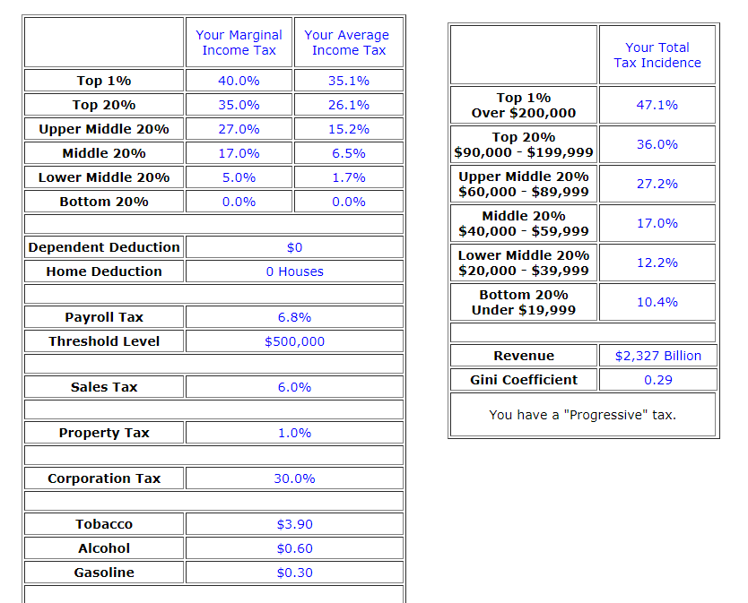
The major concept used by me is the increase in sacrifice with the increase in income. This choice has led me to keep the direct taxes higher. The higher income people should pay a higher tax and vice versa. There are no deductions in case of income taxes. Some of the taxes like sales tax has been kept lower than the current rate so that the impact of such decrease can be measured.
The Gini coefficient is a measure of inequality of distribution of income in the society. The figure closer to 1 shows a higher degree of inequality among the individuals. The coefficient will increase if the indirect taxes are increased by the government. This is because the indirect taxes have to be paid by the rich and the poor at the same rate. In order to decrease the coefficient, the government should focus on increasing the direct taxes and that too for the richest people of the country.
The income tax will result in the decline of the coefficient because the impact of the tax can be adjusted according to the increase or decrease of the incomes. This will also mean that the burden of the tax will be proportionate to the income of the individual.
Answer 3
I have chosen the petrol as the product for this example. The price of the petrol has fluctuated many times in the recent past. This will allow me to study some particular concept like elasticity of demand.
The quantity demanded of petrol will decrease from 100 to 90.
The price of petrol has risen from $ 4 to $4.75.
The elasticity is given by:
%age change in Q_{d}/ %age change in price
This formula is further expanded as:
Q₁-Q₀/Q₀

P₁-P₀/P₀
If we place the above values in the formula, we get:
90-100/100
4.75-4/4
The calculation reveals the answer of -0.5. This answer is according to the rational because the people who are using the cars cannot quit to use the petrol if the prices are higher. The elasticity in this case is said to be price inelastic, having the answer less than 1. The negative sign shows the negative relationship between price and demand.
The other possible answer is the elasticity greater than 1 which is called elastic demand. This is the case when percentage change in the quantity demanded will be more than the percentage change in price. The main determinant of this aspect is the availability of substitutes, if close substitutes are available, the commodity will be price elastic. There are some other considerations in this regard about the nature of the products when we study the elasticity. The basic needs have inelastic demands because their substitutes are not available and their demand cannot be postponed as well.
Answer 4
The decision to buy a new car had to be made by my family. After going through the chapter, I suggested to my family that they should not buy the new car because the prices of the petrol have risen. The concept applied here is the cross price elasticity of demand in case of complementary goods. I had learnt that the complementary goods have to be used in tandem and rising the price of one will affect the other as well. Thus, my family postponed the purchase of new car until the prices of petroleum go down. There are some other considerations in this regard. The urgency of the need of the family has to be considered, if the family has no other option to commute, they will buy the car any way.
Answer 2
The concept used by the author is the consideration of external costs while deciding on any alternative. These costs are the ones that are to be borne by the people who are not using a product directly. The author pays higher consideration to the environment. This aspects relates to the external costs that will be borne by our next generations. Generally we do not consider the external costs while making a decision. The private costs are more important for the individuals in making the decisions.

References
Senthilnathan, S., 2016. The imopact of elasticity on firm's revenue. international journal of science and research, pp. 1728-1731.

