Question 1

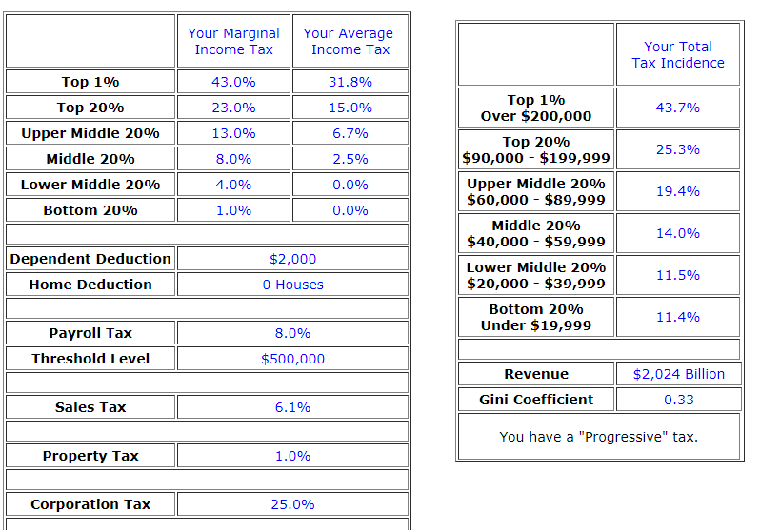

The above person has one dependent person due to which he is entitled to an annual deduction of
$ 2000 from the taxable income. The threshold level for the payroll tax is set at $ 500000.

The gini coefficient is used to measure the inequality of the income across the percentiles of the people. The figure is used to assess how much of the total income is enjoyed by the top part of the population. The income inequality is not the issue for a single country but at the global level. The figure is not the most accurate of the measures for income inequality, it misses some of the important aspects that can affect unequal distribution of wealth.
The above diagram shows a gini coefficient of 0.33 which shows that the proposed system is able to stop the unequal distribution of wealth by 33%.
The unequal distribution of wealth can be overcome by the application of methods that affect the consumption ability of the person. In other words the direct taxes should be altered so that the person is left with either more or less of the personal disposable income. The indirect taxes on the other hand do not affect the personal disposable income directly. The example of the indirect tax is the sales tax that is collected by the shopkeeper from the customer but in turn the producer will collect it from the shopkeeper. Another distinction between the direct and indirect taxes is that the burden of the direct taxes falls directly on the customer while the burden of the indirect taxes is not felt directly by the customers.
The corporation tax will increase the gini coefficient because this will not directly affect the consumers. The Disposable income is not affected by the corporation tax.
The wealth tax will cause the gini coefficient to fall down. The reason for this is that the wealth tax will have a direct impact on the purchasing power of the consumer.
Answer 2
The concept used here is the opportunity cost which is defined as the cost of next best alternative that is forgone so that the person can take on the given alternative. The opportunity cost is discussed in the article in a sense that the expenses that we make today can be postponed and the resources that are kept free can be used for some other work preferably for the betterment of the environment or climate. Making and implementing the climate policy will certain involve some costs, these costs have to be borne with the help of the resources that can be used for some other aspects. There is a certain level of difficulty to put pricing to the climatic aspects as we cannot put the price tags on something like human lives, health and certain other issues. The author argues that the investment in the climate management will not only benefit the society today but also in the future. AS far as present benefits are concerned, the investments in the climate management will create a large number of jobs and also generate income for individuals and the society as a whole. Thus, the opportunity cost related to the investment in climate management will be justified.

Answer 3
The product chosen is the IPhone that is a high priced product. In order to judge the behavior of the product, we have to see two aspects of the scenario. First of all we consider this as a luxury good that is bought by the elite class only. In this case the calculations will be as follows:
%age change in quantity demanded/%age change in price
This is the basic formula for elasticity which measures the change in quantity demanded with respect to change in price. In the scenario above the quantity demanded will go down from 100 to 90. The price will go up from $ 345 to $370. Now we calculate the value of elasticity by putting the values in the formula:
Q1-Q0/P1-P0 * P0/Q0
90-100/370-345*345/100
= 1.38
This shows an elastic demand which means that the percentage change in the quantity demanded is more that the percentage change in price of the product. The quantity demanded is very much responsive to the change in price. The second scenario is where we can consider the said product as an addiction that people are not willing to leave. In that case the quantity demanded will change from 100 to 98 and price will go up from $748 to $ 770
Q1-Q0/P1-P0 * P0/Q0
98-100/770-748*748/100
=0.68
This answer is less than 1 which shows that the demand is relatively inelastic for the products that are considered status symbols or addictions.
Answer4
The decision that I took while purchasing the mobile phone was affected by the concepts of elasticity. When I went to buy the phone, I wanted to buy some specific brand. When I reached and consulted various shops in the market, I came to know that there are certain number of substitutes available for me. Further, i had an old phone so my need for the new one was not very immediate. Thus I can postpone my purchase decision until the prices of phones come down to my liking. The elasticity of demand for me regarding the mobile phone is high. This means that I will not increase my quantity demanded until the prices fall down to a certain level.

