Week 4 Project
Mark Wrublewski
South University
BUS305
Prof. Stottlemyer
7/31/19

Introduction
Moving average forecasting models is applied to forecast future values. It is regarded as a technique for predicting or obtaining future values. It mostly used by stock analyst to predict the future prices of stock. Moving average smooth a data and therefore, it makes it easy to spot a trend in a volatile market. Moving average also form a blocks which are used for many other technical overlays and indicators in market. According to Toms (2011), it plays an essential role in stocking exchange and other money markets to determine the trend in the market. It brings competitiveness in the stock market which improves the performance of stock market and the economy. Without moving average, it would be difficult for traders and analysts to understand the trend and predict future prices (Kolkova, 2018). This could easily make the stock market lose competiveness hence investors. It therefore, plays a critical role in ensuring that the stock market remains active and viable.
However, this study intends to investigate the performance of stock market using moving average forecasting. In order to understand how moving average is applicable, stock market of UTIW, OEX and CIEN would be analyzed using moving average and centered moving average. The comparison will also be done using moving average and centered average to understand the application of the two concepts and their importance in the analysis of the stock market performance. It is also important to point out that the result obtained reflects the performance of the market. As pointed out by Hyndman (2010), it is important to understand how the stock market move and predict the future price based on trend. Through the use of moving average stock trend could be predicted. This study therefore, present techniques applied in moving average to understand the daily stock market performance by compared the performance of three stock market using moving average.
Create trend-moving averages with the following values form: 10, 100, and 200
Moving Average for three different stock markets
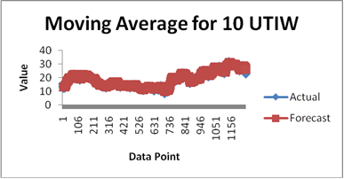
Graph 1: moving average for 10 UTIW

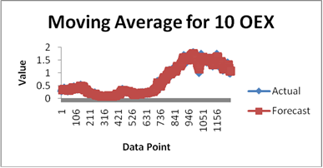
Graph 2: Moving average for 10EX

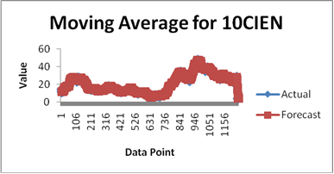
Graph 3: Moving average for 10 CIEN

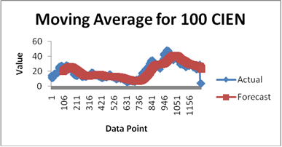
Graph 4: Moving average for 100CIEN

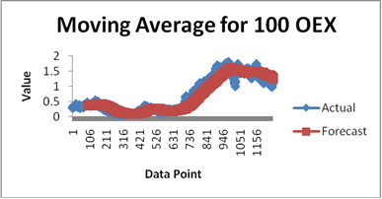
Graph 5: Moving average for 100 OEX

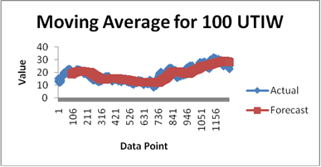
Graph 6: Moving average for 100 UTIW

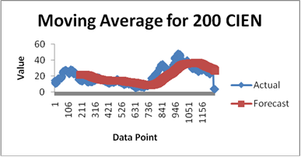
Graph 7: Moving average for 200 CIEN

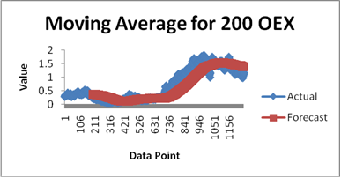
Graph 8: Moving average for 200 OEX
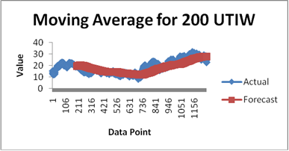
Graph 9: Moving average for 200 UTIW
Create centered-moving averages with the following values form: 10, 100, and 200
Centered Moving Averages for UTIW stock market
The UTIW is one of the known and the biggest stock market. It provides worldwide stock prices and some historical data of several companies. The center moving average after obtained using the value 10 is as indicated in the diagram below. In this, the stock data is used to develop centered moving average of the UTIW stock markets. First, it is essential to understand centered moving average. Centered moving average is used to create a series of average of different subsets which below to the same and full data. The centered moving average means that the data is centered on the mean.

- Create centered-moving averages with the value of 10
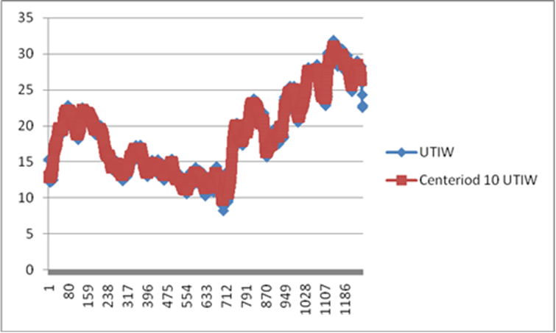
Diagram 1: Centered moving average with the value of 10
The graph indicates that the centered is longer compared to the UTIW. In this case it could mean that stock prices are highly predicable. The mean is around the center of the information and therefore, it can easily be used to provide prediction.
- Centered moving average with value of 100
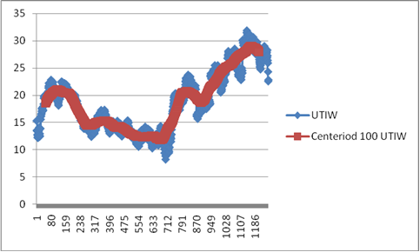
Graph 2: Center moving average with value of 100
In the graph, it is evidence that centeriod 100 UTIW is shorter compared to UTIW index. It could means that it provides faster update on the change of values compared to 10 values. Though the predictability of the index market is similar, efficiency and competency could be different.
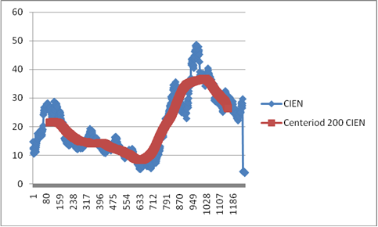
Graph 3: Centered moving average with 100 values
Centered Moving Average for OEX Stock Market
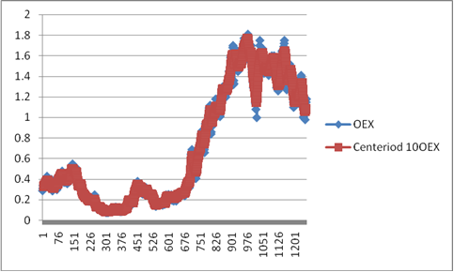
Diagram 4: centered moving average for OEX 10
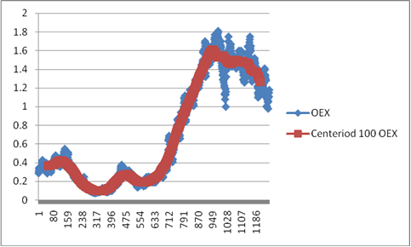
Diagram 5: centered 100 OEX

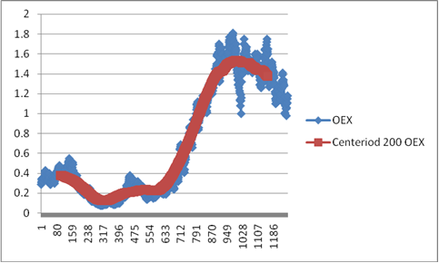
Diagram 6: Centered 200 OEX

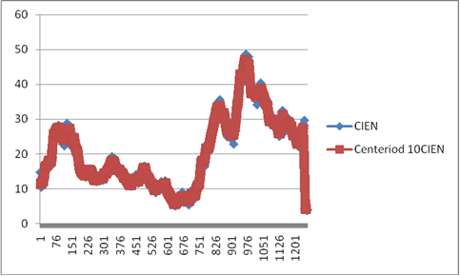
Diagram 7: Centered 10 CIEN

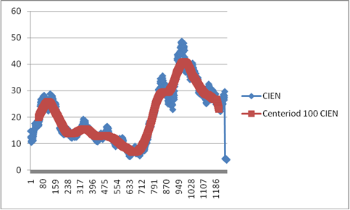
Diagram 8: Centeriod 100 CIEN
Diagram 9: Centeriod 200 CIEN
The moving averages for the same values of m compare between a trend-moving average and a centered-moving average
Based on the above graphs, it is evident that where the trend moving average is dealing with a situation where the point was not established and therefore, the centered moving average deals with the exact time of time. In this, the moving average is directed towards the right, which can indicate a positive response of the stock market. It can either means that the stock market is experiencing constant increases. This is what is used by analysts to predict the next value of the stock price.
The moving averages can assist a stock analyst in determining the stocks' price direction. Provide a detailed explanation with justifications
Moving average is an essential aspect in stock market. According to OEX, (2019), it is applied by stock brokers and other traders to determine the prices of various stocks in the market. Kolkova (2018) pointed out that it assists stock analysts to determine the stock’s price direction. The main point is how it helps stock analysts to determine stock price direction. Moving average is a technical analysis tool which smooths out price data by providing constant update of the average prices of stock. It provides update on the stock price based on period set by stock analysts. With moving average a stock analysts is able to predict the future prices of shares of a company. The advantage of using moving average is that it is popular can be tailored to meet any time frame. The simplest method to use moving average is to plot a single moving average on chart and then monitor the performance of a stock. As stated by Hyndman (2010), when the price action stays above the moving average line, it means that the price of the stock is in a general trend.

References
Hyndman, R. J. (2010). Moving Averages.
https://www.researchgate.net/publication/222105796_Moving_Averages , 2-35.
Kolkova, A. (2018). Indicators Of Technical Analysis On The. Basis Of Moving Averages As
Prognostic Methods In The Food Industry , 2-34.
OEX. (2019). Stock market Analysis. https://coinmarketcap.com/exchanges/oex/ , 2-34.
Toms, M. C. (2011). The Technical Analysis Method of Moving Average Trading:. Rules That
Reduce the Number of Losing Trades , 2-34.

