Housing Market
[Name of the Writer]
[Name of the Institution]

Housing Market
The housing market is made up of the supply and demand of houses made on land where we live. The stock of housing consists of various types like occupied houses, privately owned, privately rented, property owned by housing associations, local authority rented accommodation, and selling of land for construction of houses. Just like markets of goods and services, the housing market also linked with economic indicators including supply, demand, pricing, inflation, mortgage, interest rate, and many more. Therefore, it directly affects the economic growth of the nation. This is why it is important to learn about the basic information about the housing market.
Demand for housing
The law of demand, which states that when the price increases demand, the good decreases, and when the price of the good decreases, it leads to an increase in demand for that good. In the housing market also, when the price of the land or house increases, demand starts decreasing and vice versa. There are numbers of factor that affects the demand for housing, including current income, price, interest rate, and wealth of the households. The market demand curve indicates the change in demand for housing with the change in house pricing. It is downward sloping due to the inverse relationship between quantity demanded and price of the houses. Whereas when factors other than price affect the demand, then it resulted in a shift in the market demand curve. Some of the reason for demand shift includes an increase in interest rates of mortgages, risk of the future economy, change in taste and preference, and change in total wealth of the individuals. Following is the demand curve of the housing market.
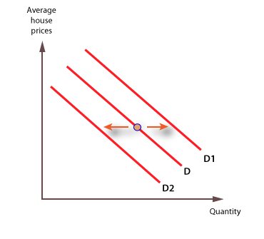
The graph shows that when the demand increases due to the factor other than price, curve shifts to the right that is from point D to D1. Similarly, when the demand decreases due to the factor other than price, curve shift to the left that is from point D to D2 (Adair, Berry, & McGreal, 1991).
Supply of housing
The market supply curve of the houses can be obtained by adding the supply curve of individuals in the economy. The supply curve is positively sloped due to the positive relationship between price and quantity supplied. It means that with the increase in price, there is an increase in the supply of houses, which resulted in the rightwards movement on the curve and vice versa. However, price effects in two ways. First, with the increase in price, firms increase the house’s quantity to earn more profit. Second, an increase in price leads to an increase in the entrance of new firms in the market, which lowers the profit of existing firms. The factors that affect the supply curve of the housing market include the change in the cost of production, delays in construction, damage in construction, and change in rules and regulations. These factors lead to a shift in the house market supply curve.

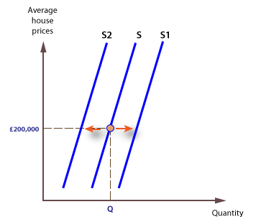
The graph shows that when the supply of houses increases, it leads to shifting in a curve towards the right while fall in supply due to the factor other than price result in shifting of the curve towards the left side (Paciorek, 2013).
Equilibrium in the Housing Market
When the demand for the housing market is equal to the supply of the housing market, then we say that the housing market is in equilibrium. When the demand is higher than the supply of the houses, then the market is said to be in shortage of houses. In this condition, equilibrium can be achieved by contracting more houses. Construction of houses takes time, so for the short-period producers, increase the price of already built houses to decrease the demand. Similarly, when the supply is higher than the demand for the houses, then the market is said to be in surplus. It means buyers of houses are less than the houses available for sale in the market. In this condition, producers lower the price of the houses to attract buyers so that demand can be increased. In-equilibrium happens in the short-run because producer gets less time to manage the production with the change in demand, but in the long-run, they get enough time to manage demand and supply. Therefore, in long-run demand and supply come back to the equilibrium point.
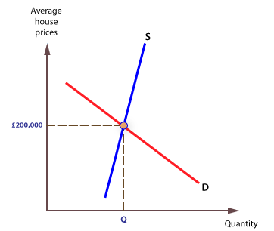
The above graph shows the demand and supply curve of the housing market. The point of intersection is the equilibrium point of the housing market. At equilibrium total quantity of the houses is Q with the price at 200,000 dollars (Goodman & Thibodeau, 1998).
Factor affecting house price
Numbers of factors are included in the growth of the housing market both from the supply and demand side. Factors that affect the housing market from the demand side include the availability of mortgages, number of households, interest rate, speculative demand, affordability of housing, and overall economic growth. Factors that affect the housing market from the supply side include new build and numbers of selling houses.
Supply-side
When the number of selling increases, producers increase the price of the houses to meet the demand to bring the market in equilibrium. Whereas, when the producers build new houses, they keep the price lower to attract individuals who increase demand for new build houses.
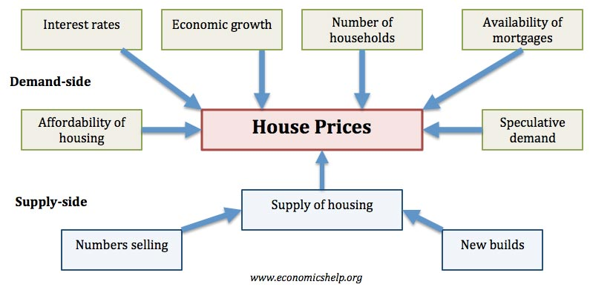
Demand-Side
The first thing that individuals think while buying the house the affordability of housing. When the income or total wealth of the individuals is lower than the demanding price of the houses, then it leads to a decrease in demand for houses. Therefore, producers lower the price of houses to increase the demand. In addition, many individuals do not buy from their wealth or income at once; instead, they take a loan to buy houses, which is known as a mortgage. When they get loans easily, demand for houses increases, but an increase in the regulation or availability of mortgage leads to the low demand, which ultimately lowers the price of the houses. Besides, when the numbers of households increase, it results in low demand for houses and low housing price.
The interest rate is a crucial factor that affects the demand for housing. When there is a fall in interest rate than the price of houses decreases which increased house demand. In addition, low-interest-rate impact the mortgage rate, and people get a mortgage at lower rates, which encourages people to invest in this market and producer to enter for business. In other words, the low-interest rate has a positive impact on the demand of the houses while high-interest rate increases the profit and opportunities for the suppliers or producers of the houses (Diao, Fan, & Sing, 2018).
Importance of the housing market
Fluctuation in the housing market affects the rest of the economy. House is the largest good of consumer wealth, and it shows the biggest single purchase by the consumer. In addition, pricing in the housing market has a direct link with the overall economic growth of the nation. When the price of the houses increases, it encourages the consumer to spend more to buy a house, which results in high economic growth. Whereas a rapid fall in the price of the houses results in more money in the hand of the consumer to save. They buy houses at a lower price and save remaining money for future consumption or investment. It lowers the circulation of money in the market, which results in low economic growth. House price, interest rate, and wealth effect are the three main factors that develop a strong relationship between the housing market and economic growth. Therefore, for stable economic growth, it is important to bring equilibrium in the housing market. This is why the government also plays a role in the housing market by deciding the mortgaging regulation, interest rate, and other policies related to the housing market.
Conclusion
Similar to the goods market, there is a housing market that affects the economic growth of the nation. Supply and demand of the housing market are relying on the interaction between the buyers and sellers of the houses. Price plays an important role in bringing the supply and demand in equilibrium. Price and quantity demanded to have a negative relationship, which makes the market demand curve negatively sloped. In contrast, price and quantity supply have a positive relationship, which results in a positively sloped housing market supply curve. Several factors affect the housing price, both from supply and demand side like mortgage, interest rate, availability of housing, wealth, total income, future risk, build houses, and government rules and regulations. The interest rate plays a crucial role in determining the prices and stability of the housing market.

References
Adair, A. S., Berry, J. N., & McGreal, W. S. (1991). Land availability, housing demand and the property market. Journal of Property Research, 8(1), 59–69. https://doi.org/10.1080/09599919108724020
Diao, M., Fan, Y., & Sing, T. F. (2018). Demand restrictions; government interventions; resale public housing market; private housing market; housing wealth (No. eres2018_32). Retrieved from European Real Estate Society (ERES) website: https://ideas.repec.org/p/arz/wpaper/eres2018_32.html
Goodman, A. C., & Thibodeau, T. G. (1998). Housing Market Segmentation. Journal of Housing Economics, 7(2), 121–143. https://doi.org/10.1006/jhec.1998.0229
Paciorek, A. (2013). Supply constraints and housing market dynamics. Journal of Urban Economics, 77, 11–26. https://doi.org/10.1016/j.jue.2013.04.001

