[Name of the Writer]
[Name of Instructor]
[Subject]
[Date]

Pablo Picasso
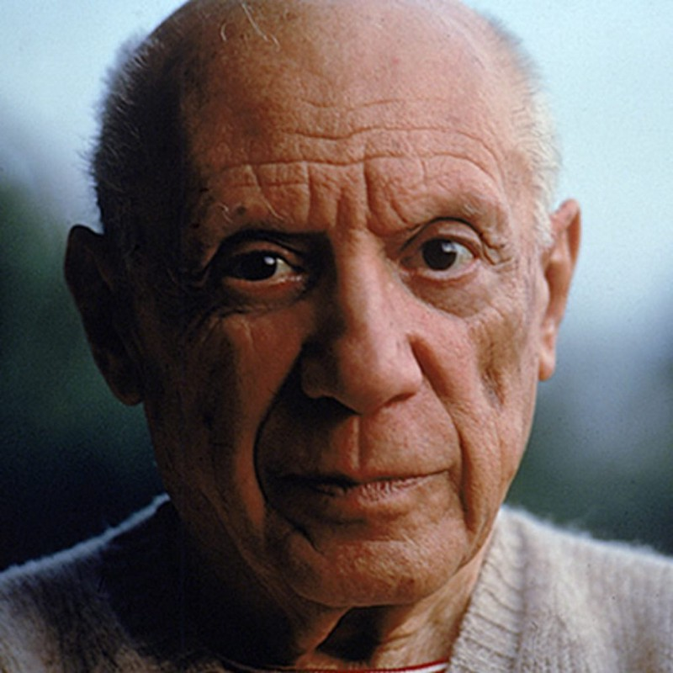
Pablo Picasso was a famous and influential artist in the 20th century. His full name was 23 words long that is “Baptized Pablo Diego José Francisco de Paula Juan Nepomuceno María de los Remedios Cipriano de la Santísima Trinidad Martyr Patricio Clito Ruíz y Picasso.” He was a Spanish painter, poet, stage designer, sculptor, playwright, ceramicist, and printmaker. Picasso was born in Málaga, Spain, on 25th of October 1881. Picasso mother’s name was Doña Maria Picasso y Lopez while father was Don José Ruiz Blasco who was also a painter and art teacher. He had two sisters Lola Picasso and Conchita Picasso. Picasso inherited artistic mindset from his father and showed his talent at a very young age. Picasso was born in a Catholic family but in later life, he became an atheist. He belonged to a middle-class family as his father was an art teacher. He showed a prodigious talent for his artwork and at the age of seven his father taught him to draw and provided him early education of arts. Later in 1891, the whole family shifted to A Coruña as Picasso’s father got the job and become a professor at the School of Fine Arts. After the death of a sister, Picasso along with his family shifted to Barcelona where he got admission in prestigious School of Fine Arts by showing extraordinary performance and cleared the entrance exams in a few days. Afterwards, he continued his study in the top art academy of Spain of his time named "Real Academia de Bellas Artes de San Fernando.” Picasso married twice first with Olga Khokhlova in 1918 and second with Jacqueline Roque in 1961. Picasso had four children (2 sons and 2 daughters) by three women.
Picasso career started from his childhood when he finished his first painting at the age of thirteen. According to his mother, Picasso first word was piz that is the short term of "lapis" meaning pencil. In 1894, he started his career as an artist where he depicted his sister, Lola. In the same year, he had painted a portrait of his aunt. With time his medium of work changed because of his confluence of influences. He was influenced by various artists like Henri Rousseau and Paul Cézanne and also from various works including tribal art and archaic. Picasso did not link himself to the same art style instead he tried to make every painting different from the previous work. His diverse mindset leads him to cubism. Cubism was the art movement that brought a prominent change in the art of Europe. The concept of the cubism was the division and broken up of the subject and object into the piece and rearranged them in an abstract form. Picasso is considered as the founder of collage used in contemporary time. He used the different pictures and out of which made a new artwork known as a collage art style. Picasso belonged to the middle-class family but due to his passion and hard work he was one of the highest-paid people of his time. During 1901-1904, most of the Picasso work was based on posthumous portraits of a friend after suicide, prostitution, and malnutrition. Picasso made his first masterpiece "Les Demoiselles d'Avignon" between 1907 and 1909. During these years most of Picasso work was influenced by African people and culture. In his masterpiece, he painted five naked women with figures made by splintered and flat planes, where faces were inspired by African masks and Iberian sculpture. In modern art history, this painting is known as the most innovative painting. Picasso spent most of his life in the different nations rather than his native land which made him involve him cubism, neoclassicism, surrealism, and sculpture.
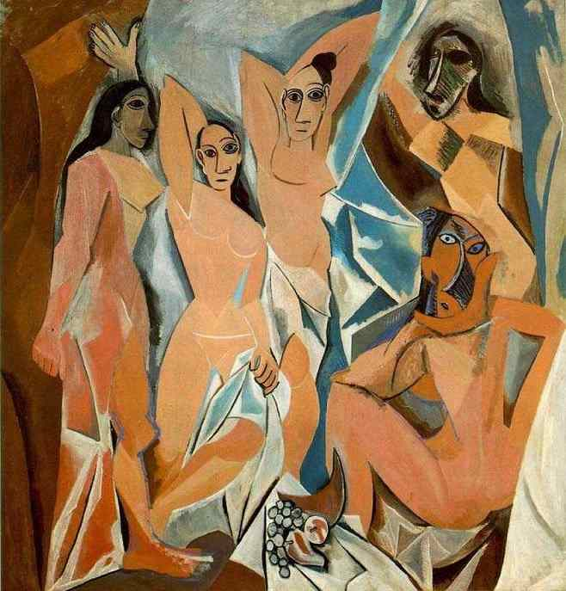
Les Demoiselles d'Avignon

Art was the passion as well as major hobby of the Picasso. Picasso did not believe in making lots of friends and most of the time he spent alone in a single room when he was young. However, he had various affairs from time to time. He had two wives and had children from third women and besides that, he had many other girlfriends in which most were young. Picasso got so much name and fame in the world of art and one of the interesting facts about him that when he completed his first painting his father was so inspired by his work that he gave his brushes to him and left the painting. He was the artist whose painting was stolen more than any other artist. According to the art loss register, Picasso lost 1,147 works which are more than twice in number than any other painter. He became communist at the age of 62. In addition, he was not just a painter he served his time in various other mediums of art. He designed the costumes for a handful of ballets and even the curtain from 1917 to 1924. Poetry was his another hobby. He started poetry in 1935 and by the end of the 1940s, he already became the author of two plays.
Picasso became the inspiration for artists at that time and even modern time artists are influenced by his work. Artists get inspiration from his work because Picasso was daring and creative who used more than one art form in his paintings. Today he is known as the father of modern art and thousands of people follow his work style around the world. He died on 8 April 1973 at the age of 91 due to heart failure.

