Title page
Mapping strategic goals

Strategic goals
The goals of the company stress on incorporating technological choices including location-based computing and artificial intelligence. Artificial intelligence will be focused on incorporating voice to text features, sales, e-commerce, and business forecasting. The location-based services involve navigation and tracking. This is focused on maximizing customer reach.
GANTT Chart & network diagram
The chart explains the activities that are required for integrating the technology choices. The first milestone for the development of location-based computing and artificial intelligence depends on financial resources. The purchase of technologies demands funds and financial support. Stakeholders of the company play a key role in the provision of financial resources. The stakeholders comprise of investors, CEO and the owner of the company. The first milestone thus aims at the collection of adequate funds that could support strategic goals of technology integration. The second milestone focuses on the evaluation of the development phase that will indicate the methods used for adopting technologies. The two selected technological choices include artificial intelligence and location-based computing. The completion of multiple project activities depends on the continuous support from the stakeholders. The technologies will be completed by March 2019.
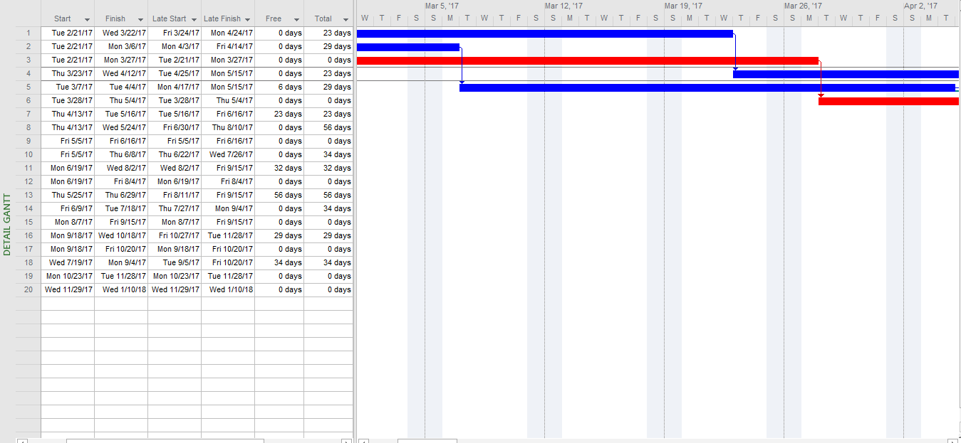
A total number of days estimated for the critical path is 223 days. Time taken by critical activities is less than the total duration of the project. Slack for marketing project is also estimated that provides a clear view about the actual time taken. Slack presents a classification of time taken for completion of the entire project including a start time for each subactivity, finish time, late start time, late finish time and a total number of days. Estimated and total number of day's gives the idea that the project cannot be completed in 150 days unless the number of pre-marketing activities is declined (NIB, 2017).
A network diagram is developed for estimating the number of days required for each subtask. Network diagram shows all activities are interconnected and a total number of day estimated for completion of the project are 523 days. Critical path analysis shows the activities that are more critical including the development of overall strategic goals (25 days), designing of the prototype (28 days), drafting of technology choices and its implementation.
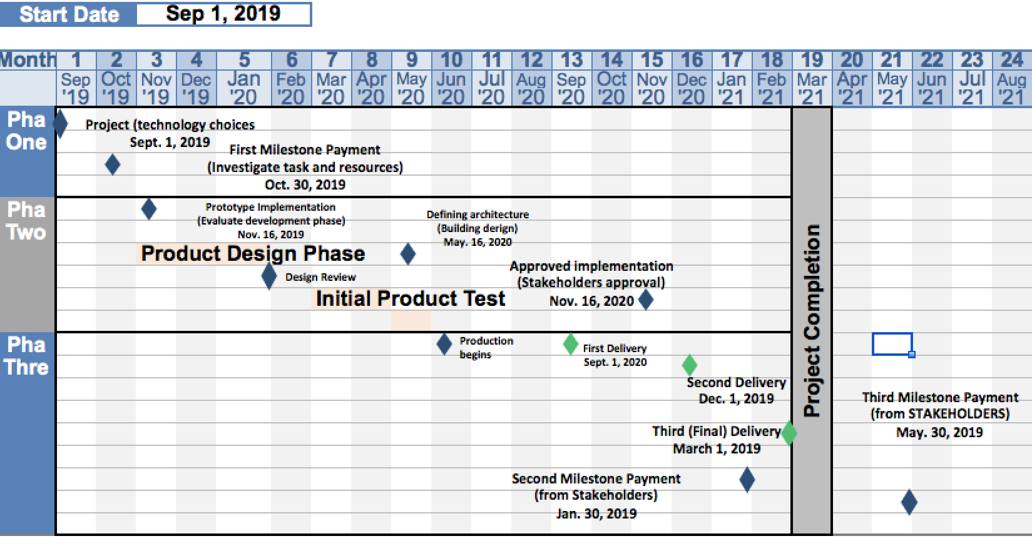
Location-based computing involve location-based promos and navigation services. Location-based promos allow companies to use these services for reaching out customers of specific geo-location. The first phase in the implementation of technology choices involves the identification of cost-effective methods. This is crucial for minimizing costs and maximizing returns. After a thorough analysis the company will conduct prototype evaluation that is crucial for the creation of technology. Two identified technologies use are thus artificial intelligence and location-based computing. After defining the technologies to stakeholders, they will approve by guaranteeing provision of finances. This will take the project to the next stage of building design. The design must be adequate for fulfilling the needs of the company (Cavalcante, 2013).
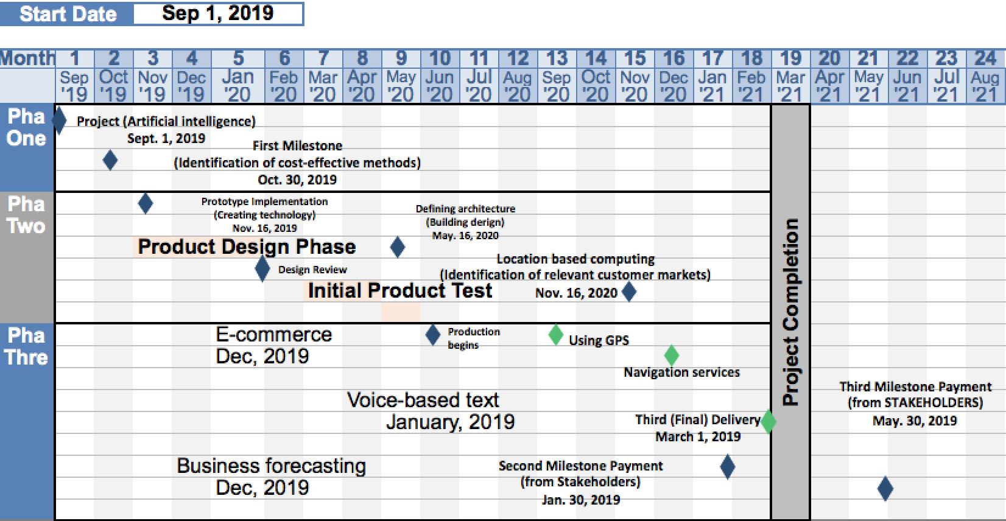

The location-based computing focuses on creating GPS and tracking logistics. The process will start from the identification of resources and evaluation of the technologies. This is crucial for determining if the selected technologies are efficient and appropriate. The next milestone stresses on creating GPS and navigation-based services. The designs are created after evaluating the architecture (Cavalcante, 2013).
The overall analysis of the Gantt chart and network diagram depicts that the implementation of the technology choices depends on some important factors including stakeholders engagement, financial funds, designing of prototype and testing of technologies. The completion period will take more than a year.

References
Cavalcante, S. A. (2013). Understanding the impact of technology on firms' business models. European Journal of Innovation Management, 16 (3), 285-300.
NIB. (2017). Artificial intelligence in business. Retrieved 03 10, 2019, from https://www.nibusinessinfo.co.uk/content/examples-artificial-intelligence-use-business

