[Name of the Writer]
[Name of Instructor]
[Subject]
[Date]
America China Trade War

Introduction
The trade war between the United States and China is an episode of trade dispute, consisting of tariff increases and threats between China and the United States, launched under the chairmanship of Donald Trump. On January 22, 2018, Donald Trump sets up "over 4 years" customs taxes on washing machines and solar panels. China is the world's leading producer of solar panels. The taxes on these panels are degressive, of the order of 30% the first year to fall to 15% the fourth year. In addition, each year, a 2.5 GW quota of photo-voltaic panels is exempt from customs duties. Similarly, tariffs on washing machines are degressive, but in two categories: 1.2 million imported washing machines are subject to a customs tax of 20% the first year, which drops to 18% the second year, then 16% the third, while the rest of the washing machines and spare parts are subject to taxes of 50% the first year, then 45% the second year and finally 40% the third year. China is the leading exporter of washing machines to the United States, followed by Mexico and South Korea.

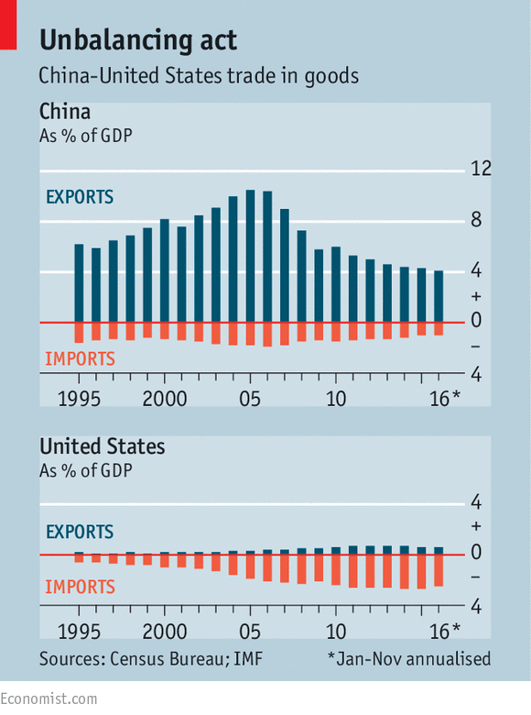Anti-

Dumping Investigation by China
In February 2018, China triggers an anti-dumping investigation into US sorghum, with the Chinese Ministry of Commerce claiming that the United States is subsidizing the cultivation of this grain. China imports about US $ 1 billion worth of US sorghum, and tariffs may penalize a US state such as Kansas, the largest sorghum-producing state in the United States, which has largely voted Donald Trump. On March 8, 2018, Donald Trump signed a decree introducing tariffs of 25% on aluminum imports and 10% on steel imports. Subsequently, several countries are exempted from this tariff increase temporarily. This temporary exemption affects Canada, Mexico , the European Union , South Korea , Brazil and Argentina , which excludes Japan and China. In March 2018, Donald Trump signs a decree prohibiting the acquisition of Qualcomm by Broadcom, denouncing the influence of China in this acquisition. One of the key policy issues is that of taxes on automobiles imported into China from the United States. "China has agreed to reduce and lift taxes on cars imported from the United States, which is currently 40%," Donald Trump announced on Twitter just after the talks. Lawrence Kudlow, president of the US National Economic Council, however, confessed a few days later at a press conference that Donald Trump's remarks on auto tariffs were a bit hasty. "We do not yet have a concrete agreement on this," he told the US media.

Prohibition and Penalties
On April 16, 2018, ZTE, a major Chinese producer of mobile phone and telephone equipment, is banned by the US government from using goods or services of US origin for a period of 7 years, following false declarations concerning its exports to Iran , subject to both international and especially American economic sanctions . ZTE was previously fined $ 1.2 billion in 2017, following re-exports of products to Iran including US-origin items, which is prohibited by the United States. Moreover, no one currently plans to lift the tariffs introduced by both parties during their trade war. These are taxes on imported Chinese products, 25% on $ 50 billion of goods and 10% on $ 200 billion (which has just frozen at this level provisionally). Finally, we must mention tariffs of 25% on $ 50 billion of American products imported into China and another 5% to 10% on $ 60 billion of American goods. Not to mention the first US tariffs on solar panels, steel and aluminum, as well as the Chinese response.
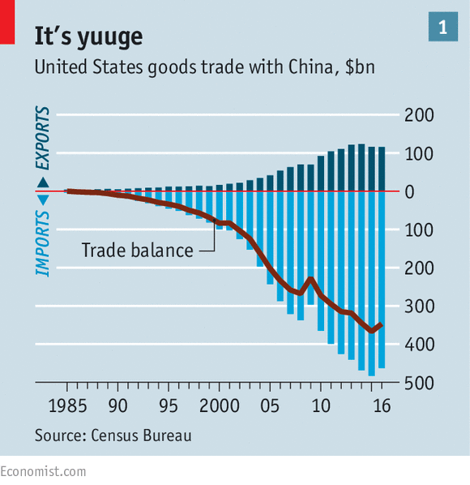

Import of Cars
This question of imports of American cars in China is very telling. If Beijing really lifted the customs duties, who would win? The answer is not obvious - and this is probably valid for the whole trade war. if US car taxes were canceled, China would show that concessions are its only response to US pressure: "The fear of Chinese companies losing the US market is so important that there is only one strategy: to give in and to consent. Thus, the authorities could announce that loans at reasonable rates will be granted only to Chinese companies that buy Chinese cars. If your company or its employees used American cars, the interest rates would be exorbitant. Beijing could also launch an information campaign against American automobiles. Donald Trump has shown the world that China is not yet ready for a full trade war with the US.

Likely Outcome of Negotiations
The most likely outcome of the negotiations that have just begun is that China agrees to make some concessions to defuse the crisis and allow Donald Trump to publish a triumphant tweet. But without giving in on the essential. "It is possible that Beijing agrees to sign some promises to purchase that would result, for example, in increases in imports of soybean and US gas," anticipates the economist. It remains to be seen whether, for a few tons of soy and liters of gas, Donald Trump will be ready to bury the hatchet. If he tries to obtain even more concessions, the risk is high that in March, at the end of the truce of 90 days, the negotiations fail. In this case, Washington has already warned that the United States will add fuel to the fire by further increasing tariffs on Chinese products.

Rebalancing the Trade
Observers generally believe that the rebalancing of the trade balance - products consumed in the United States are massively manufactured in China - is the least arduous issue in these difficult negotiations, as Beijing has already hinted that it could buy more American agricultural or other products. The Trump administration is counting on the slowdown in the Chinese economy to convince Beijing that it must yield to US pressure to obtain the lifting of Uncle Sam's tariffs. The figures released Friday by the Chinese government bring water to the mill of this strategy: producer prices fell in January to the lowest in two years, at almost zero level of + 0.1% over one year, indicating a marked slowdown in activity in the world's second-largest economy.

Conclusion
Chinese and Americans have reported progress in trade negotiations, but deadline of 1 March, before new punitive measures by Washington, remains in place and both sides agree that "very difficult" issues are still pending. Negotiations will continue next week in Washington, Chinese President Xi Jinping said on receiving US negotiators, Treasury Secretary Steven Mnuchin and Trade Representative Robert Lighthizer, after five days of talks between the two delegation’s country. China has agreed to waive the tariffs it imposed after the United States decided to levy $ 250 billion worth of Chinese goods. It is committed to opening up its market to cars, beef and chemicals, and promises that Chinese companies will buy Americans hundreds of billions of dollars’ worth of natural gas. Boeing or Tesla, both of which rely heavily on the Chinese market, would not want to suffer the same fate. The aircraft manufacturer has just assembled for the first time a plane in China, and the car manufacturer has laid this Monday, the cornerstone of a factory in the suburbs of Shanghai.

