Implementation of the Healthcare Policy
[Name of the Writer]
[Name of the Institution]

Implementation of the Healthcare Policy

Introduction
When the policy is being devised, the most important thing for all the stakeholders is now to make sure that there is a common ground in terms of how the implementation of the policy is going to be carried out and how the roles are going to be defined in terms of how the policy is going to be implemented. At the same time, it has to be made sure that once the roles are defined, there is clarity in terms of how the evaluation and accountability is needed to be there in terms of how these roles are going to be fulfilled and how with the fulfilment of these roles, effort can be made to make sure that he more compliance organizational structure is going to be created at the given point of time. The process and the procedures are also needed to be looked as well as making sure that if there are any financial implications, they are being taken into account when the decisions are going to be made. These groupings provide a reasonable way of examining barriers to policy implementation at the practice level.

Key Personnel Roles
Whenever there is implementation of any healthcare policy, the broader idea is to make sure that there has to be an agreement among all the stakeholders that how the policy is going to be implemented and how the implementation mechanism is going to be created at the given point of time. Keeping this aspect in mind, it would be interesting to see how different stakeholders pan out in terms of the way implementation of the policy is being done at the given point of time. Some of the key personnel and their roles during the implementation of the policy is as followed.

- The major stakeholder during the process is going to be the government. They are the ones that should make sure that the policy is being given the shape of the legislation and effort is being made to make sure that once that legislation is being made. Not only that, the role of the government becomes important in the sense that they have to make sure that they come up with the budgeting and financing solution
- The legislation bodies are the ones that should make sure that once the bill is being presented, effort should be made that the legal draft is being passed and the proper implementation mechanism has to be there. At the same time, effort is needed to be made that how it is going to be implemented at the state like level in the United States
- The other aspect that is important is the healthcare providers, they are the final piece of the jigsaw in a sense that they are supposed to be making sure that the policy is being implemented in its true heart and soul and thus allowing better management among all the stakeholders at the given point of time with regards to the way whole of these things would be managed.

Financial Implications
One of the major considerations that has to be kept in mind when it comes to the implementation of this policy is that how it is going to be made sure that the financial implications during the course of the whole process would be carried out. The first thing that has to be kept in mind is that the budget that is going to be allocated for the implementation of this policy would be rather limited, so there is a need to make sure that an effort is being made with regards to making sure that there has to be sense of purpose in terms of the way each of the penny is spent. The idea is to come up with the more robust and efficient healthcare mechanism that allows the blanket of the healthcare to be implemented at the given point of time in a much more appropriate manner. Not only that, there is also a need to make sure that the effort is being made with regards to how the mechanism is going to be created where the allocative efficiency would be made possible at the given point of time. Without making sure that the mechanism is being implemented where allocative efficiency would be taken care of. One of the ways the financial implications of the whole process is going to be managed is to make sure that the periodic reviews are being carried out with respect to the way policy is being implemented at the given point of time and what was the mechanism that was implemented in terms of how the allocative efficiency was being made possible at the given point of time. So, all these factors are needed to be kept in mind when the determination of the right mechanism is developed in terms of the implementation of the policy at the particular point of time. Policy enactment is sometimes inadequate to stimulate practice changes in health care. Policy as a tool for practice change must thoughtfully address the organizational, professional, and social contexts within which the policy is to be implemented. These contexts can either facilitate or block implementation. Our examination of Ontario's universal postpartum program provides an example of differential implementation of a common policy intended to change post-natal care practices that reflects the differential influence of context on implementation.

Process and Procedures for the Implementation
One of the key things that has to be kept in mind during the course of the process through which the implementation is going to be done is that how the process flow for the implementation of the policy is going to be worked out. It has to be noted that during the course of how the process flow is being designed, there is a need to make an effort that that functional hierarchy is needed to be created. One of the reasons that such a structure would work out well is due to the fact that each of the stakeholder has a very specific role when it comes to the way implementation of the policy is going to be carried out and how the underlying rationale is going to be created in terms of how the implementation of the policy is carried out at the given point of time. No specific implementation mechanism was prescribed for extending the LOS; hospitals were charged with developing their own implementation plans.

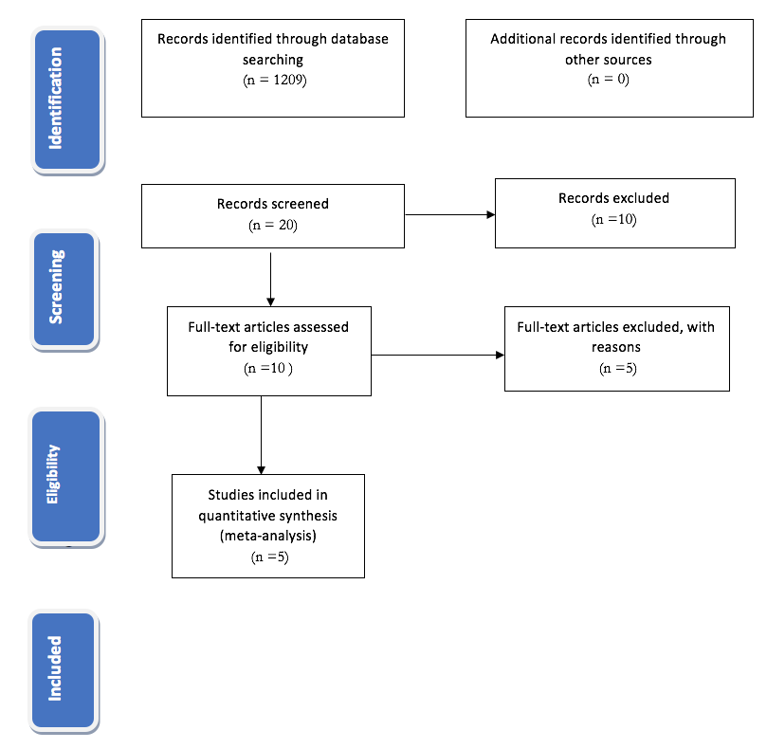

Conclusion
In the hindsight, it is quite important to make sure that first the roles and the responsibilities of the each of the stakeholder that is involved in the healthcare delivery process is being recognized. Once that recognition is being made, it goes a long way towards making sure that the implementation of the policy is done in the right manner. Governments often create policies that rely on implementation by arms length organizations and require practice changes on the part of different segments of the health care system without understanding the differences in and complexities of these agencies. In 2000, in response to publicity about the shortening length of postpartum hospital stay, the Ontario government created a universal program offering up to a 60-hour postpartum stay and a public health follow-up to mothers and newborn infants. The organizational, professional, and social contexts into which a policy is introduced may block or facilitate practice change.

References

Brownson, R. C., Colditz, G. A., & Proctor, E. K. (Eds.). (2018). Dissemination and implementation research in health: translating science to practice. Oxford University Press.
Eccles, M. P., & Mittman, B. S. (2016). Welcome to implementation science.
Härter, M., van der Weijden, T., & Elwyn, G. (2017). Policy and practice developments in the implementation of shared decision making: an international perspective. Zeitschrift für Evidenz, Fortbildung und Qualität im Gesundheitswesen, 105(4), 229-233.

