Top Reasons to work at  W&A Engineering  The company provides incentives and longevity rewards to the new hires.  The company offers numerous benefits, perks and rewards.  These benefits include Comprehensive Health and Dental Insurance, Time Flexibility and Paid Holidays, Family and Medical Leave Benefits, Progressive Maternity Leaves, and On-boarding and Mentoring Programs. |  |  | ABOUT US:  Founded in 1999, W&A Engineering (previously Williams & Associates) is a growing multidisciplinary firm with offices in Athens, GA, and Nashville, TN. W&A has project experience in over 45 states and provides on-call economic development services in more than 35 communities. W&A Engineering has six core departments: Civil Engineering, Land Surveying, Landscape Architecture, Traffic Engineering, Economic Development, and Soil & Environmental Consulting.  NOW HIRING!  W&A Engineering is looking for enthusiastic Civil Engineers to help tackle our growing list of public and private projects. Our ideal applicant has experience completing projects in manifold divisions, amazing communication skills, and a flair for identifying project issues up-front and applying ingenious solutions.  W&A Engineering is an Equal Opportunity Employer proposing competitive recompense in consort with an outstanding and progressive benefits package. |  |  | EMPLOYEE BENEFITS BROCHURE  - W&A Engineering improves communities with innovative design, effective and efficient engineering, and professional service.  - Building Better Communities, One Client at a Time.

Other Benefits  Health/Wellness Program  W&A offers health and wellness programs to allow employees to take care of their health. The company offers an on-site fitness center that also includes yoga classes, and employee assistance program to employees against a minimal fee.  Life Insurance  A life insurance policy covers full-time employees of the company. The company pays for the premiums of benefits of the insurance plan.  Flexible Time Off  Under section 125 of the Internal Revenue Code, the company pays all the administrative costs and allows employees to pay for unreimbursed  Medical and daycare expenses. |  |  | Family Friendly Benefits  At W&A, we allow employees to maintain a balance between family and work responsibilities.  Flexible Time Off  Employees having family obligations are allowed to have a flexible working schedule as long as they fulfill the requirement of total working hours.  Job Sharing  W&A allow employees to share a single position if both employees have family responsibilities and want to hold the position at the same time.  Maternity and Paternity Leaves  Employees are allowed to take maternity and paternity leaves as per the medical condition of the employee and his family members.  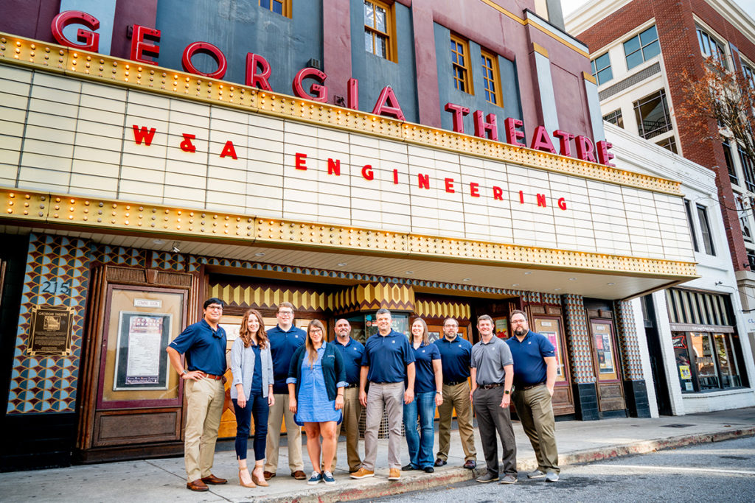 |  |  | Have a Question?  Do not be shy! …  Share all your questions on the email given below.  You are also welcomed to visit!  Contact Us  Williams & Associates  2470 Daniells Bridge Rd bldg 100 suite 161, Athens, GA 30606  Careers@WAengineering.com  Visit us on the Web:  https://www.waengineering.com/

