TRAINING MANUAL FOR THE FAMILY PET
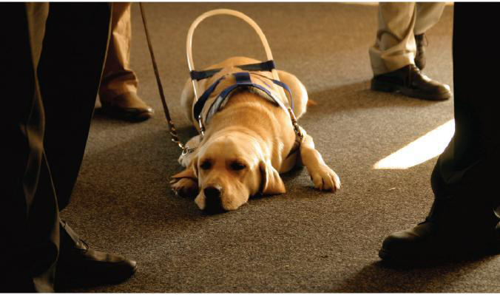

Basic Care for Pets
The possession of a companion animal in our home implies a series of responsibilities related to its care and attention that we must know. Almost all children have dreamed one day or another to work with animals but before moving from dream to reality, we must know the implications of the animal sector: accessible trades, necessary training and mandatory certificates (Wood, & Davidson, 1987). According to psychology, there are three approaches to train the animals such as behavioral therapy, classical conditioning and operant conditioning.
Observational learning
The fundamental principles to which the behavioral theories adhere can be summarized in the following way: to. The behavior is ruled through regulations and subject to ecological variables: persons reply to the variables of their situation (Bandura, 2018).
External services excite to persons to performance in particular means, whether accomplishment a performance or evading it.
From this opinions, the psychologist is measured as an "engineer behavioral ", which manages conservational variables; likewise, as a "researcher", that studies the kind of environmental variables that impact behavior.
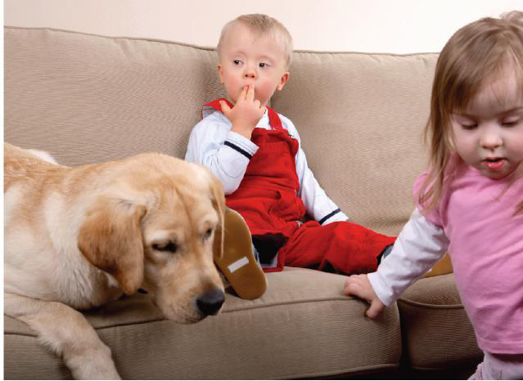
Watson studied fear behaviors in infants and young children, and found that children very small they had almost no fears (for example, rats, cats, etc.), while, advancing age, the number of fears children presented was considerably higher. This author suggested that this was because the children learned these fears of social environment, and not to be instinctive fears, as stated before. In a classic experiment, Watson used conditioning techniques with a small child healthy, Albert B., and managed to show fear of a white rat that previously did not produce no fear Watson presented the rat, which originally did not produce fear, associated with a loud noise. After some trials, the child developed fear of the rat, fear which then generalized to other furry objects.
The psychologist is considered as an "engineer behavioral ", which manages environmental variables; also as a "researcher", that studies the type of environmental variables that affect behavior.
Watson studied fear behaviors in infants and young children, and found that children very small they had almost no fears (for example, rats, cats, etc.), while, advancing age, the number of fears children presented was considerably higher. This author suggested that this was because the children learned these fears of social environment, and not to be instinctive fears, as stated before (Carlisle-Frank, et.al. 2004). In a classic experiment, Watson used conditioning techniques with a small child healthy, Albert B., and managed to show fear of a white rat that previously did not produce no fear Watson presented the rat, which originally did not produce fear, associated with a loud noise. After some trials, the child developed fear of the rat, fear which then generalized to other furry objects.

In this means, Watson presented how Children can change doubts by generalizing a habituated emotional response learned in linking by a single motivation, to other like incentives. By using these similar philosophies, the writer developing a technique to produce the conflicting reply in children, that is, to reduce certain doubts. With his trainings, Watson presented that not all the humanoid "instincts" known until then, were really, but that some of them consisted only in emotional responses learned. So, this author came to suggest that it was possible, through a deliberate and adequate training, change a 'normal' child into any type of person that is desired.
Classical Conditioning
Classical conditioning is a learning process by which the body learns to respond to a stimulus that previously did not respond by association with another stimulus that produced that response. It is easy to create associations that one needs with the dog, because it is very attentive to its environment and in particular its humans, and able to realize many learnings.
Conditioning is more effective if the conditional stimulus (in this case, the ringing of the bell) precedes for a few seconds the unconditional stimulus, namely the presentation of the food. It is very important to master this aspect: synchronicity is essential for the dog to use its associative memory, it is observed that after only a few seconds, the dog no longer makes the link between two events (and especially if we want to link an order and a behavior) (Rehman, & Rehman, 2018).
Here is an example of classic conditioning: a dog appears punctually every day in front of his master at the first strokes of midday while claiming his meal: the sound of the chime represents the neutral stimulus that induces the conditioned reflex, that is to say the request for food The dog then associates this sound with meals; he can also systematically wait for the bowl at the place where it is laid. It only takes a few experiments (one or two) to fix in the dog's mind the situation that made him feel pleasure or even pain and the resulting conditioned response.
Example of the Pavlov dogs
Pavlov was the one who discovered the classic conditioning process in a study with dogs. When a hungry dog is fed, it begins to secrete a flow of saliva from certain glands. This is what we call salivation reflex. We can say that food is an unconditioned stimulus that provokes an unconditioned response of salivation.
Unconditioned Stimulus (EI): We refer to a stimulus that by nature provokes a certain response that does not need to have been learned previously.
Unconditioned response (RI): We refer to the response that the unconditioned stimulus evokes.
(Ejm: EI - RI-salivary food / EI-Alcohol in blood RI- Embarrassment / EI-death of a loved one-RI-Sadness).
But this is not all. Pavlov noticed that the dogs were also salivating when the food had not yet reached their mouths: simply seeing the food or smelling it made the same salivating response as having food in the mouth. This led him to develop a series of experiments in which he discovered how there were associations between different stimuli and responses, getting a bell to elicit the same salivation response as food (Eelen, 2018).. How did he do this? Very easy! During repeated times he played the bell (neutral stimulus) just before presenting the food (unconditioned stimulus) to the dogs so that he managed to associate the sound of the bell with the food, getting that after several days repeating this process, the sound of the bell without the need to present food later, will cause the same salivation reflex as food. The neutral stimulus initially assumed by the bell becomes a conditioned stimulus. This conditioned stimulus causes a conditioned response of salivation.
Conditioned stimulus (EC): previously neutral stimulus, which acquires the property of provoking a certain response when associated with another stimulus that already provoked that response (McLeod, 2007).
Conditioned response (CR): Response learned in front of a stimulus that before the process of association with another did not provoke it.
You're probably thinking and this could affect me?
Examples applied to real life:
• Ej1: A child sees scary movies in his room. Associate the room with the movies and the simple fact of entering your room causes fear
• Ej2: Someone who has recurring nightmares and takes fear of sleep or bed for association with these nightmares.
• Ej3: Someone who has just received bad news is very overwhelmed and gets into the subway. An association can be established between the state of overwhelm produced by the news and the subway, causing the next time that person goes to the subway to be overwhelmed.
• Ex4: A person who stays locked in a small elevator and full of people for hours and from there is unable to get back into an elevator.
• Ej5: A couple that is known when a romantic song plays in the background.
• Ex6: A person sticks a bite to cherries and they are indigestion, from there every time he thinks of cherries his stomach churns. We must take into account the individual differences in this process. Some people have more facility to associate certain stimuli than others. Just as some people need many trials (repeats of EI and EN (neutral stimulus) together to condition)), others with a single trial can establish an association. The level of activation of the moment also influences a lot, when we are emotionally activated it is easier to establish associations than when we are not.
Operant conditioning
The operant conditioning is a learning process by which we associate certain behaviors (we call these behaviors operant responses and operating with medium) with the consequences that follow. Behavior in its broadest sense, including thoughts as well. I include thoughts within the definition of behavior, since a thought is not more than what I say to myself, therefore it is a behavior that can be worked on and modified just like any other.
It is more likely that a behavior will be repeated if positive consequences follow (Reinforcement of behavior) and is more unlikely to be repeated if negative consequences follow (punishment of behavior). It is important that these consequences are contingent on the response so that they influence it, that is to say that they occur immediately afterwards. However, not all positive consequences act as reinforcement, nor all negative as punishment. A reinforcement or punishment by definition are events that increase or decrease the probability that a certain behavior will occur (Iversen, 1992). Therefore, if a positive event does not increase the likelihood of that behavior, it is not acting as a reinforcement, and if a negative event does not decrease the likelihood that a behavior will occur, it is also not acting as punishment.
It is also important to know that the short-term consequences weigh much more on our way of behaving than the long-term consequences. That is why it is so difficult to follow a diet, because if you eat a bun the immediate consequence will be rewarding however in the long term you will not achieve your goal of losing weight (If immediately to eat a bun we gained a few grams, few people would eat buns). In situations with very delayed reinforcements over time it is important to have a lot of self-control and remind ourselves (bringing reinforcement to the present) what we will achieve if we follow certain steps.
• Positive reinforcement: Provide something pleasant to increase the likelihood that a behavior will occur. (Give a bauble or a compliment to a child after doing homework)
• Negative reinforcement: Remove something unpleasant to increase the likelihood that a behavior will occur. (If doing homework, the child gets rid of setting the table, assuming he does not like to set the table)
• Positive punishment: Provide something negative to decrease the likelihood that a behavior will occur (Slap the child when he misbehaves)
• Negative punishment: Remove something positive to decrease the likelihood that a behavior will occur. (Take the child's pay when he misbehaves)
• Discriminative stimulus: Encouragement in which a behavior is more likely to be reinforced (The child asks for things from the parents in front of the family because it is more likely that they get them in that situation).

References
Bandura, A. (2018). Toward a psychology of human agency: Pathways and reflections. Perspectives on Psychological Science, 13(2), 130-136.
Carlisle-Frank, P., Frank, J. M., & Nielsen, L. (2004). Selective battering of the family pet. Anthrozoös, 17(1), 26-42.
Eelen, P. (2018). Classical conditioning: Classical yet modern. Psychologica Belgica, 58(1), 196.
Iversen, I. H. (1992). Skinner's early research: From reflexology to operant conditioning. American Psychologist, 47(11), 1318.
McLeod, S. (2007). Skinner-operant conditioning. Simply Psychology, 1(1), 2.
Rehman, I., & Rehman, C. I. (2018). Classical Conditioning. In StatPearls [Internet]. StatPearls Publishing.
Wood, C. D., & Davidson, J. A. (1987). PET: An outcome study. Australian Journal of Sex, Marriage and Family, 8(3), 134-141.

