Running Head: FINANCIAL ANALYSIS

Financial Analysis
[Enter your name here]
[Enter name of institution here]

Financial Analysis

Answer 1
Standard deviation of returns
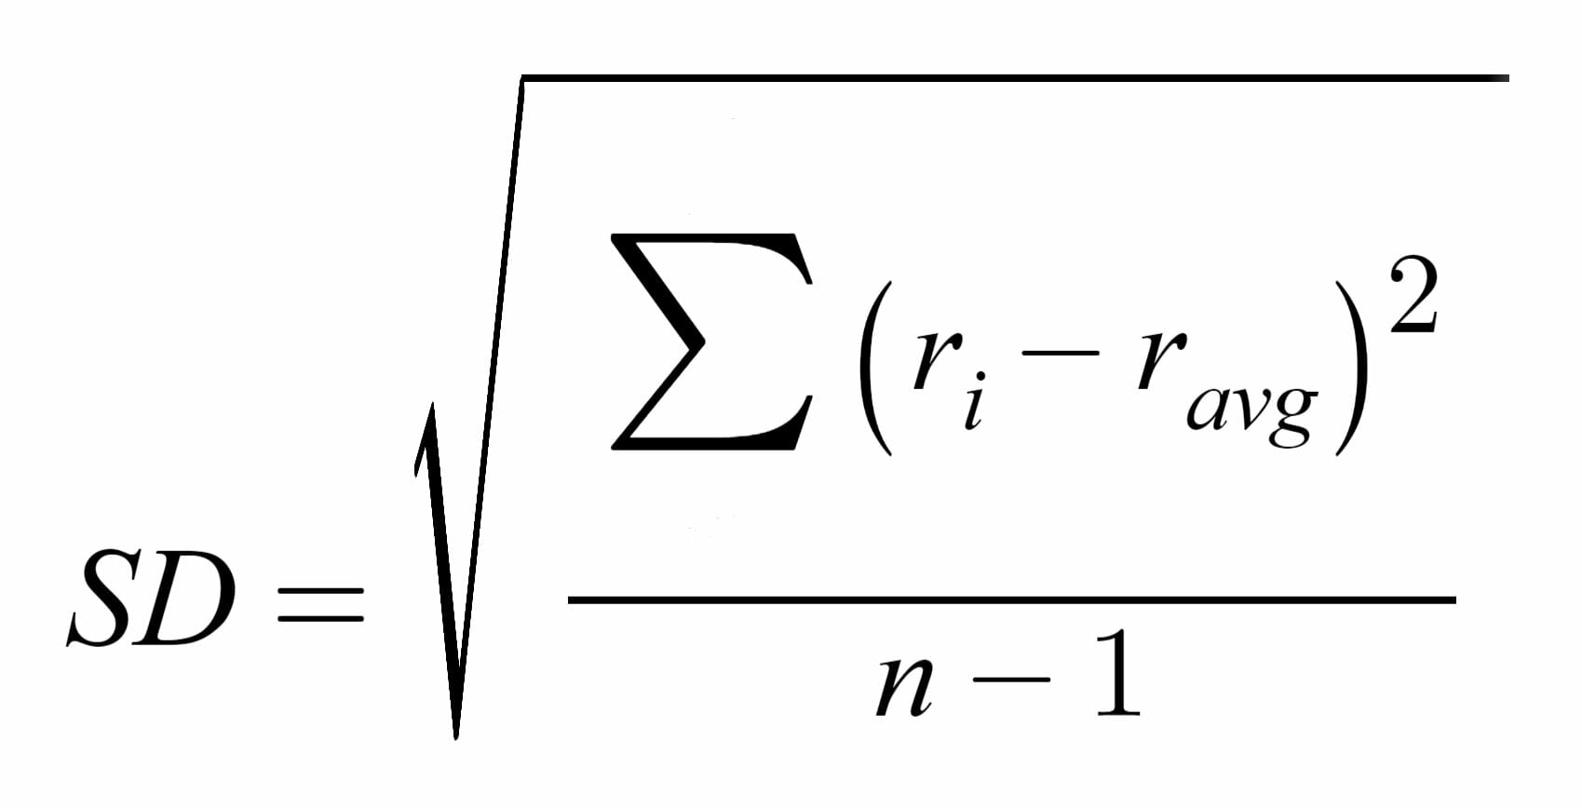
The above formula will be used to calculate standard deviation of returns for the company. Average return is 7.5% and annual returns are given. The value of n will be 4 as there are 4 values given in the analysis.
= √ (-4-7.5) ^2+ (7-7.5) ^2+ (14-7.5) ^2+ (24-7.5) ^2
3
= √447/3
= √149
=12.20
This figure shows that the given company is much riskier than the average market and it will have to provide higher returns to attract investors. It I not a good idea to invest in this company.
The CAPM calculates the return for any given security from the following formula:
R = Rf +β (Rm – Rf)
Risk free rate is 3%, market average rate is 7.5% and beta is 1.1, putting these values in the above formula, we get a value of 8.5% which is higher than the average market return. Using CAPM is a powerful tool to be used in financial investment analysis, because it is based on the concept of diversification. The idea of diversification is considered important by financial markets. If people hold efficient portfolios, they will all add up to an efficient market portfolio (Smith & Walsh, 2013). Diversification is achieved by selecting less risky and more risky assets in a portfolio so that it is balanced. There is no guidance in the CAPM on how to price assets to be included in efficient portfolios. The empirical implication of CAPM can be judged by comparing to the market portfolio which is the only efficient portfolio available. The factors like size or market to book will communicate the same thing over and over again in case of CAPM. Geographical indices such as standard and poor will not suffice the need for a proxy and a global more representative index may have to be developed.
Answer 2
WACC
Cost of equity* percentage of equity + Cost of Debt * percentage of debt (1- tax rate) + Cost of preferred stock * percentage of preferred stock
Cost of Equity = D1/P0 + g
= 0.1957/1.88 + 0.03
= 0.1340
Cost of Preferred stock = D/ P
= 1.2/11.45
= 0.105
Cost of debt 0.05, putting values
= 66.67% * 0.1340+0.05*26.67%*0.7 + 0.1045*6.67%
= 0.0893+0.00933+0.00697
= 10.56%
Since weighted average cost of capital is less than the required rate of return by the investors, they will not be willing to invest in this company. Dividends are the cash payments made to shareholders both preferred as well as common stockholders. Dividend discount models help to ascertain the cost of preferred stock as well as common stock. The discount model factor is used to calculate the costs of both preferred and common stocks. The dividend discount model is very sensitive to the relationship between growth rate of dividends and required rate of return. There is an increase in valuation error when there is less gap between cost of stock and growth rate of dividends. The managers should know that there is no exact price for the stock rather the model gives a range within which share price may fall (Payne & Finch, 1999).
Answer 3
For project 1 NPV = ∑ CF/ (1+i) ^n
Putting values, we get
13000000/1.12+13000000/1.12^2 +13000000/1.12^ 3+ 13000000/1.12^ 4+13000000/1.12^ 5+ 13000000/1.12^6 + 13000000/1.12^7
Solving the expressions, we get the net present value as
$ 59328835-55000000
= $ 4328835
For second option, the NPV will be:
∑ CF/ (1+i) ^n
In this case cash flow is $ 11000000 and number of years are 11 which brings us to the following table.
11000000 | 1.12 | 9821429
11000000 | 1.2544 | 8769133
11000000 | 1.404928 | 7829583
11000000 | 1.573519 | 6990699
11000000 | 1.762342 | 6241695
11000000 | 1.973823 | 5572942
11000000 | 2.210681 | 4975841
11000000 | 2.475963 | 4442716
11000000 | 2.773079 | 3966710
11000000 | 3.105848 | 3541706
11000000 | 3.47855 | 3162237
65314690 | Initial | NPV
 | 60000000 | 5314690
In the above table, 11 million is the cash flow expected and $ 60000000 is the initial cash outflow. The NPV is the difference between sum of discounted cash flows and initial cash outflow. The net present values for both these projects are positive but there is more value in the second project so company should choose it as first choice. If these projects are not mutually exclusive, company can take up both of them.
The first principle of the NPV discussion is that a risky dollar tomorrow is less valuable as compared to a certain dollar today so future cash flows are discounted each year. Discount rate is the opportunity of capital employed in a certain project which is directly proportional to the estimated riskiness of project. Riskier projects are supposed to provide higher returns which make them more risk adjusted as against other approaches. Discount rate is settled by calculating the original cost of capital as calculated by the weighted average cost of capital including both equity and debt. All the future net cash flows are considered while studying the net present value approach whereas methods like pay-back period only consider initial investment. This approach associates a cash value with opportunity rather than with any arbitrary rate or time period. Risk is also considered while setting up the discount rate for any project and riskier projects have higher discount rates. The limitation of this approach is that discount rate calculation is not done in an appropriate way. The managers are not able to evaluate the exact cash flows for certain projects which does not enable them to calculate NPV correctly (Zizlavsky, 2014).

References
Payne, T. H. & Finch, J., 1999. Effective teaching and use of the constant growth dividend discount model. Financial Services Review, 8(4), pp. 283-291.
Smith, T. & Walsh, K., 2013. Why the CAPM is Half-Right and Everything Else is Wrong. ABACUS, Volume 49, pp. 73-78.
Zizlavsky, O., 2014. Net Present Value Approach: Method for Economic Assessment of Innovation Projects. Procedia- Social and Behavioral Sciences, Volume 156, pp. 23-25.

