Essentials of Systems Design
[Name of the Writer]
[Name of the Institution]

Essentials of Systems Design

Q 1.Draw a network diagram that summarizes the systems described above; devices used by administrators, staff, instructors, and students; and the network connections among them. Assume that the current survey system will be replaced by a new Web-based system. Assume further that each existing CSU system is hosted on its own server.
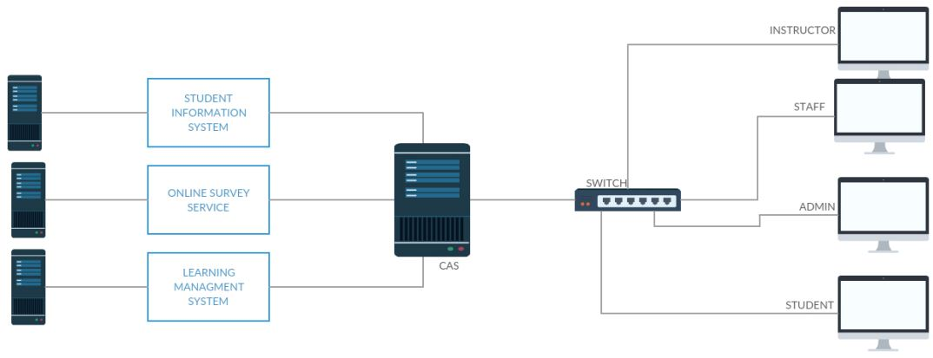
Since analyzing, designing, and implementing a new system require special efforts. When it comes to integrating a new component within a pre-existing system, it demands even more deft handling (Satzinger, Jackson & Burd, 2016). Identifying all the entities that interact with each other, through what devices do they interact with each other. How the flow of data takes place and how entities and devices share resources with each other are some of the initial requirements for analyzing the system under consideration (Okano, Iizawa & Morimoto, 2016).
.
Cooper State University (CSU) has decided to move on from an outdated and redundant practice to a modern one-web based system. The new Online Survey System is designed to perform the task that consumed precious resources of Cooper State University (CSU).
How the system designed would work is elaborated below.
- The users are staff, admin, student, and instructors
- They each would interact with different components of the system based on their needs
- These users are connected to a switch which directs requests to a particular component in a network
- For example, if a student wants to view his grades. He only needs to open the result tab in the software screen. But in the background, a switch will direct the request to the Student Information System
- Similarly, if an instructor needs to update available courses, he only needs to interact with the front end of the software. He does not have to be worried about his request not reaching its intending destination
- After the request is directed by the switch, before reaching its destination, the credentials need to be authenticated. That purpose is fulfilled by the Central Authentication Server (CAS)
- Central Authentication Server (CAS), once verifying the credentials, lets the request reach its destination
- The request has now reached its destination
- Now the response is generated.
- For instance, the student wanted to view his grades. The request is processed and the marks from the Student Information System are fetched and routed towards the user. That is a student in this case.
- Student Information System, Online Survey System, and Learning Management system have their own servers.

Q 2. Which systems need access to current data regarding course sections, their assigned instructors, and registered students? Select a system to be the system of record for that data and justify your decision. Draw a diagram similar to Figure 7-21 to summarize all required synchronizations.
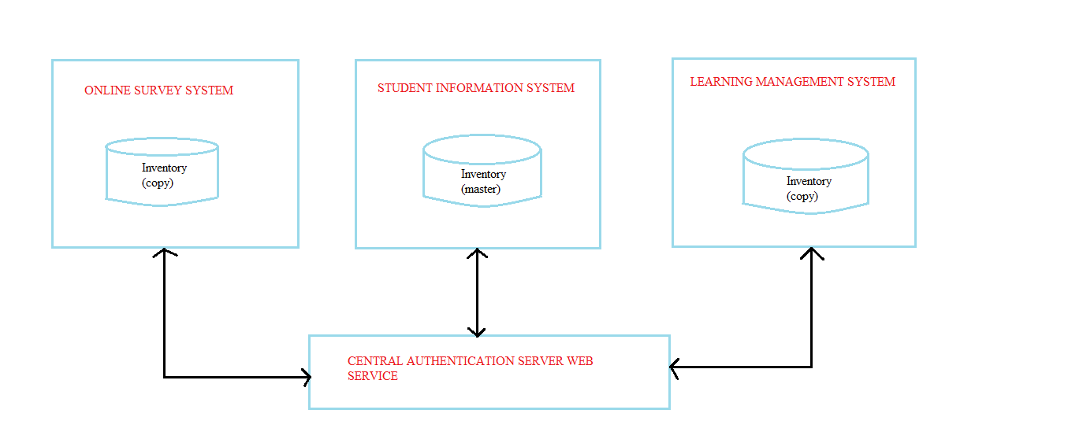
Once the network diagram of the system is completed, the system can be developed and deployed. But unless it integrates clear data flow routes between different interacting components, the system is unlikely to yield desired results. All the components of the system must be in sync and reciprocate the change that occurred in one component.
Cooper State University's system is in place now. Consider a scenario when a student registers with the system for the first time. All the necessary information about the student is stored in the database of the Student Information System. All other components will use the basic information of the student from now on. So now the student has been registered.
Consider another instance, when a course instructor has to make available a course for students that had failed it earlier. All the necessary information of students having a ‘fail’ status attributed against them will be shown to the instructor.
Hence, the decision to make the Student Information System as the system for the record is further cemented.
Coming back to the diagram once again, there is Central Authentication Server web service in place. The web service is the gateway to all the components of the system (Lemos, Daniel & Benatallah, 2016). The Central Authentication Server web service is invoked every time when the user wants to manipulate the data. Be it a student trying to view his grades, or registering a new course. Or completing the all-important survey form towards the end of the semester. Or an instructor wanting to make available a new course that has been offered. Central Authentication Server web service will be invoked. The web service is the pivot in the smooth operation of the data flow in the system among components.

References

Satzinger, J. W., Jackson, R. B., & Burd, S. D. (2016). Systems analysis and design in a changing world.
Okano, Y., Iizawa, Y., & Morimoto, M. (2016). U.S. Patent Application No. 15/035,531.
Lemos, A. L., Daniel, F., & Benatallah, B. (2016). Web service composition: a survey of techniques and tools. ACM Computing Surveys (CSUR), 48(3), 33..

