Sun Coast Remediation Final Project
Rosa M Jones
Columbia Southern University

Table of Contents
Executive Summary 3
Introduction 4
Statement of the Problems 4
Particulate Matter (PM) 4
Safety Training Effectiveness 5
Sound-Level Exposure 5
New Employee Training 5
Lead Exposure 6
Return on Investment 6
Literature Review 6
Research Objectives 8
Research Questions and Hypotheses 9
Research Methodology, Design, and Methods 11
Research Methodology 11
Research Design 11
Research Methods 12
Data Collection Methods 12
Sampling Design 12
Data Analysis Procedures 12
Correlation 12
Regression 13
ANOVA 13
The Sample t-Test 13
Data Analysis: Descriptive Statistics and Assumption Testing 13
Correlation: Descriptive Statistics and Assumption Testing 14
Frequency distribution table. 14
Histogram. 14
Descriptive statistics table. 15
Measurement scale. 15
The measure of central tendency. 15
Evaluation. 15
Simple Regression: Descriptive Statistics and Assumption Testing 16
Frequency distribution table. 16
Histogram. 16
Descriptive statistics table. 17
Measurement scale. 17
The measure of central tendency. 17
Evaluation. 17
Multiple Regression: Descriptive Statistics and Assumption Testing 18
Frequency distribution table. 18
Histogram. 18
Descriptive statistics table. 19
Measurement scale. 19
The measure of central tendency. 19
Evaluation. 19
Independent Samples t-Test: Descriptive Statistics and Assumption Testing 20
Frequency distribution table. 20
Histogram. 21
Descriptive statistics table. 22
Measurement scale. 23
The measure of central tendency. 23
Evaluation. 23
Dependent Samples (Paired-Samples) t-Test: Descriptive Statistics and Assumption Testing 23
Frequency distribution table. 23
Histogram. 24
Descriptive statistics table. 25
Measurement scale. 26
The measure of central tendency. 26
Evaluation. 26
ANOVA: Descriptive Statistics and Assumption Testing 26
Frequency distribution table. 26
Histogram. 28
Descriptive statistics table. 30
Measurement scale. 32
The measure of central tendency. 32
Evaluation. 32
Data Analysis: Hypothesis Testing 32
Correlation: Hypothesis Testing 33
Simple Regression: Hypothesis Testing 35
Multiple Regression: Hypothesis Testing 37
Independent Samples t-Test: Hypothesis Testing 40
Dependent Samples (Paired Samples) t-Test: Hypothesis Testing 41
ANOVA: Hypothesis Testing 43
Findings 44
Recommendations 46
References 48

Executive Summary
The Sun Coast Company is a well-known business name that focuses on offering corporate and government organizations remediation services. The working of this organization can mainly be observed in sites where different toxic substances are eradicated from the elements of soil and water. Currently, the leadership of the organization identifies six main issues that require necessary and immediate fixation. These specific problems are identified in the forms of particulate matter, safety training effectiveness, sound-level exposure, new employee training, lead exposure, and return of investment. A comprehensive approach of research is used by considering different techniques of assessment and data collection in the case of employees of the organization. Both domains of descriptive and applied research work applied to find out the intensity of existing issues. Quantitative research design is selected by the researcher to conduct the approach of hypothesis testing analysis successfully. The finding of research methods indicates that there is a need to offer a better safety environment for all the workers.
Sun Coast Remediation Final Project

Introduction
Senior leadership at Sun Coast has identified several areas for concern that they believe could be solved using business research methods. The previous director was tasked with conducting research to help provide information to make decisions about these issues. Although data were collected, the project was never completed. Senior leadership is interested in seeing the project through to fruition. The following is the completion of that project. It includes the statement of the problems, literature review, research objectives, research questions and hypotheses, research methodology, design, and methods, data analysis, findings, and recommendations.

Statement of the Problems
Six business problems were identified:

Particulate Matter (PM)
There is a concern that job-site particle pollution is adversely impacting employee health. Although respirators are required in certain environments, PM varies in size depending on the project and job site. PM that is between 10 and 2.5 microns can float in the air for minutes to hours (e.g., asbestos, mold spores, pollen, cement dust, fly ash), while PM that is less than 2.5 microns can float in the air for hours to weeks (e.g., bacteria, viruses, oil smoke, smog, soot). Due to the smaller size of a PM that is less than 2.5 microns, it is potentially more harmful than PM that is between 10 and 2.5 since the conditions are more suitable for inhalation. A PM that is less than 2.5 is also able to be inhaled into the deeper regions of the lungs, potentially causing more deleterious health effects. It would be helpful to understand if there is a relationship between PM size and employee health. PM air quality data have been collected from 103 job sites, which is recorded in microns. Data are also available for average annual sick days per employee per job-site.

Safety Training Effectiveness
Health and safety training is conducted for each new contract that is awarded to Sun Coast. Data for training expenditures and lost-time hours were collected from 223 contracts. It would be valuable to know if training has been successful in reducing lost-time hours and, if so, how to predict lost-time hours from training expenditures.

Sound-Level Exposure
Sun Coast’s contracts generally involve work in noisy environments due to a variety of heavy equipment being used for both remediation and the clients’ ongoing operations on the job sites. Standard ear-plugs are adequate to protect employee hearing if the decibel levels are less than 120 decibels (dB). For environments with noise levels exceeding 120 dB, more advanced and expensive hearing protection is required, such as earmuffs. Historical data have been collected from 1,503 contracts for several variables that are believed to contribute to excessive dB levels. It would be important if these data could be used to predict the dB levels of work environments before placing employees on-site for future contracts. This would help the safety department plan for the procurement of appropriate ear protection for employees.

New Employee Training
All new Sun Coast employees participate in general health and safety training. The training program was revamped and implemented six months ago. Upon completion of the training programs, the employees are tested on their knowledge. Test data are available for two groups: Group A employees who participated in the prior training program and Group B employees who participated in the revised training program. It is necessary to know if the revised training program is more effective than the prior training program.

Lead Exposure
Employees working on job sites to remediate lead must be monitored. Lead levels in the blood are measured as micrograms of lead per deciliter of blood (μg/dL). A baseline blood test is taken pre-exposure and post exposure after remediation. Data are available for 49 employees who recently concluded a 2-year lead remediation project. It is necessary to determine if blood lead levels have increased.

Return on Investment
Sun Coast offers four lines of service to its customers, including air monitoring, soil remediation, water reclamation, and health and safety training. Sun Coast would like to know if each line of service offers the same return on investment. Return on investment data is available for air monitoring, soil remediation, water reclamation, and health and safety training projects. If the return on investment is not the same for all lines of service, it would be helpful to know where differences exist.

Literature Review
A literature review is characterized as an important section of the overall research project that helps to explore the existing connection between different factors. This segment is comprised of a detailed summary of the previous research work on the issue and identifies the correct research direction. Scholarly articles, books, and other scholarly resources are used to establish the theoretical foundation of the research work for the Sun Coast.
The importance of research methodologies increases to multiple folds in case of quantitative research, where various statistical tools and methods are used to come upon findings that are needed to test the hypothesis. These tests and tools include T-test, regression, correlation, ANOVA, and several other methods to find a relation between the independent and dependent variables.
While reading the Occupational Exposure to Diesel Particulate Matter in the Municipal, Household Waste Workers, it reads that 72 MHW from different companies to conduct a study. This study was to determine the levels of diesel particulate that the workers were exposed to. These workers were exposed to carbon (electrical, organic, and black) and fine particulate, which was used as indicators to identify the levels of exposure. The test will be determined how fast and/or the time of the exposure to examine the risk for the workers.
While reading several articles, it seems as though the most important thing for these companies would be training and on-going training. When you deal with toxic material daily, you must make sure that you are aware of all the risk old and new so you can protect not only you and the company but the workers as well. Knowing all the risks will help you educate everyone on the types of jobs and the precautions that they need to make sure they stay on top of.
You have companies that will use simple household items, such as rice, that contains certain levels of toxins to test amongst families to see how much its toxins will affect them. These tests or the research can take six months or longer to get verifiable data. At this point, you have companies that will test something with higher levels. All the data is used to educate people. Dealing with toxic materials on a worksite can be compared to the foods we eat or the chemicals we use in the homes daily. So, I am adamant when it comes to researching your company, your work, and even the food you eat.
Occupational noise exposure is one of the main risk factors that affect the health and sleeping pattern of workers. For example, Textile machines produce a high level of noise that can cause adverse health effects in workers. Data that was captured and examined b Mann-Whitney test and Kruskal-Wallis test, simple linear regression, and multiple regression tests with the results being geared to sound level, experience, and age. The results showed that the higher the age and the length of time at work experience a higher rate of sleep disturbance. When it comes to toxins, you have to remember that it can come from many shapes and sizes. You can be affected by chemical and noise and have similar results.
There is also another article that discusses the emergency fueling option of the company the “Sun Coast expands the emergency fueling program.” It discusses the past fueling options of the company and the changes to its new program. Sun Coast's POWER Program is a priority generator fueling service that provides contract customers with fuel sampling and treatment, plus an inspection of any of the equipment that has been standing still to provide some sort of relief when it comes to exposure.
Overall, research takes time, collecting data takes time and money. When data is collected correctly, you will get results that will benefit everyone and not harm them in the long-run.

Research Objectives
Appropriate development of research objectives for the research project is important to establish the necessary frame of action effectively and efficiently. Research objectives are recognized as concise statements to define what the researcher wants to achieve through the comprehensive process of research (Ngulube, 2019). In simple words, research objectives are essential to illustrate the overall direction of the research. The objectives of the research project clearly defined the main aim of the entire research procedure.
RO₁: To determine the association between a Particular Matter (PM) size and overall employee health.
RO₂: To examine the effectiveness of training in case of reducing lost-time hours, and, if this is true, how to anticipate lost-time hours from the approach of the training cost.
RO₃: To analyze if the perspective of data collected could be considered to predict the decibel (dB) levels of conditions before enlisting employees on site.
RO₄: To observe that if the new training program is more beneficial as compare to the previous training program.
RO₅: To critically investigate if blood levels have increased.
RO₆: To assess if any form of differences prevails on return-of-investment in case of all lines of service.

Research Questions and Hypotheses
The crafting of research questions is one initial step of the research project that is characterized in the form of answerable inquiry concerning the overall idea of research. This research approach is considered in case of a research project for the Sun Coast Remediation Organization to find out better solutions to the organizational problems (Banerjee, Chitnis, Jadhav, Bhawalkar, & Chaudhury, 2009). Moreover, the development of null and alternative hypotheses is a critical practical measure to determine the overall significance between two variables. It is crucial to explain the authenticity of the research objectives.
RQ₁: What are the association between a particulate matter (PM) size and overall employee health?
H0₁: There is no statistically significant association exist between particulate matter (PM) size and overall employee health.
HA₁: There is a statistically significant association exists between a particulate matter (PM) size and overall employee health.
RQ₂: How training is effective in case of reducing lost-time hours?
H0₂: There is no statistically significant prove that training is effective in case of reducing lost-time hours.
HA₂: There is statistically significant prove that training is effective in case of reducing lost-time hours.

RQ₃: How the perspective of data collected could be considered to predict the decibel (dB) levels of conditions before enlisting employees on-site?
H0₃: There is no statistically significant evidence that data collected could be considered to predict the decibel (dB) levels of conditions before enlisting employees on site.
HA₃: There is statistically significant evidence that data collected could be considered to predict the decibel (dB) levels of conditions before enlisting employees on site.

RQ₄: How the new training program is more beneficial as compared to the previous training program?
H0₄: There is no statistically significant evidence that the new training program is more beneficial as compared to the previous training program.
HA₄: There is statistically significant evidence that the new training program is more beneficial as compared to the previous training program.

RQ₅: Is the approach of blood levels have increased?
H0₅: There is no statistically significant evidence that blood levels have increased.
HA₅: There is statistically significant evidence that blood levels have increased.

RQ₆: Are there any differences prevail on return-of-investment in the case of all lines of service?
H0₆: There is no statistically significant evidence that any differences prevail on return-of-investment in the case of all lines of service.
HA₆: There is statistically significant evidence that any differences prevail on return-of-investment in case of all lines of service.

Research Methodology, Design, and Methods
The research methodology is a generalized categorical approach that is utilized in research. The basic methods used include mixed methods, qualitative and quantitative. The approaches are rooted in varied philosophical traditions (Farrugia et al., 2010). One research approach is dependent on one's philosophical worldview.

Research Methodology
The chosen methodology for this research is the quantitative research methodology. This is high because the approach that will be used throughout the study is based on the positivist tradition. The latter is my philosophical worldview; hence, it shall be suitable while carrying out the Son Coast research.

Research Design
The research design for the study involves detailed methods that lookout for certain from the participants. The most suitable research design applied will be descriptive (non-experimental), which will help in differentiating different variables being studied in the research.

Research Methods
The research methods used based on research questions, research methodology, and the research design is descriptive statistics. The statistics help in identifying a correlation between the variables given in the case study.

Data Collection Methods
Before this research was proposed, there were specific records that had been collected by the previous health and safety director. This documentation will be used to test the research hypotheses.

Sampling Design
Depending on the documentation used, it is evident that convenience sampling was used. The targeted participants must meet the criterion and should be available for participation. The chosen participants are workers in the Sun Coast firm. The 321 participants will represent the whole company’s population.

Data Analysis Procedures
The hypotheses of the study help in dictating the most suitable data analysis design. The hypotheses chosen for the research helped in predicting variables’ relationships. The best statistical procedures utilized in testing hypotheses for the research included;

Correlation
This analysis procedure is utilized in testing the null hypothesis to illustrate that there is no existent relationship between the research variables. The chi-square correlation test was used in testing whether there is a relationship between particulate matter and the health of employees. The test results will illustrate whether high levels of pollution in the particulate matter are linked to the high number of leaves reported from employees in varied sites.

Regression
The data analysis tool not only helps in determining the variables' relationship but also in specifying the percentage of the relationship between the two. The regression analysis will help in testing how the lost time hours variable is correlated with safety training. Safety training was measured based on the money utilized in safety training (Nardi, 2018). Utilizing the firm's data set, the training program's effectiveness will be evaluated through Toolpak, which is a data analysis technique.

ANOVA
This one-way test will be sued in determining differences between two different sets of groups in the Sun Coast Company. The test has similarities with the t-test and will be used in testing the null hypothesis to prove no differences exist between two or more groups. The dependent variable will be the return of investment, which will be tested based on four factors amongst employees. One of them being training.

The Sample t-Test
This test will be utilized in testing the null hypothesis illustrating that there are no differences between two different group samples. Results attained will help in improvement in a variable such as safety training.

Data Analysis: Descriptive Statistics and Assumption Testing
Sun coast remediation provides remediation services to business and governmental organizations. This paper will provide a detailed descriptive analysis of the data given that will be crucial for data-driven decisions to be taken by the company. The assumptions for parametric techniques will also be tested in the course of this paper.

Correlation: Descriptive Statistics and Assumption Testing

Frequency distribution table.
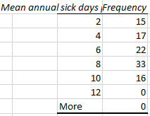

Histogram.
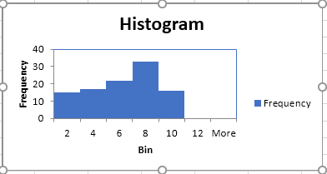

Descriptive statistics table.
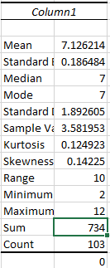

Measurement scale.
Ratio scale is used as a measurement scale here, as the

The measure of central tendency.
The mean of the average number of days an employee remains sick in the company is measured at 7.1262. Standard deviation or the average variation per person is at 0.1864. The median and mode, both remain at 7.

Evaluation.
On average, an employee takes approximately seven leaves due to illness as per the given data. On the histogram, we can visualize that the frequency on the 6 to 8 bracket is relatively high. In terms of normality, the curve is slightly skewed towards the left; the kurtosis is close to zero, i.e., distribution is normally distributed. In the given dataset, one can conclude that the assumptions for parametric statistical testing were met.

Simple Regression: Descriptive Statistics and Assumption Testing

Frequency distribution table.
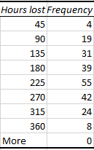

Histogram.
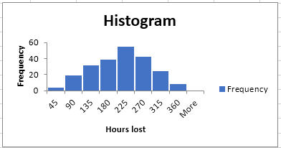

Descriptive statistics table.
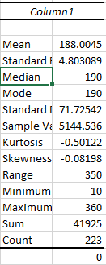

Measurement scale.
Since there is a true zero present here, we can conclude that ratio scales are used as measurement scales in the representation of this data.

The measure of central tendency.
The central tendency of this data is measured by its mean, standard deviation, and skewness. Skewness and standard deviation indicate the direction in which most of the data lies and.

Evaluation.
The data given gives us a normal distribution curve; thus, the data is normally distributed. The assumption regarding the independent variables being linearly correlated does not apply as there is only one independent variable. The variable in the first variable is the contract number.

Multiple Regression: Descriptive Statistics and Assumption Testing

Frequency distribution table.
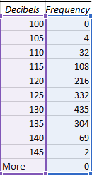

Histogram.
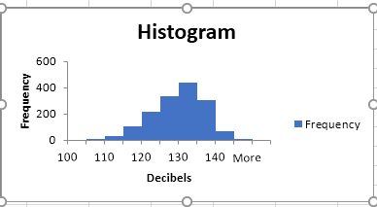

Descriptive statistics table.
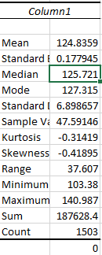

Measurement scale.
The measurement scale used in this data set is known as the ratio scale, as decibels can attain an actual value of zero.

The measure of central tendency.
The mean value of the dependent variable i.e., decibels, is equal to 124.8359, and the standard deviation suggests that most of the values are concentrated near the mean value. The value of kurtosis and the shape of the histogram suggests that the frequency distribution is normal as well.

Evaluation.
The initial assumption of normality is met in the data set, as seen in the histogram curve. The assumption of multi-collinearity and multi-variate normality is also being fulfilled. Thus, we can conclude that the assumptions for parametric statistical testing were met.

Independent Samples t-Test: Descriptive Statistics and Assumption Testing

Frequency distribution table.
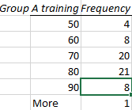
Figure 1-Group A freq. distribution

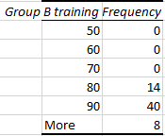
Figure 2-Group B freq. distribution.

Histogram.
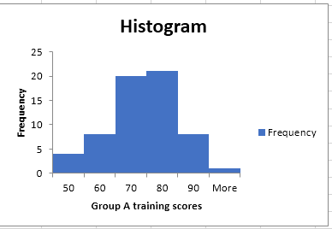
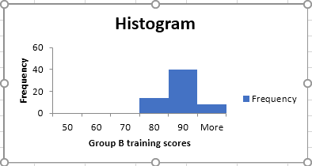

Descriptive statistics table.
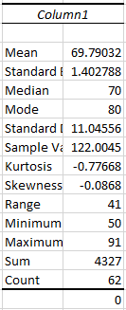
Figure 3-Statistical summary of group A data
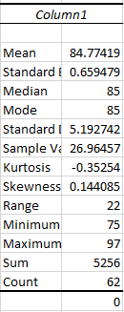
Figure 4-Statistical summary of group-B data

Measurement scale.
The measurement scale used in the representation of this dataset is the ratio scale.

The measure of central tendency.
The central tendency for such a dataset is generally used as a median because it is more robust in tackling the problem of outliers.

Evaluation.
The assumptions of normality of both the variables are met as seen in the histogram and the value of kurtosis for both variables but the assumption of homogeneity of variances is not being met so we can conclude that the assumptions for parametric statistical testing were not met in the given data (Zou, Tuncali, & Silverman, 2003).

Dependent Samples (Paired-Samples) t-Test: Descriptive Statistics and Assumption Testing

Frequency distribution table.
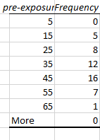
Figure 5-freq distribution table for per-exposure data
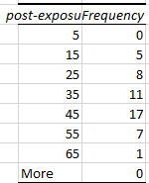
Figure 6-freq. distribution table for post-exposure data

Histogram.
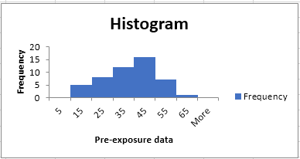
Figure 7-Histogram for pre-exposure data
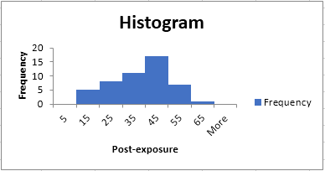
Figure 8-Histogram for post-exposure data

Descriptive statistics table.
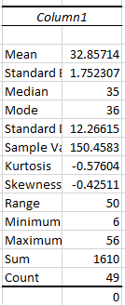
Figure 9-Pre exposure statistics
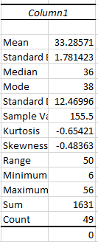
Figure 10-Post exposure statistics

Measurement scale.
The ratio scale is used as a measurement scale in this dataset.

The measure of central tendency.
The most appropriate measure for the central tendency in a sampled t-test is the median, as it is the one which is least affected by outliers.

Evaluation.
The assumption of normality for both the variables is met, as seen in the histogram. In the given data, the assumption that both variables need to be independent of each other is not being met. Therefore, we can conclude that the assumptions for parametric statistical testing are not being met.

ANOVA: Descriptive Statistics and Assumption Testing

Frequency distribution table.
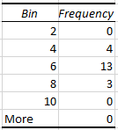
Figure 11-Frequency dist. for D

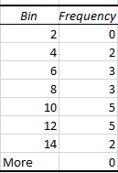
Figure 12-freq. Dist. table for A

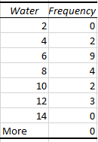
Figure 13-freq. Dist. table for C

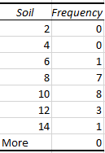
Figure 14- freq. dist. table for B

Histogram.
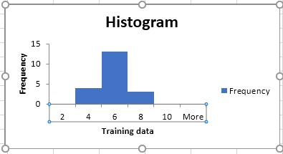
Figure 15-Histogram for D
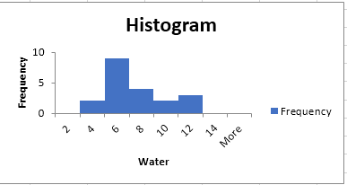
Figure 16- Freq. Dist. table for C

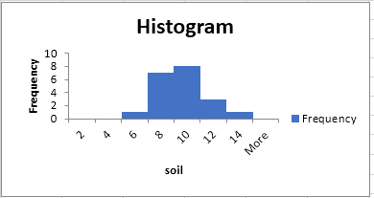
Figure 17-freq. Dist. table for B

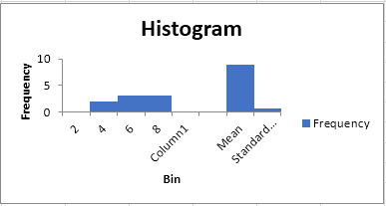
Figure 18-freq. Dist. table for A

Descriptive statistics table.
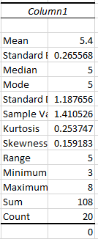
Figure 19-Statistics for D
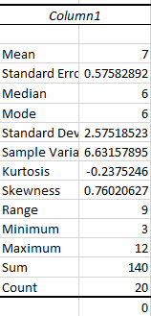
Figure 20-Statistics for C

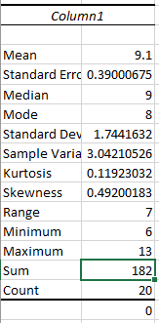
Figure 21-Statistics for B

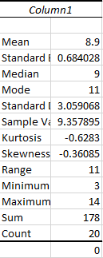
Figure 22-Statistics for C

Measurement scale.
The ratio scale is being used for measurement here.

The measure of central tendency.
Mean is the most appropriate measurement measure of a central tendency here.

Evaluation.
The histogram for the dependent variable is normally distributed. The sample variance for all the given variables is not the same, so we can conclude that the assumptions for parametric statistical testing were not met.

Data Analysis: Hypothesis Testing
In this case study, we are going to use the Sun Coast data remediation data set and conduct a correlation analysis, simple regression analysis, and multiple regression analysis using the correlation tab, simple regression tab, and multiple regression tab, respectively. The statistical output tables should be cut and pasted from Excel directly into the final project document. For the regression hypotheses, display and discuss the predictive regression equations.

Correlation: Hypothesis Testing
 | SUMMARY OUTPUT
 | Regression Statistics
 | Multiple R | 0.601842
 | R Square | 0.362274
 | Adjusted R Square | .360083
 | Standard Error | 5.518566
 | Observations | 1503
 | ANOVA
 |  | df | SS | MS | F | Significance F
 | Regression | 5 | 25891.89 | 5178.378 | 170.0361 | 2.1E-143
 | Residual | 1497 | 45590.49 | 30.45457
 | Total | 1502 | 71482.38
 |  | Coefficients | Standard Error | t Stat | P-value | Lower 95% | Upper 95% | Lower 95.0% | Upper 95.0%
 | Intercept | 76.825 | 0.62382 | 203.2997 | 0 | 125.5988 | 128.0461 | 125.5988 | 128.0461
 | X Variable 1 | -2 | 4.76E-05 | -23.4885 | 4.1E-104 | -0.00121 | -0.00102 | -0.00121 | -0.00102
 | X Variable 2 | 0.047342 | 0.037308 | 1.268957 | 0.204654 | -0.02584 | 0.120524 | -0.02584 | 0.120524
 | X Variable 3 | 5.49532 | 2.927962 | -1.87684 | 0.060734 | -11.2387 | 0.248026 | -11.2387 | 0.248026
 | X Variable 4 | 0.08324 | 0.0093 | 8.950317 | 1.02E-18 | 0.064997 | 0.101482 | 0.064997 | 0.101482
 | X Variable 5 | -24.506 | 16.51903 | -14.5593 | 5.21E-45 | -272.909 | -208.103 | -272.909 | -208.103

The value of r-squared has shown that the independent variables account for 74% of the variation in the dependent variable. The intercept is value of the dependent variable when value of all independent variables has been put to zero. The most potent independent variable is variable five, which has the highest value of the coefficient. The negative sign shows that the increase in variable 5 will increase the dependent variable and vice versa (Nickerson, 2000). The variables that have p-values less than 0.05 will reject the null hypothesis, whereas other variables will have their null hypothesis accepted.

Simple Regression: Hypothesis Testing
Restate the hypotheses:
Ho₂: _{β1 = 0}
Ha₂: _{β1 ≠ 0}
Enter data output results from Excel Toolpak here.
 | SUMMARY OUTPUT
 | Regression Statistics
 | Multiple R | 0.939559
 | R Square | 0.882772
 | Adjusted R Square | 0.882241
 | Standard Error | 161.303
 | Observations | 223
 | ANOVA
 |  | df | SS | MS | F | Significance F
 | Regression | 1 | 43300521 | 43300521 | 1664.211 | 7.7E-105
 | Residual | 221 | 5750122 | 26018.65
 | Total | 222 | 49050644
 |  | Coefficients | Standard Error | t Stat | P-value | Lower 95% | Upper 95% | Lower 95.0% | Upper 95.0%
 | Intercept | 1753.602 | 30.36296 | 57.75465 | 2.6E-135 | 1693.764 | 1813.44 | 1693.764 | 1813.44
 | X Variable 1 | -6.15739 | 0.150936 | -40.7947 | 7.7E-105 | -6.45485 | -5.85994 | -6.45485 | -5.85994
The above table shows that the p-value is less than the significance level of 0.05, which will result in the rejection of the null hypothesis that the coefficients are equal to zero. The ANOVA table also supports this conclusion because the significance level is less than 0.05. The intercept shows the value of the dependent variable when the independent variable is put equal to zero. The value of the coefficient for variable 1 shows that a unit change in this variable will bring a change of 6.15 units in the dependent variable.

Multiple Regression: Hypothesis Testing
Restate the hypotheses:
Ha₃: There is no significant impact of any independent variable on the dependent variable.
Ha₃: There is a significant impact of independent variables on the dependent variable.
Enter data output results from Excel Toolpak here.
 | SUMMARY OUTPUT
 | Regression Statistics
 | Multiple R | 0.601842
 | R Square | 0.362214
 | Adjusted R Square | 0.360083
 | Standard Error | 5.518566
 | Observations | 1503
 | ANOVA
 |  | df | SS | MS | F | Significance F
 | Regression | 5 | 25891.89 | 5178.378 | 170.0361 | 2.1E-143
 | Residual | 1497 | 45590.49 | 30.45457
 | Total | 1502 | 71482.38
 |  | Coefficients | Standard Error | t Stat | P-value | Lower 95% | Upper 95% | Lower 95.0% | Upper 95.0%
 | Intercept | 126.8225 | 0.62382 | 203.2997 | 0 | 125.5988 | 128.0461 | 125.5988 | 128.0461
 | X Variable 1 | -0.00112 | 4.76E-05 | -23.4885 | 4.1E-104 | -0.00121 | -0.00102 | -0.00121 | -0.00102
 | X Variable 2 | 0.047342 | 0.037308 | 1.268957 | 0.204654 | -0.02584 | 0.120524 | -0.02584 | 0.120524
 | X Variable 3 | -5.49532 | 2.927962 | -1.87684 | 0.060734 | -11.2387 | 0.248026 | -11.2387 | 0.248026
 | X Variable 4 | 0.08324 | 0.0093 | 8.950317 | 1.02E-18 | 0.064997 | 0.101482 | 0.064997 | 0.101482
 | X Variable 5 | -240.506 | 16.51903 | -14.5593 | 5.21E-45 | -272.909 | -208.103 | -272.909 | -208.103

The above tables show the output for multiple regression analysis. Some variables have a significant relationship with the dependent variable, whereas some variables have an insignificant contact. The variables 2 and 3 have inappropriate relationships with the dependent variable, and other variables have a significant relationship with it. Thus, we can reject the null hypothesis because it stated that no independent variable would have a substantial connection with the dependent variable.

Independent Samples t-Test: Hypothesis Testing
Ho4: There is no significant difference in mean values for the DV between Group A (Prior Training Scores) and Group B (Revised Training Scores).
Ha4: There is a statistically significant difference in mean values for the DV between Group A (Prior Training Scores) and Group B (Revised Training Scores).
t-Test: Two-Sample Assuming Unequal Variances
 | Group A Prior Training Scores | Group B Revised Training Scores
Mean | 69.79032258 | 84.77419355
Variance | 122.004495 | 26.96456901
Observations | 62 | 62
Hypothesized Mean Difference | 0
df | 87
t Stat | -9.666557191
P(T<=t) one-tail | 9.69914E-16
t Critical one-tail | 1.662557349
P(T<=t) two-tail | 1.93983E-15
t Critical two-tail | 1.987608282

The central aim of conducting independent samples t-test is to successfully compare the means of two separate groups to statistically determine whether the population means of two groups are significantly different or not. The means values for both the groups are mixed as this value (69.790) for group A is less than the mean value of group B (84.7741). The results for this test provide information to establish the existing difference between two independent groups of prior training scores and revised training scores for the 62 observations. The alpha value for this test will be set as 0.05 that is established as a benchmark to determine the significance of p-value. The outcomes of the study show that the mean value for Group A is lower as compared to Group B.
Moreover, the results for the p-value, the two tail, helps identify the overall significance of the hypothesis development. The outcome for the indicator of p-value shows that the p-value (1.939) is more significant than the alpha value (.05). The null hypothesis is accepted, which means that there is no statistically significant difference in the mean values of the DV between Group A and Group B.

Dependent Samples (Paired Samples) t-Test: Hypothesis Testing
Ho5: The actual mean difference between the paired samples of (Pre-Exposure) and (Post-Exposure) is equal to zero.
Ha5: The true mean difference between the paired samples of (Pre-Exposure) and (Post-Exposure) is not equal to zero.

t-Test: Paired Two Sample for Means
 | Pre-Exposure μg/dL | Post-Exposure μg/dL
Mean | 32.85714 | 33.28571429
Variance | 150.4583 | 155.5
Observations | 49 | 49
Pearson Correlation | 0.992236
Hypothesized Mean Difference | 0
df | 48
t Stat | -1.9298
P(T<=t) one-tail | 0.029776
t Critical one-tail | 1.677224
P(T<=t) two-tail | 0.059553
t Critical two-tail | 2.010635

The results for this study are helpful in better determine the mean difference of paired samples for the selected groups. The results based on consideration of 49 observations for the paired samples of Pre-Exposure and Post-Exposure. The results for this analysis are impressive, the p-value for two tail domain is equal to the level of significance (0.05), which means that result helps the researcher to accept the null hypothesis of this study, that the true mean value between paired samples is equaled to the value of zero.

ANOVA: Hypothesis Testing
Ho6: Mean value for all the four groups (Air, Soil, Water, and Training) is the same
Ha6: Mean value for all the four groups (Air, Soil, Water, and Training) is not the same
ANOVA: Single Factor
SUMMARY

Groups | Count | Sum | Average | Variance
A = Air | 20 | 178 | 8.9 | 9.357895
B = Soil | 20 | 182 | 9.1 | 3.042105
C = Water | 20 | 140 | 7 | 6.631579
D = Training | 20 | 108 | 5.4 | 1.410526
ANOVA
Source of Variation | SS | df | MS | F | P-value | F crit
Between Groups | 182.8 | 3 | 60.93333 | 11.9231 | 1.76E-06 | 2.724944
Within Groups | 388.4 | 76 | 5.110526
Total | 571.2 | 79

The results of the ANOVA test explicitly show that the p-value (1.76) for this analysis is more significant than the level of significance (0.05). This form of consideration helped to determine that the null hypothesis for this analysis is accepted. Statistical relationship in a sample can be interpreted in either of these two ways; One might have occurred by chance, or it might reflect a relationship in the population. In other words, it is established that the mean value for the groups is the same.

Findings
This section is the most crucial part of the entire research project because it helps to examine the relationship between the dependent and independent variables with the help of statistical analysis. The results of the study can be assistive for the researcher to determine the importance of research objectives in the context of the research aim. The findings in the form of statistical results help to examine the suitability of research objectives and research questions according to the requirements of the main research issue. The findings of this project are discussed in the case of each crafted research objective separately to examine the accuracy and validity of statistical outcomes under the domain of hypothesis testing analysis.
RO₁: To determine the association between a Particulate Matter (PM) size and overall employee health.
The results of statistical testing analysis help to establish the existing relationship between variables of particulate matter (PM) size and the overall health of the employees. The outcomes of the study indicate a strong and significant association between the two major factors related to the Sun Coast remediation project. The PM size is closely linked with the health domain of employees working in the organization. In other words, the small size of a particular matter (PM) ultimately negatively influences the health of the employees.
RO₂: To examine the effectiveness of training in case of reducing lost-time hours, and, if this is true, how to anticipate lost-time hours from the approach of the training cost.
The process of hypothesis testing analysis is used by the researcher to evaluate the effectiveness of training concerning the factor of reducing lost-time hours. The results in the form of statistical analysis help to examine the influence of training, specifically in the context of the training costs. It is noteworthy to established that the facet of training cost is mainly related to the factor lost-time hours. It is observed that there is a negative association exists when it comes to safety training cost and the lost hours.
RO₃: To analyze if the perspective of data collected could be considered to predict the decibel (dB) levels of conditions before enlisting employees on site.
The focal point of this research objective is to examine the domain of data collected in the scenario of decibel (dB) levels of conditions. This form of consideration is vital when it comes to exploring working conditions for the employees working on site. The results of this research project explicitly show the variability level in the case of decibel (dB) referring to working conditions. The inconsistency of decibel (dB) mainly appeared in the forms of velocity, frequency, and the displacement level of the employees working on site.
RO₄: To observe that if the new training program is more beneficial as compare to the previous training program.
The effectiveness of the new training program in the context of the organization of the Sun Coast is observed by examining the suitability of this research objective. The primary aim of this research objective is to critically compare the effectiveness of former and new training programs for the workers. The results relevant to this research objective and hypothesis clearly indicate that the revised training program in the case of Sun Coast is considerably strong. It is observed that upgraded safety measures positively meet the revised standards of safety training programs for the workers.
RO₅: To critically investigate if blood levels have increased.
The aim of developing this research objective is to examine the increasing domain of blood levels in the context of Sun Coast Remediation. It is established that the blood level is slightly increasing, referring to the current organizational perspective. This form of statistical results shows that the company should follow the current domain of the blood levels exposures, referring to the overall health domain.
RO₆: To assess if any form of differences prevails on return-of-investment in case of all lines of service.
The focus of the last research objective for this exploratory research work is to evaluate the existence of any difference referring to the factor of return-of-investment. This specific approach is linked to all lines of service. The results of the study indicate that there was a significant statistical difference in the case of different levels of service.

Recommendations
The results of the study further help to enhance the overall performance level of the organization in the future. The results of the study provide significant directions that require further attention and rapid improvement. Careful consideration of the research issue also guides the researcher to offer some suitable recommendations according to the need of the Sun Coast Remediation Project.
- The organization of the Sun Coast should focus on various practical measures to provide a better and safe working environment for all the workers. The safety of the workers should be a priority factor for the management to reduce the risk of health concerns.
- The development of a proper training program is also an essential condition to meet a changing perspective of organizational performance. Offering regular training programs can be helpful for the workers to understand the nature of their work and perform accordingly successfully.
- Active observation and assessment of the different organizational issues are necessary to condition for the management. This perspective is vital to offer better solutions according to the need of time.
- A large portion of the company’s investment should be delivered to ensure better health and safety measures for the employees working for the company.

References
Banerjee, A., Chitnis, U. B., Jadhav, S. L., Bhawalkar, J. S., & Chaudhury, S. (2009). Hypothesis testing, type I and type II errors. Industrial Psychiatry Journal, 18(2), 127.
Farrugia, P., Petrisor, B. A., Farrokhyar, F., & Bhandari, M. (2010). Research questions, hypotheses, and objectives. Canadian Journal of Surgery, 53(4), 278.
Nardi, P. M. (2018). Doing survey research: A guide to quantitative methods. Routledge.
Ngulube, P. (2019). Handbook of Research on Connecting Research Methods for Information Science Research. Retrieved from https://books.google.com/books?id=RsO4DwAAQBAJ
Nickerson, R. S. (2000). Null hypothesis significance testing: A review of an old and continuing controversy. Psychological Methods, 5(2), 241.
Zou, K. H., Tuncali, K., & Silverman, S. G. (2003). Correlation and simple linear regression. Radiology, 227(3), 617-628.

