Your Name
Instructor Name
Course Number
Date

The Use of Social Media among Different Age Groups

Introduction
In the present age, almost 90% Americans own a smartphone, with more than 70% of them spending better time of the day to use it. While some may really use it to make calls or send a random text, others use it to simply browse through their social media feeds and see what others are up to (Chassiakos et al.). However, given the power held by social media, a sense of responsibility need to be cultivated, especially considering the number of teens and even pre-teens using the platform on daily basis (Lissak).
The rapid growth in the use of social media among the masses increasing at an alarming percentage (Lenhart et al.), the problems associated are getting out of hand as well. The reason behind this is often the compelling nature of social media apps like Instagram and Snapchat that is filled with features capable of holding your interests for hours. Keeping that in mind, some of the vices found courtesy of unmonitored social media use are (Vannucci et al.);
- Being distracted from doing homework/ doing work assigned.
- Gives people a faux sense of popularity given their number of follows.
- Promotes depression among people with less number of likes and followers online.
Thus, it is high time that this matter is given the attention that is due and viable solutions are made to deal with the issues at hand in an efficient and effective manner.

Results
Four distinct age demographics were analyzed using a survey to find the percentage of social media between the members of certain age groups. The chosen age groups were, 11 to 14 i.e. Pre-teens and early teens, 15 to 18 i.e. adolescents, 18 to 25 i.e. young adults, 25 to 35 i.e. Adults and finally those above the ages of 45 i.e. middle adulthood. One participant was chosen from all age groups, with myself representing the group of young adults. On the basis of the results obtained, clustered columns were used.
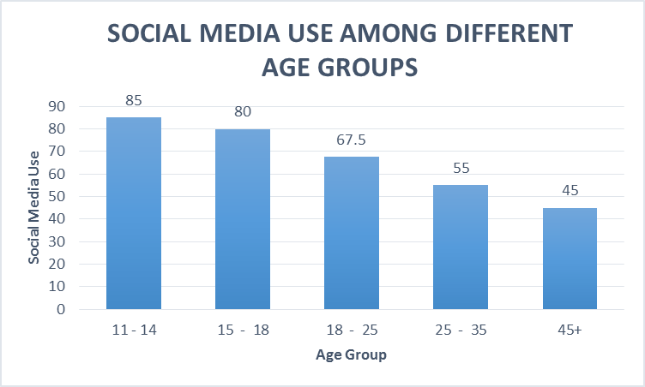
This shows the average percentage of individuals using social media on a regular basis. According to the results

Discussion
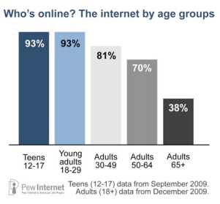
According to a survey conducted by the Royal Society for Public Health, most 14 to 24 year olds in the UK about the impact of social media on their wekkbeing. Based on their survey’s Twitter, Facebook, Instagram and Snapchat are reported to have increased the feelings of loneliness and poor body image among teens and young adults. However, an analysis by Pew Research Center, about 81% of teens between the ages of 13 and 17 claim that social media is a medium to dtay connected with their friends. Some even claim that social media has also helped them through anxious times. Quite contrary to the findings of Royal Society for Public Health, 71% teens teens and young adults associated the use of social media by stating that it made them feel included and gave them a boost in their confidence (Anderson and Jiang).
On the other hand, adults between the ages of 30 and above associate social media use with lifetime social bonds. However, they are not as inclined towards the use of social media as opposed to teens, young adults ans even adults as shown in the graphical representation of data above.

Conclusion
Given the details mentioned above, the results from Pew Research Center findings are quite similar to the ones discovered during our survey. At present, the use of social media in nearly universal among all age groups. While some people have been subjected to the negative and rather traumatic side of social media, some are also exposed to the positive side, one that allows them to strengthen their friendships, cultivate better relationships, expose them to new cultures and stay up to date with the causes that are close to your heart.

Works Cited
Anderson, Monica and Jingjing Jiang. Teens’ Social Media Habits and Experiences. 28 November 2018. Pew Research Center.
Chassiakos, Yolanda Linda Reid, et al. “Children and Adolescents and Digital Media.” Pediatrics, vol. 138, no. 5, 2016, p. e20162593.
Health, Royal Society for Public. # StatusOfMind: Social Media and Young People’s Mental Health and Wellbeing. 2017.
Lenhart, Amanda, et al. Teens, Social Media & Technology Overview 2015. Pew Research Center [Internet & American Life Project], 2015.
Lissak, Gadi. “Adverse Physiological and Psychological Effects of Screen Time on Children and Adolescents: Literature Review and Case Study.” Environmental Research, vol. 164, 2018, pp. 149–57.
Vannucci, Anna, et al. “Social Media Use and Anxiety in Emerging Adults.” Journal of Affective Disorders, vol. 207, 2017, pp. 163–66.

