Lab Final
Student’s Name
Institution
Date

Introduction
The main purpose of the study was to evaluate the memory as a topic. The study intends to test whether the presence of subtitle assists in memory retention of students. Therefore, the research answered the hypothesis of whether the presence of subtitle is directly related to memory retention. In this study, the subtitle is the independent variable while memory retention is the dependent variables. Therefore, these two variables are used to conduct the study efficiently focusing on memory retention of grade students. The variables also helped in establishing the relationship between the memory level of students and the subtitles to determine whether the use of subtitle helps in improving students’ memory.

In order to conduct the study, a quantitative research method was used where participants were invited in a classroom and interview conducted. The samples were gathered using random sampling and the interview conducted using structured interview techniques to obtain accurate data from the participants. The question whether subtitle help to improve memory of students has been a core issue in a class of psychology and therefore, the study on the performance of a student from grade, freshman, sophomore and junior to established whether using subtitle improves students class performance.

Materials and methods
In order to complete the research, the quantitative research method was used to collect the data. Quantitative research method emphasizes its objectives in the statistical, measurement, and numerical analysis of data collected (Michael, 2018). The data collection is done through polls, survey, polls and manipulating of the existing statistical data. The quantitative research method was, therefore, used to evaluate the topic of memory. It was used to test the hypothesis of whether using subtitle improves the memory retention of students. This helped to identify the direct relationship between subtitle and memory retention of students especially grade students. The two variables, independent and dependent variables were used to establish the direct link between memory retention and students. In the study, the subtitle was the independent variable while memory retention is the dependent variable. However, each participant was allowed to bring in new variables to make the study effective. The variable introduced by student could affect the overall outcome of the data and therefore, affect the result as well. Different level, the subject matter of grad students were also tested to determine the effect of memory and how it helps in the improvement of memory. The test score was then used to illustrate to express the viable differences in the memory level as indicated in the data.
Participants
The participants for the study were mainly students from a different level. The participants were one hundred and five in numbers, representing a different level of classes. Demographic of participants was based on gender, age and level of study or class. Most participants were aged between 18-25 years of both female and male. The selection of the participants was done through random sampling method. In this case, participants were invited and selected randomly in the classroom to participate in the study. However, one hundred and fifty were selected randomly and only in a hundred and five turns up for the study in the classroom. The random selection was based on two groups, group which is familiar with subtitle and group which does not and has not applied during the studies. The participants were then requested to sign in the agreement form before taking part in the study. This was to ensure that the content is sealed and to avoid any legal issue related to information or data provided by student or participants.
Procedure
The study then occurred through an interview where each student was asked some questions regarding the subtitle. The interview occurred through a structured-interview technique to ensure that accurate feedback is obtained. The interview took place after watching two different movies with title and movie without subtitles. First, the participants were categorized into two groups, the group to watch a movie without subtitle and a group to watch a movie with subtitle. Second, the movie was chosen based and given to each group to watch. The selection of the movie was based on the content, subtitle and the theme whether it can help in memory retention. Third, each group was required to watch the movie separate hours and days and therefore, these movies were watched separately and the detail earmarked for the study. The data were then collected after the movie. After the movie, the participants were asked questions regarding the movie each group watch to determine the level of retention or understanding of the movie. These questions were asked through a structured – interview technique. First, the group which watched a movie without subtitle was asked questions and then the group which watched a movie with subtitles. The interview process was recorded both on a tape recorder and on questionnaires which were used to asked questions.
Results
The result will have a complete result after analyzing the data and the methods used to analyze the data gathered. The result of the study was obtained through data analysis using the descriptive statistical method.

Table 1: Descriptive statistics
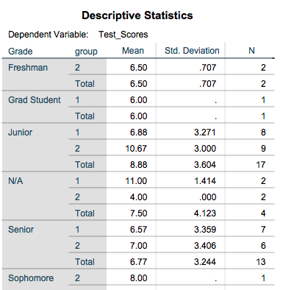
Graph 1: Estimated Marginal Mean of Test Scores
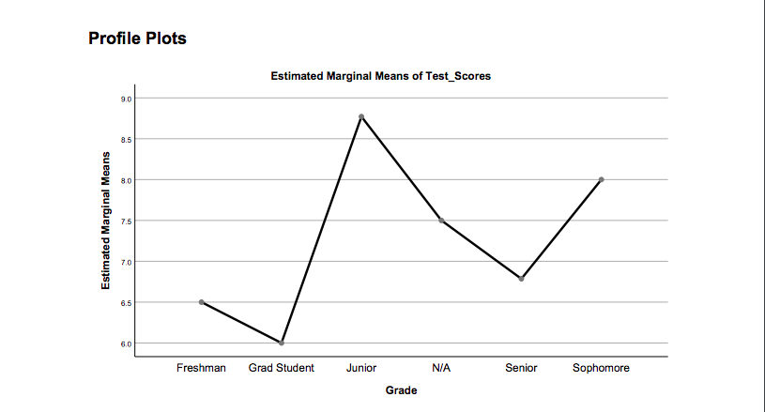
Graph 2: Estimated Marginal Mean of Test Score
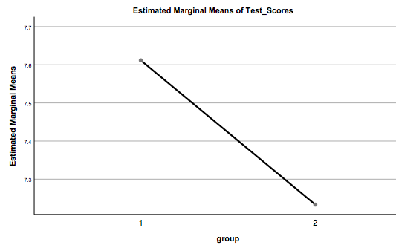
Graph 3: Estimated Marginal Mean of Test Score
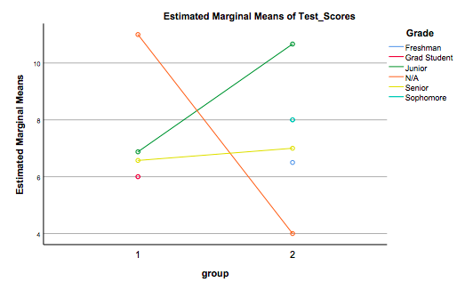
Discussion
The result of the study indicates that there is a direct link between subtitles and memory retention. The study established that the memory retention of junior students high at 8.75 followed by sophomore and then a freshman. The junior students provided an efficient illustration of the information after watching a movie compared to the rest of the students. The descriptive statistics also give the Junior students a mean score of 10.67 for students who watched the movie with subtitles and 6.88 for students who watched the movie without subtitles. Among the students, the result indicates that students who watched the movie with subtitles registered high score compared to the other students who watched the movie without subtitle. According to Amin and Malik (2017), subtitles jogs the minds of students and help them memorizes subjects and therefore, it is easier for students to understand a movie when the movie has a subtitle. This is because it makes it easy to understand the flow and the theme (Amin & Malik, 2017). It, therefore, helps in improving the memory of students. Among the group, which watched the movie without subtitles, the test score was flat or reduces compared to when they watched the same movie and now with subtitles. It means that the clear the subtitle, the high the test score among students. This can mean that students' memory retention is efficient when the movies have a subtitle.

It, therefore, explained the two variables, which has been tested using the study. The memory retention of students depends on the subtitle of the movie. It is, therefore, possible to improve memory os students by using subtitles when teaching students in class or through the use of movie. It is likely to improve students performance. Since the study has established a direct link between subtitle and student performance because students who watched the movie with subtitle registered better test score compared to the rest who watched the movie without subtitles. It is, therefore, recommended to have notes with titles to make it easy for students to understand a subject. This is likely to improve the performance of students in each subject. This has been confirmed by the study since students who watched the movie with subtitles had high test scores compared to other students.

References
Amin, H. U., & Malik, A. (2017). Memory Retention and Recall Process.
https://www.researchgate.net/publication/299456892_Memory_Retention_and_Recall_Process, 2-35.
Michael, P. (2018). Organizing Your Social Sciences Research Paper: Quantitative Methods.
Research Guide, 2-34.

