Separate System of Justice For Juveniles
[Name of the Writer]
[Name of the Institution]

Separate System of Justice for Juveniles

Introduction
The justice system for juveniles is separately established for juveniles in the United States for many years. Its main aim is directed towards diversion of young delinquents from the devastating prosecution or punishments given by criminal courts, and also to encourage the rehabilitation based on the wellbeing of these young offenders. This separation was intended in various other ways too, i.e., its primary focus was on the child's recovery or restoration to the healthy lifestyle, not just to punish the child. The trends and patterns are shown in the past decade direct towards the significant increase and decrease in the crime rate of the juveniles. There are many theories identified by sociologist and psychologist related to criminology and the attitude of the whole society. Thus it gave rise to the policies and strategies related to the wellbeing of the public. The following paper will describe the mechanics and justifications for the separation of the juvenile justice system from the adult justice system.
Discussion
Juvenile Offense Patterns and Trends
The past and recent trends and patterns of juvenile delinquencies suggest the increase in some offense and decrease in the others. These are best measured and recorded through three kinds of information sources or data; official, victim and self-report. The analysis of arresting for violent criminal acts and drug abuse among juveniles in different states has been estimated over the year 1990 onwards. These two categories are comprehensive and universal in almost every state in the USA. According to the official data source, the violent acts of crime in juveniles, i.e., murder, rape, robbery, and assaults were increasing from the year 1990-1995, after that, it started declining till lowest-historic point in 2012 (Oudekerk et al., 2018). The trend comparison among gender, i.e., male and female has been slightly varying, as it drastically declined in males than females in recent years.
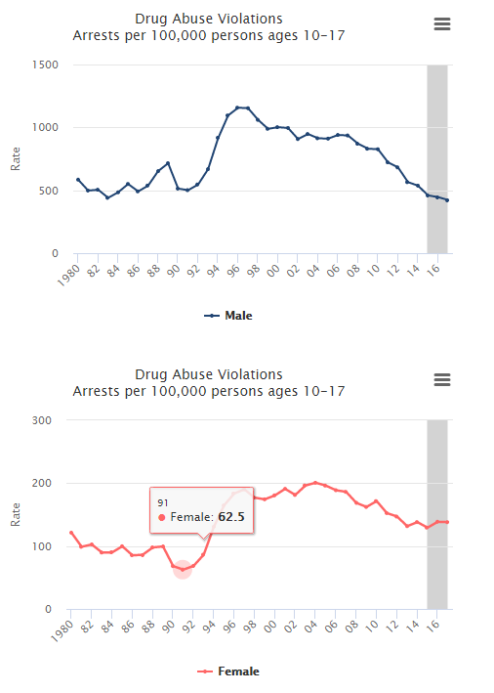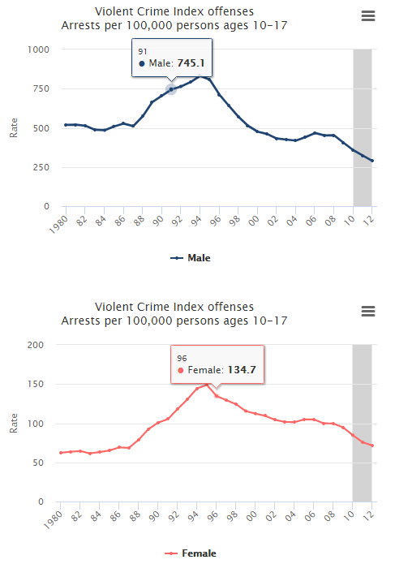
The pattern and trend of juvenile delinquency for drug abuse as generally estimated to be on varying degrees since the 1980s. The violence of drug abuse includes all the aspects of drug and substance-related crimes in juveniles. It started increasing adversely from 1990 to 2000 and then till 2016 it has been declining ever since 2017. The comparison between males and females show no significant difference just that the decreasing rate since 2000 is slower in females than males (Pusch, & Holtfreter, 2018).

Theories
The theoretical explanation of offending and criminal rate is derived from different types of researches. The first sociological program was started in the University of Chicago in the United States. According to this program, the main focus was on the social environment in which an individual was living, not on the individual solely. This shift in the paradigm occurred during the later years of the industrial revolution when urbanization was taking place. During this succession period, various studies explained the stake at which the environment and communities were due to the disorganization of the social system, such that it gave rise to the vice crimes, truancies, and delinquencies. Thus fundamental theories were formed due to this paradigm shift, which says that behaviors are formed due to the arrangement of the society.
The values emerged from the structural theory suggest that the conflict within the society occurs due to inequality and discrimination (Zimring, 2018). The other concern is related to the availability or unavailability of the opportunities. In this regard, the subcultural theories direct towards the desirability, acceptability, and importance of competing ideas. Furthermore, this theory directs towards the failure of the moderate behavior and providence of control mechanisms in the society which leads towards the erosion of the society. Furthermore, the theory of different approach says that conflict may occur between various aspects of the society, i.e., religion, sex, race, ethnicity, political adherence, and occupational scenario.
Public Policy
The policies made by lawmakers to prevent and manage juvenile behavior and conduct in the justice system. The early juvenile system of justice focused on the upbringing and parenting of the children, leading towards policies such as person or Child in Need of Supervision (Underwood & Washington, 2016). The recent system is different as it foresees and manages the overall system of the child’s conduct and behavior in the society and interventions are made for the child delinquents. They are now more focused towards the community-based and school-based intervention programs, i.e., training, mentoring and preparing them for later life in adulthood. The classification theories educated the justice system of juveniles, working as the primary driver for the avoidance of stigmatization. That is why this justice system has its own words of the choice dictionary, such as conviction, arrest, prison, trial, crime, guilty, and parole.
Evaluation of Recent Researches
The recent researches have focused on the rehabilitative treatment model of juvenile delinquents. The youths are provided with the training and educational programs while they are in prison. Therapeutic rehabilitation is focused entirely on young delinquents (Guarino-Ghezzi, 2017). The child is allowed to attain education in school grounds, and also the child is placed either in a residential treatment program or in a community-based program. Many researched have focused on the child or developmental psychology, according to these new trends is formed in the prosecution of juvenile offenders, i.e., competency of the child to stand trials and dependability of the child’s confessions.
Justification
The juvenile justice system which incorporates the incapacitation, deterrence, retribution, rehabilitation, restoration, and tolerance is far better than giving the punishments and prosecution to the delinquent children. The separation of the juvenile justice system from the adult system is essential as children are the pillars of society and on whom a society relies entirely. This separation has indistinctly provided advantages, as the recent studies show how the rate of adult delinquency of these child offenders have gone low just due to the reason that these people got the rehabilitative support during the onset of their criminal attitude, thus it was catered at the beginning of this (Dunn, 2017). As the ultimate goals of punishment are to straighten a person and eliminate the criminal attitude and recover the person from offensive state to the normal one, so the rehabilitative phase is essential in this regard for the juvenile delinquents.

Conclusions
This paper is concluded on the fact that separation of the juvenile system of justice form the adults is the necessity to the wellbeing of the child's mind, soul and body which will, later on, affect the adult-life of the child. The rates, trends, and patterns estimated by the data gathered from official, victim and self-report measures gives exact and accurate data regarding the increasing or decreasing rate of the illegal or criminal act in juveniles. Different theories explained the attitude of societies which formed the felonies and wrongdoings in the society, thus increasing the crime rate. These theories gave rise to the policies made by lawmakers to prevent and manage the juvenile behavior and conduct in the justice system. However, the recent researches have focused on the rehabilitative treatment model of juvenile delinquents. Therefore the ultimate goal of punishment is met by this rehabilitative model due to the reason that they both eliminate the criminal attitude and recover the person from offensive state to the normal.

References
Dunn, J. C. (2017). Social Antecedents of Juvenile Delinquency (Doctoral dissertation, The Chicago School of Professional Psychology).
Guarino-Ghezzi, S. (2017). Balancing juvenile justice. Routledge.
Oudekerk, B. A., Langton, L., Warnken, H., Greathouse, S. M., Lim, N., Taylor, B., ... & Howley, S. (2018). This report was prepared by the Bureau of Justice Statistics (BJS), RAND Corporation, NORC at the University of Chicago, and the National Center for Victims of Crime using federal funding provided by BJS.
Pusch, N., & Holtfreter, K. (2018). Gender and risk assessment in juvenile offenders: a meta-analysis. Criminal justice and behavior, 45(1), 56-81.
Underwood, L., & Washington, A. (2016). Mental illness and juvenile offenders. International journal of environmental research and public health, 13(2), 228.
Zimring, F. E. (2018). American juvenile justice. Oxford University Press.

