Your Name
Instructor Name
Course Number
Date

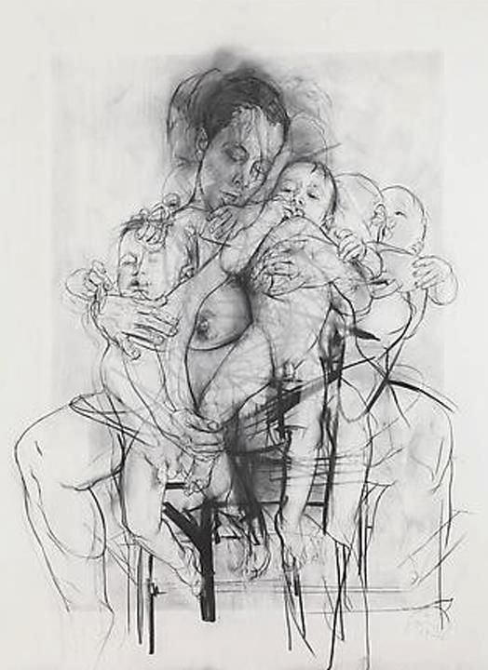
Title: Drawing art essay
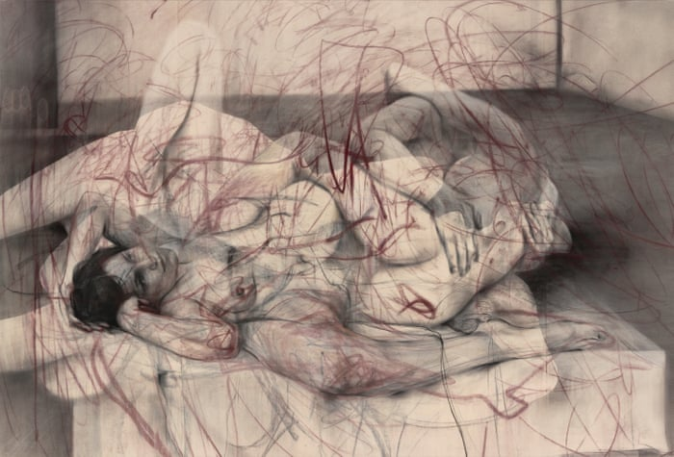
Jenny Saville emerged as a young British artist and became part of the movement Britart. The movement at that time was politically motivated and the media had created the hype for that. Saville's work had revolved mainly around feminism. She read extensively about why the feminists keep themselves away from art. Within a very few spans of time, based on her feminists' perception her artwork were compared with those of Linda Nochlin. Oldfield categorizes her among the very few artists who managed to reach such heights in feminists paintings within such time(Oldfield). Oldfield has also compared her paintings with that of Rubens and Courbet. Saville is best known for her work on female nudes. Her this idea of presenting female nudes has helped in bringing the artistic representation of male dominance down. Based on her technical aptitude of presenting such nudes she is often referred to as the New Old Master(Fleming). Saville's artwork is much different from those male artists who have worked on female portrayal. She is believed to reflect a true sense of the feminist’s perspective by portraying the nude images of the ladies. Her work is different from the idealized stereotypical; male mindset. She has done so by molting the flesh of the bodies in her paintings and by posing them erotically. About her own paintings, she mentions that I have taken out the idea of women as sexual objects and have made them stand like a full body and not parts(Cué). She further attributes her paintings as how women want actually wants to see herself. Oldfield has also mentioned that Saville’s work about flesh is leaking out, but this has been done in order to just portray that for men women have remained imperfect and a paid material, which she basically denounced(Oldfield).
Figure 1: Saville projecting Feminism
Figure 2: Saville's Work
Considering the context presented by Zeller in the figurative artist's handbook, Jenny Saville's work appears confirming all three aspects argued by Zeller. By presenting the naked body whose flesh has been torn away and who is trying to reveal more about herself, her works appear fulfilling the aspect of gestures, as illustrated by Zeller. She has made the body of women more like an object rather than a feeling, this is what the structural approach of Zeller is. She has presented women as a faraway object from this society. Zeller's arguments about the presentation of the artwork, reveals that unless a phenomenon has been totally encapsulated in an artwork, the art remains incomplete. The comparative analysis of Zeller's arguments and the work of Saville, it appears that she has met every aspect of Zeller's aspect of the paintings.
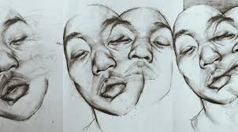
In light of the political voices of today which in times speaks in favor of women's right and in times against the women's, Saville's work has remained dominant over all that. She has just elaborated what she thinks is literally the true side of society. Her many images depict the shocking reality and remains a testament to prove what Zeller has worked on. There is also another theme in Saville's work which is of close contact. She has worked also with some fashion photographers to reflect that. The resulting art of her collaborations with fashion photographers results in presenting the distortions of society. These distortions, what Saville portray are just related to women. How women present themselves differently at different places, and how people understand this contrast. Again it is important to analyze here that Zeller's work also presents this idea as atelier methods. Zeller quotes this method as presenting what sensual is and how smooth renderings are based on. Saville’s work although depicts a single sense in projecting the image of society but remains accomplished on how Zeller thinks the art is.
Figure 3Sensual projections

Works Cited:
Cué, Elena. “Interview with Jenny Saville.” Huffington Post Haastattelu. Viitattu, vol. 2, 2016, p. 2017.
Fleming, Jenny. Working through Networks: The Challenge of Partnership Policing. 2006.
Oldfield, Sybil. This Working-Day World: Women’s Lives and Culture (s) in Britain, 1914-1945. CRC Press, 2003.

