Title of the Paper

Author Name

[Name of the Institution]

Evaluate the social-political and economic impact that the Reconstruction era had on African Americans from 1865 to 1900.
In 1865, after the American Civil War ended, the southern states in America started to enact black codes to restrict the rights of slaves. As a result, three major state laws were passed by The Republican-controlled Congress that assured the freedom rights of slaves and blacks, they also gave the right to vote to all the Americans without any discrimination of caste, color and creed. The reconstruction era lasted from 1865 to 1877; this period is said to have the period of laws that recognized the importance of Southern states. In addition, laws made during this time helped African Americans to have voting rights and other rights. They were allowed to participate in political matters, have their own jobs, to acquire lands for farming and to use public accommodations. The result of reconstruction was a wave of black leaders in the South, including mayors, state politicians, Congressmen, and even a Senator.
Such as the 14th Amendment to the Constitution granted citizenship rights to all the freed slaves, freed as a result of civil war ¹. The amendment allowed for equal protection of laws to all the American citizens without any discrimination. The Freedmen's Bureau Bill was a step taken to ensure aid in terms of food, clothing, shelter and legal assistance to the recently freed slaves. This bill aimed at the smooth transition of African Americans from slavery to freedom. The bill was vetoed by Andrew Johnson, but the new bill passed in 1866 offered more rights to ex-slaves ². The 13th amendment abolished slavery and African American started to participate in the Congress. The following graph shows the African Americans serving in Congress right after the civil war. During 1867-69, African Americans stood side by side in the political arena of the US.
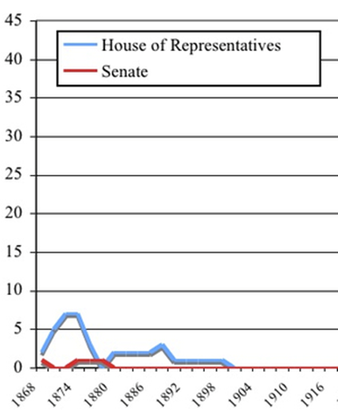
One of the significant change was the woman suffrage bill in 1869; the bill granted voting rights to women and the first place in the entire world was Wyoming ³. During the time, Southern states also enacted Black codes, laws to limit the freedom rights of slaves. These codes allowed some rights to African Americans but it was aimed at using the black salves as cheap labors to restore the plantation economy. Black Code of Louisiana, 1868 is one such example, though the Constitution of 1868 extended rights to the blacks and did little to end segregation ⁴. In 1874, the cartoonist Thomas Nast advocated the abolishment of slavery and deplored the violence of white supremacy. His one most famous cartoons are the title, "Worse than Slavery" ⁵.
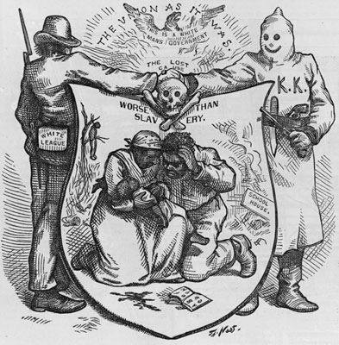
In addition, during the years of reconstruction, black and white teachers, churches and organizations offered many learning opportunities to the former slaves. About 2000 African Americans also held government jobs during the reconstruction period. Family, church and life were key elements in the lives of ex-slaves. Another element observed in the lives of African Americans was sharecropping that allowed autonomy in their work and social lives. Former slaves having no access to capital made a way to earn a livelihood by working on lands owned by others ⁶.
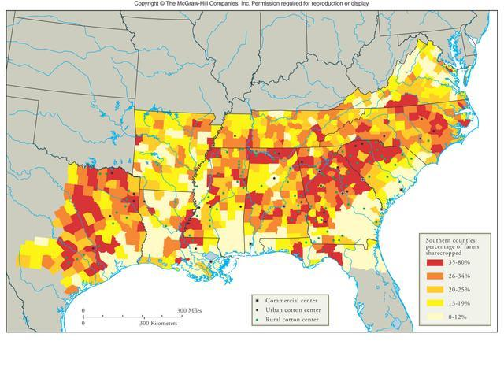
Thus African Americans, after the Civil War and during the reconstruction period, enjoyed their rights. They actively took part in politics, were allowed to vote and enhance their literacy rates. However, the existence of several opponents resulted in the eradication of freedom movement. Such as by the end of the 19th century, Plessey v Ferguson, the landmark case in the history of the US sustained the constitutionality of racial discrimination by declaring ‘separate but equal’ ⁷. After this case, Jim Crow laws spread across the US paving the way for continuous racial segregation in the US.

Endnotes
1. 14th Amendment to the U.S. Constitution: Primary Documents of American History (Virtual Programs & Services, Library of Congress). https://www.loc.gov/rr//program/bib/ourdocs/14thamendment.html. Accessed December 19, 2019.
2. Veto of the Freedmen’s Bureau Bill. Teaching American History. https://teachingamericanhistory.org/library/document/veto-of-the-freedmens-bureau-bill/. Accessed December 19, 2019.
3. Adiletta D. Elizabeth Cady Stanton: Women’s Suffrage and the First Vote. The Rosen Publishing Group, Inc; 2004.
4. Reconstruction: A State Divided. MuseumSubAgency-2013-09-18. https://DCRT-MAIN/louisiana-state-museum/online-exhibits/the-cabildo/reconstruction-a-state-divided/index. Accessed December 19, 2019.
5. Worse Than Slavery | Facing History and Ourselves. https://www.facinghistory.org/resource-library/image/worse-slavery. Accessed December 19, 2019.
6. Digital History. http://www.digitalhistory.uh.edu/disp_textbook.cfm?smtID=2&psid=3100. Accessed December 19, 2019.
7. Our Documents - Plessy v. Ferguson (1896). https://www.ourdocuments.gov/doc.php?flash=false&doc=52. Accessed December 19, 2019.

