RUNNING HEAD: DATA STORY

Data Story: Household size
Name of Student
[Name of the Institution]

Data Story: How family-oriented is Australia, really?

Introduction
The data story which is being told in this paper is based on the number of households and the types of household in the country. The data is collected for three years and is based on the census held that year. In 1986, the data collected is based on the household in which the person happened to be residing on the night of the census, rather than the household in which the person usually resided. In 1996, 2006 and 2011, households were classified according to “usual residence” for up to three residents who were temporarily absent on Census night. The question that I am asking about this data is “Are the family-based households decreasing over time?”. There are several parts of the dataset that are being analyzed for the answer of this question and these datasets consist of data related to the types of Australian house, the average size of the Australian household as it varies with time and the descriptive summary of the general data as it relates to Australian society.

How family oriented are we?
Considering the stats provided by the Australian Bureau of Statistics regarding the number and type of households, we can observe that the percentage of household that considered themselves as family households were at 77.1% which with the passage of time dropped to an all time low of 71.5% in 2011. The data can be represented in the form of a table as follows.
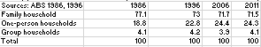
Figure 1-Household data from ABS
In order to understand the general trend that exists in this set of data, let us visualize the data provided using a stacked bar chart.
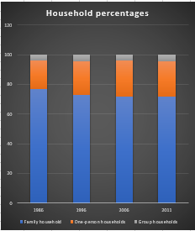
Figure 2-Household percentages

From this visualization we can see that the overall percentage of family households have decreased gradually with the passage of time and one person households have slightly increased. The answer to the question being asked, may not be very elaborate or alarming but the general trend is that the percentage of family households are on the decrease with the passage of time as seen from the visualizations and the data.

Is the household size increasing or decreasing with time?
In order to analyze the trends regarding the household sizes in Australia, we need to observe the data form the Australian Bureau of Statistics regarding the average household size and visualize it in order to find the necessary insights in the trends. The data provided with regards to the average household size is extensive in nature and is represented in the form of a table below.
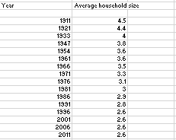
Figure 3-Average Australian household size over time
A deep connection exists between the study of average household size and our thesis question, and that connection can be envisaged and understood extensively once we visualize the similarity in trends regarding the two dets of data. The trend in average household size as compared to time can be seen using a scatter plot as seen below.
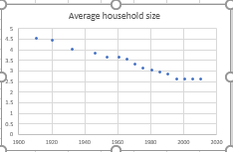
Figure 4- Scatter plot for data regarding average household size.
A similar trend can be observed if we use a bar graph to envisage the data.
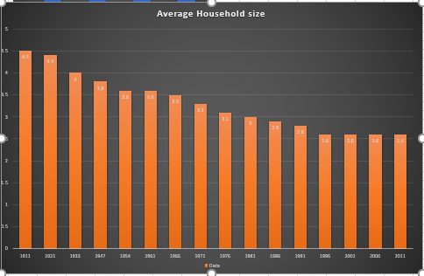
Figure 5-Bar graph regarding the average household size.
The average household size is observed as decreasing with the passage of time and that can be correlated to the decreasing percentage of family households with time. This insight can be used in the answering of our thesis question that is “Are family-based households decreasing with time?” The answer seems to be in the positive as far the data, we have observed till now.
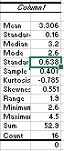
Figure 6-statistical summary of the household size data
As seen from the statistical summary from our average household size data, we can see that the average size for Australian household over the years has been 3.306 which, from a family-oriented mindset is not very discouraging. The standard deviation in the dataset is very high as the data is well spread at both ends.

Types of Australian households
In order to get further insights into the trends that exist regarding the answer of our thesis questions, we will observe the in-depth classification of the types of homes that exist in the Australian society. The data thus used to extract further insights is shown below in the form of a table.

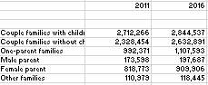
Figure 7-Types of Australian households
The data that is shown above, does not provide such a long timeline in order to analyze the trends that exist in the types of households over time but it does provide enough information to make our minds up regarding the classification of the types of households that exist in the Australian community. The data thus seen can be further simplified and the general trends can be envisaged by the following graph.
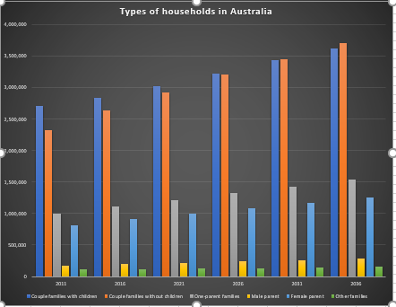
Figure 8-Bar graph of Australian household types over time
From the bar graph as shown above, we can see how the couple families with children are increasing in terms of numbers, but decreasing in terms of percentage of the overall population. The growth in terms of numbers can be very deceiving as the total population of Australia is also increasing with time. We can see though, in terms of proportions, the trend is that the number of families without children are increasing rapidly while the growth rate of the families with children are not increasing at the same rate. This trend can be explained by the overall decrease in the size of families that was observed in the earlier visualizations. Similarly, such a trend can be correlated with the decrease in percentage of family-oriented households in Australia that was seen in the first data visualization.
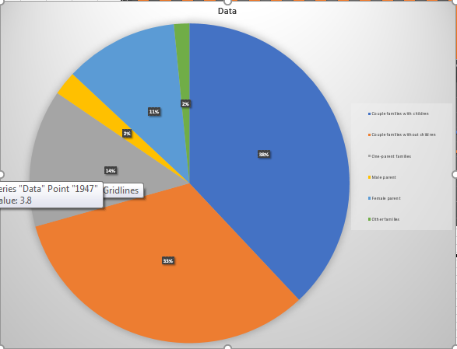
Figure 9-Pie chart showing Australian family populations
The overall percentages as related to the types of households that exist in the Australian community can be seen in the pie chart shown above. The maximum percentage are taken up by families who are having children while they are followed by couples who do not have any children, which makes up for a very pleasant picture if you are a family-oriented personality and believes in any form of organized religion.
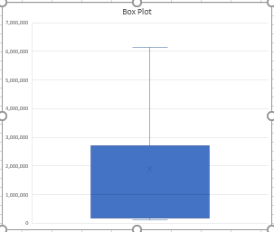
Figure 10-Box Plot explaining the distribution of types of families.
From the box plot, we can observe the way that the data is distributed in terms of numbers. There are no outliers in the data while the maximum number of families lie on the average and that is the mean of the box plot.

Comparison between total and family-oriented households
A similar pattern can be observed when talking about the distribution of the number of families and the number of households together. The data depicting the number of total households and the total number of families is shown in the graph below.
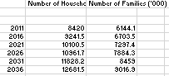
This data can be better understood if we envision this set of data using a scatter plot, we can see that the rates of increase of total households is not the same as the rate of increase of family-based households. This piece of statistics can prove to be very important in the description and explanation of our thesis statement.
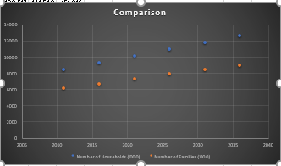
Figure 11-Scatter plot regarding the numbers of families.

From the above shown scatter plot, we can see that with the passage of time, the numbers that are being associated with the increase in the number of family households are not the same as the number that are associated with the increase of total households in Australia.

Conclusion
The data that is being analyzed is a study in itself that can be used to make the case that over the years, the trend of being family-oriented has decreased gradually over the years. Certain counter-arguments can also be presented that the number of family-oriented households have been affected by the number of people dying and the number of people who have been divorced over the years, but the fact of the matter is that the thesis statement has been proven to be true from a number of different sources of data. The data for the number of households corresponding to the number of family households provide one of the insights into the Australian society and the general trend towards the decrease in the households with a family structure. The decrease in the average household size as seen above can also be shown as one of the reasons why the decrease in family households can be seen as reasonably prominent over the years. The decrease of family-oriented households can also be reasoned to a decrease of belief in organized religion and the increase in ideologies that generally abstain from the idea of a very well knitted family-oriented households.

