RUNNING HEAD: WEBSITE EVALUATION

Website Evaluation Based on 10 Heuristics
Author
[Institutional Affiliation(s)]

Website Evaluation Based on 10 Heuristics

Executive Summary
The selected website has been analyzed based on the 10 heuristics that have been proposed by Nielsen. The evaluation is based on the overall functionality of the interface and the design of the website. The website contains a simplistic design and functionality and lacks in many of the areas that a user may find important. As a result, the website fails to achieve the level of sophistication that is demanded in the present world. Its competitors are doing great when it comes to the overall design and it is fairly simple to implement these design changes for the betterment of the website.

Introduction
The website that has been selected for the assignment is www.roverp6cars.com. The website is based on a car parts selling company, MGBD Parts and Services that particularly specializes in the parts of Rover P6. The business model of the company revolves around the transactions of parts of antique cars especially those of the Rover P6 model. The main target of the company are owners of the same antique cars. Anyone who has a Rover P6 or is interested in one, is targeted by the company.

Tasks for Evaluation
The tasks that are the basis of the evaluation include:
- Navigation of the website: How easily and efficiently a user may be able to make way through the website. Every user wants that the site should be self-explanatory and there is comfort when navigating it(Hsiao et al., 2017).
- Finding information: The efficiency with which the desired information can be retrieved
- Portal usage: Since the website is dedicated to the buying and selling of Rover P6 parts, so portal functioning is of paramount importance. The portal should be easy to use and user friendly so that there is least chance of errors that a user may commit (Marcus and Gould, 2000).

Design Perspective
Since the website mainly focusses on the buying and selling of Rover P6 parts, hence it has been designed to highlight that. The whole website has elements of the car model in every aspect of it. The website is trying to promote its vision through graphical representation. The website is following the latest trend of displaying information and navigation through the use of images. A lot of the latest websites have abandoned the use of text and instead, pictures are used. The same vision is followed by the MGBD Company on its website. The website also contains a portal for e-commerce related to the buying and selling of car parts. This is one of the major ways that the companies in today’s world make a profit. People these days are more interested in what they may get from the comfort of their homes. For a visual representation of the website, please see Appendix A.
10 Heuristics
The evaluation of the website based on the 10 heuristics is as follows:
Heuristic 1
Heuristic one focuses on the fact that the system should display the state that it is in e.g. the option or menu item that has been selected on the website should convey to the user that it has been highlighted (Martinez et al., 2017). This can be done through a tick mark or a change of color. The website in question has no proper means of showing the state the system is in. The website continuously shows a single state and there is no way of identifying what the action of the user was that led to a particular state.
Heuristic 2
The 2nd heuristic states that the information should be presented to the people in such a way that it is easily understandable for them. The information displayed on the website is easy to understand but still, there are some elements that need to be properly elaborated e.g. the name of parts of the cars should be properly identified. If the user wants to order something, the menu to reach the portal is not easily identifiable. This would cause inconvenience for the user since it would be difficult for them to find it.
Heuristic 3
The user should be able to undo/redo their actions easily according to the 3rd heuristic. The user may make a mistake in the selection that they did not intent. In such a case, it should be easy to navigate to the initial state (Reeves et al., 2004). The website is very simple and thus much effort is not required to undo the action made by mistake. The main interaction occurs through the opening of new pages which can easily be navigated back to. One of the things that might trouble the user is navigating the portal. It is not as straightforward as it should be and may cause confusion for the user.
Heuristic 4
This heuristic is based on consistency. Every element of the UI has to have a defined function and should not be mixed with the other functions. The navigation on the website is complex because of the use of a similar outlook given to different levels of the menu. This may make the users wonder about the outcome of their actions. Each element of the website should be clearly defined and be such that it is set apart from the other functionality. The website lacks heavily in the design area. There is a great chance of error in the judgment of the website users.
Heuristic 5
Heuristic 5 is based on error prevention and how the user might be able to handle the mistakes. Since the website under evaluation is very plain, without any room for dangerous errors, so it is not a big issue to have error handling elements in place. The portal for the transaction has warnings available for the user but the warnings are not very prominent and are old fashioned so there might be a chance that the user might overlook these when using the website.
Heuristic 6
This heuristic highlights the importance of recognition in websites. A good website design should be optimized such that the user does not have to spend much time to find the right information. The main thing is that the user should be able to recognize rather than recall. The MGBD website has a very single dimensional UI. The user could get easily confused as many a time, it is not clear which menu option leads to which page. That is why the website negates heuristic 6. As mentioned above, the main component of the website is the portal and it should be easily accessible by the user but in the case of this website, it is not.
Heuristic 7
Heuristic 7 throws light on the significance of efficiency and flexibility. A website may be home to lots of users. Some of these might be new and some old and seasoned. The website should allow easy access to all its features to every level of the user. There should not be any difficulty for any class of user. The subject website does not define any proper means of navigating through the menus. This makes it difficult to understand for novice users. Beginners tend to find it easy if information is strategically displayed. An expert user might navigate based on their experience but a new user would definitely find it difficult to access the desired parts.
Heuristic 8
Aesthetics is a major feature of any website, and this aired with the minimalistic design, is an ultimate combination. The latest trends have the websites follow a design where minimal information is sufficient to make sense. The MGBD website has a lot of jumbled information on every page making it difficult to recognize what is important and what is not in the eyes of a particular user. The portal is developed in a very conventional way which shows minimum instructiveness. The portal should be such that it attracts the eye of the user and makes them want to search the website for more. This element is missing in this case.
Heuristic 9
Error handling is a major component of any website. Any inconvenience for the user may be avoided. The website under discussion has no major errors that might occur and disrupt major activities. That is why there is no sign of error prevention methods. The portal section, on the other hand, is primitive looking and the error information that is displayed, is not proper. A user may get stuck at a stage with no means of getting away. The errors are not properly highlighted which could lead to frustration by the user.
Heuristic 10
The last heuristic is linked to documentation and assistance. The website does little to highlight the ways through which information can be gained. Since the website is mostly static information, there is basically not much need for any documentation to help with the navigation.
Competitors

There are many similar websites performing similar functions. One of the better examples is www.carparts.com. The website is dedicated to online buying of automobile parts. As soon as the website is displayed, there is a clear difference between the design methods used. The design that is used is the latest and much more user-friendly as compared to the other website’s. Information is clearly displayed and a portal for ordering of the parts is available on the main page which makes it easier to find. Every section of the website is clearly defined and there is no confusion that might be created for the user. The website is easy to navigate and user-friendly from the perspectives of both the beginner and the experts. The clarity in the way that the website handles the error is also an essential part which makes it more efficient. See Appendix B for carparts.com website design.

Improvements
The website in question has much potential to be modified for the betterment. Some of the key changes that could make the website a much better experience for the users are:
- The outlook of the website should be changed and proper sections should be formed.
- Since the website is supposed to be a portal that is designed to perform transactions related to parts, it should be highlighted properly. The portal should be one of the things that are displayed on the main page of the website rather than at the backend (Stone et al., 2005).
- Less textual data and more visual data should be added to give the website a feel of the modern paradigms.
- The major trouble lies in the aesthetics of the website. The website is very one dimensional and it is really difficult to navigate the right parts. Even the portal used old fashioned design schemes which may disappoint the user.
Conclusion
The whole website is based on a very primitive model with the least user-friendliness. These days, the main thing that the user requires is efficiency and clarity by which they may perform different functions using the website or a portal. The information should be clear and concise with less textual data and more visual data (Hawlitschek et al., 2016). The website needs to compare itself to other much better websites with similar functionalities. Changing the outlook is not a major task and can easily be done with the help of a few changes. The main information is present; it just needs to be displayed in a proper way to increase the efficiency of the user and avoid any inconvenience on their part.

Appendix A

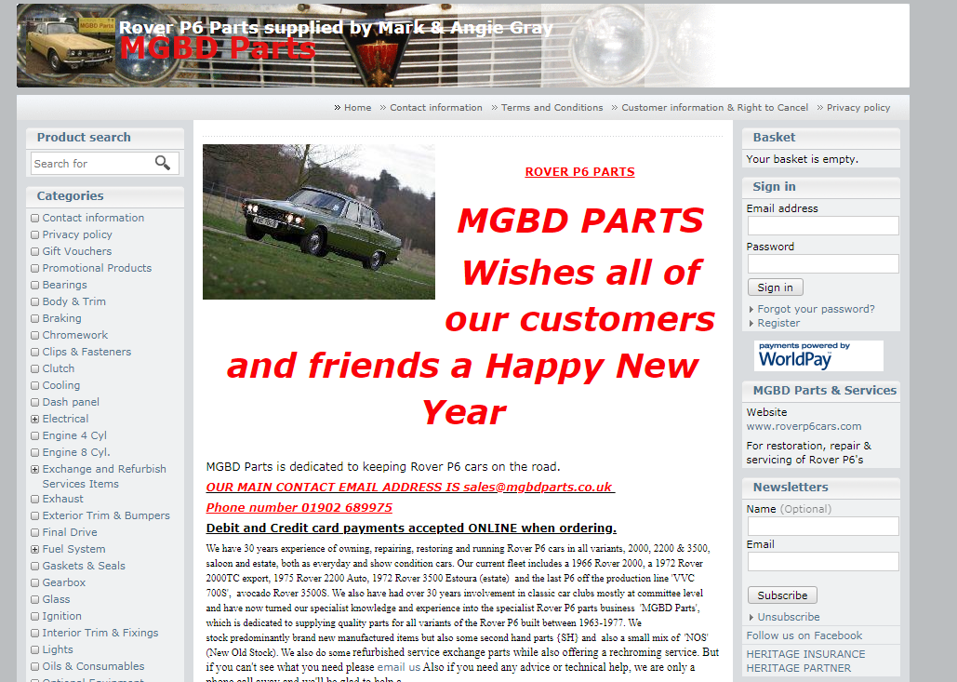

(“Rover P6 Parts supplied by Mark & Angie Gray,” n.d.)

(“MGBD Parts,” n.d.)

Appendix B

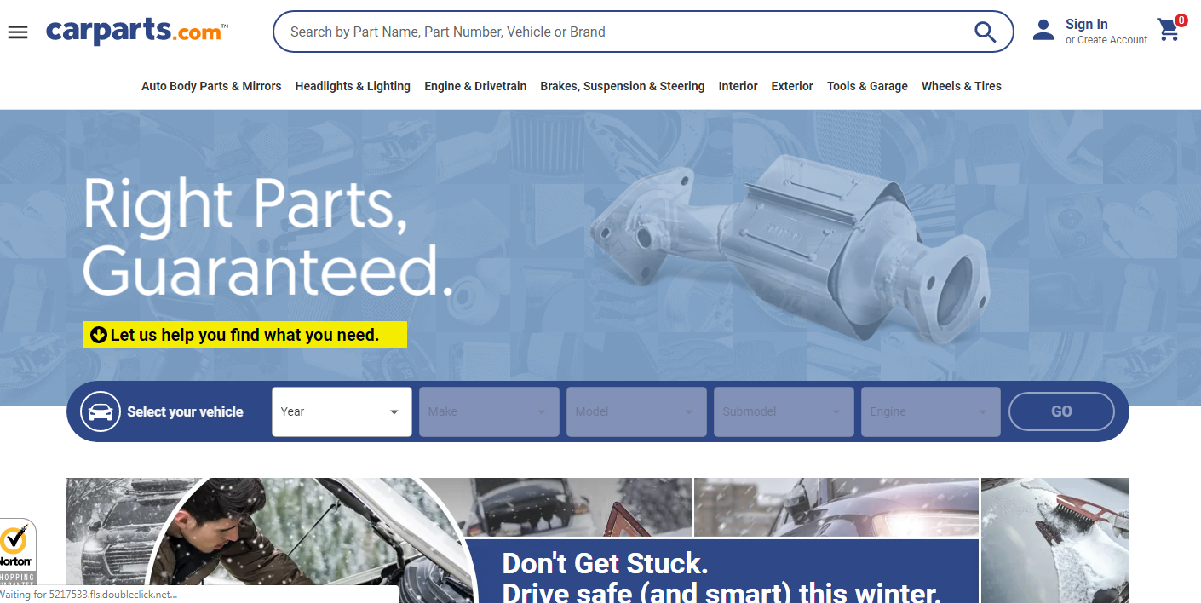

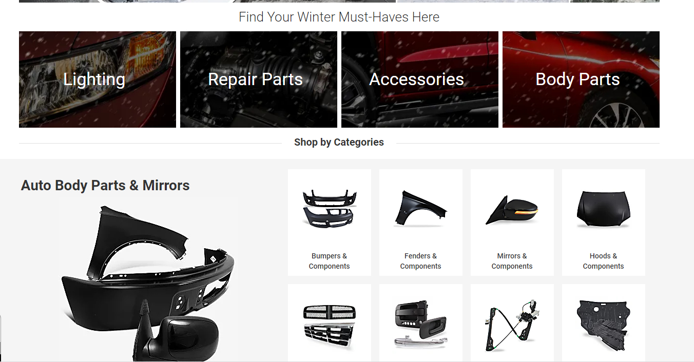

(“CarParts.com – The Right Auto Parts for the Right Price,” n.d.)

Bibliography

CarParts.com – The Right Auto Parts for the Right Price [WWW Document], n.d. URL https://www.carparts.com/ (accessed 1.13.20).
Hawlitschek, F., Jansen, L.-E., Lux, E., Teubner, T., Weinhardt, C., 2016. Colors and trust: the influence of user interface design on trust and reciprocity, in: 2016 49th Hawaii International Conference on System Sciences (HICSS). IEEE, pp. 590–599.
Hsiao, S.-W., Lee, C.-H., Yang, M.-H., Chen, R.-Q., 2017. User interface based on natural interaction design for seniors. Comput. Hum. Behav. 75, 147–159. https://doi.org/10.1016/j.chb.2017.05.011
Marcus, A., Gould, E.W., 2000. Cultural Dimensions and Global Web User-Interface Design 15.
Martinez, J., Sottet, J.-S., Frey, A.G., Ziadi, T., Bissyandé, T., Vanderdonckt, J., Klein, J., Le Traon, Y., 2017. Variability Management and Assessment for User Interface Design, in: Sottet, J.-S., García Frey, A., Vanderdonckt, J. (Eds.), Human Centered Software Product Lines. Springer International Publishing, Cham, pp. 81–106. https://doi.org/10.1007/978-3-319-60947-8_3
MGBD Parts [WWW Document], n.d. URL http://www.roverp6cars.com/?LMCL=o0Pa12 (accessed 1.13.20).
Reeves, L.M., Martin, J.-C., McTear, M., Raman, T., Stanney, K.M., Su, H., Wang, Q.Y., Lai, J., Larson, J.A., Oviatt, S., Balaji, T.S., Buisine, S., Collings, P., Cohen, P., Kraal, B., 2004. Guidelines for multimodal user interface design. Commun. ACM 47, 57. https://doi.org/10.1145/962081.962106
Rover P6 Parts supplied by Mark & Angie Gray [WWW Document], n.d. URL http://shop.roverp6cars.com/ (accessed 1.13.20).
Stone, D., Jarrett, C., Woodroffe, M., Minocha, S., 2005. User Interface Design and Evaluation. Elsevier.

