Your Name
Instructor Name
Course Number
Date
My Ecological Footprint
Introduction
As human beings, planet Earth is our home. Just like in our home, our every activity impacts us and the home in which we live in. In the same way, our activities at a small or large level impact our bigger home, the Earth. This impact is generally known as “the Ecological Footprint” (Wackernagel). Ecological footprint can simply be defined as the effect or impact of the human activities, measured in terms of the biologically productive land and water required to produce the good and assimilate the wastes generated. I also took a test to check my ecological footprint on Earth. The test was easily available on http://www.footprintcalculator.org/.
Supported Information
The ecological footprint of a person is calculated by summing up all the demands of the people that they compete for the biologically productive space (Dietz p.13). This space includes the fertile land to grow crops and vegetables, and the forests land to grow wood-like timber to sequester CO2.
The results for the test that I took for checking my ecological footprint on Earth gave me the following results.
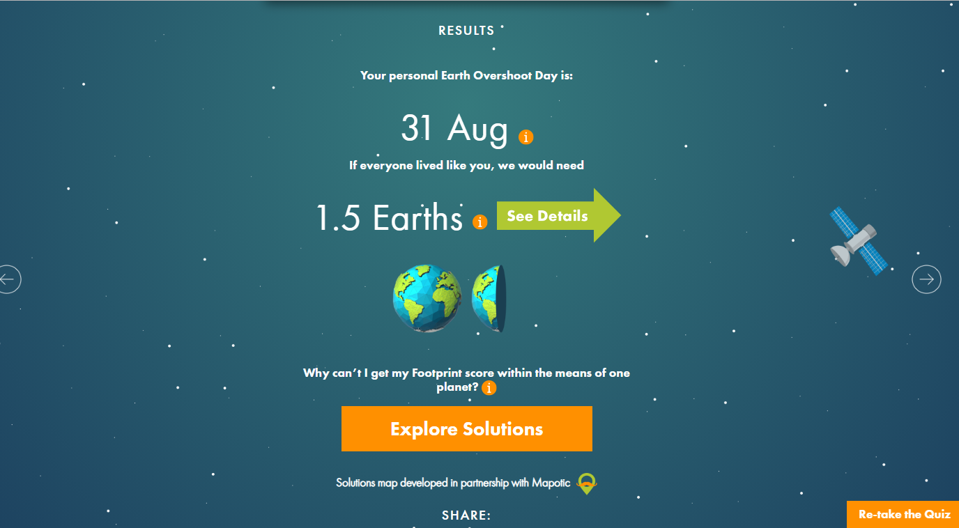

Evaluation
The evaluation of the results exhibited that most of the portion of my footprint consisted of carbon and the second biggest portion was cropland. So, in order to be a beneficial citizen for the plant, I need to lower the consumption of such products that emit carbon dioxide (Network). The best idea to do so is to reduce the use of fuel and automobiles and travel more by public transport or on foot.
Conclusion
In a nutshell, it can be seen that Ecological Footprint holds great importance in calculating the impact of a person’s activities on our planet. It also helps in determining which activities a person needs to control and prevent completely in order to prove to be beneficial for the Earth.
Works Cited
Dietz, Thomas, Eugene A. Rosa, and Richard York. "Driving the human ecological footprint." Frontiers in Ecology and the Environment 5.1 (2007): 13-18.
Network, Global Footprint. "Ecological footprint." The Share Guide: The Holistic Health Magazine and Resource Directory.< http://www. shareguide. com/Ecological. html>(25 March 2008) (2018).
Wackernagel, Mathis, and William Rees. Our ecological footprint: reducing human impact on the earth. Vol. 9. New Society Publishers, 1998.

