Capstone Essay
[Name of the Writer]
[Name of the Institution]
TABLE OF CONTENTS
Capstone Essay 3
Abstract 3
Introduction 3
Major League Baseball (MLB) 4
Thesis Statement 5
Research Question 5
Significance of the Study 6
Promotion and Major League Baseball (MLB) 6
How Major League Baseball (MLB) do Promotion 7
Literature Review 8
Notice of Gaps in Knowledge 12
Results 13
Conclusion 15
Recommendations 16
Appendices 17
References 21

Capstone Essay

Abstract
This paper is developed to analyze the role of promotion for Major League Baseball (MLB). The paper specifically analyzes and explains why promotion is so important for Major League Baseball (MLB) as well as for sports industry. Promotion and its strong presence and growth have several roles to be played in even every industry. The promotion has been found a positive contribution for Major League Baseball (MLB) because of its crucial benefits to the MLB. The benefits include enabling the MLB to be self-sustained. Furthermore, the promotion has enabled MLB to perform more productively. No doubt exists that promotion is used in many ways that benefited every organization especially the sports organizations and this has been elaborated in the paper. In the sports industry, promotion creates persuasion and attraction of consumers and develops contact between organizations like MLB and clients. Beyond that, there are several strategies and tactics which can be used by MLB to have a strong presence in the marketplace and to enable itself to grow successfully.

Introduction
This report is prepared to clarify and provide a detailed understanding of the topic which is going to be analyzed and researched for the purpose to know the importance of promotion for Major League Baseball (MLB). The topic we have at hand for this Capstone essay is “Why promotion is so important in the Sports Industry and for Major League Baseball (MLB)”. For finding the goals of knowing why promotion is so important in this particular industry and organization, we will research and analyze even every available source and materials or information available. The essay mainly includes different parts such as introduction, body or analysis, and conclusion. Beyond that, the essay covers each and every promotion strategy and tactics used by the Major League Baseball (MLB) for different purposes like growth, profitability, sustainability, enhancing a number of customers and clients, business growth and success.

Major League Baseball (MLB)
Major League Baseball (MLB) is a professional baseball organization and the oldest of all major and well-established professional sports leagues in the US and Canada. The main leagues of the baseball organizations (National League and American League) have merged into one or a single organization which is led by the Commissioner of Baseball in 2000. The MLB also oversees a minor league baseball which includes 256 teams that are affiliated with other major league clubs. MLB on the other side also manages the international WBC (World Baseball Classis) with the World Baseball Softball Confederation. In short, the MLB is currently composed of 30 teams where 29 are in the US while only 1 is in Canada and 162 games are played by the teams in each of the sessions (MLB, 2019). MLB uses several marketing, advertisement, and promotional strategies to promote itself. The management of the organization is focused to utilize every platform available and suitable for the organization for a number of purpose such as the attraction of new teams and increase the number of spectators in every session. The management is concerned about this because an increased number of visitors, spectators and teams would enable the organization to have more revenues and the result would be like, the organization will be efficiently self-sustained.

Thesis Statement
The essay will be covering the above mentioned (main) topic by answering the research question listed in the report. Furthermore, this essay is also concerned with the provision of additional strategies and tactics for the MLB that how they can use marketing and promotion in a better way than they currently do. In short, analysis and concluding the aforementioned topic is the main focus of the essay. Hence, the thesis statement that answers the research question of the paper/essay is;
"In order to get more advantage of the promotion and overall marketing by MLB, every strategy, tactic, and technique of promotion must be used. There should be huge efforts to educate MLB on how to get benefited from promotion, what MLB can do for the purpose and how MLB make itself to be successful and self-sustained in the future."

Research Question
Promotion is one of the most important things after overall marketing. It is important to be utilized by every organization in every industry and market. It is considered so important and crucial because it contributes a lot to the growth of every organization and makes it successful. Promotion does so by ensuring the attraction of potential customers, engaging and persuading customers, and ensuring the overall profitability (ISYB, 2018). Hence, the promotion has the same and even more important for MLB.
After analyzing every aspect of the topic we have at hand or the topic which would be researched in the Capstone essay, we came to answer the Research Question listed below.
What is the role of Promotion for Major League Baseball (MLB) and how it enables MLB to be self-sustainable?

Significance of the Study
This Capstone Essay is an important project to be completed because it is beneficial for me in several ways. It would contribute a huge amount of skills and understanding of the concerned topic. As well as, it would assist to incorporate the knowledge and understanding learned from my major. Beyond that, it will uphold my competences of information literacy and critical thinking where we are going to write about the chosen question while enhancing my knowledge about a particular organization called MLB by analyzing and assessing how MLB use promotion and why it is important for the League. As well as it would be a credible contribution of the study to my learning when I explain a theory by using facts of an organization e.g. MLB to explain it, as student and having Sports as major.

Promotion and Major League Baseball (MLB)
Promotion is processing and set of activities or actions that are taken into action for communicating product, brand or services to the ultimate user, audience, and/or customers. The idea of promotion is to make every individual aware, pursue, and induce to get/purchase the product or service in preferences over the others. In other words, promotion is communication between the seller and buyer. In promotion, the activities of the seller include the efforts taken to persuade the buyer to buy the products or services of the seller. For example, the process of pursuing and capturing people to purchase tickets of Major League Baseball (MLB) for a league or event and putting efforts to uphold the league or event can be defined as promotion of promotion (Boyd, & Krehbiel, 2006). The promotion also assists every organization to develop a strong public image and improve the public image. Beyond that, promotion (a method of marketing) develops an interest in buyers' minds to make loyal customers.
The organization under analysis (MLB) do promotion in more than a few ways. As the main source of the organization’s revenues is the sale of tickets for the sessions and associated events they arrange and manage. So the organization promotes its sessions and events to ensure possibly higher sales of tickets. For the purpose, MLB uses its best teams and leagues to promote itself and attract visitors to the sessions and leagues. They also make payments to the top teams which are used for the organization’s promotion so that the teams are found more likely to cooperate with the MLB in promotion itself and events (Mbaskool, 2019). Despite this, the promotion is also done in a way in which fans of different teams are persuaded and encouraged to support their teams and support their favorite teams and even players. MLB is the league in the region where they offer services like events holding and management as well as products that are sports-related which can be goods, people, ideas, and/or places.

How Major League Baseball (MLB) do Promotion
There is a number of practices and strategies that MLB adopts for promotion. The promotion strategy and how MLB uses promotion is as follows.
MLB uses extensive promotion by the use of TVCs, online ads, merchandise, and social coverage etc. Most of the stadiums of the MLB have their own way of promoting that matches they hold and host. If the match is between two teams that are rivals then the amount of efforts to be put by promoters of MLB is less. Further, the promotions are done by the banners, hoarding, TV commercial, billboards, print media, and other promotional sources like radio stations (Mbaskool, 2019).
There are several other techniques and ways through which the organization called Major League Baseball (MLB) uses promotion. Some of the ways, techniques, as well as platforms that MLB uses is an important discussion part of this paper. The organization (MLB) firstly looks at the type of promotion and the promotional message they want to communicate to the public and community and interesting people. After that they go for deciding which platform to use and how. Hence, most of the time, Major League Baseball uses print media, including magazines and newspaper advertisements for promotion especially when they are planning to arrange and conduct the annual sessions and major events such as the international World Baseball Classic tournament with the World Baseball Softball Confederation (Boyd, & Krehbiel, 2006). Beyond that, Major League Baseball (MLB) also uses internet platforms such as social media and other sources of electronic media to promote its brands and strengthening its presence and connections with the clients, teams, associated and affiliated organizations, and players.

Literature Review
Based on the research question and research statement we will be keeping at hand during the process of the entire essay, a brief literature review is as follows.
The main and major task of promotion for the sports organizations is the process of promoting the organizations by promoting sports events and other activities of them and making sure that each fan or customer of the organization like MLB is properly communicated and engaged with the organization (Boyd, & Krehbiel, 2006). This is done for enabling the growth and success of the organization in the present and future as well as ensuring that the organization can be considered as well-sustained. In the current time, the promotion of sports and non-sports products through sports events and other promotional ways must be important for enabling the MLB to be self-sustained (Boyd, & Krehbiel, 2003).
According to (Ferrand, & McCarthy, 2008), promotion plays an important and huge role in the sports industry it enables the industry to engage with each of the customers and ensure the success of the industry. Beyond that, a research finding states that promotion in the sports industry is found crucial because it ensures the growth and success of the industry by enabling the industry to promote the brands and products which are not related to sports and generate revenues through that practices.
Promotion for the sports leagues has been viewed is the application of entire marketing and promotional concepts and practices for the purpose to introduce and promote sports leagues as well as its products and services (Boyd, & Krehbiel, 2006). While incorporating the promotion of products and services that are not fully related to the sports industry while has a bit of association with the industry. Interestingly, the concept of promotion is highly crucial for the sports events and organizations and potential customers as well as for academicians (Boyd, & Krehbiel, 2006). Promotion for the sports organizations is the ultimate process of promoting the sports organizations and every product and service of the organizations which ranges from the promotion of a match ticket to the promotion of the entire organization.
(Ferrand, & McCarthy, 2008) states that sports have become a promotion medium and it can target, engage, and communicate with each of the customers. So when sports are considered as a marketing and promotional tactic, then the role of promotion in such a field or industry can be a huge and the most productive contribution ever viewed. In this way, the sports industry can become strongly and highly self-sustained if the concept of promotion has been adapted in the industry that can efficiently promote, advertise, and market itself.
According to the research findings of (Irwin, Sutton, & McCarthy, 2008), promotion in sports industry helps the industry to stay strong and successful in terms of growth and sustainability because sportsman is the people who are considered as the greatest source for promotion of brands hence, they can be utilized for the promotion in a better way. So based on the argument and findings of (Ferrand, & McCarthy, 2008), the sports industry can be made self-sustained by the utilization of promotion and its practices productively and creatively. This also means that promotion by the sportsmen for the sports industry cannot be found as expensive as using them for promoting other industries. Beyond that, (Irwin, Sutton, & McCarthy, 2008) find that sports professionals and sportsmen also make investments in the sports industry. So, in this case, every sportsperson or sportsman would prefer to do not look at their interests and benefits such as getting paid for the promotions done, while they would prefer to work for the success and growth of the leagues and industry (Boyd, & Krehbiel, 2006). Hence, it can be stated that promotion enables the sports industry and leagues like MLB to be self-sustained.
(Boyd, & Krehbiel, 2003) finds that the growth of the sports industry is mostly ensured as a result of strong and effective promotion and overall marketing. He further investigates that promotion around 65% of the growth of the sports industry has been witnessed due to strong marketing and promotion in the industry. Beyond that, the amount of sales and annual growth has also impacted positively by the promotion in the industry. As well as the role of promotion in the huge increase in annual revenues of the overall industry cannot be hidden.
According to (Szymanski, & Valletti, 2010), promotion is a related area of overall sports marketing. Further, (Boyd, & Krehbiel, 2003) finds that the promotion for MLB cannot be found limited to sponsorships only. But, it is to enable success and play a role in industry growth. Beyond that, the promotion is beneficial to develop the coverage that perfectly fits the context of marketing by using sports activities. Furthermore, they argue that promotion in sports and even in other industries does not only promote industry and brands but it covers every issue aside from the advertisement and developing public relations. In short, promotion in the sports industry can be found the most crucial, important and major source that develops the industry and enables it to be fully sustained from every aspect such as financial sustainability or sustainability of market place. Besides, it can also be stated (after reviewing the concept and role of promotion in the sports industry) that the sports industry can be made successful and stable if the strong presence of promotion exists in the industry.
Promotion in every industry can be found helpful in the case when you have many customers and consumers to target. In other words, if an industry has many consumers to persuade then the concept of marketing and promotion can be a source of stability and success. Otherwise, promotion or even marketing would be considered useless if the organization like MLB and industry does not have enough number of consumers. In the sports, the customers and sports consumers are the fans who are emotionally connected and committed individuals or groups of people to sports activities, products, and events.
According to (Whitson, 1998), sports customers and sports consumers are the individuals who purchase and use sports products and services personally or for their personal uses. Beyond this study, (Szymanski, & Valletti, 2010) states that not every fan would be connected and passionate about his or her favorite team or sports player nor they would allow their identities as fans of a specific team or player to be utilized as the means of their own and personal identity. In the same way. Almost every player has a strong loyalty towards their teams or sports stars while consumers of sports can be categorized into two major categories (Boyd, & Krehbiel, 2003). The categories are that one fan or group shows behavioral loyalty towards their team or favorite while the second one shows attitudinal loyalty towards his or her team or players. Hence each of the categories prefers and pays different amounts to watch their teams and players.
So based on definitions above and coming to our main point, each of the above-discussed fan categories should be persuaded in different ways. This means that different promotions and promotional tools are needed to be used to target these customers effectively. So, once these customers are persuaded efficiently, then they would have a credible contribution to the growth and success of the industry and each organization or league like MLB as they pay huge amounts of payments to watch their teams. Hence it is clear that promotion for the MLB has to be taken with high value as it benefits the league a lot and is highly important for it.

Notice of Gaps in Knowledge
After analyzing every aspect of promotion and its role for Major League Baseball (MLB), it has been concluded that the role of promotion in the growth and success of the MLB is credible but gaps exist almost everywhere. Hence, one of the major gaps that exist in the studies and knowledge available is; there is no strong focus on finding the actual role (financial with exact statistics and figures) of promotion for MLB as well as what amount of financial growth and success has been ensured by the MLB till today. It has also come to know that some aspects like expenses of Major League Baseball (MLB) can be found higher than some other leagues in the region. Hence, a gap that can be witnessed that there is no enough research and studies conducted by researchers to identify the role of promotion for a particular sports league like MLB. As well as how a sports organization or league can use promotion in a way that benefits from it in the most possible and most beneficial way. While the thing that can be witnessed up to as extent is the study on how the sports leagues like MLB can use promotion to increase awareness and marketing practices with lowest possible costs and expenses.

Results
After the analysis of every aspect of the research question, available materials, sources, other information, the result has been drawn that the role promotion for Major League Baseball (MLB) is highly credible. The promotion for Major League Baseball (MLB) is the only source that ensures that MLB can be self-sustained and that is why it is important for the league (MLB). It is the business and marketing fact that as you will be successful and well-sustained as you have a huge amount of potential and loyal customers. So the Major League Baseball (MLB) is one of the successful Baseball Leagues due to its potential and loyal customers. In terms of MLB, the organization also has a strong presence in public minds as well as the organization has enough wide-ranging customer based. The reason behind such a wide-ranging customer base is the organization uses Bubblehead promotion and it has always found a credible promotional strategy by MLB (Nguyen, 2019).
Further, it is also a fact that a higher number of customers leads to higher revenues while higher revenues enable a business or industry to be self-sustained. As a result, a well-sustained organization or leagues like MLB enables it to be well-established. Hence the same situation can be witnessed from the healthy, successful and thriving sustainability of MLB. So, this success and sustainability in terms of a huge amount of customers (potential and loyal) and higher revenues are ensured by the concept of promotion for MLB.
In short, the reasons and facts that role of promotion in the MLB and Why Promotion is Important for MBL is because;
- Promotion and attendance was significantly different than no promotion while with promotion, attendance showed a 28% increase since 2018.
- Promotion “through sponsorships and huge amounts of payments by sponsors” increases the average revenues of Major League Baseball (MLB).
- The Bubblehead promotion and promotion of shirt and caps have ensured enough increase in fans/customer's attendance by promoting the MLB, its teams, players, and events (ESPN, 2019).
- Promotion enhances the interest of individuals and sports teams or groups in sports activities which leads to higher sales of products and services of MLB.
- The promotion enables the MLB to enjoy direct revenues and earnings from large size events (Boyd, & Krehbiel, 2006).
- The annual revenues of the Major League Baseball (MLB) have increased by $9.9 billion since in 2018 where Marketing has been considered as the main factor. While promotion is an aspect of marketing.
- The promotion enables the Major League Baseball (MLB) to be self-sustained by gaining awareness of sporting activities and events independently.
- The promotion enabled the MLB to have charges from the sponsors (bodies whose purpose is to promote MLB’s brands). The league can do it because they credibly help to promote others brands in its sports events (Boyd, & Krehbiel, 2003).

Conclusion
After the analysis of every aspect of the concern (research question), research and findings, it has been concluded that the concept of promotion is highly crucial and important for Major League Baseball (MLB). The promotion is very important for MLB and industry as well because the promotion can be found playing a vital role in the growth and success of MLB. It has also concluded that promotion in the sports industry is the only source that has ensured the growth and success of the sports organizations and industry itself for several years. The element (promotion) has ensured the growth and success of MLB because it enabled MLB to be growing and get succeed.
Besides, a massive increase in worth $1.78 billion, which is 8% increase from last year (2018). In short, the concept of promotion for MLB enabled the MLB to have strong and more awareness in the people minds, enhanced interest of sports teams, groups of people, and even the interest of individuals, as well as helped MLB to attract potential sponsors so that the league would have more revenues. Despite, promotion and its usage by MLB, promotion has also found a contributing factor to the growth and sustainability of MLB. Hence, it can be stated that if MLB has a huge number of consumers, higher sales and revenues, increased awareness, and amplified revenues then they would able to become self-sustained. And that is the role of promotion and why promotion is important for MLB. In other words, promotion is highly important for MLB because it provides the above-listed benefits to it and that the way it (promotion) makes MLB self-sustained.

Recommendations
After the analysis of role of promotion in term of its importance for MLB and how they use it, it has been understood that MLB performs notably but it is also a reality that there is always room for improvement. Hence, some highly credible and beneficial strategies and tactics have been listed and suggested which could be used by MLB and which can improve and empower the MLB up to an extent. Those strategies (recommendations) for the league are as follows.
- MLB should use promotion in a way that saves their customers from switching to other leagues. It is crucial because MLB may loss customers and even sponsors if not doing so.
- MLB has to ensure that they use every promotional source available to them to get connected with the public and enhance its brand and events’ awareness. For the purpose, they should use all social media platforms while not ignoring other promotional strategies such as discounted prices/offers and appreciation & participation gifts, etc.
- Promotion is the way of allowing individuals to try products and services. So the MLB needs to allow all of the potential customers to try its products and services. For example, allowing people to attend sports events for lower charges and even free of charges or costs for the very first time. As a result, they would be likely to become customers and even loyal ones to MLB (Boyd, & Krehbiel, 2006).
- The industry and MLB should set promotional goals and objectives and then put efforts in accordance to accomplish those goals and objectives within the specified timeframe.
- MLB has to practice content marketing to drive in more number of visitors to the major events through engaging them on the online platforms.
- MLB and sports industry should use the informative promotion to explain that what additional services and products are there as well as what elements of sports and sports activities are crucial for sportsmen and teams while which product or service is a better fit for them.
- Major League Baseball (MLB) should explore and increase the usage of social media marketing and promotion up to the highest possible extent so that they would be able to attract more potential customers and users of sports products and events.

Appendices
Appendix 1
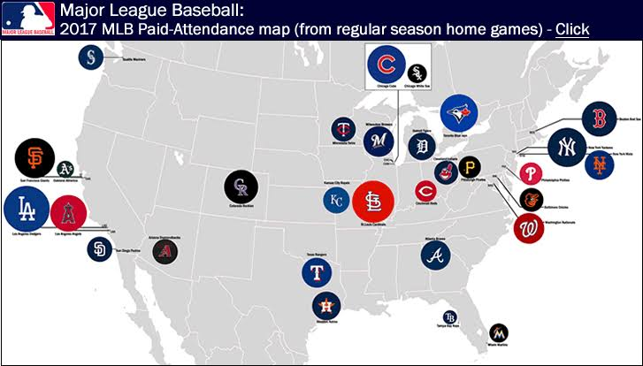
Appendix 2
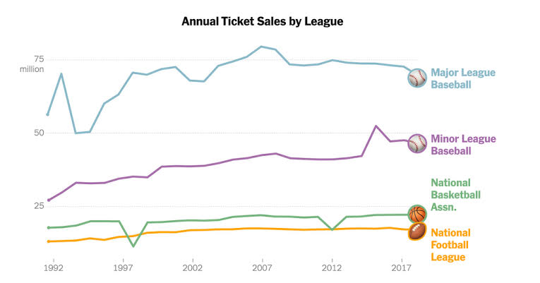
Appendix 3
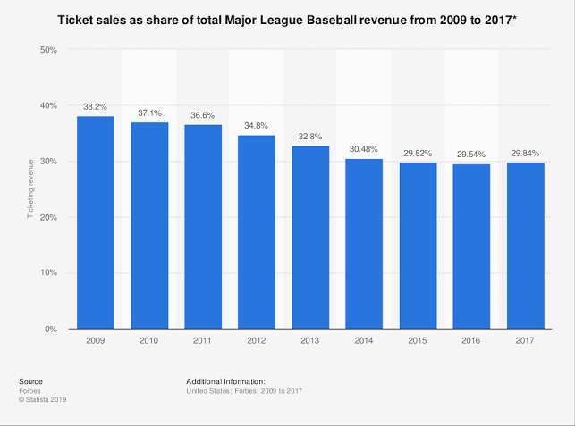
Appendix 4
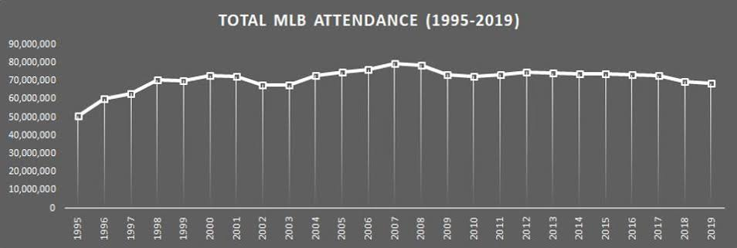
Appendix 5
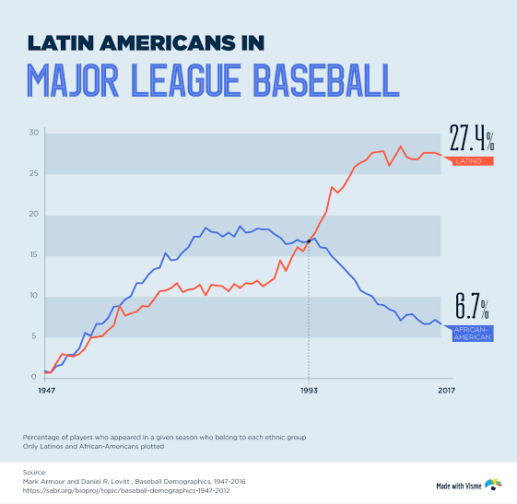
Appendix 6
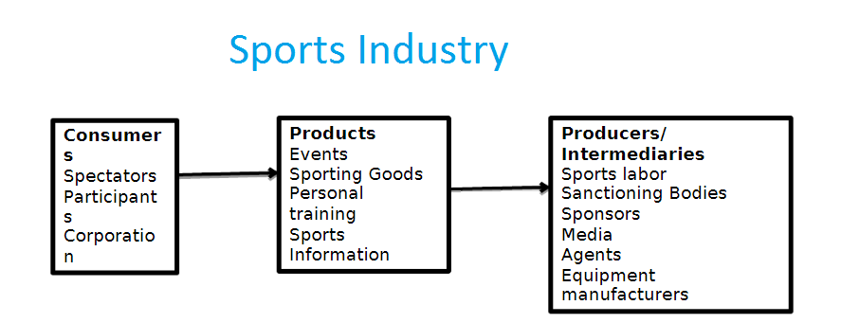

References
Boyd, T. C., & Krehbiel, T. C. (2003). Promotion Timing in Major League Baseball and the Stacking Effects of Factors That Increase Game Attractiveness. Sport Marketing Quarterly, 12(3).
Boyd, T. C., & Krehbiel, T. C. (2006). An analysis of the effects of specific promotion types on attendance at major league baseball games. American Journal of Business, 21(2), 21-32.
Bryman, A. (2017). Quantitative and Qualitative Research: further reflections on their integration. In Mixing methods: Qualitative and quantitative research (pp. 57-78). Routledge.
ESPN. (2019). MLB Attendance Report – 2019: Major League Baseball - ESPN. Retrieved 10 December 2019, from http://www.espn.com/mlb/attendance
Ferrand, A., & McCarthy, S. (2008). Marketing the Sports Organization: Building Networks and Relationships. Routledge.
Irwin, R. L., Sutton, W. A., & McCarthy, L. M. (2008). Sports promotion and sales management. Human Kinetics.
ISYB. (2018). 5 Reasons Why Sports Marketing Is Important For Your Company - Important Signs Your Business. Important Signs Your Business. Retrieved 25 September 2019, from http://www.burntisland-and-district-pipe-band.co.uk/5-reasons-why-sports-marketing-is-important-for-your-company/
Mbaskool. (2019). MLB Major League Baseball Marketing Mix (4Ps) Strategy | MBA Skool-Study.Learn.Share. Retrieved 10 December 2019, from https://www.mbaskool.com/marketing-mix/services/17815-mlb-major-league-baseball.html
MLB. (2019). The Official Site of Major League Baseball. MLB.com. Retrieved 30 October 2019, from https://www.mlb.com/
Nguyen, M. (2019). Applied Multi-Level Model on Panel Data in MLB Promotion Marketing. Medium. Retrieved 30 October 2019, from https://towardsdatascience.com/evaluating-bobblehead-promotion-in-mlb-an-application-of-multi-level-model-on-panel-data-8f5c6fc9e044
Rafique, A. (2012). Importance of Sports Marketing in the Modern Era - News Pakistan. News Pakistan. Retrieved 25 September 2019, from http://www.newspakistan.pk/2012/05/30/importance-sports-marketing-modern-era/
Red Card Global. (2018). Why is Sports Marketing important? Retrieved 25 September 2019, from http://redcardglobal.com/2018/03/16/why-is-sports-marketing-important/
Szymanski, S., & Valletti, T. M. (2010). Promotion and Relegation in Sporting Contests. In The Comparative Economics of Sport (pp. 198-228). Palgrave Macmillan, London.
Thomas, R. (2016). Why More and More Companies Are Choosing Sports Marketing Today. Linkedin.com. Retrieved 25 September 2019, from https://www.linkedin.com/pulse/why-more-companies-choosing-sports-marketing-today-rahul-thomas
Whitson, D. (1998). Circuits off Promotion: Media, Marketing and the Globalization of Sports. MediaSport, 57.

