History Paper: The Trial of Salem’s Witches

Name

Date

Following are the two images selected from the online Denver Art Museum Collection from two different centuries depicting American Indian History.
North American Indian
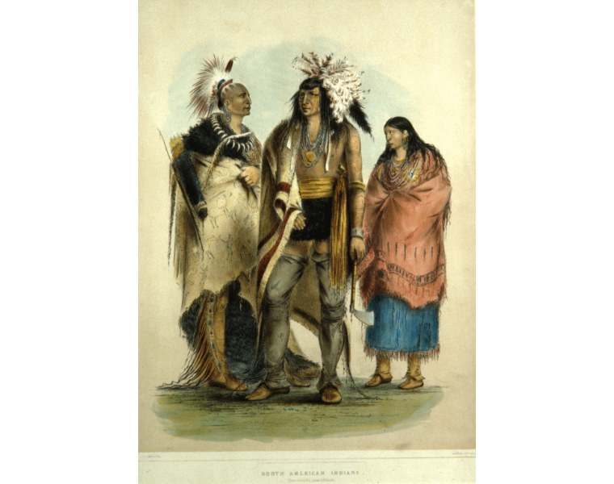
Piece of art:
North American Indian
Year of creation:
The 1830s
Artist:
George Catlin, an American who was born in Pennsylvania.
Tribe:
American Indian
Piece of art:
Essay
George Catlin is one of the most famous painters in American history. He started his professional life as a lawyer but he was not that satisfied with his work, so he gave time to his real passion that was painting and used to travel a lot so that he could find his painting subjects. From 1831 to 1837, George Catlin was famous in history for traveling extensively among native people, particularly he used to visit North America. This painting is one of the paintings that he made after studying the habits, customs, and modes of life he used to visit. Being a painter, George Catlin used to make small and large paintings but still, he wanted to make something unusual and important. One day, while he was thinking regarding his painting subject, he decided to paint the Native Americans after seeing a delegation of the Indians when they were on their way to Washington D.C. He is one who has studied the life of native indigenous people very closely when he used to visit their far-off places. In the 1830s, he traveled to Saint Louis, Missouri and it was the place from where he traveled towards the north into the lands where, for the very first time, he saw a few white Americans that he never came across before. It was the same place where he met the very first of many American Indians that he was about to paint. This painting “North American Indian” was made by Catlin for showing his love and respect for the American Indians as he believed that they were people of great worth. He painted this painting as he was aware that American Indians would quickly disappear.
This painting was painted in the period, Catlin used to travel to a far-off place for finding the inspiration for his paintings. In this painting, he depicted how worthy and important American Indians people were for him as he tried to paint all the positive aspects that he found in them. For this painting, Catlin was also criticized as he made the critics angry by depicting American Indians as brave and intelligent people. This painting shows his passion for appreciating American Indians and this painting was made when Catlin discovered these people in the northern lands. This painting itself depicts the greatness of the American Indian such as it shows that they had a well-organized civilization because they are portrayed as well-dressed people in the painting. This piece of art also depicts how such a sophisticated people, they were. This painting points towards their bravery and from their facial expressions, it becomes prominent that they are satisfied with their life. This masterpiece gives a glimpse of their life and the importance of their familial life as it portrays en elderly man along with a woman which means that women and elders are equally important for them. This painting also shows that they were a very creative people and knew how to make things for their daily use. The use of fur in this painting shows their skill and brilliance of mind. This painting also depicts their characteristic of valor, as they used to carry weapons (bow and arrow) that depicts that they were well aware of how to protect their families.
The American Indian (Russell Means)
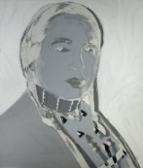
Piece of art:
The American Indian (Russell Means)
Year of creation:
1976
Artist:
Andy Warhol, who was born in Pittsburgh, PA

Tribe:
American Indian
Essay
Andy Warhol was born in Pittsburgh on 6 August 1928 and was a successful advertisement and magazine illustrator. He became famous as an artist after the popular art movements. Andy Warhol is one of the famous artists of the 19th century who used to painted celebrities’ portraits in garish vivid colors. This painting portrays Russell Means was an activist who worked hard for the rights of Native American people. He became a prominent figure of the American Indian Movement (AIM) after being a part of the organization in 1968. This painting was made by Catlin for paying his respect, as Russell is one of the people who attracted both national and international media towards Native Americans. This painting was made when the Native Americans used to be oppressed by authorities when, in the early period of the 1970s, militancy was over-exercising its powers. This painting was painted to show sympathy and support for Russell Means and all other Native Americans. It was the same time when Black Panthers emerged as a strong group. This painting reflects the darkness and gloominess of Russell's life as it was tough for him to raise a voice when violence was becoming more common. This painting was painted to show the bravery and courage of Native Americans. Warhol made this painting to drag the attention towards this nation and the efforts that were made for saving them. The portrayal of Russell Means shows the strength and struggle that Native Americans have been facing.
Through this painting, Warhol used a trick so that viewers could see the Native Americans as a stock character that specifically plays a type. Expressions portrayed in this painting depict the valor and fearless nature of this nation and Means was notorious as the fiercest and meanest Indian leader. It also depicts the cultural colors and uniqueness of these people. Choosing Russell as his portrayal subject, shows that Warhol was interested in studying the culture and life of the Native Americans. Colorlessness of this portrayal also points towards the lifeless life of Russell as he was merely focused on bringing his nation into the limelight so that they could be recognized as a cultural nation and could make the world realize their importance and existence.
So, taking a look at this painting of Warhol, it could be promulgated that this painting is a symbolic representation of the struggle that Russell went through in the 1970s so that his nation would be brought in the eye of the world and could make them realize their importance. The art itself reflects the courage, greatness and strength of one of the most prominent American Indian leaders. He participated in several treaties and also appeared on different important occasions to represent his nation. This piece of art was a symbolic representation of the greatness of American Indians who were a unique and well-civilized people. This painting was created when Russell was actively participating in a public gathering. He is the only one in the history of American Indians who came on the public forums to claim their rights. This painting reflects the valor and strong-headed leader who put all his efforts into raising his voice against all the injustices against his people. It also depicts Russell Means as a one-man army who stood for all the American Indians. “The American Indian (Russell Means)” shows a great history that the American Indians used to have and points towards the period when their great leader was fighting for them.

End Notes
Cholerton, Brenna, Adam Omidpanah, Steven P. Verney, Lonnie A. Nelson, Laura D. Baker, Astrid Suchy‐Dicey, William T. Longstreth Jr, et al. "Type 2 diabetes and later cognitive function in older American Indians: The Strong Heart Study." International journal of geriatric psychiatry 34, no. 7 (2019): 1050-1057.
Gaskell, Ivan. Paintings and the Past: Philosophy, History, Art. Routledge, 2019.
Bélanger, Pierre. "No Design on Stolen Land: Dismantling Design's Dehumanising White Supremacy." Architectural Design 90, no. 1 (2020): 120-127.
Bryan Jr, Jimmy L. "Our Eyes Ached with the Very Vastness": Reimagining the Great American Desert as the Great American Prairie." Great Plains Quarterly 39, no. 3 (2019): 243-263.

Bélanger, Pierre. "No Design on Stolen Land: Dismantling Design's Dehumanising White Supremacy." Architectural Design 90, no. 1 (2020): 120-127.
Bryan Jr, Jimmy L. "Our Eyes Ached with the Very Vastness": Reimagining the Great American Desert as the Great American Prairie." Great Plains Quarterly 39, no. 3 (2019): 243-263.
Cholerton, Brenna, Adam Omidpanah, Steven P. Verney, Lonnie A. Nelson, Laura D. Baker, Astrid Suchy‐Dicey, William T. Longstreth Jr, et al. "Type 2 diabetes and later cognitive function in older American Indians: The Strong Heart Study." International journal of geriatric psychiatry 34, no. 7 (2019): 1050-1057.
Gaskell, Ivan. Paintings and the Past: Philosophy, History, Art. Routledge, 2019.

