Rich Picture, Catwoe And Root Definition Report
[Name of the Writer]
[Name of the Institution]

Rich Picture, Catwoe And Root Definition Report

Introduction
Operations management is a critical aspect of how any business is supposed to run (Hart & Paucar, 2014). The key thing that has to be taken care off when operational management has to be run is to make sure that the business has complete insight about what are the particulars of the business, and how some of the thing that are going to affect the prospect of the business in the long run are needed to be improved to bring about more customer optimization (Green & Simister, 2016). The idea behind any operational management process has to make sure that it should be customer centric in a sense that it should take into account the fact that how maximum efficiency can be achieved out of it. During this paper, the operational management issues of the organization are going to be looked at in the light of the two problem solving matrices, which are the Rich Picture and CATWOE analysis (Gencoglu et al, 2018).

Rich Picture
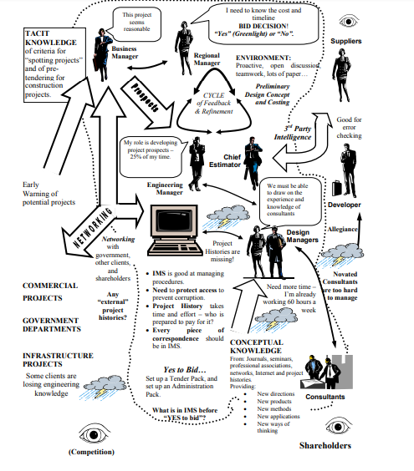

It has to be noted that the most important thing during the course of this process is to make sure that the insight is needed to be developed with regards to the particular of the projects and how they are going to be shaped up at the given point of time (Taylor et al. 2017). For instance, one thing that can be seen in the given scenario is that more effort is needed to be put together towards making sure that the pre-tender analysis is needed to be carried out (Gencoglu et al, 2018). The pre-tender analysis is going to go a long way towards making sure that the accurate assessment of the set of the requirement of the business are carried out (Finegan, 2016). As far as the method that was carried out for the development of the rich picture, it is important that insight from all the stakeholders is taken in the whole case so that clarity of the purpose is achieved with regards to how one is supposed to progress during the project (Bunch & Dudycha, 2017). The major thing that has to be taken care off is that how the interviews are going to be done in a semi structured narrative that even though that there is a sense of direction to the way things are supposed to be carried out, effort is going to be made to make sure that the management of the expectations of the stakeholders is going to be done in an appropriate manner (Doloi, 2016). The other thing that is important is that the role definition of all the stakeholders that are involved in the process must be carried out (Heyer, 2016). Now some sense of clarity is being developed with regards to the development and the purpose of the rich picture, in the next section, the CATWOE analysis is going to be carried out (Bunch & Dudycha, 2017). It also adds a sense of purpose through which operation management is done.

CATWOE Analysis

Customer
The customer in this case is going to be the regional manager (Ingram, 2018), One of the reasons that the regional manager has been selected as a customer is due to the fact that they are the one who is controlling the whole process and thus it is their insight that is going to be playing an important role when it comes to the way major developmental work for the project is going to be carried out (Bunch & Dudycha, 2017).

Actors
This is the part where the involvement of all the major stakeholders is quite important. The idea is to bring about and involve as many as people as possible to make sure that the sense of direction could be given to the project (Bunch, 2016). Not only that, effort is going to be made to make sure that the holistic view of the project is going to be developed so that the margin of error that is involved in the project could be brought down (Petkov et al, 2017). In this regard, it is important to make sure that some sense of perspective is also developed in terms of how the business requirements are going to be shaping up in this given case (Bunch, 2016).

Transformation
This is the area where the knowledge and the insight about the way tender process and operational management is going to be done would be quite critical (Bunch, 2016). The idea behind the whole process is to make sure that the technology and power are going to be clubbed together in the sense that the not only effort is going to be made to make sure that some sort of insight is developed about the overall business requirement, effort is going to be made to make sure that how the development of the prospective projects is going to be done at the given point of time (Petkov et al, 2017). What this process is going to do is that it would make sure that all the basic understanding in terms of the requirement is going to be made possible and then the feasibility and the tender bid process of the project is carried out in the manner that it aligns with the operational strength of the business (Bunch, 2016).

Welt Anschauung/Worldview
The worldview with regards to the project goes to show what are some of the holistic changes that are needed to be done to make sure that the broader changes in the project are implemented in an appropriate manner (Avison et al, 2016). Other aspect of the whole thing is to make sure that the how the determination of the feasibility of the tender bid is going to be carried out (Siddiqui & Tripathi, 2018). Most of the times, what happens is that the RM are the ones that are supposed to have good understanding in terms of the way functionality of the project is supposed to be working out and how the underlying understanding is going to work in that manner (Avison et al, 2016). The other thing that happens is that how it goes a long way towards making sure that the broader corporate objectives of the business are being taken care off (Avison et al, 2016).

Owner
The pre contract team are going to be the one that would administer and supervise the whole process (Sørensen et al, 2015).

Environment
The environment concerns are going to be managed in the manner that the quality and time criticality during the course of the project is going to be managed in the right manner in the pursuit of the corporate goals (Avison et al, 2016).

Conclusion
In this paper, the CATWOE and the Rich picture were being used as a tool to make sure that how the process improvement drive in the organization is supposed to be carried out (Taylor et al. 2017). The idea at the broader level when such exercises are carried out is to make sure that in some ways the value preposition of the business is going to work out well. Not only that, the other idea is to ensure that the level of correspondence among stakeholders is managed in the appropriate manner (Taylor et al. 2017).

References

Avison, D. E., Golder, P. A., & Shah, H. U. (2016). Towards an SSM toolkit: Rich picture diagramming. European Journal of Information Systems, 1(6), 397-408.
Bunch, M. J. (2016). Soft systems methodology and the ecosystem approach: a system study of the Cooum River and environs in Chennai, India. Environmental Management, 31(2), 0182-0197.
Bunch, M. J., & Dudycha, D. J. (2017). Linking conceptual and simulation models of the Cooum River: collaborative development of a GIS-based DSS for environmental management. Computers, environment and urban systems, 28(3), 247-264.
Doloi, H. K. (2016). Understanding stakeholders' perspective of cost estimation in project management. International journal of project management, 29(5), 622-636.
Finegan, A. (2016). Soft Systems Methodology: An Alternative Approach to Knowledge. Complex Systems: From Biology to Computation, 232.
Gencoglu, G., Altmann, G., Smith, R., & Mackay, D. (2018). Using soft systems methodology to address supply chain management problems. Australasian Journal of Information Systems, 9(2).
Green, S. D., & Simister, S. J. (2016). Modelling client business processes as an aid to strategic briefing. Construction Management & Economics, 17(1), 63-76.
Hart, D., & Paucar‐Caceres, A. (2014). Using Critical Systems Heuristics to Guide Second‐Order Critique of Systemic Practice: Exploring the Environmental Impact of Mining Operations in Southern Peru. Systems Research and Behavioral Science, 31(2), 197-214.
Heyer, R. (2016). Understanding Soft Operations Research: The methods, their application and its future in the Defence setting (No. DSTO-GD-0411). DEFENCE SCIENCE AND TECHNOLOGY ORGANISATION SALISBURY (AUSTRALIA) INFO SCIENCES LAB.
Ingram, H. (2018). Using soft systems methodology to manage hotels: a case study. Managing Service Quality: An International Journal, 10(1), 6-10.
Nakatani, T., & Fujino, T. (2018, December). Role and owner based business domain analysis. In 12th Asia-Pacific Software Engineering Conference (APSEC'05) (pp. 8-pp). IEEE.
Petkov, D., Petkova, O., Andrew, T., & Nepal, T. (2017). Mixing multiple criteria decision making with soft systems thinking techniques for decision support in complex situations. Decision Support Systems, 43(4), 1615-1629.
Siddiqui, M. H., & Tripathi, S. N. (2018). Application of soft operations research for enhancing the servicescape as a facilitator. Vikalpa, 36(1), 33-50.
Sørensen, C. G., Fountas, S., Nash, E., Pesonen, L., Bochtis, D., Pedersen, S. M., ... & Blackmore, S. B. (2015). Conceptual model of a future farm management information system. Computers and electronics in agriculture, 72(1), 37-47.
Taylor, M. J., Baskett, M., Hughes, G. D., & Wade, S. J. (2017). Using soft systems methodology for computer game design. Systems Research and Behavioral Science: The Official Journal of the International Federation for Systems Research, 24(3), 359-368.

