Week 8 Question 1:
The problem under consideration has a total of five constraints. The data provided shows that the problem is a maximization problem in which the profit generated by selling the beer need to be maximized.
There are three variables that need to be adjusted for this maximization problem. The number of beers for each type constitute the variables. The constraints for the problem include the budget, the storage capacity and the maximum customer demand provided in the question. The objective function in this problem is defined as the cost function depending upon the prices of each type of beer being sold. The solution as found in Microsoft Excel is shown below. The excel file is attached as well.

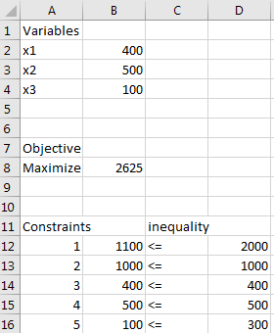

The number of beers that need to be sold for maximum profit can be seen in front of the variables x1, x2 and x3. The maximized profit can be seen in front of the cell stating objective function. The way that the constraints have been met can also be seen from the given excel sheet.

Week 9 Question 5:
The office manager for the Gotham Life Insurance Company orders letterhead stationery from an office products firm in boxes of 500 sheets. The company uses 6,500 boxes per year (250 working years). The annual carrying cost is 20% of the price of a box of stationery and ordering cost is $28. The following discount price is provided by the office supply company.
Order quantity: 1-499 Price per box: $16
Order quantity: 500-999 Price per box: $14
Order quantity: 1000-1499 Price per box: $13
Order quantity: 1500 or more Price per box: $12
A. What is the optimal order quantity?
B. How many orders are placed per year?
C. What is the cycle time?
D. What is the reorder point if the lead time is two weeks?

Economic Order Quantity (EOQ)
If using the economic order quantity for placing orders, the company has to monitor its inventory continuously. Such a policy minimizes the total inventory-related costs. These costs include the cost of purchasing, ordering and holding inventory.

Answer and Explanation:
A. Finding the optimal policy
We will calculate the EOQ for each price as
Q=√2∗Annual Demand ∗ Ordering Cost/Carrying Cost ∗ Purchase Price
If a particular quantity is not feasible for the price it is calculated for, we will adjust it to the nearest feasible quantity. Then, we will calculate the total cost of each option as
C(Q)=Annual Demand ∗ Purchase Price + Annual Demand / Q ∗ Ordering Cost + Q/2∗ Carrying Cost ∗ Purchase Price
- If the price is $16 per box, then
Q=√2∗6,500∗$280.2∗$16=337 boxes
The total cost is
C(337)=6,500∗$16+6,500337∗$28+3372∗0.2∗$16=$104,000+$540+$540=$105,079C(337)=6,500∗$16+6,500337∗$28+3372∗0.2∗$16=$104,000+$540+$540=$105,079
- If the price is $14 per box, then
Q=√2∗6,500∗$280.2∗$14=361 boxes
This order quantity is not high enough to get this price, and so we adjust it to 500 boxes.
The total cost is
C(500)=6,500∗$14+6,500/500∗$28+500/2∗0.2∗$14=$91,000+$364+$700=$92,064
- If the price is $13 per box, then
Q=√2∗6,500∗$280.2∗$13=374 boxes
This order quantity is not high enough to get this price, and so we adjust it to 1,000 boxes.
The total cost is
C(1,000)=6,500∗$13+6,5001,000∗$28+1,0002∗0.2∗$13=$84,500+$182+$1,300=$85,982
- If the price is $12 per box, then
Q=√2∗6,500∗$280.2∗$12=389 boxes
This order quantity is not high enough to get this price, and so we adjust it to 1,500 boxes.
The total cost is
C(1,500)=6,500∗$12+6,5001,500∗$28+1,5002∗0.2∗$12=$78,000+$121+$1,800=$79,921

The lowest cost is achieved at the order quantity of 1,500 boxes. Hence, the optimal order quantity is 1,500 boxes
B. Finding the number of orders per year
Average Number of Orders Placed per Year=Annual Demand/Q=6,5001,500=4.33 orders per year
C. Finding the cycle time
Cycle Time = Number of Days in a Year/Average Number of Orders Placed per Year=250/4.33=58 days
D. Finding the reorder point
Reorder Point=Lead Time in Working Days ∗ Daily Demand=10∗6,500/250=260 boxes

Question 3:
Assume the carpet store makes N orders per year
Then the quantity of carpet ordered will be 10000/N yards.
Since no particular details about carpet inventory are given, you will assume that the inventory is
completely depleted during each order period, just as a new order is received. This means the average
inventory during the order period is 1/2 of the order quantity, or 5000/N yards.
The total annual cost (C) of ordering and warehousing the carpet is...
(at $8 per yard)
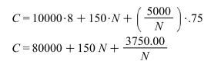
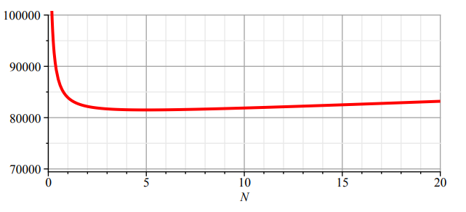
Plotting this function shows that a minimum cost is achieved somewhere around 5 orders per year. Find the exact value by setting the derivative of Eqn 1 equal to zero, and solve for N.
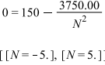
The negative solution for N is meaningless in this problem, so N = 5 is the number of orders that will (5) (6) (8) (9) (7) (4) result in the lowest overall cost for the year when the carpet costs $8/ yard The inventory cost (I), at N = 5 orders per year is...
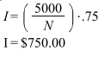
When the carpet cost is $6.50/yd, the cost equation changes, but the optimum number of orders per year does not. I'll let you recalculate eqn 1 based on a carpet price of $6.50 and prove it to yourself. The inventory cost will change however, since you will only need 2 orders of 5000 yards to satisfy the annual demand. So the inventory cost at N = 2 is,
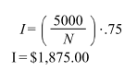
Some folks would add the average cost of the carpet in inventory to this value, but your problem statement gives no indication of whether or not to do this. Do not let the inventory cost be the only consideration for what number of orders to make. Go back and use the first equation to determine annual cost at $8/yd and 5 orders per year...
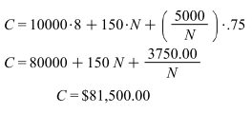
at $6.50/yard and 2 orders per year.
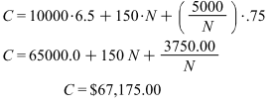
Week 10 question 3
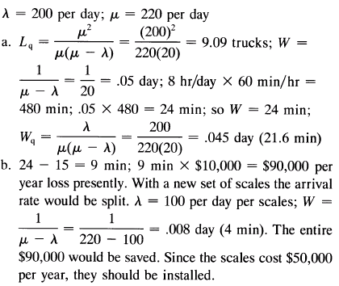
Week 10 question 2
