Sports Facility Business Plan
[Name of the Writer]
[Name of the Institution]

Sports Facility Business Plan

Concept Overview
The idea behind the business plan is to make sure that the multi sports and multi-faceted sports complex and facility can be created. In the facility, there is going to be place for the casual people who would just like to work out (Coates & Humphreys, 2018). Other than that, there is going to be provision for the people who want to pursuit sporting as a full-time career and thus there is going to be a high-performance centre where people would be trained for the future events and tournaments. The key feature of the program is that there are going to be specialized programs for women and children as well (Baade, 2016).

Business Organization
At the moment, the business plan is formulated on the basis that as the interest of the community is involved, it is going to be partnership where stakes are going to be organized in the manner that there would be both involvement of the local organizers and effort would be made for some sort of intervention from the local government (Baade, 2016). The program is going to be pitted for other businesses and stakeholders as well during the given time period (Baade, 2016).

Operational Plan
As discussed, it is going to be a multi user facility where users are going to be combined and a platform is going to be provided to them in order to make sure that the users would be utilizing various services. There is going to be a fitness and lifestyle centre and its usage is going to be mandatory for all the people who are the part of the people that have enrolled in the plan. The idea would be to build the core strength of the people.
Then there is going to be a weight and fitness centre that will be matched with the fitness facility. It would have special trainers to make sure that the core of the people that are enrolling in the program is in the right place and they are able to build towards their strength and conditioning so that they are in the position to make sure that they pursuit much tougher sports-oriented plans (Baade & Matheson, 2016). There would be full faze basketball, badminton and volleyball courts that are going to be the part of the main floor. Furthermore, effort is going to be made to make sure that the floors are designed in the manner that they accommodate badminton, indoor soccer and range of some of the services. At the same time, there is going to be a food and service areas that would be designed in the manner that the options that are going to be placed there would be such that should allow people who have enrolled to have healthy eating options (Bach, 2017). The idea behind the whole facility is to make sure that the environment is being provided to the people where they are able to make the most of their abilities and build upon their strength. There is going to be a massage centre and rehabilitation centre that allows people to make sure that they are able to manage their injuries or their wellbeing in an appropriate manner if something happens to them during the course of the training.

Training Requirements
Each of the person that is going to be enrolled in the program would have to go through a training program. The basis of the training program is to make sure that the people are in the position to make sure that they are able to press forth the advantage in terms of how they are going to be learning their broader set of skills at the given point of time and what are some of the things that are needed to be done at the broader level by them (Greenberg et al, 2016). They would be made to adhere to the strict diet regime as well to make sure that they are in the right shape (Baade, 2016).

Licensing Agreements
The effort would be made to make sure that the trainers are brought on board that have the knowledge and insight about how the industry is supposed to be working and what are some of the broader variables that are needed to be kept in mind when such a facility is created (Swindell & Rosentraub, 2018). The idea is to make sure that these trainers would have the required certification so that they are in the position to embark the knowledge to the people who are enrolling into the institution (Greenberg & Hughes, 2017).

Financial Plan
The first thing that is needed to be done when it comes to making sure that the financial planning is being done is to make sure that some sort of evaluation of the start-up cost is being carried out (Rappaport & Wilkerson, 2018). As per the initial estimates, the cost for this project is going to be around $ 2,500,000 million at the initial level. This cost includes the proceeds that are going into the equipment, the start-up capital as well as some other major provisions that are going to be important to make sure that the business can be kick started.
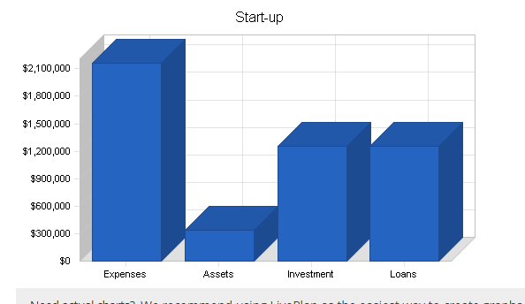
As some insight is developed about the way start-up cost is going to be managed. In the next section, it is going to be seen that how the sales forecast for the given business is going to be working out. It can be seen that how in the case of this business, as there are broader range of services, there are going to be lot of avenues through which it is going to be made sure that the revenue accumulation is going to be carried out. Below mentioned is the plan that how the sales are going to be working out for first three years (Humphreys, 2014).

SALES FORECAST
 | YEAR 1 | YEAR 2 | YEAR 3
Unit Sales
Membership Fees | 741 | 950 | 1140
Walk-in Fees | 10,260 | 10,260 | 10,773
Camps, Clinics, and Programs | 684 | 684 | 1,425
Court Rentals | 684 | 684 | 718.2
Leagues | 2,189 | 1,946 | 2,043
Personal Training | 1,026 | 1,077 | 1,131
Pro Shop | 11.4 | 0.95 | 0.95
Food and Beverages | 11.4 | 0.95 | 0.95
Massage Therapy Clinic | 998 | 1,026 | 1,077
Other (Outside Tournaments...) | 3.8 | 0 | 0
TOTAL UNIT SALES | 16,608 | 16,629 | 18,309
Unit Prices | Year 1 | Year 2 | Year 3
Membership Fees | $614.65 | $645.38 | $645.38
Walk-in Fees | $4.28 | $4.51 | $4.75
Camps, Clinics, and Programs | $23.75 | $71.25 | $74.81
Court Rentals | $38.00 | $39.90 | $41.90
Leagues | $61.75 | $64.84 | $68.07
Personal Training | $14.25 | $15.20 | $16.15
Pro Shop | $1,425.00 | $17,955.00 | $18,852.75
Food and Beverages | $2,375.00 | $29,925.00 | $31,421.25
Massage Therapy Clinic | $4.75 | $4.99 | $5.23
Other (Outside Tournaments...) | $3,800.00 | $3,990.00 | $4,132.50
Sales | 0 | 0 | 0
Membership Fees | $479,427 | $645,383 | $774,459
Walk-in Fees | $46,170 | $48,735 | $53,865
Camps, Clinics, and Programs | $17,100 | $51,300 | $112,219
Court Rentals | $27,360 | $28,728 | $31,673
Leagues | $142,272 | $132,787 | $146,346
Personal Training | $15,390 | $17,237 | $19,235
Pro Shop | $17,100 | $17,955 | $18,853
Food and Beverages | $28,500 | $29,925 | $31,421
Massage Therapy Clinic | $4,988 | $5,387 | $5,925
Other (Outside Tournaments...) | $15,200 | $0 | $0
TOTAL SALES | $793,507 | $977,436 | $1,193,994

Future Plans and Strategic Risk
At the starting level, effort is going to be made to make sure that the activities of the sports complex are being managed in the smaller scale, but as the facility is going to be expanding (Peric, 2015), following are some of the plans.
- A high-performance centre is going to be carried out
- Range of the services are going to be inclined in the manner that more sports-oriented basis are going to be made.

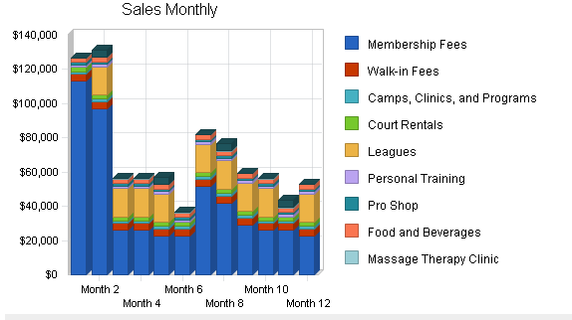

References

Baade, R. A. (2016). Professional sports as catalysts for metropolitan economic development. Journal of urban affairs, 18(1), 1-17.
Baade, R. A., & Matheson, V. A. (2016). Financing professional sports facilities. Financing economic development in the 21st century, 323.
Bach, L. (2017). Sports without facilities: the use of urban spaces by informal sports. International review for the sociology of sport, 28(2-3), 281-296.
Coates, D., & Humphreys, B. R. (2018). Professional sports facilities, franchises and urban economic development. Public Finance and Management, 3(3), 335-357.
Greenberg, M. J. (2016). Sports facility financing and development trends in the United States. Marq. Sports L. Rev., 15, 93.
Greenberg, M. J., & Hughes Jr, D. (2017). Sports. comm: It takes a village to build a sports facility. Marq. Sports L. Rev., 22, 91.
Humphreys, B. R. (2014). The myth of sports-led economic development. West Virginia Univ., Department of Economics.
Peric, M. (2015). Managing sports experiences in the context of tourism. UTMS Journal of Economics, 6(1), 85-97.
Rappaport, J., & Wilkerson, C. (2018). What are the benefits of hosting a major league sports franchise?. Economic Review-Federal Reserve Bank of Kansas City, 86(1), 55-86.
Swindell, D., & Rosentraub, M. S. (2018). Who benefits from the presence of professional sports teams? The implications for public funding of stadiums and arenas. Public Administration Review, 58(1), 11-21.

