Physical Science
Name:
Student Number:
Type your answers in the space below each question. Do NOT use the internet - use ONLY the textbook to create solutions in your own words.
Answer questions #1-3 based on the following scenario.
Scientists tested the effect of a fertilizer on the growth of plants. They had 2 sets of plants, Group A which gets fertilizer, water and sun and Group B which gets only water and sun (but in equal amounts to Group A).
- Explain how this scenario is a controlled experiment and identify the manipulated variable.
It is a controlled experiment because scientists have made two different groups for observation and testing.
- Group A which gets fertilizer, water, and sun, it a control variable
- Group B which gets only water and sun, it is an independent variable.

- If the scientists only performed 1 experiment but it supported their hypothesis, why can it not be considered a theory?

Hypothesis’s validity is tested by multiple experiments that show the same results. A single experiment is not enough to prove the validity of the hypothesis. Its validity demands repeatability and precision in results. A successful hypothesis then takes its voyage of becoming a theory.

- The graph below was created showing the growth of the plant. How would you know that the y-axis is measuring the growth of the plant?

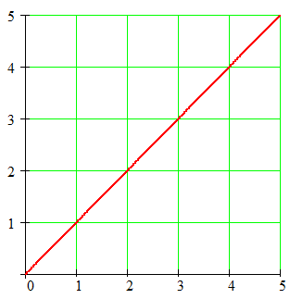
As time is independent quantity in this graph, so it will be placed in the x-axis of the graph. On the other hand, the growth of the plant is dependent on time, so it will be placed in the y-axis of the graph.
4. You make the following measurements of an object: 42 kg and 22 m³. What would the object’s density be? Show your work for credit and include final units.
Given data:
Mass of an object= 42kg
Volume of an object= 22 m³
Formula:
Density of an object = Mass/Volume
Solution:
Density of an object = 42 kg / 22 m³
Density of an object = 2kgm⁻³

5. Explain why a chlorinated swimming pool water would be a homogenous mixture?
The chlorinated swimming pool will be a homogeneous mixture because it will have a uniform composition throughout. On visually seeing, we won’t be able to tell chlorine (solute) and water (solvent) apart.
6. Both slicing a tomato and a chemical change such as burning toast cannot be reversed. However, why is slicing a tomato still considered only a physical change?
When we burn toast, it's physical, as well as its chemical nature is changed. But when the tomato is cut, only physical aspects are changed such unity or wholeness, and shape, etc. but the chemical composition of the tomato remains the same that is why it is considered as a physical change only.
7. If an ice cube melts at 0ºC, but water also freezes at 0ºC, what is the difference between melting and freezing in terms of (a) the energy involved in the phase changes and (b) particles of the substances during the phase changes?
Answer:
(a) When the ice cube melts at 0⁰C that means energy is being provided/absorbed, the kinetic energy of the molecules of the solid will go on increasing and they will start vibrating at their mean positions unless their kinetic energy will get high enough to increase intermolecular forces between them and ice will change its state into liquid.
On the other hand, when water freezes at 0⁰C that means that kinetic energy of the molecules is dropping, they become motionless, come close to each other by lessening intermolecular forces and align themselves in geometrical alignment.
(b) In melting, particles of H₂O start vibrating at their mean position and their kinetic energy goes on increasing which increases intermolecular space between them, and they become able to move.
On the other hand, in freezing, energy is released by the water and low kinetic energy become responsible for the immobility of the molecules, and they come close to each other and align themselves geometrically.
For questions #8 – 9 use the following pictures:
- 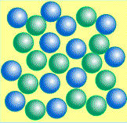 B. 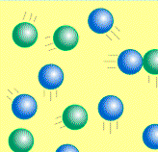 C.
8. Which picture(s) would best represent atoms in the gas of a neon sign? Explain why.
It picture “B.” As the molecules are far apart from each other, moving here and there and colliding which is clearly a property of the gas.
9. Which picture(s) would best represent a rock? Explain why.
Picture C, as molecules are closely packed, motionless and aligned in a geometrical shape which represents the properties of a solid.
10. If measurements of a gas are 75L and 300 kilopascals and then the gas is measured a second time and found to be 50L, describe what had to happen to the pressure (if temperature remained constant). Include which law supports this observation.
Boyle’s law supports this observation as it describes the relation between pressure P and Volume V.
V∝1/P
PV = k (constant)
Boyle's law states that the volume and pressure of a gas are inversely proportional to each other if the temperature is kept constant. It means if the pressure is increased, the volume of the gas will be decreased and vice versa.
Calculations
Given Data:
P1= 300 kPa
V1 = 75 L
V2 = 50 L
Formula:
P1VI = P2V2
P2 = P1V1/V2
By putting values:
P2 = 75*300/50
P2 = 450 kPa
Increase in pressure decreases the volume.

11. Which statement matches the scientists to their research on atomic theory?
a. Dalton used gold foil; Bohr made the planetary model of atoms
b. Thomson used gold foil; Dalton believed atoms had no internal structure
c. Rutherford used gold foil; Thomson discovered electrons
d. Rutherford discovered electrons; Thomson made the planetary model of atoms
(c) Rutherford used gold foil; Thomson discovered electrons.
For question #12, use the following picture:
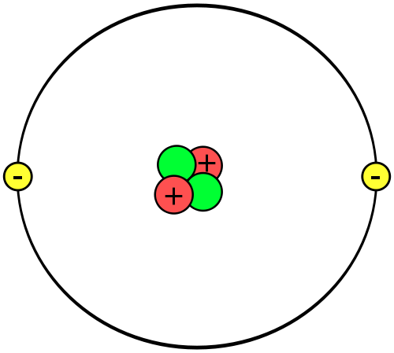
12. What element is this? How do you know?
Answer:
This element is Helium which is a noble gas because it has:
Number protons = 2
So,
Atomic number = 2
Number of neutrons = 2
So,
Atomic mass = Number of protons + number of neutrons = 2+2 = 4
And 2 electrons in valence shell which are fulfilling the duplet rule.
For question #13, use the following picture:
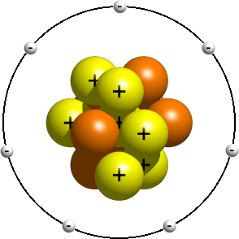
13. The picture is a model of a nitrogen atom. What is incorrect about the atomic orbital arrangement of electrons in this model and how should they be arranged?
Mentioned model of the Nitrogen atom is incorrect because of its arrangement of electrons in orbits.
Its placements need to be done in 2 orbits. As there is space of only 2 electrons in K shell (the first shell that is nearest to the nucleus), so 2 electrons will be placed in the first orbit. In L shell (second shell from the nucleus) maximum 8 electrons can be added in it, so remaining 5 electrons will be added in L shell.
For questions #14 – 17, write an equation for the reaction of magnesium chloride and sodium oxide to produce magnesium oxide with sodium chloride.
14. Show the formulas of the reactants.
Magnesium chloride = MgCl₂
Sodium Oxide = Na₂O

15. Show the formulas of the products.
Magnesium Oxide = MgO
Sodium Chloride = NaCl
16. Write the balanced the equation for this reaction.
Balanced equation:
MgCl₂ + Na₂O → MgO + 2NaCl
17. What type of chemical reaction is this? How do you know?
The reaction is double displacement reaction. As the negatively charged anions and positively charged cations switch their places to form products.
18. When is an atom unlikely to react and form chemical bonds?
When an atom has enough electrons in its outer most shell to fulfill its duplet and octet rule, and it has attained the electronic configuration of the nearest noble gas, atom gains stability and is unlikely to react and form chemical bonds.
19. What is the order of the types of nuclear radiation from lowest to highest energy?
Alpha particles <Beta particles <Gamma particles.
20. Which statement is false? Rewrite it so that it is true.
a. Fusion involves the combination of two smaller atoms into a larger atom.
b. Fission involves the splitting of an atom into smaller atoms.
c. Fission and fusion are two processes that release very little amounts of energy.
Statement “c” is false. Rewriting it as:
Fission and fusion both are the processes that release a massive amount of energy.
21. What naturally occurring radioisotope is used as the fuel for a nuclear reactor?
Uranium-235 is a naturally occurring radioisotope that is used as the fuel for a nuclear reactor.
22. Magnesium oxide is a binary ionic compound. From its formula, MgO, how do you know that Mg is the metal?
MgO is an oxide. Oxides are those chemical compounds that house at least one atom of oxygen and one atom of another element. The oxidation number of oxygen in oxides us -2. Similarly, in MgO, the oxidation number of Mg is +2 and Oxygen is -2.
When we write formulas of binary ionic compound metal is always written first because of its positive oxidation number.
23. On the periodic table, there are two numbers in the block for the element potassium, K: 19 and 39.098. What are the names of the numbers and what do they measure?
These numbers measure the atomic number, and the atomic mass of potassium K. 19 represents the atomic number of potassium and 39.098 represents the atomic mass of potassium.
24. Element X has five valence electrons, element Y has one valence electron, and element Z has one valence electron. Which two of these elements are most likely to have similar properties? Explain your answer.
Y and Z have similar properties as both elements are of the same group. Elements in a group share similar properties because of the similar number of electron in the outer most shell — for example, sodium and potassium.

