Your Name

Instructor Name

Course Number

Date

Title: Simple and Fractional Distillation of a Binary Mixture

**Introduction**

The experiment of simple and fractional distillation of toluene and cyclohexane was performed. The difference in volatility will enable us to separate the liquids. There are two types of liquids ones which easily vaporize are called volatile whereas others are nonvolatile liquids. The vapor pressure of a liquid is a state of the pressure of gas while it's in a liquid state. The boiling point is a temperature at which the vapor pressure of the liquid is equal to external pressure. Distillation is a process that depends on the vapor pressure of the liquid. The liquid having higher vapor pressure would be distilled initially as the concentration would be greater (Santos et al.). Through simple distillation, liquids having a greater difference in the vapor pressures would be separated. The fractional distillation process utilizes a fractioning column and various condensations and vaporizations would be collected to separate the liquids. This procedure is effective for liquids having less difference in their boiling points. According to Raoult's law, the mole fraction of solvent when multiplied by the vapor pressure gives the vapor pressure of the solution. Dalton's law states that every gas in a container will exert equal pressure as if it is present separately (Santos et al.). Or the mixture of gases will exert the same vapor pressure on the container as they would exert when no other gas is present. Azeotropes are those mixtures of liquid having constant boiling points and composition through the distillation process. For example, disopropyl ether, and isopropyl alcohol.

**Experimental Section**

**Simple Distillation**

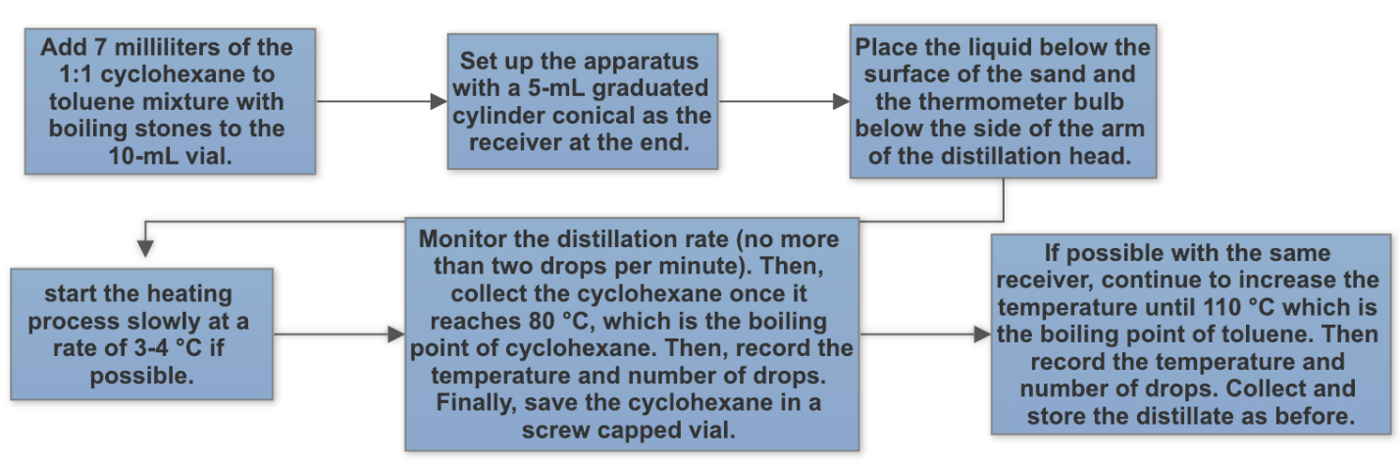

**Fractional Distillation**

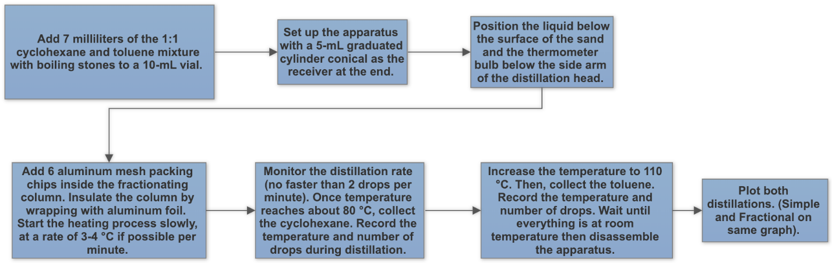

**Table of Contents**

**Table 1.** General information about the chemicals used.

|  |  |  |
| --- | --- | --- |
| Chemical | Cyclohexane | Toluene |
| Formula | C6H12 | C7H­­­8 |
| Molar Mass | 84.16 g/mol | 92.14 g/mol |
| Melting Point | 6.47 °C | -95 °C |
| Boiling Point | 81 °C | 111 °C |
| Structure |  |  |
| Systematic IUPAC name | Cyclohexane | Methyl benzene |
| Toxicity | It causes skin irritation, drowsiness, and may be fatal if swallowed. | It causes skin irritation, drowsiness, and suspected of damaging fertility. |
| Hazards | Highly flammable liquid and vapor. | May cause damage to organs through prolonged exposure. |

**Results**

**Table 2.** Fractional and simple distillation data for toluene and cyclohexane

|  |  |  |  |  |  |
| --- | --- | --- | --- | --- | --- |
| Simple Distillation | Temperature (°C) | Drops ml | Fractional Distillation | Temperature (°C) | Drops ml |
| Cyclohexane | 40 | 0.8 ml | Cyclohexane | 49 | 3.1 ml |
| 44 | 1 ml |  |  |
| 45 | 1.1 ml |  |  |
| 47 | 1.5 ml |  |  |
| 48 | 1.8 ml |  |  |
| 48 | 2 ml | Toluene | 49 | 1.4 ml |
| 48 | 2.2 ml |  |  |
| 48 | 2.5 ml |  |  |
| 48 | 3 ml |  |  |
| Toluene | 50 | 0.5 ml |  |  |
| 51 | 1 ml |  |  |
| 52 | 1.1 ml |  |  |
| 52 | 1.2 ml |  |  |
| 49 | 1.4 ml |  |  |

**Figure 1.** Distillation curves for simple and fractional distillation

Percent recovery = $\frac{Amount of pure product recovered}{ amount of crude material used}$ x 100

**Simple distillation percent recovery for cyclohexane**

Percent recovery = $\frac{2 mL}{3.0 mL}x 100=66.6\%$

**Simple distillation percent recovery for toluene**

Percent recovery = $\frac{2 mL}{3.0 mL}x 100$ = 66.6%

**Fractional distillation percent recovery for cyclohexane**

Percent recovery = $\frac{3.1 mL}{3.2 mL}x 100$ = 96.0%

**Fractional distillation percent recovery for toluene**

Percent recovery = $\frac{2.1 mL}{3.0 m}ax 100$ = 70%

**Discussion**

The purpose of the experiment was to perform fractional and simple distillation to separate a mixture of cyclohexane and toluene. The percent recovery was performed after the experiment as 96% cyclohexane and 70% toluene (Anokhinaa et al.). Fractional distillation has produced a slightly higher percentage of cyclohexane and toluene as compared to a simple distillation process. Also, the graphical representation has described that the simple distillation curve was steady slightly and the fractional distillation curve was not linear. The graphical representation was slightly different as when performed in the lab (Santos et al.). The boiling temperature of toluene was 111 °C and cyclohexane has 81 °C. After half of the time in the experiment, the number of fractions collected was gradually increasing.

**Conclusion**

Distillation is a process based on the vapor pressure of the liquid that can help in the separation of liquids. The liquid having higher vapor pressure would be distilled firstly as the concentration would be better (Santos et al.). Through simple distillation, liquids having a greater difference in the vapor pressures would be separated as we observed in the experiment. The fractional distillation process utilizes a fractioning column and various condensations and vaporizations would be collected to separate the liquids.

Work Cited:

Anokhinaa, Elena A., et al. “Energy Saving Schemes for Separation of Benzene-Cyclohexane-Toluene Mixture with Different Initial Compositions by Extractive Distillation.” *CHEMICAL ENGINEERING*, vol. 69, 2018.

Santos, Cecília IAV, et al. “Isothermal Molecular Diffusion in Mixtures Containing Toluene, Cyclohexane and Methanol.” *The European Physical Journal E*, vol. 40, no. 4, 2017, p. 40.