History 12
Propaganda Posters
[Author Name(s), First M. Last, Omit Titles and Degrees]
[Institutional Affiliation(s)]

Author Note
[Include any grant/funding information and a complete correspondence address.]

History 12
Propaganda Posters
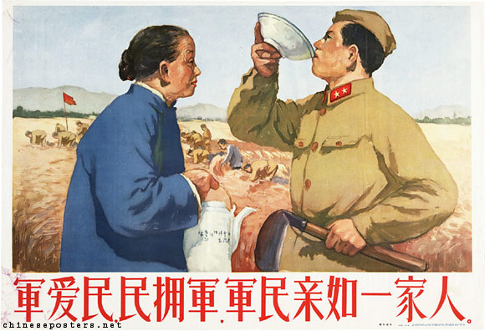
This poster is intended for the promotion of propaganda about Chinese military history. Usage of propaganda can be traced back to hundreds of years but it was most popular and effective in China during the 20th century. Specific mention should be made of the Chinese Communist party who played an instrumental role using propaganda as a key control mechanism. In this poster, the most immediate information that can be identified is that people love the army and in turn, the army loves the people of its nation as well. It can be noticed that even though there is hard labor and toil depicted in the background, the flag of communism is high and very obvious. The two characters in the poster, a soldier also regarded as the son of the soil, and an old woman, both share equal space in the poster which represents the level of equality enjoyed by them. The text written as a caption below the figures also indicates the bilateral love shared between the army and citizens of a nation.
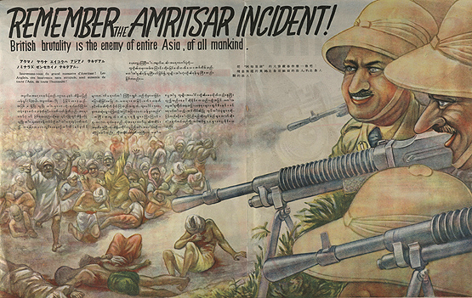
In this poster, the Indian national army propaganda is being depicted. The British soldiers have a cunning smile on their faces and they both seem too powerful. An expression of hedonism can also be seen on their faces. Contrary to these two figures, hundreds of wounded, battered, crying, and miserable Asians are also seen lamenting in the face of the two British soldiers. This poster also illustrates the history of a provisional and powerful government when the Asian sub-continent was imperialized by the British army. In the poster, the poignant line, “Remember the Amritsar Incident” is written appearing to be terrifying the weak Asians. The Amritsar incident was the 1919 mass killing of the Indians and the Sikhs by the brutal British, and in this poster, Japanese propaganda is also aimed at the Indians and natives of the sub-continent. This propaganda is British in nature.

What features of the Vietnam War contributed to the mental disorder of PTSD in returning victims?
The Vietnam War can be largely attributed to the spread of communism in the concerned region. This war can also be associated with the struggles of the United States of America to prevent Vietnam from turning into a communist state. There was a misunderstanding about the motives of political and military leadership on both sides and in this process, the collateral damage was borne by the civil citizens and the general masses. The death toll was entirely and almost Vietnamese and according to a rough estimate, over a quarter million Vietnamese War veterans still have to go for therapy to lessen the symptoms of post-traumatic stress disorder. Apart from many other incidents, the Vietnamese army was outmanned and out of ammunition most of the time even though it was a professional and courageous fighting force. There was also the development of an underground market solely aimed at trading the enemy’s weapon which was more deadly. A big chunk of American soldiers who fought in Vietnam was not drafted or signed up, rather they volunteered and this fact can be associated with high levels of PTSD in the returning victims. There was also an extensive network of underground tunnels and whenever the air combat or aerial scrutiny was high, soldiers had to survive in those tunnels for weeks and months with a very limited amount of food and water available. Also, the conflict was initially between only the Northern and Southern parts of Vietnam, but later it spread to a lot of other countries including the Soviet Union, China, and Cambodia.

Israeli/ Palestinian Conflict
A major root cause of the Israeli Palestinian Conflict can be linked with the Zionists’ disrespect of the partition boundaries and other issues related to ethnic cleansing. The origin of this deadly conflict can also be referred to as sectarian violence and immigration which the Jews had to go through. In 1948, the establishment of the Israeli state started the intercommunal violence in the region and then, it erupted into hostilities of a massive scale in the Civil War which followed in the years to come. Apart from this, there are several historical, national, ethnical, and religious elements that can be held responsible for driving off this conflict. I believe that the most obvious factor is the desire of both Israelis and Palestinians to possess a common and sacred land.
Some specific groups that can be held responsible for intensifying the conflict include Hamas, which is a Muslim fundamentalist party and the Israeli settlers who have gone to great lengths in order to lay claim on the neighboring areas around Palestine. The two parties which are currently engaged in a negotiation are PLO (Palestinian Liberation Organization) and the Israeli government which has a strong say in global decisions due to its strong economy.
WWII, the Arab-Israeli conflict of 1948, the Suez Crisis of 1956, and the Six Days’ War of 1967 have further intensified this conflict because of the incorporation of many new and different elements in the dynamics of this deadly dispute.
Decades later, the nations of Palestine and Israel are still engaged in a vicious cycle and it is high time that this must be broken. The only realistic option which can be adapted by the two nations is to set aside the argument between these nations in lieu of the Israeli and Arab argument. A two-state solution where Israel exists as a separate country and does not meddle into the state and economic issues of Palestine, is also feasible but it is not expected in the near future.

In a short response (250 words), where do you see the global issue of women’s rights going over the next couple of decades? Will the situation get worse or better? What factors do you think will bring about change?
The global issue of women's rights will get better over the passage of time. The reason behind this is the awareness that these issues have received over the last few decades. There are people who have argued that there is fewer gender inequality in society; this decline can be seen in all walks of life. There is a higher level of gender inequality in countries with higher population growth. The awareness is inadequate in these countries. Education plays a vital role in the whole scenario because it will let people know about their rights and responsibilities. Social media is playing a very important role in this regard. Although the pace of change is different among different countries, things are getting better as a whole. There are more instances where both genders are working together for the economic progress of the society. There are females participating in the politics of various developed and underdeveloped countries. The organizations have to keep a certain percentage of employees belonging to different genders and there are certain laws governing any discrimination based on gender. Global organizations like the UN also release their ratings based on opportunities available to both genders. Thus, there is a cumulative effort to improve women's rights all over the world.

A Critical Response to Moise’s Take on the Two Wars:
In his essay, "Afghanistan, The Soviet Union's Limited War”, Edwin Moise defies a handful amount of statements and assessments by a deep and shrewd analysis of the governmental and military documents. Moise also estimated the force of enemy strength in Vietnam and manipulated all these estimates to serve the purposes of political and military agenda. In his essays, Moise does not hesitate from giving credit where it is due and offers a comprehensive understanding of all those motives which are considered as full of errors and are also falsified when in reality, they are useful arguments and evidence. The essays are in a concise style and illuminate the readers about the reality of various myths.
Many believe in the myth of a victory that was stolen but Moise corroborated on his stance that the Vietnamese army, particularly the Viet Cong, suffered a lot of casualties and writhed with the consequences of a terrible and catastrophic defeat. Moise has also propounded that the internal dynamics and patterns of the two wars had a greater degree of resemblance. In both cases, a third world country and its weak government were greatly challenged by the adversities of a guerrilla war.
In the essay, Moise says,
“In each case, there was a superpower providing massive support to the government; another superpower provided much more modest support to the guerrillas. In each case the superpower backing the government finally tired of the effort and withdrew its forces. The government in question had been strengthened enough during the time it had been supported by large numbers of foreign troops so it could hang on for a couple of years without them, given substantial financial aid, but soon political turmoil in the superpower supporting the government led to drastic reductions even in financial aid, and the government fell to the guerrillas in 1992”, (Moise, 1988).
This quote indicates a conscientious assessment of the calculation done by the military and civilian officials when they tried to gauge the strength of the enemy forces in Vietnam.
In his essay, Moise substantiated that a major reason for the failure of the Afghanistan war was the poor training of the Soviet army and this can be verified by many research reports as well. I am also in agreement with this fact because according to a study, which probed into the combat effectiveness of the Soviet troops, there is proof that the Soviet army has been unable to maintain good morale in the last 5-6 years.
''Over most of the past eight years, the Soviet Army in Afghanistan has proved neither well-disciplined nor a highly motivated force,'' the report says, (Beehner, 2018).
The essays also inform the readers about the tactics used by the Soviet army in Afghanistan and how they were similar to those strategies and campaigns that were deployed in the Vietnam War by the United States of America. I also agree with this point after a thorough and in-depth reflection of the two wars.

UN Vs. League of Nations
The League of Nations is regarded as the first universal organization involving the key members and governments of the world’s nations and it largely grew out of the catastrophe of the deadly World War I. This organization was dedicated to settling the disputes and conflicts of different nations and it also strived to prevent the casualties of any war in the future. Although it significantly failed to completely prevent the outbreak of the Second World War, nations around the world still hoped and desired for a universal organization that could work on global issues and find solutions for problems on a macro level. The maintenance of peace at an international level is the need of every era, therefore, the failure of League of Nations also led the governments to learn from their previous mistakes.
United Nations was much more successful than the League of Nations as the scale of members in the United Nations was huge and stronger than that of the League of the Nations (LN). League of Nations was formed in 1919 at the PPC on the suggestion made by President Wilson of the United States. The sole reason behind its formation was to prevent wars and to settle major disputes. The League of Nations was formed after the catastrophe of World War I in the Paris Peace Conference. However, the league failed as World War II took place in 1939; however, still, no one came up with a belief that there is a strong need to have an international organization. The key features of the United Nations were established during the WWII and it was assigned more comprehensive powers to preserve peace on an urgent basis. Likewise, the UN Charter was also drafted as a legal instrument under which no nation has the legal right to start a war under any circumstances. The League of Nations actually failed to hold the hostile action of the Axis powers, which resulted in World War 2.
Here are some proposed changes that can be made in the existing model of the United Nations:
- Accountability changes should be made with high-impact management so that the existing model of the United Nations can thrive and maximize its potential. Appointments should be strictly merit-based and the organization should also ensure gender parity.
- The peacekeeping reforms should be prioritized. Many courageous volunteers are already on the frontlines, striving to maintain peace and more often than not, they have insufficient training, and continue to survive in austere environments.
- The capabilities of the existing model of the United Nation related to the prevention of conflict and mediation should be strengthened. Although these efforts are already in place, the concerned departments face deficiencies and are largely understaffed and undermanned.
- Violent terrorism and counter-terrorism should be faced with new structural and efficiently designed operational measures that can address the global challenges associated with the adversities of terrorism.
- Lastly, the architecture of humanitarian assistance can be improved with concerted efforts and enhance its struggles regarding emergency prevention and timely humanitarian responses.

“How effective has the UN been in meeting its purpose to reduce global poverty?”
The United Nations has not been effective in meeting its highly prioritized goal of reducing global poverty. Although the United Nations greatly promotes its narrative of reducing poverty and is the world’s top organization to do so, the narrative fails to support the claim of this paper which will be backed up by sufficient evidence. According to some studies, poverty and its dimensions have been getting worse and people are not able to get out of the vicious circle of poverty (Lucci, 2018).
Another policy brief written by a financial and economic committee advocated that absolute poverty is still the most significant challenge faced by mankind and due to the changing global economic conditions, this condition will continue to worsen. In an international conference, Nepal’s representative was of the view that,
“At the rate of decline observed from 1990 to 2005, it would take another 88 years to eradicate extreme poverty”, (1.5 Billion People Living in Absolute Poverty Makes Its Eradication Humankind’s Most Significant Challenge, Second Committee Told | Meetings Coverage and Press Releases, n.d.)

References
Beehner, L. C. (2018). Analyzing the Russian way of war: Evidence from the 2008 conflict with Georgia. Analyzing the Russian War of War: Evidence from the 2008 Conflict with Georgia.
Lucci, P. B. (2018). Are we underestimating urban poverty? World development, 297-310.
Moise, E. (1988). Afghanistan: The Soviet Union's Limited War.

1.5 Billion People Living in Absolute Poverty Makes Its Eradication Humankind’s Most Significant Challenge, Second Committee Told | Meetings Coverage and Press Releases. (n.d.). Retrieved January 27, 2020, from https://www.un.org/press/en/2011/gaef3313.doc.htm

