Name of student
Name of institution
Name of instructor
Date of submission
Macro Strategies for Developing Customer Value
Macro marketing strategies refer to the elements that should be put in place if any business is to increase amount of sales. Sales only increase when the customer is more satisfied when they buy products from the business compared to when they go for goods from the competitors. The macro strategies that should be used in this case relate to how one can improve the marketing mix. These include how one can optimize price, place, promotion and price. Basically, they are strategies that help in improving the Ps of marketing (Watershoot & Bulte, 1992). The focus in this case is how such strategies can be used to influence the society as a whole (Macro-marketing).
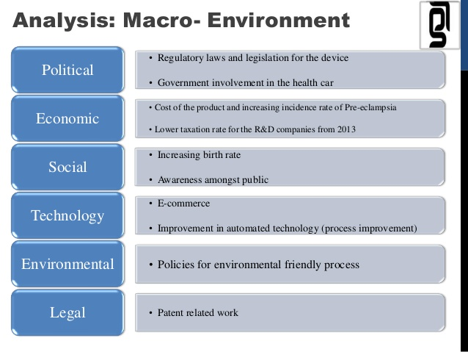
Application of macro strategies used to develop customer value
Different approaches can be applied to improve the level of customer satisfaction. First is by developing a brand that can fit what the clients need in the market. The best way to achieve this is by researching different market segments to establish the things that most clients want in your products. Once you have come up with a list of the things that should be included in the brand, you can then go ahead and design one that is appealing to the clients. The positioning of such a brand will also determine the extent to which clients will love it. Most clients want products that they can find within their locality.
Another approach that will work for business is engagement in corporate social responsibility. It is not possible to make the presence of the business felt in the community without engaging in activities that attract the attention of the society. It is important to identify activities that can bring a good relationship between the community and the business. When the business and the community come together to achieve a common goal, the community will be willing to use the products and services from the business because they are sure to get returns. They will feel that they are also part of the business and will want to see it prosper (Watershoot & Bulte, 1992).

Works cited
W. van Waterschoot; C. van den Bulte (1992). "The 4P Classification of the Marketing Mix Revisited". Journal of Marketing. 56 (4): 83–93. JSTOR 1251988.

