Business Data Communications and Networking
Student’s Name
Institution

Introduction

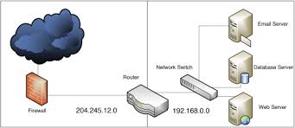
Figure 1: Network structure
Network structure provides an overview of the network layout. It shows how network s planned where each device is connected to the network and the type of security features used. The network design above in figure 1 is designed to create one of the best network structures for security and efficient communication. The topology used is ring topology where devices are connected at a point for efficient data flow. However, several servers, RAID and other devices such as router and switches are used for connection. Within the network structure, there are switches, printers, main workstation and PC workstation.

References
FitzGerald, J., Dennis, A., & Durcikova, A. (2012). Business Data Communications and Networking. New York: Wright Studio/Shutterstock.

