National Public Land/Urban

La Tonya Lee-Johnson
[Institutional Affiliation(s)]

Author Note

National Public Land/Urban
Mapping the cultural landscape of a location provides the land and its dwellers with a sense of identity and connection to it. It traces visible imprints of both past and current human activity on the land, how people interacted with it over time, and how their activities and events shaped the environment. Alongside the cultural landscape, observing the physical landscape help identify the geographic and geological features that are characteristic of the land. Together, these observations provide people with the physical, social, economic, and cultural significance of the area and its inhabitants, and establish their link with its physical features. In this paper, the physical and cultural landscape of the Grand Canyon National Park in Arizona will be observed to identify the physical, historical, and cultural aspects of this site.
The Grand Canyon is considered to be one of the greatest geological spectacles on earth. The gorge's depth and vastness are attributed to nearly 6 million years of erosion and geologic activity on the upraised earth's crust by the Colorado River. The depth extends to nearly a mile while its width varies between 0.3 miles to 18.5 miles, that spreads across a length of nearly 280 miles (Borneman, 2014). The exposed horizontal strata of the canyon are considered to retrace over 2 billion years of geological history (UNESCO, 2019). Although the Colorado River drainage area frequently experienced precipitation, owing to its higher elevation, the Grand Canyon area remained semi-arid. The area frequently experienced mass-wasting events and landslides, which lead to stream capture and erosion, which contributed to the vast width and depth of the canyons that are seen today. Nearly 3.6 million years of floods created and shaped the layers of the gorge, while the depth and height of its strata are thought to have resulted from the uplift of the Colorado Plateaus by up to 10,000 feet over a period of 65 million years (Kaiser, 2018). Several theories about the creation, age, and evolution of the canyon have been developed by observing the walls and layers of rock, which also speak of prehistoric human settlements and adaptation to the land. The formation of the canyon walls and assemblage of fossils can be traced to the Paleozoic and Precambrian era, while the animal remains and cave shelter fossils are thought to be from the Pleistocene era (Borneman, 2014).
Archaeological research conducted within the Grand Canyon National Park suggests that human settlement in the area properly began during the Archaic Period, between 8500-1700 BC. Many clans of Native Americans trace their ancestors from this area, such as the Hualapai, the Paiutes, the Navajo, the Zuni, and the Havasupai people. The land was agriculturally suitable with its plentiful water resources and animal life that allowed for hunting and farming, enabling indigenous communities to survive here for centuries (Kaiser, 2018). The oral traditions and tribal origin stories related by the Native American people speak of the canyon's cultural significance to them. In particular, the Hopi, Hualapai, and the Zuni clans trace their ancestral origin to the Grand Canyon. The Zuni people locate their point of origin to Bright Angel Creek, while the Hopi clans believe their people to have emerged near the junction of the Little Colorado River in the canyon. The Navajo and Havasupai people also attribute their ancestral knowledge of cultivation to the same site, and nearly all of them ascribe certain sacred, religious, and culturally significant traditions to the land (Kaiser, 2018).
Like other parts of North America, the traditional lifeways of native populations were adversely affected by European contact through subjugation, disease, and displacement. As Arizona was formally declared American territory in 1863, the federally-funded expeditions and exploration of the land were, in particular, damaging for the native populations. As images and reports of the canyon's unique landscape captured the colonists' attention, it opened the way for tourism and mining operations in the region in addition to conservation efforts to preserve the site. In 1893, the Grand Canyon had declared a Forest Reserve and subsequently declared a National Monument in 1908. As the Grand Canyon was federalized, it accentuated tensions between the federal government and indigenous populations of the land over conservation and land ownership. Consequently, many native populations were removed from their traditional and ancestral lands (Anderson, 2000; Kaiser, 2018). In 1919, President Woodrow Wilson passed the bill to declared the Grand Canyon a National Park. By that time, most of the native tribes had been displaced from the region.
Today, the Grand Canyon National Park is valued for its vast size, extensive tributary canyons, its unending depth, and layers of colorful rocks that date back to the Precambrian era. The park has two main public areas; the South and the North Rim. The South Rim is nearly 7000 ft above sea level and is the most accessible area of the park, drawing the most visitors that flock from all over the world to admire the view. The North Rim of the National Park is nearly 1000 ft higher than the South Rim and is located on the Walhalla Plateau and the Kaibab Plateau. It is considerably harder to access owing to its height and the harsh winter weather that often leads to road closures. The distance between the North Rim and the South is nearly 220 miles across by road. However, trekking through the Kaibab Trails shortens this distance to 21 miles (NPF, 2018). Visitors usually enter the North Rim from the Bright Angel point, but access is blocked during the peak winter season. On the other hand, the South Rim of the park receives nearly 90% of public visitation owing to the ease of accessibility. The Arizona State Route 64 takes visitors directly towards the South Rim, allowing them to enter the National Park at its Southern Entrance near Tusayan, AZ. Traveling across the South Rim, it is possible to cover at least 30 miles of the Park Area (NPS, 2019). Some adjacent areas of the Canyon besides the North and South Rims are also open for public recreation and visits, but the remaining portion of the park is particularly rugged and remote and is usually accessed by pack trail.
The entire Grand Canyon National Park area is a semi-arid desert, yet, the higher elevation frequently leads to snowfall even sometimes in the summers. Distinct vegetation and habitats are located at various elevations across its gradient. Sandy beaches and riparian vegetation can be observed near the Colorado River, while a wide variety of desert scrub species and cacti exist just above the corridor of the river. In between the 6200-8200ft area, the land has abundant ponderosa pine vegetation, while a spruce-fir forest lies at the top of the Park near the North Rim at 8200ft (NPF, 2018). The climate drastically changes below the Rims in the inner part of the canyon. The bottom, along the Colorado River, is nearly one mile lower and temperatures here can reach up to 120 degrees F. The fall and spring seasons see unpredictable weather patterns and a single visit to various areas inside the park can expose one to a variety of climates. The Colorado Plateau and the gorge itself is home to unique species of animals such as the gray fox, Kaibab squirrel, condor birds, and bighorn sheep. Besides that, the National Park has nearly 250 species of birds, 70 mammal species, and 25 types of reptiles (Borneman, 2014).
To conclude, the Grand Canyon National Park is one of the most remarkable and identifiable landscapes in North America. It has become one of the most easily recognizable symbol of nature in the U.S. owing to its physical and geological features. However, besides being an awe-inspiring sight, the cultural landscape of the National Park provides historical and cultural context to its geographic features. The land has been feared, traveled through, and marveled at by people for thousands of years, while it has also been exploited for profit and witnessed oppression and forcible displacement of its people. Various Native American tribes continue to trace their origins in the land and still ascribe to the various mythologies and cultural traditions associated with it. As a result, this unique National Park has influenced American art, science, popular culture, tourism, and environmental values to a significant degree and serves as an important window into American history.
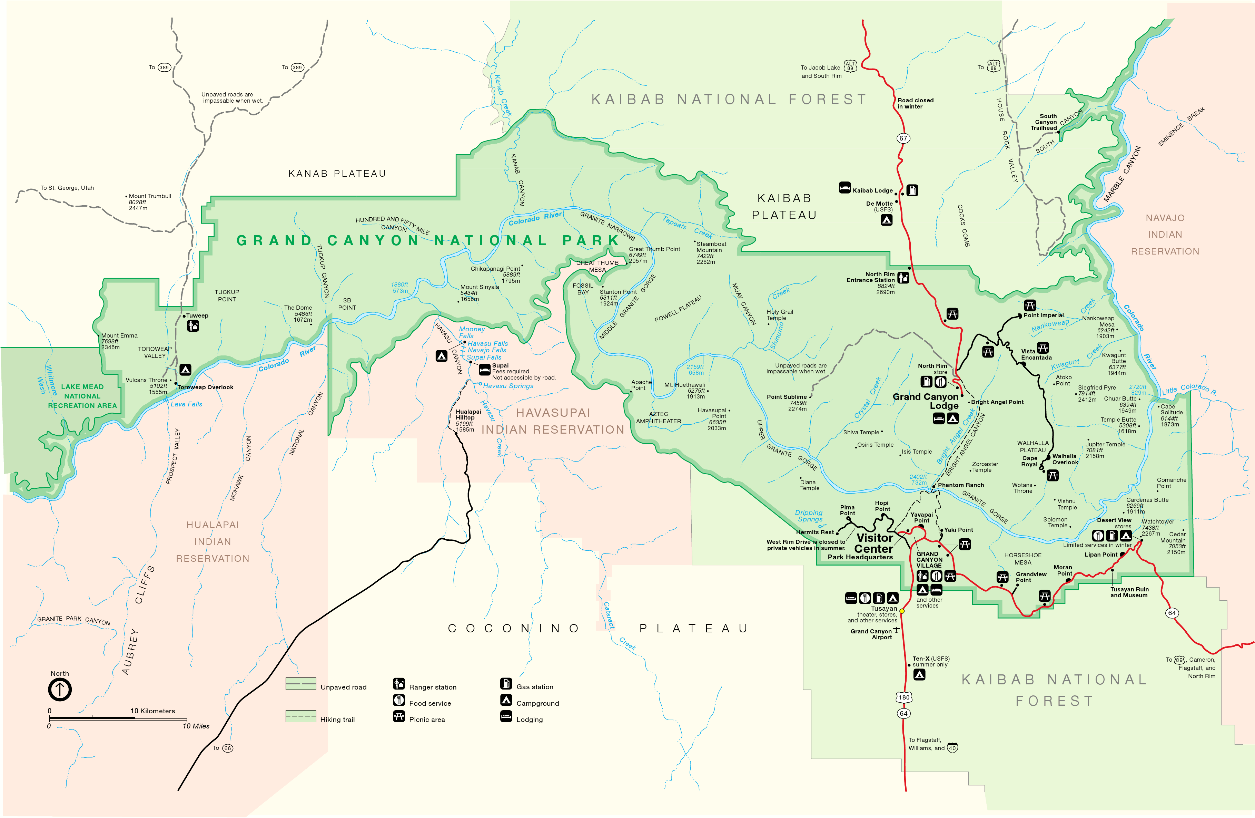
Figure 1 – Grand Canyon Maps (NP Maps, 2019)

References
Anderson, M. F. (2000). Becoming a National Park 1882-1919. In Polishing the jewel: An administrative history of Grand Canyon National Park (pp. 2-10). Strawberry, AZ: Grand Canyon Association. Retrieved from https://www.nps.gov/grca/learn/historyculture/upload/chapter1.pdf
Borneman, E. (2014). The Grand Canyon. Retrieved July 17, 2019, from Geo lounge: https://www.geolounge.com/grand-canyon/
Kaiser, J. (2018). Grand Canyon: the complete guide (7th ed.). Arizona: Destination Press.
NP Maps. (2019). Grand Canyon Maps. Retrieved July 17, 2019, from National Park Maps: http://npmaps.com/grand-canyon/
NPF. (2018). A Sight Beyond Words: Grand Canyon National Park. Retrieved July 17, 2019, from National Park Foundation: https://www.nationalparks.org/explore-parks/grand-canyon-national-park
NPS. (2019, June 17). North Rim. Retrieved July 17, 2019, from National Park Service: https://www.nps.gov/grca/planyourvisit/north-rim.htm
UNESCO. (2019). Grand Canyon National Park. Retrieved July 17, 2019, from UNESCO World Heritage Centre: https://whc.unesco.org/en/list/75

