Genetic Algorithms Improves School Transportations Performance
Student’s Name
Institution
Course Code
Date

Introduction
The school bus problem is associated with the class of vehicle routing problem. This problem includes the use of several vehicles to transport students from schools to their destinations. The problem could be solved through the extraction of school buses routes by reducing the total number of buses, distance covered by buses to pick students from various picking points and reducing the number of buses. The manual schedule of buses generates several routes of buses, many routes and the number of buses and therefore, it creates a lot of confusion leading to delay in the transportation of students. It also results in multiple buses transporting on the same route hence increasing the cost and time of the pick. As stated by Gen and Ida (2015), it is a major bottleneck in bus transportation and why the use of genetic algorithms system was established to address the bottleneck. However, the problem could be solved through the use of Genetic algorithms system. The genetic algorithms are integrated with the chosen route of each fleet of buses. The system would then be able to choose the route based on the routes integrated with the system and apply across the network. The route, which is chosen by the genetic algorithm are superior choose system and the current route and therefore, genetic algorithms would be able to evaluate and decide on the best route. The algorithms terminate when the maximum number is achieved and this ensures that there are less multiple transits in a given route.

Genetic algorithms are described as adaptive heuristic search strategies, which are based on the doctrine of population genetics. According to Gen and Ida (2015), genetic algorithms have been utilized before to solve several problems and obtaining successful results. Some of these problems, which have been solved using genetic algorithms, are the problem of a salesman traveling, job shops scheduling, telecommunication networks, and vehicle routing problem. In this paper, the generic router system used for routing school buses using genetic algorithms is availed. The genetic algorithms have been used by several schools across the district to improve the bus schedule and the pick to the routing point, which is the school in this case (Oluwadare, Oguntuyi, & Nwaiwu, 2018). The genetic algorithms system is a solution to the problem of wastages being incurred by the school, which use a manual system to pick and drop students. The manual system results in multiple trips, which is a waste a lot of time and resources of schools. This paper, is, therefore, investigate how genetic algorithms improve school transport performance hence brings efficiency within the school transport system.
Statement of the problem
Most schools are experiencing a problem of picking and dropping students using a fleet of school buses. This is because schools within most districts use manual scheduling system. As stated by Kang, Kim, Choi, and Cho (2015), this results in multiple schedules hence a waste of resources and finances of the school. School bus routing problem is a complete set of problem, which are based on the way students are picked and dropped by a fleet of school buses (Kang1, Kim, Choi, & Cho, 2015). In many occasions, the fleet of bus routing schedule is not well planned and it ends up scheduling several businesses in one route. This is because the bus network is a very difficult problem to solve because of the cost, bus lines, coverage, fleet size, transit travel time and frequency of buses. With several buses scheduled to pick students, it becomes difficult to optimize the use of time and therefore, genetic algorithms provide the best solution and therefore, improve the performance of school transport.
Purpose of the study
The main purpose of the study is to investigate how genetic algorithms are used to solve the problem of school bus transportation. It is noted that school bus transportation problem is majorly caused by poor scheduling, several fleets of buses in a route and poor plan for the routing. This study is, therefore, meant to establish the cause of the problem and how the genetic algorithms are used to develop transport network solution to the school bus transportation problem. The main goal of the study is to extra the best possible solution to address the problem of school bus transport system. The genetic algorithms, therefore, the best solution to the school transportation problem because it is able to select the bus stop, generate bus routes, and schedules the generated routes as well.
Methods and materials /Plan
The study was conducted through a descriptive and analytical research method. In this case, various journals, peer review and research papers were read and analyzed. These Journals, peer review, and other readings materials used were obtained through search from different databases. The databases used to complete the study were Google Scholar, EBSCO database and Pro-Quest database. It is, therefore, important to state that a search was conducted using keywords such as school bus transport problem, genetic algorithms improve school bus transportation performance. Several journals and peer review were obtained and analyzed. Out of 250 journals obtained only twenty (20) journals and articles were selected and only ten used to complete the proposal. Each article or journal used to complete the study was analyzed based on the author, date of publication and relevancy to the topic being addressed. The routing problem was analyzed and the way they have been solved to improve efficiency in
Finding
It is obtained that genetic algorithms are the best system, which can be used to solve the problem of school transportation. The genetic algorithms solve the problem through the use of subdivision of the transport system into groups. From the analysis of various studies, it is discovered that genetic algorithms help in solving the problem through the efficient allocation of buses based on the need and the route. It is done through the integration of the bus system with genetic algorithms system so that it could be able to select the route based on the data.
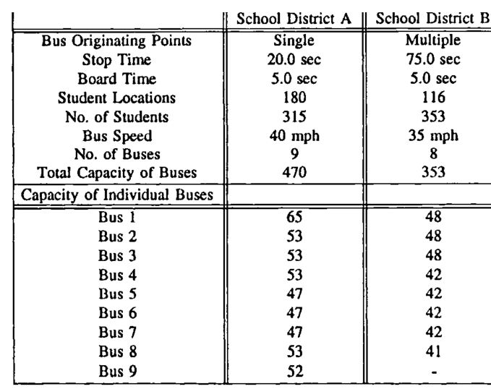

Diagram 1: School bus transportation schedule

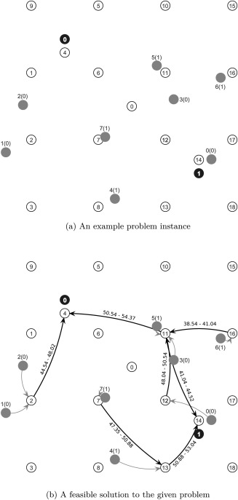

Diagram 2: School transport problem and solution offered by algorithms
Discussion
Normal algorithms use a normal sequence to pick and drop schools. The school bus transport system, which still uses normal algorithms, utilizes a linear method of operation. However, it is likely that genetic and normal algorithms are associated with random and stochastic phenomena. As stated by Gen and Ida (2015) stochastic are defined as things, which happen periodically and independent but still exist. The stochastic search algorithms like genetic algorithms are controlled by rules, which are related to optimization and evolution. But in case of random search, we have to locate the error to find the best solution and therefore, this is the techniques, which is used by genetic algorithms to allocate bus stops and schedule of the routes. All normal algorithms have been used to try to address the problem of school transport with little success because of the multiple trips of busses on the same route. This is because the use of normal algorithms means that the bus is destined to use the linear route. And with linear route means that the buses picked students from point A, B, C and D and during dropping time, the same method is used. In this case, several buses are found to be on the same route and therefore, it leads to a waste of cost and time hence it become expenses to the school.

It is the reason the genetic algorithm was inverted to help in addressing the same problem. Research indicates that genetic algorithms use data integrated with the system (Rafaa, Guedria, & Sayda, 2017). This means that the system is updated with a number of students, bus fleets, routes and time. The system then gets updated automatically after every few minutes and this allows every bus on the fleet to have a bus schedule, next bus, and updated routes. The genetic algorithms calculate the population of each station and update its system based on the availability of the next bus. And therefore, with the algorithm, it is possible for school transportation would be able to get the next available bus and reschedule buses based on the unpicked students. It helps to avoid having several buses in one route and therefore, it limits the cost and time being utilized in picking students. In this case, it is important to point out that genetic algorithms help in reducing expenses being incurred by the school in transportation.
Conclusion
It is, therefore; important to point that genetic algorithm is the most effective technique to solve the problem of the school transport system. And therefore, it enhances the school transportation system hence productivity of the school. The core reason for this approach is to solve the problem, which exists due to the available several buses, the poor scheduling techniques being used by many schools and because of nonsymmetric questions. It addresses the problem of several buses on one route to help in reducing the time being used for picking and dropping students. Genetic algorithms have a more improved solution to the problem, which affects the transport system of several schools.

References
Bögl, M., & Doerner, K. (2015). The school bus routing and scheduling problem with transfers. Network
New York, 2-14.
Gen, M., & Ida, K. (2015). An improved genetic algorithm for generalized transportation problem. Artificial
Life and Robotics, 2-35.
Kang1, M., Kim, S.-K., Choi, R. H., & Cho, M. (2015). Development of a Genetic Algorithm for the School
Bus Routing Problem. International Journal of Software Engineering and Its Applications, 2-38.
Oluwadare, S. A., Oguntuyi, I., & Nwaiwu, J. (2018). Solving School Bus Routing Problem using
Algorithm-based Model. I.J. Intelligent Systems and Application, 21 (5), 50-68.
Rafaa, M., Guedria, N. B., & Sayda, L. B. (2017). Solving School Bus Routing Problem with a genetic
algorithm. Conference: Advanced Logistics and Transport (ICALT), 2013 International Conference on, 2-14.
Sadrsadat, H., Poorzahedi, H., Haghani, A., & Sharifi, E. (2013). Bus Network Design Using
Algorithm. ://ageconsearch.umn.edu/record/207124/files/2012_155_Bus_Design_Gen_Algorithm.pdf , 2-21.
Vignaux, G., & Michalewicz, Z. (2014). A genetic algorithm for the linear transportation problem. IEEE
Transactions on Systems Man and Cybernetics, 2-18.
Wang, W., Shuyan, C., & Haoyang, D. (2015). Genetic Algorithm for Multiple Bus Line Coordination on
Urban Arterial. Comput Intell Neurosci. 2015; 2015: 868521. , 2-35.

