Program Development in Recreation & Sports
[Name of the Writer]
[Name of the Institution]

Program Development in Recreation & Sports

Program Title
The title of the program is going to be as followed.

“Youth Development and Training Initiative”

Agency Mission and Programming Strategy
The underlying mission of the program is to make sure that how the healthy place is being provided to the people where they are able to gather, have a good time and get involved in the host of the activities. During the course of the program, effort is going to be made to make sure that the youth of the community as well as some other people are able to get together at a place where they are going to make sure that they can get together for hosts of healthy activities. The other aspect of the program is to make sure that the community of the people is going to be created that would provide long term benefits to the people at the given point of time. The strategy of the program is about making sure that how people are going to be in the position to ensure that they have a long-term advantage in terms of the hosts of the physical activities that are being carried out during the premises of the program.

Need for the Program
The need for such type of program was being felt for a very long time and it can be said that with the “Youth Development and Training Initiative” it is going to be made sure that the particulars of the program are going to turn out well. The other major factor is that how the overall evaluation of the program is needed to be done in a manner that there are going to be hosts of activities that are going to be conducted in the manner that would benefit most of the population at the given point of time. With such a program in place, it would made sure that the underlying developmental aspects are going to be shaped out well at the particular point of time.

Venue Arrangement
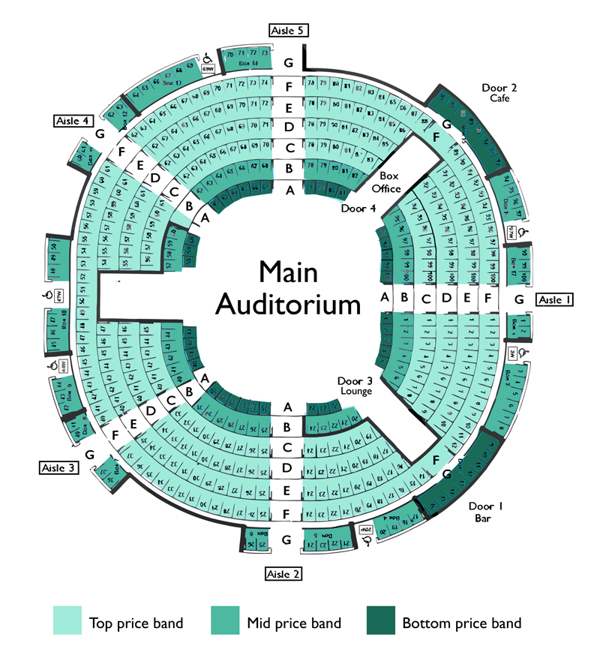

Budget and Decision Making Template

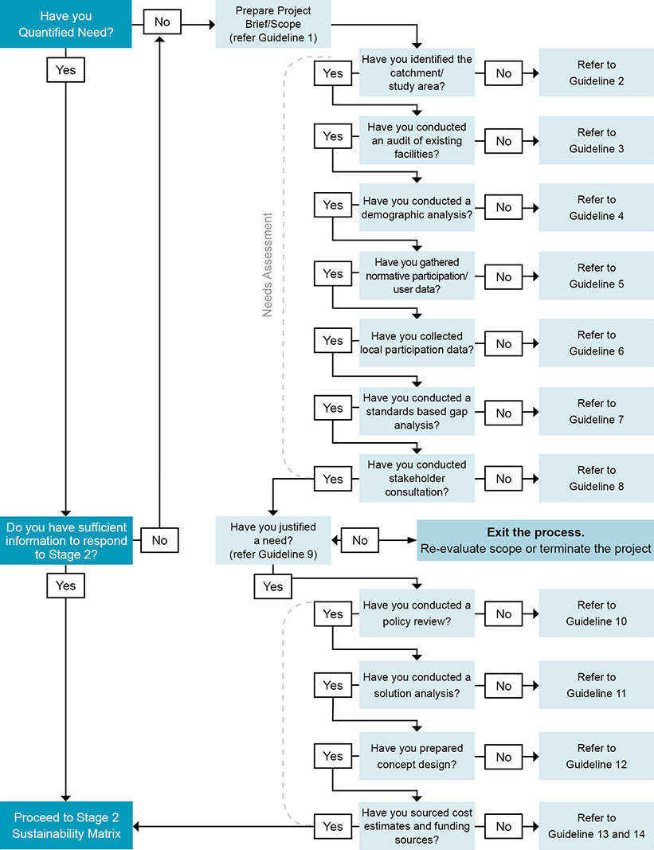

Staffing Plan

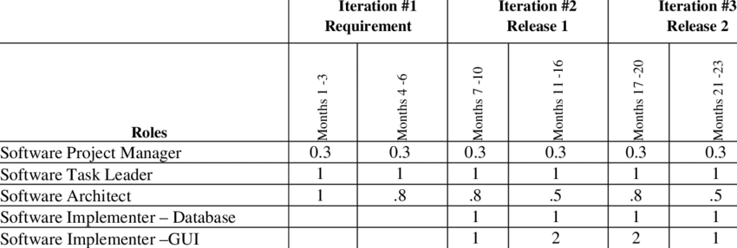

Terminal Performance Outcomes
There are very specific performance outcomes that are intended to be achieved by initiative this program. The idea is to make sure that these goals and outcomes. Some of the performance outcomes that the program intends to achieve are as followed.
- To make sure that the sports training and the zeal for the physical activities is increased among the community.
- To make sure that the people who are part of the community are working in the correspondence and ensuring that they develop insight about how important physical health is
- Allowing the development of finer athletes by ensuring that the state-of-the-art facilities are being provided to them.
- Also increasing the span of activities that are carried out at the given point of time and having a perspective about the long-term benefits of the populace
- The other objective that the plan intends to achieve is to make sure that the performance outcome is being determined in an appropriate manner. In this regard, more inclusive policies are going to be developed which means that the participation of the women, and other racial dimensions are kept in mind during the course of the whole process.

Program Evaluation
The key thing about the program evaluation is that how it is going to be making sure that the specific outcomes that were underlined during the course of the paper earlier are going to be met. What it means is to make sure that the measuring the performance outcomes against a specific criterion and then determining what are some of the reasons that the broader objectives are the plan are not being mat at the given point of time.

Program Decision Plan
The decision plan about the plan would be about to make sure that how the major decision making at the level of the is to ensure that how the specific outcomes that are related to the plan are going to be taken care off. The other aspect is to make sure that whether the broader objectives and the state-of-the-art facility that the plan intends to be creating could be materialized at the given point of time. These determinants are some of the things that could make sure that the decision could be made about the future of the plan.

