Student Name
Instructor Name
Course Number
Date
Post 8: The Five Cs of Pricing
Introduction
Pricing decisions are the most important ones in the marketing mix because they result in revenue generation for a company (Camilleri). There are certain considerations for a company when price is set. Following are the five C’s which have to be considered while setting price of the product:
Cost
Price is based on the cost incurred to produce a product. There are two major components of costs incurred on a product, fixed and variable costs. The price should be such that the total revenue covers both variable and fixed costs (Korman).
Customers
Customers are the ultimate judge of the product and price. A pricing strategy should consider the expectations of customers regarding price of a product.
Channel Members
The number of channels used by a company will affect the price charged by it for the product. Companies selling directly to customers can charge a lower price for its products.

Competition
A higher level of competition will put extra pressure on the company to choose the right pricing strategy. Price can be used to differentiate a product from those offered by competitors.
Company objectives
A price set for a product should work well with all the other components of marketing mix. All the components of marketing mix should coordinate with each other to achieve the company goals.
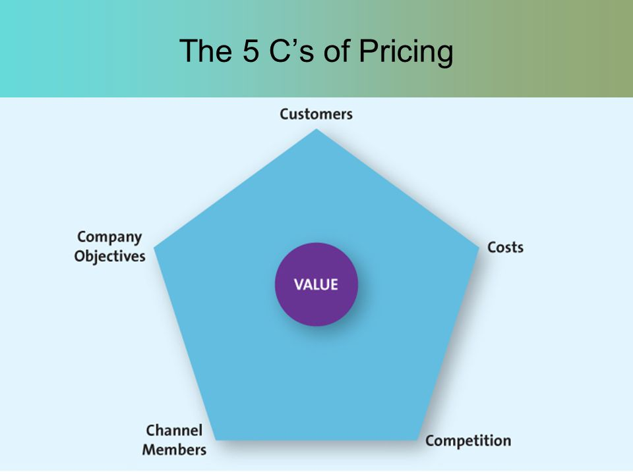
Fig 1. (Korman)
Application
The most important aspect for the Kellogg’s Raisin Bran will be the competition. There will be a very low level of differentiation between products offered by the company and competitors. This means that the price should also be very close to their prices. In an industry with such standardised product, the cost will be almost similar for all the companies. Channels of distribution for all the companies will also be similar to each other. The assessment of all these factors gives us the conclusion that the competitive pricing strategy will be the most appropriate for Kellogg’s in the case of Raisin bran crunch (Liozu).
Fig 2. (BMS.co.in)

Works Cited:
BMS.co.in. "https://www.bms.co.in/explain-the-goods-service-continuum/." 8 June 2012. https://www.bms.co.in. <https://www.bms.co.in/explain-the-goods-service-continuum/>.
Camilleri, M.A. "Integrated Marketing Communications." Camilleri, M.A. Travel Marketing,Tourism Economics and the airline product,Tourism, hospitality and Event Management. Springer International Publishing, 2018. 85-103.
Korman, Lindsay. "https://scalefinance.com/the-5-critical-cs-of-pricing/." 2018. https://scalefinance.com/the-5-critical-cs-of-pricing/. 28 January 2020.
Liozu, Stephen M. The pricing Journey: The organizational transformation toward Pricing Excellence. Stanford University Press, 2015.

