SSL/TSL Certification
[Name of the Writer]
[Name of the Institution]

SSL/TSL Certification

Screenshot of the Signing Setup of SSL?TSL Certification
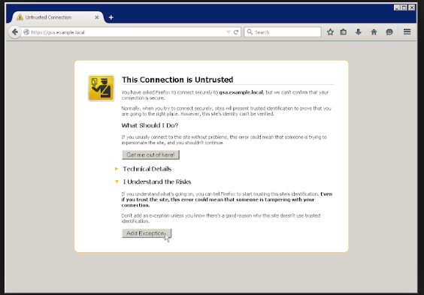

Introduction
With the passage of time, more and more webite have started to take usage of the way SSL certification are supposed to work. The expectation on the part of the user is that how they SSL certitrication is going to make sure that the security protocol of that website that they are trying to log in are secure and how they can be assured that the data encruption is going to be applied in this website is one of the major reasons that the users tend to prefer SSL Certifications these days. The first thing that is going to be looked at during the course of this paper is that how the information regarding SSL Certitification is being provided by different set of browsers.

Internet Explorer
The presentation of the SSL Certification is located in the main interface of the website. Most of the times what happens is that the users have complaied about the loading time of the way Internet Explorers are supposed to work and thus it was a gimmick on their part to make sure that how the main interface would show the certification making sure that the users have to go beyond the initial interface when logging in using the SSL Certification.
Now, in the case of the Internet Exploror, what happens is that when the padlock is being clicked, it brings about the issuing of the CA that goes through the global sign of the identification. This goes to show that the connection on which the website is established is encrupted. There is also some information in terms of the identification of the how the EV’s and non EV’s are going to be done. These certifications contain the company name and the location of the organization as well.
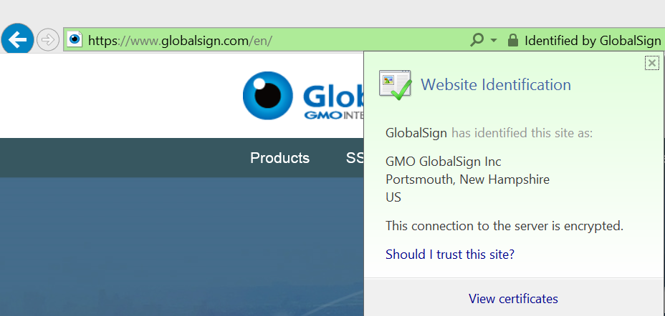

FireFox
Even though the presentation of the interface was being done in a pretty similar manner like Internet Explorer, in some of the more advanced and updated versions of the Firefox, not only the certitication is being showed, there is lot more information about how the ceritifcation are supposed to work and how the information is located in the interface of the main browser. They have the ability to make sure that they are providing further details about the certificate if user wants to know something about. When the padlock is being clicked in the address bar, it tends to bring the preliminary dropdown that is supposed to indicate more secure connection and how it is being configured in a proper manner in terms of how the placement of the SSL is being done. The other thing that can be done by the user in order to make sure that they are able ot gain more information about is that how they can click at the dropdown arrow to make sure that they are able to witnessed more information about the particulars of the subject and how the whole thing about the certitication is supposed to work. It has to be noted that if there is a case that there is extended validation, there are identifying information about the EV that make sure that it defines the protocol about how the operation of the website is supposed to be run at the particular point of time. On the other hand, if there are non EV certifications, then they can be seen at the bottom of the pile as far as the way their placement is supposed to be carried out.
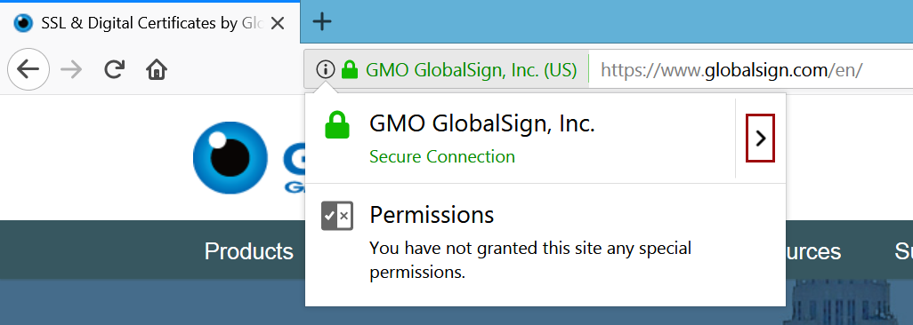

Google Chrome
One of the reasons that the Chrome is the sought after browser at the moment is that the user does not need to click anywhere and all the information regarding the security certification is available with the help of the interface of the browser. It was something that was not there in some of the previous versions but it had now being brought back. The user can see the information about the certification by clicking the padlock in the URL bar. What it is going to do is that it would trigger a dropdown and thus it would correspondingly open a valid link certification that can be seen by the user at that point of time. As far as the display of the EV certification, it can be seen on the heart’s content that is located on the central interface of the website.
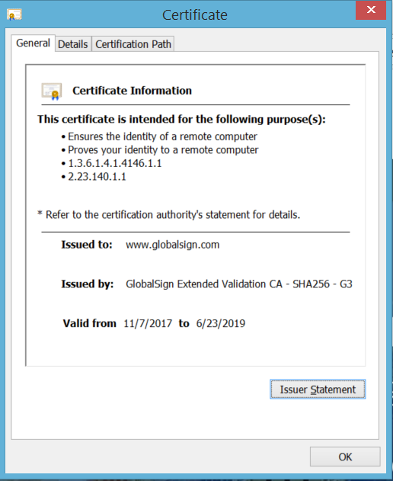

Usage and Importance of the SSL/TSL Certification
There are many advantages and beneifst that these certifications tend to provide to the user. The first thing that they do is that they make sure that all the data transfer that happens between the servers is carried out in an appropriate manner. Not only that, when the website has an SSL/TSL certification it is bound to ensure that it brings an increase in the Google Ranking of the website at the given point of time. Not only that, it also plays an important role in enhancing the customer trust. The Root Certificate must be present on the end user's machine in order for the Certificate to be trusted. If it is not trusted the browser will present untrusted error messages to the end user. In the case of e-commerce, such error messages result in immediate lack of confidence in the website and organizations risk losing confidence and business from the majority of consumers. SSL Certificates need to be issued from a trusted Certificate Authority. Browsers, operating systems, and mobile devices maintain list of trusted CA root certificates.

References

Adamovic, S., Sarac, M., Stamenkovic, D., & Radovanovic, D. (2018). The importance of the using software tools for learning modern cryptography. The International journal of engineering education, 34(1), 256-262.
Bayramova, T. (2014). The importance of self-management mechanisms to ensure Software safety.
Hacker, A. J., & CISSP, I. (2018). Importance of Web Application Firewall Technology for Protecting Web-based Resources. ICSA Labs an Independent Verizon Business.
Hongwu, L. X. H. Y. Y. (2016). Application of security communication based on SSL in the system of selecting courses [J]. Journal of Anhui Vocational College of Electrontcs & Information Technology Z, 1.
Roosa, S. B., & Schultze, S. (2017). The" Certificate Authority" trust model for SSL: a defective foundation for encrypted Web traffic and a legal quagmire. Intellectual property & technology law journal, 22(11), 3.

