Individual Personality Traits
Name
[Institutional Affiliation(s)]

Author Note

Introduction
The five-factor model is a personality theory that describes the taxonomy of personality behaviors. It provides statistical data through which one can understand and assess his personality traits. The theory was founded on the use of words and these words are linked with neuropsychological experiments (Kayiş et al., 2016). The five elements are characterized by the abbreviation OCEAN or CANOE. Underneath all projected universal elements, several associated and additionally precise chief elements are present. For instance, extraversion is associated with embracing such abilities as sociability, confidence, enthusiasm seeking, friendliness, action, and optimistic feelings (“The Big Five Personality Test | Truity,” n.d.). Researchers used five trait theory to evaluate traits of persons (Stajkovic, Bandura, Locke, Lee, & Sergent, 2018). The five-factor model states that biological and genetic factors are linked with the person’s brain and all the processes occur with coordination to define one’s personality.

Big Five Personality Assessment
The use of common languages is broadly evaluated by describing five personality psyche terms. The five traits are:
- Openness to experience
- Conscientiousness
- Extraversion
- Agreeableness
- Neuroticism

Openness to Experience
This score tells about a person’s social interactions. The open people have a sense of comfort and they enjoy thinking about creative ideas and theories. They like ideas, innovations, and changes in life (Stajkovic et al., 2018). Those who are less open are conventional and conservative. The score represents that I am less open and are more under the influence of cultures and preferably vote those leaders who follow civilization.
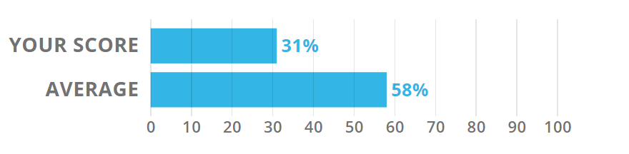

Conscientiousness
This trait represents an individual's ability of determination to achieve their goals and aims. The trait identifies that a person is determined, persistent and responsible. Persons high in conscientiousness are more determined, dutiful, orderly and dependable. These people are ambitious and have the aim and courage to achieve their success. People scoring low in conscientiousness are impulsive and less determined (Vedel, 2016). The score represents that the person is highly organized and determined. The high score in conscientiousness, person will be able to chase dreams and aims to achieve them. Person has strong will power and self-control.
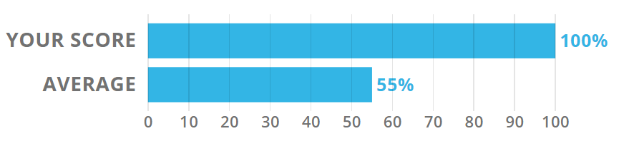

Extraversion
Extraversion states how a person gets his energy to perform normal functions of life. People having higher scores in Extraversion are excitable, energetic and gregarious. People scoring low in Extraversion are reserved and quiet (“The Big Five Personality Test | Truity,” n.d.). They like and prefer to spend time alone to energize themselves. The score 94% represents that I am more energetic and enthusiastic (“The Big Five Personality Test | Truity,” n.d.). This ability is associated with brain activity to respond to dopamine. People having a high level of Extraversion are more responsive to dopamine and remain motivated to chase their goals. They feel satisfied when they achieve their targets, incentives, and success.
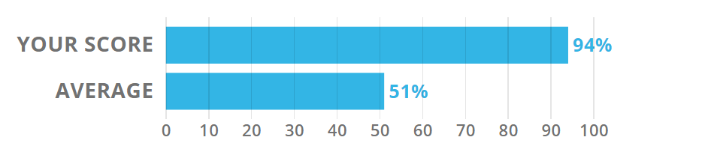

Agreeableness
Agreeableness assesses a person's tendency to put the needs and necessities of others first. They are more compassionate and sympathetic. They are helpful and accommodating and support others in accomplishing their tasks and goals. Less agreeable people are more competitive and argumentative and are more interested in accomplishing their tasks rather than helping others. My score 27% represents that you are more concerned about your goals and needs (“The Big Five Personality Test | Truity,” n.d.). I do not have emotions for others and prefer myself. During negotiation or argumentative situations, I will be more competent and concerned and are not easy to convince.
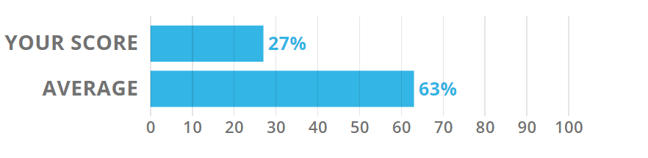

Neuroticism
Neuroticism evaluates one's response to anxiety and stress. These people are vulnerable to stress and depression having neuroticism score higher than normal. It is very difficult for them to achieve stability in a state of depression or anxiety (Vedel, 2016). People having less scores in neuroticism usually struggle with their negative emotions. Persons having lower scores in Neuroticism are resilient and can manage stressful conditions. They are stable, resilient, self-confident and carefree (“The Big Five Personality Test | Truity,” n.d.). It is often observed that people with high scores in neuroticism are anxious and self-conscious. This trait is associated with the development of mental health problems such as high scores in neuroticism will represent that the person is prone to stress and may develop mental health issues in the future. My score is low in Neuroticism that is 6% therefore, I am more stable, calm and self-confident and can manage stressful conditions (“The Big Five Personality Test | Truity,” n.d.).
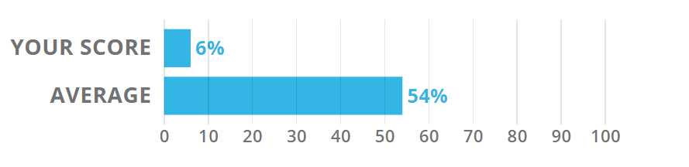

Core Pattern
This represents your empathetic idealist, practical caretaker, analytical thinker and logical mechanic nature of core elements of a personality.
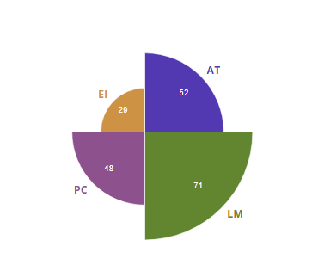

Interpersonal Pattern
This pattern represents that you are more of a commanding leader and social butterfly. Aloof thinker and sympathetic ear traits are also present in your personality according to this ratio.
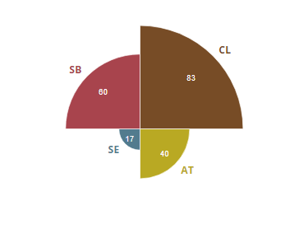

Social Pattern
This pattern describes the nature in terms of gleeful rebellion, anxious alienation, easy belonging and safety in number. I enjoy social interactions that give me a sense of belonging. The results are displayed below.
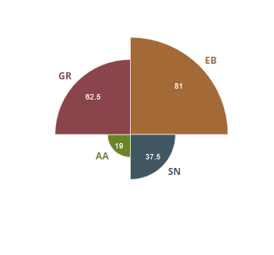

Communication Pattern
The communication ways of thoughts, emotions, and ideas are represented with the help of this circumflex. I can easily communicate my views and have expressive ideas and vision.
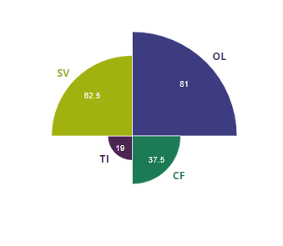

Emotional Pattern
Mostly sunny, full-spectrum, even keel and mostly gloomy nature are represented by this circumflex. My personality is mostly sunny means a happy and forward thinker.
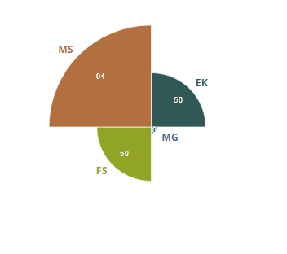

Motivational Pattern
This circumflex shows how a person gets his motivation. This represents in terms of confident drive, anxious diligence, carefree fun and scattered anxiety.
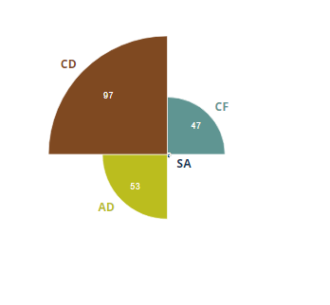

Productive Pattern
This representation of circumflex shows how a person approaches tasks and activities in terms of grand plans, bright ideas, reliable results and adaptable action (“The Big Five Personality Test | Truity,” n.d.). My results are representing the personality of the more reliable person with innovative ideas and plans.
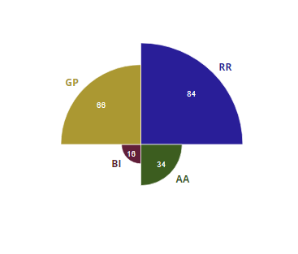

Rewards Pattern
This circumflex shows the personality having focused ambition, dizzy excitement, and steady drive and laid back traits of a personality (“The Big Five Personality Test | Truity,” n.d.). My results show that I have more ambitious and dedicated personality.
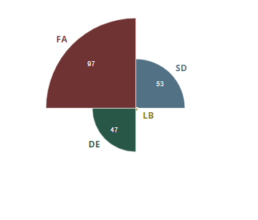

Esteem Pattern
This represents open arm, anxious affection, take charge and lone wolf nature of a personality. Overall it is stated as esteem pattern. My results for esteem pattern are as follows:
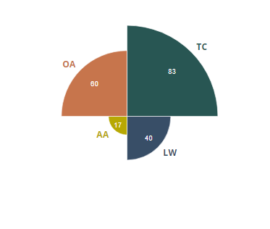

Conclusion
Different models are presented to explain and describe the nature and traits of a personality. The five-factor model is useful in analyzing one's behaviors, traits, and personality. Different verbal communication elements are discussed by which personality is judged and the results are shown in terms of various traits (Stajkovic et al., 2018). The nature of emotions and traits is connected with the brain and nervous system where all responses are answered according to the stimulus. More determined people have higher scores in agreeableness and openness (Kayiş et al., 2016). They are motivated and self-confident by nature and are also present in their genes to lead in life. Experiences of life and event also influence the development of traits of persons (“The Big Five Personality Test | Truity,” n.d.). Different studies have shown that various traits of a personality are strongly influenced by their socioeconomic status, significance and childhood events. Certain environmental factors and genetic factors also influence the development of traits particularly openness and extraversion.

References
Kayiş, A. R., Satici, S. A., Yilmaz, M. F., Şimşek, D., Ceyhan, E., & Bakioğlu, F. (2016). Big five-personality trait and internet addiction: A meta-analytic review. Computers in Human Behavior, 63, 35–40.
Stajkovic, A. D., Bandura, A., Locke, E. A., Lee, D., & Sergent, K. (2018). Test of three conceptual models of the influence of the big five personality traits and self-efficacy on academic performance: A meta-analytic path analysis. Personality and Individual Differences, 120, 238–245.
The Big Five Personality Test | Truity. (n.d.). Retrieved November 30, 2019, from https://www.truity.com/sites/default/files/big_five_sample.html
Vedel, A. (2016). Big Five personality group differences across academic majors: A systematic review. Personality and Individual Differences, 92, 1–10.

